



|  |  |
| --- | --- |
| **Version Number** | 1.0 |
| **Status** | Final |
| **Document Date** | 5/25/2017 |
| **Owner** | NetCracker |

Contents

**Introduction** **6**

1.1 Document Purpose 6

**Document Scope** **7**

Actors 7

Use Cases Map 8

**Use cases** **11**

**Main page functionality** **11**

Use case 1 Registration of new client 11

Use case 2 Log in to the web site 14

Use case 3 Log out of the system 15

Use case 4 Reset password 16

Use case 5 View product catalogue (from the main page) 18

**Manage product catalogue** **20**

Use case 6 View product catalogue (Admin page) 20

Use case 7 Add new product 21

Use case 8 Edit product 23

Use case 9 Add new product type 25

Use case 10 Edit product type 27

Use case 11 Sort products 29

Use case 12 Filter product catalogue 30

Use case 13 Search product 30

Use case 14 Add discount 31

Use case 15 Edit discount 33

Use case 16 Add marketing promotion 35

Use case 17 Edit marketing promotion 38

**Order** **41**

Use case 18 Place order (for registered clients) 41

Use case 19 View orders made by clients 43

Use case 20 Sort orders 45

Use case 21 Filter orders 46

Use case 22 Search orders 47

Use case 23 View list of orders by the client 47

Use case 24 Cancel order by the client 49

Use case 25 Edit order 50

Use case 26 Change status of order 52

Use case 27 Create order 54

Use case 28 View history of orders status changes 56

**Service management** **57**

Use case 29 View list of ordered services 57

Use case 30 View list of product instances / Change status of client’s service 58

Use case 31 Suspend/deactivate/resume service 59

**Complaints** **61**

Use case 32 View list of complaints 61

Use case 33 Place complaint 62

Use case 34 View complaints made by clients 64

Use case 35 Change status of complaint 66

Use case 36 Filter complaints 67

**Accounts management** **68**

Use case 37 View list of users 68

Use case 38 Sort / filter/ search users 70

Use case 39 Create user 71

Use case 40 Edit user 74

Use case 41 Edit account information 76

Use case 42 Add address domain 78

Use case 43 Generate a report as xls/xlsx file 79

Use case 44 Edit notification letter templates 80

*Document Reference*

|  |  |  |
| --- | --- | --- |
| # | Document Name | Description |
|  | Functional requirements | Detailed description of functional requirements |

*Glossary of Terms*

|  |  |  |
| --- | --- | --- |
| # | Acronym | Interpretation |
| 1 | CSR | User role of Customer Sales Representative |
| 2 | PMG | User role of Problem Management Group |
| 3 | M | Priority “Mandatory” |
| 4 | O | Priority “Optional” |

# Introduction

The system is designed for making online orders, service management and solving problems (if needed). The purpose of this System is to get new clients and make the process of service ordering and management easier and more convenient.

## 1.1 Document Purpose

The general purpose of this document is to show relationship between users and the system.

# Document Scope

## Actors

|  |  |  |
| --- | --- | --- |
| # | Actor | Description |
|  | Client | Person who uses services provided by the company. |
| 2 | CSR | Person who deals with clients’ orders. |
| 3 | PMG | Person who deals with clients’ complaints. |
| 4 | Admin | Person who deals with web pages content (provides up-to-date information about available for specified region product catalogue; discounts) and manage users’ account information. |

## Use Cases Map

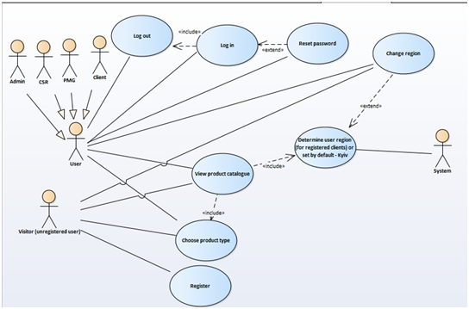

Figure “Main page” functionality

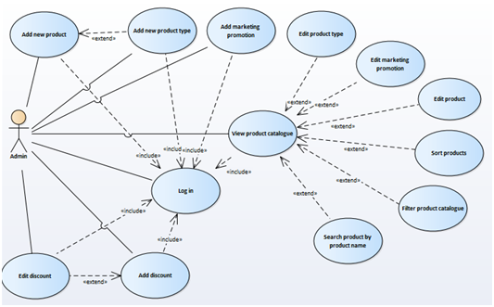

Figure “Admin functionality: Management of product catalogue”

## 

Figure “Admin functionality: Accounts management”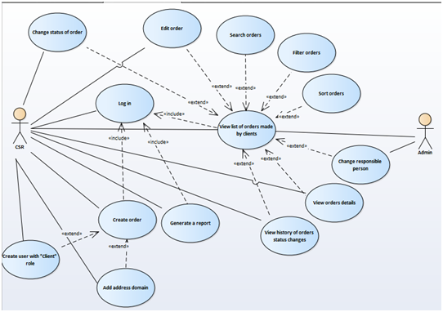

Figure “Orders management”

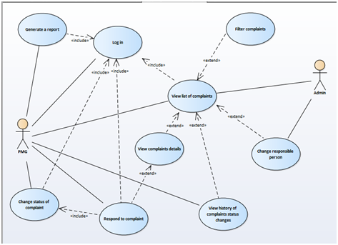

Figure “Complaints management”

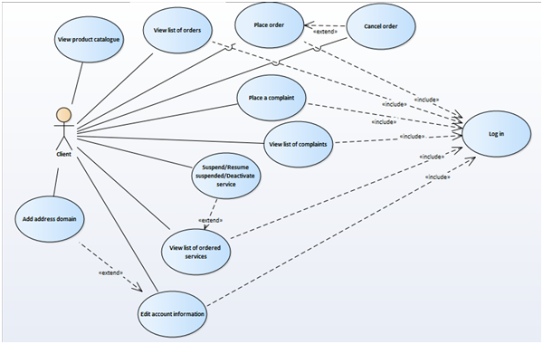

Figure “Client’s functionality”

# Use cases

# Main page functionality

## Use case 1 Registration of new client

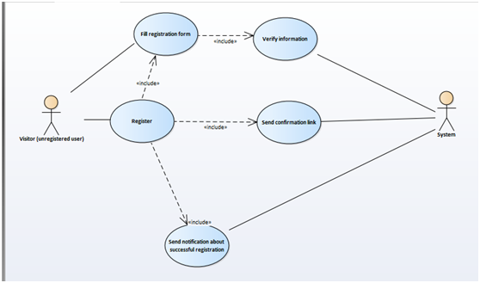

Figure “Registration” use case

1. **Brief Description:** This use case is for the user’s registration. Registration is needed if the user has decided to make order for the first time.
2. **Actors**: Visitor
3. **Preconditions**: Visitor is connected to the website and has no registered accounts in the system.
4. **Base Flow of Events**
5. Visitor clicks on “Register” button on the main page.
6. The system displays the registration form (“Email”, “Password”, “First name”, “Last name”, “Phone number” fields with “Register” and “Cancel” buttons).
7. Visitor fills the registration form. All fields are mandatory to be filled.
8. Once the Visitor completes the filling of registration form, «Register» button should be used.
9. The system verifies the specified information.
10. The system sends a confirmation link to the specified email address and informs Visitor about need to check email with following information message: ”The confirmation link has been sent to your email. Please, click that link to finish your registration”.
11. Visitor checks the email and clicks on the link to confirm email address.
12. The system accepts the confirmation link and sets access permissions (new user with “Client” role is created in the system).
13. The system displays information message: “Congratulations! Your registration is complete.”
14. Visitor receives a notification via email that registration has been accepted.
15. The use case ends successfully.
16. **Alternative flows**

**5.1**  **Invalid email address**

If in step 3 of the base flow the Visitor entered invalid email (only email in ^[_A-Za-z0-9-\\+]+(\\.[_A-Za-z0-9-]+)*@[A-Za-z0-9-]+(\\.[A-Za-z0-9]+)*(\\.[A-Za-z]{2,}$;

form is allowed), then:

1. The system will display the error message “Incorrect email”.
2. The use case resumes at step 2.

**5.2**  **Email address is already registered**

If in step 3 of the base flow the User entered the email which is already registered in the database of users then

1. The system will display the error message “Such email is already registered”.
2. The use case resumes at step 2.

**5.3**  **Invalid password**

If in step 3 of the base flow the User entered invalid password (only Latin characters, digits ([a-zA-Z0-9]) and specific symbols (!@#$%^&*()_+|~-=\‘{}[]:";’<>?,./) are allowed; allowed length - 8-20 symbols) then

1. The system will display the error message “Incorrect password. Minimum length - 8 symbols”.
2. The use case resumes at step 2.

**5.4 Invalid phone number**

If in step 3 of the base flow the Visitor entered invalid phone number (only phone numbers in ^[+]*[(]{0,1}[0-9]{1,4}[)]{0,1}[-\s\./0-9]*$ format are allowed) then

1. The system will display the error message “Incorrect phone number”.
2. The use case resumes at step 2.

**5.5 Not all fields are filled**

If in step 3 of the base flow the Visitor didn’t fill all the fields and completed registration (step 4) then:

1. Entered fields should be saved.

2. Empty fields should be highlighted with red colour and Visitor shall be warned by appropriate text (“Please, enter your email address/ password / first name/ last name/ phone number”) near appropriate textboxes.

3. The use case resumes at step 2.

**6. Post-conditions**

The Visitor is registered on the website and new account with “Client” role is inserted into a database of users. The user is logged in to the website and  main page is displayed.

## 

## 

## Use case 2 Log in to the web site

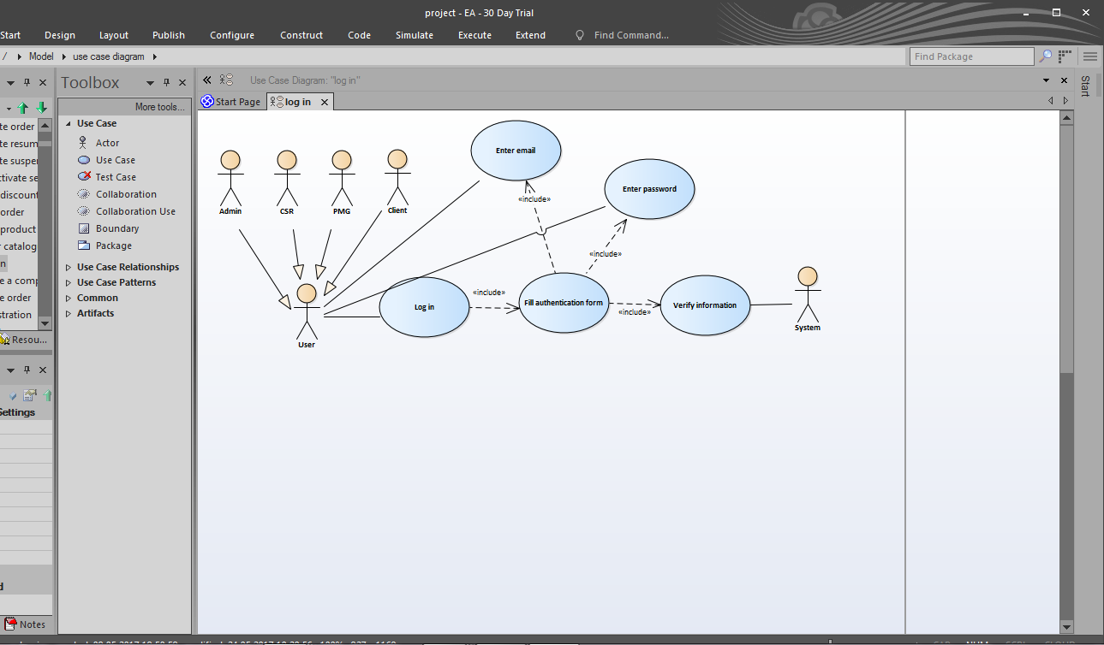

Figure “Log in” use case

1. **Brief Description:** This use case is for the user’s authentication.
2. **Actors**: User (Admin, Client, CSR, PMG)
3. **Preconditions**: User is connected to the website  User is registered in the system.
4. **Base Flow of Events**
5. User clicks on «Log in» button.
6. The system displays the authentication form (a user must enter username (an email address is used as a username) and password).
7. User enters email address and password which were used during the registration.
8. Once the user completes the filling of authentication form, «Log in» button should be used.
9. The system verifies the information.
10. The user will be logged in to the website.
11. The use case ends successfully.
12. **Alternative flows**
    1. **Invalid email address or password**

If in step 5 of the basic flow System doesn’t find email, specified by the user in step 3, in the database of users or data, saved in the database differs from specified by the user then

1. The system will display the message “Wrong email address or password. Please, try again ”
2. The use case resumes at step 3.

**5.2 Not all fields are filled**

If in step 3 of the base flow the User didn’t fill any of the fields and submitted enter (step 4) then:

1. Entered fields should be saved.

2. Empty fields should be highlighted with red colour and User shall be warned by appropriate text (“Please, enter your email address/ password”) near appropriate textboxes.

3. The use case resumes at step 2.

1. **Post-conditions**

The user is logged in to the website. The main page is displayed.

## Use case 3 Log out of the system

1. **Brief Description:** The system allows users to log out of the user account from any page of the system.
2. **Actors**: User (Admin, Client, CSR, PMG)
3. **Preconditions**: User is logged in to the system.
4. **Basic Flow of Events**
5. User clicks on “Log out” button.
6. The main page is displayed.
7. The use case ends successfully.
8. **Alternative flows**
   1. **Log out of the system from the page, which doesn’t contain personal account information**

If User with “Client” role wants to log out of the system from any page of product catalogue or “About” / “Contacts” page (pages, which aren’t personal pages (like “My account”, “My services”, “My orders” or “My complaints”)) then:

1. The same page which was shown before clicking “Log out” button is displayed.
2. The use case ends successfully.
3. **Postconditions**

User is logged out of the system.

## Use case 4 Reset password

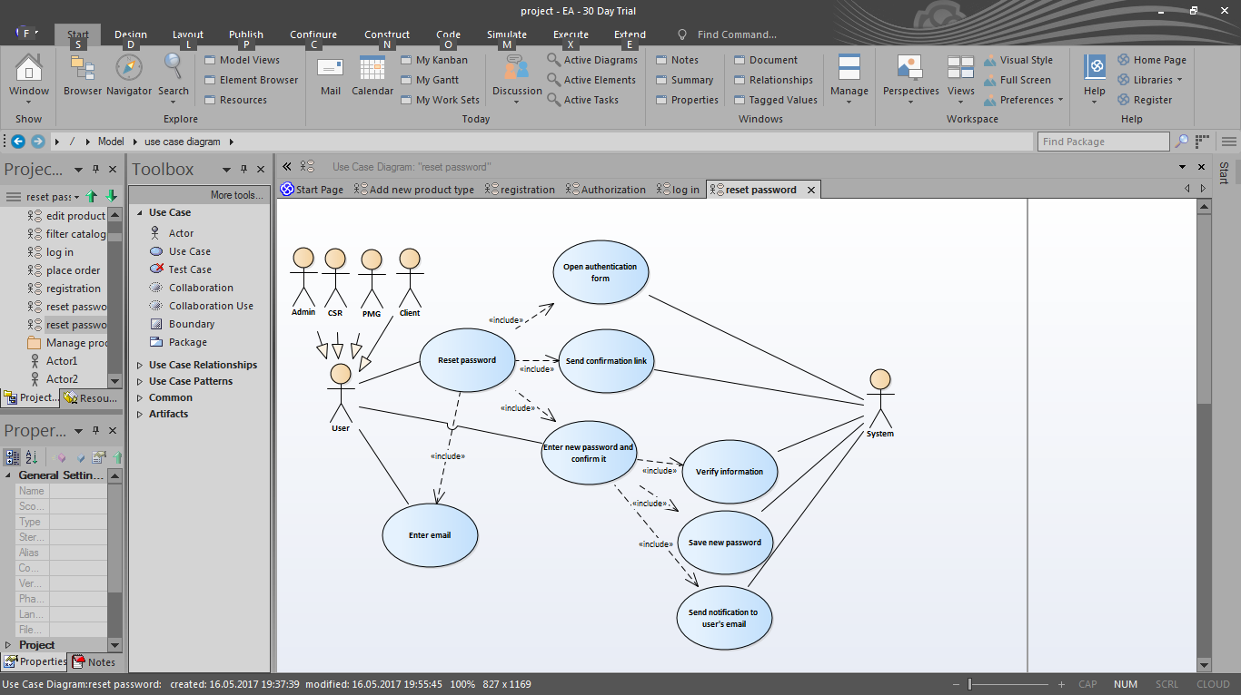

Figure “Reset password” use case

1. **Brief Description:** The system allows User to recover password if it was forgotten.
2. **Actors**: User (Admin, Client, CSR, PMG)
3. **Preconditions**: User is connected to the website  User is registered in the system.
4. **Basic Flow of Events**
5. User clicks on «Log in» button.
6. The system displays the authentication form.
7. User clicks on the link “Forgot your password?”
8. The system opens a new page with a form which consists of: “Email” field and “Reset” button.
9. User enters email and clicks on “Reset” button.
10. The system sends a confirmation link to the specified email address and informs User about need to check email with following information message: ”The confirmation link has been sent to your email. Please, click that link to reset your password”.
11. User checks the email and clicks on the link to confirm email address.
12. The system accepts the confirmation link and redirects User to “New password” page with form which consists of “New password” and “Confirmation password” fields.
13. User enters new password in appropriate field and reenters it in confirmation field.
14. User clicks on ”Set new password” button.
15. The system verifies the information.
16. The use case ends successfully.
17. **Alternative flows**

**5.1 Invalid email address**

If in step 5 of the base flow the User entered invalid email (there is no such user login registered in the system) / left it empty then:

1. The system will display appropriate error message “Sorry, there is no such user. Please, try again”/ “Please, enter your email address”.
2. The use case resumes at step 4.

**5.2**  **Invalid password**

If in step 9 of the base flow the User entered invalid password (only Latin characters, digits ([a-zA-Z0-9]) and specific symbols (!@#$%^&*()_+|~-=\‘{}[]:";’<>?,./) are allowed; allowed length - 8-20 symbols) and completed setting new password (step 10) then

1. The system will display the error message “Incorrect password. Minimum length - 8 symbols”.
2. The use case resumes at step 9.

**5.3** **Invalid confirmation of password**

If in step 9 of the base flow the User entered correct password but repeated it incorrectly in confirmation field and completed setting new password(step 10) then:

1. The system will display the error message “The passwords don’t match”.

2. The use case resumes at step 9.

1. **Postconditions**

New password is saved in the system. The notification about password reset is sent to user’s email.

## Use case 5 View product catalogue (from the main page)

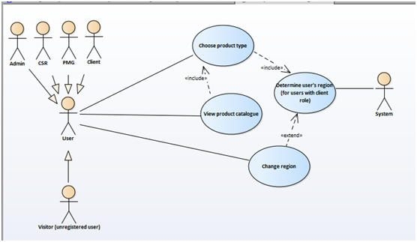

Figure “View product catalogue on the main page” use case

1. **Brief Description:** The system allows users (both unregistered and registered) to view product catalogue on the main page according to region.
2. **Actors**: User (Client, Admin, CSR, PMG), Visitor (unregistered user)
3. **Preconditions**: User/Visitor is connected to the website.
4. **Base Flow of Events**.
5. The system displays main page with “Our services”(active; consists of subtabs with product type names), “About” and “Contacts” tabs and determines user’s region: for registered users region is set according to user’s address domain; for Visitors default region is Kyiv. Only available for the user’s region product types are displayed.
6. User/Visitor chooses product type from available on the main page subtabs.
7. The system displays only available for region products according to chosen product type option.
8. The use case ends successfully.

**5. Alternative flows**

**5.1. User/Visitor wants to change the region**

If User/Visitor wants to see product catalogue available for another region then:

1. User/Visitor clicks on regions drop-down list and chooses needed one
2. The system displays product types available for chosen region.
3. The use case resumes at step 3.

# 

# 

# Manage product catalogue

## Use case 6 View product catalogue (Admin page)

1. **Brief Description:** This use case is for viewing list of products saved in the system.
2. **Actors**: Admin/CSR
3. **Preconditions**: Admin/CSR is logged in to the system.
4. **Base Flow of Events**
5. The system displays Admin page.
6. Admin/CSR chooses “Catalogue” tab.
7. The system displays the product catalogue (list of products, saved in the system; list consists of following columns; product name (link to product details, if clicked, UC 8 Edit product begins) product type, price and region).
8. The use case ends successfully.

## 

## 

## Use case 7 Add new product

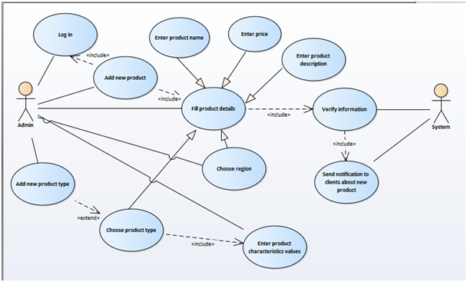

Figure “Add new product” use case

1. **Brief Description:** The system allows Admin to create product catalogue by adding new products.
2. **Actors:** Admin
3. **Preconditions:** Admin is logged in to the system with authorized access. Admin is viewing product catalogue (see UC 6 View product catalogue).
4. **Basic Flow of Events**
5. Admin clicks on “Add new product” button.
6. The system displays “Add new product” form with “Main information” (active tab) and “Characteristics” tab.
7. Admin fills main characteristics of product (product name, description), chooses product type, region and sets price for chosen region.
8. Admin clicks on “Characteristics” tab. The characteristics are shown according to product type chosen on “Main information” tab.
9. Admin inputs values of displayed characteristics.
10. Admin clicks on “Save” button.
11. The system verifies the information.
12. The system displays information message: “Product is saved in the system”.
13. The use case ends successfully.
14. **Alternative flows**

**5.1. Not all fields are filled**

If in step 3 of the base flow Admin didn’t fill all the mandatory fields (product name, price, product type, region) and completed adding (step 6) then:

1. Entered fields should be saved displayed.
2. Empty fields should be highlighted with red colour and Admin will be warned by appropriate text (“Please, enter product name/ price”, “Please, choose product type / region”) near appropriate fields.
3. The use case resumes at step 2.

**5.2 There is no needed type of product**

If in step 3 of the base flow Admin didn’t find needed type of product then:

1. Admin clicks on “Add new type” link;
2. Use Case 9 Add new product type begins from step 4 (see [UC 9 Add new product type](https://docs.google.com/document/d/1wrxNJD-ONU5Wm3xW1oIsP5rhsQmuVDDab2s7bsQ6eJA/edit#heading=h.2xcytpi))
3. The use case resumes at step 3.

**5.3 The product is available in more, than one region**

If in step 3 Admin wants to add several regions to set price then:

1. “Add regional price” button should be used.
2. The system shall display additional drop-down list with available options of regions and additional “Price” field.
3. Admin chooses additional region and input price for this region.
4. The use case resumes at step 3.

**5.4 The product with input characteristics already exists**

If in step 3 of the base flow Admin fills product name or all the mandatory fields (product type, characteristics values, region and price) with the same values which are already saved in the system and completed adding (step 6) then:

1. Warning message “Such product already exists” is displayed.
2. The use case resumes at step 6.

**6. Post-conditions**

New product with input details and chosen characteristics is saved in the system and added to product catalogue (on “Catalogue” tab and on the main page).The status of product is set as “active” by default. The notification about new available product is sent to clients’ email whose notification settings are turned on.

## Use case 8 Edit product

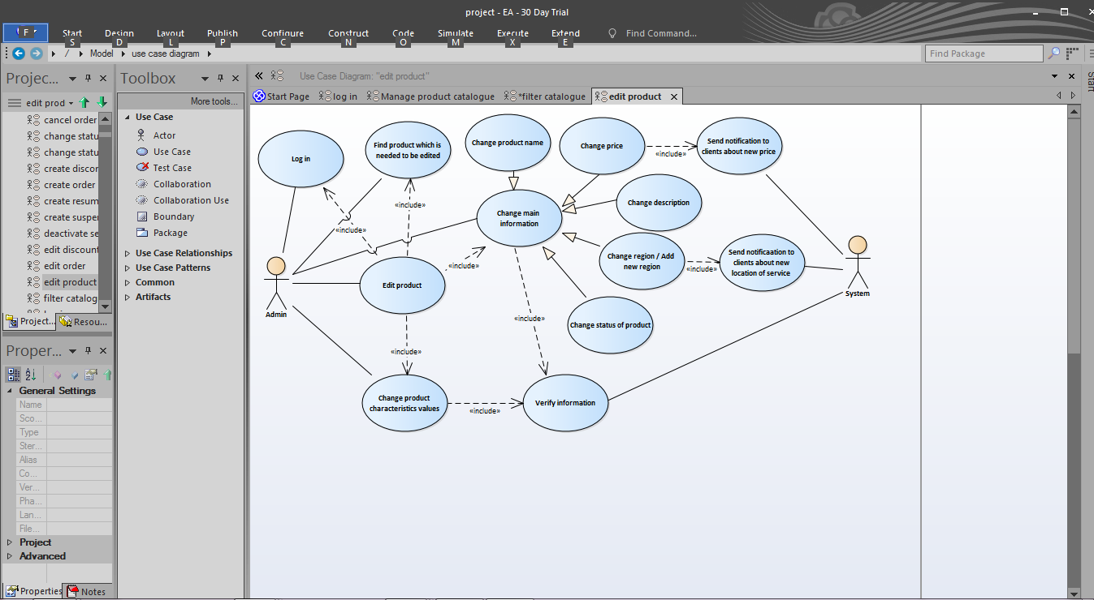

Figure “Edit product” use case

1. **Brief Description:** The system allows Admin to change product characteristics values of product in product catalogue.
2. **Actors:** Admin
3. **Preconditions:** Admin is logged in to the system with authorized access.Admin is viewing product catalogue (see UC 6 View product catalogue).
4. **Basic Flow of Events**
   1. Admin clicks on the name of the needed product.
   2. The system displays “Edit product” form with “Main information” (active tab) and “Characteristics” tab.
   3. Admin changes necessary values of characteristics of product (product name / price / status / description are editable) or adds new region and price for it on the “Main information” tabs or available for determined product type values of options on “Characteristics” tab (are set according to the product type).
   4. Admin clicks on “Save changes” button.
   5. The system verifies the information.
   6. The system displays information message: “Changes are saved in the system”.
   7. The use case ends successfully.
5. **Alternative flows**

**5.1. Not all mandatory fields are filled**

If in step 7 of the base flow Admin didn’t fill all the mandatory fields (product name, price) and completed editing (step 8) then:

1. Entered fields should be saved.

2. Empty fields should be highlighted with red colour and Admin will be warned by appropriate text (“Please, enter product name/ price”) near appropriate fields.

3. The use case resumes at step 6.

**5.2 The product with input characteristics already exists**

If in step 7 of the base flow Admin changes values of product name, but product with such name is already saved in the system and completed editing (step 8) then:

1. Warning message “Such product already exists” is displayed.
2. The use case resumes at step 6.
3. **Post-conditions**

Changes in product characteristics values are saved in the system and updated in product catalogue (on “Catalogue” tab and main page). If status of product was changed to “inactive” then the product will not be displayed in the product catalogue and clients will not be able to order this product. If price for product was changed then notification about new price is sent to clients’ email whose active product instance is the same as product’s. If new region was added then notification about new location for product is sent to clients’ emails whose notification settings are turned on.

## Use case 9 Add new product type

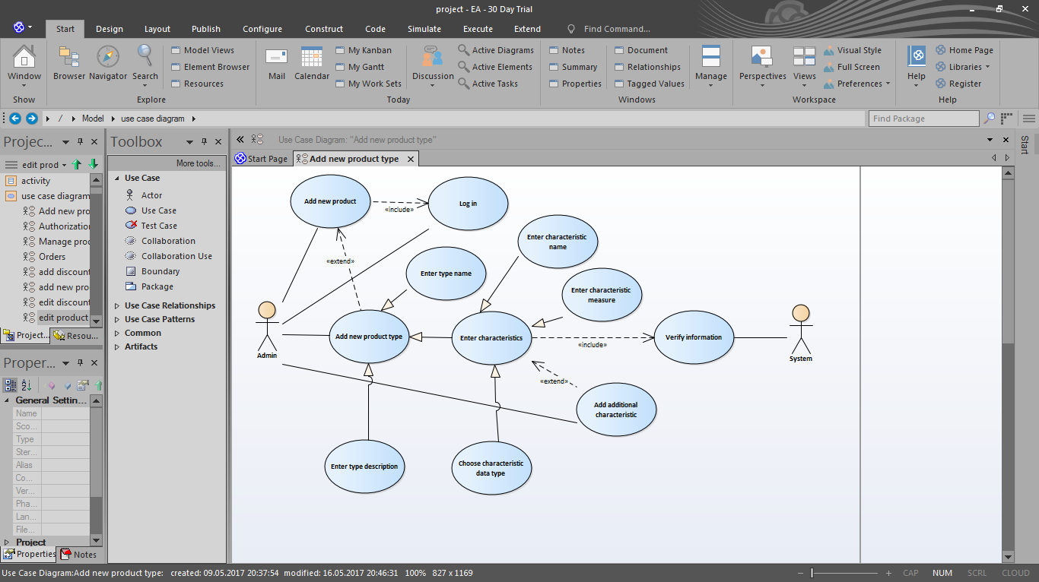

Figure “Add new product type” use case

1. **Brief Description:** The system allows Admin to add new product type for adding new products in product catalogue.
2. **Actors:** Admin
3. **Preconditions:** Admin is logged in to the system with authorized access. Admin is viewing product catalogue (see UC 6 View product catalogue).
4. **Basic Flow of Events**
5. Admin clicks on “Product types” subtab.
6. The system displays list of product types saved in the system (list consists of: product type id, product type name, status of product type: active(available for ordering; displayed in the product catalogue) or inactive(not visible in product catalogue)).
7. Admin clicks on “Add new product type” button.
8. The system displays “Add new type” form (form includes “Product type name”, “Description” “Product type status” (by default - active (available for ordering; displayed in the product catalogue)), set of fields for product type characteristics (“Name”, “Measure” and “Data type” fields with “Delete” button for deleting characteristic if input was mistaken) and “Save” button)
9. Admin fills all mandatory fields (“Description” field can be empty).
10. Admin clicks on “Save” button.
11. The system verifies the information.
12. The system displays information message: “Product type is saved in the system”
13. The use case ends successfully.

**5. Alternative flows**

**5.1. Not all mandatory fields are filled**

If in step 7 of the base flow Admin didn’t fill all the mandatory fields (all fields except “Description” are required to be filled) and completed adding (step 8) then:

1. Entered fields should be saved displayed.

2. Empty fields should be highlighted with red colour and Admin will be warned by appropriate text (“Please, enter product type name or product characteristic name / measure / data type”) near appropriate fields.

3. The use case resumes at step 7.

**5.2 The product type has more than one characteristic**

If there is need to add several characteristics for new product type then:

1. “Add characteristic” button should be used.
2. The system shall display additional set of fields (“Name”, “Measure” and “Data type” with “Delete” button for deleting characteristic if input was mistaken)
3. Admin fills all the fields.
4. The use case resumes at step 9.

**5.3 Such product type already exists**

If in step 8 of the base flow Admin inputs “Product type name” field with the same value which is already saved in the system and completed adding (step 9) then:

1. Warning message “Such product type already exists” is displayed.
2. The use case resumes at step 6.

**6. Post-conditions**

New product type with input characteristics is saved in the system.

## Use case 10 Edit product type

1. **Brief Description:** The system allows Admin to change product type characteristics in product catalogue.
2. **Actors:** Admin
3. **Preconditions:** Admin is logged in to the system with authorized access. Admin is viewing product catalogue (see UC 6 View product catalogue).
4. **Basic Flow of Events**
   1. Admin clicks on “Product types” subtab.
   2. The system displays list of product types saved in the system (list consists of: product type id, product type name, status of product type: active(available for ordering; displayed in the product catalogue) or inactive(not visible in product catalogue).
   3. Admin chooses needed product type and clicks on “Edit” button near it.
   4. The system displays details of product type: “Product type name”, “Description” “Product type status”,”Description”. set of fields for product type characteristics (“Name”, “Measure” and “Data type” fields with “Delete” button for deleting characteristic if input was mistaken) and “Save changes” button)
   5. Admin changes necessary values of characteristics of product type (product type name / status / description fields are editable, add or delete characteristics)
   6. Admin clicks on “Save changes” button.
   7. The system verifies the information.
   8. The use case ends successfully.
5. **Alternative flows**

**5.1. Not all mandatory fields are filled**

If in step 9 of the base flow Admin didn’t fill all the mandatory fields (product type name) and completed editing (step 10) then:

1. Admin shall be warned by appropriate text (“Please, enter product type name”) near appropriate field.
2. The use case resumes at step 8.

**5.2 The product type with input characteristics already exists**

If in step 9 of the base flow Admin input new product type name which is already saved in the system and completed editing (step 10) then:

1. Warning message “Such product type already exists” is displayed.
2. The use case resumes at step 6.
3. **Post-conditions**

Changes in product type are saved in the system and updated in product catalogue (on “Catalogue” tab). If status of product was changed to “inactive” then all product type will not be displayed in the product catalogue.

## 

Figure “View/Sort/Filter/Search product catalogue” use case

## Use case 11 Sort products

1. **Brief Description:** The system allows Admin/CSR to sort products in product catalogue by specified parameter (name, product type, price and region).
2. **Actors:** Admin, CSR
3. **Preconditions:** Admin/CSR is logged in to the system with authorized access. Admin/CSR is viewing product catalogue (see UC 6 View product catalogue).
4. **Basic Flow of Events**
5. Admin/CSR chooses parameter (name, product type, price and region) by which product catalogue is needed to be sorted from “Sort by” drop-down list.
6. The system displays catalogue in ascending sorted order. For change the sort of orders to descending name of column should be clicked.
7. The use case ends successfully.
8. **Post-conditions**

The product catalogue is sorted by specified parameter.

## Use case 12 Filter product catalogue

1. **Brief Description:** The system allows Admin/CSR to filter products in product catalogue by product type and region.
2. **Actors:** Admin, CSR
3. **Preconditions:** Admin/CSR is logged in to the system with authorized access. Admin/CSR is viewing product catalogue (see UC 6 View product catalogue).
4. **Basic Flow of Events**
5. Admin/CSR chooses region or product type from drop-down lists (names of columns should be drop-down lists with saved regions/product types options and additional “All” option)
6. The system displays products with specified values (chosen region/ product type).
7. The use case ends successfully.
8. **Post-conditions**

The product catalogue is filtered by specified parameter

## Use case 13 Search product

1. **Brief Description:** The system allows Admin/CSR to search products in product catalogue by product name.
2. **Actors:** Admin, CSR
3. **Preconditions:** Admin/CSR is logged in to the system with authorized access. Admin/CSR is viewing product catalogue (see UC 6 View product catalogue).
4. **Basic Flow of Events**
5. Admin/CSR input name or part of name into “Product search” field and clicks “Find” button.
6. The system displays products with input name or names which contain input string.
7. The use case ends successfully.

**5. Alternative flows**

**5.1 Not found product**

If there are no saved products with names like input string then the system shall display information message “Sorry, there are no products with such name”.

**6.** **Post-conditions**

Only product names that match the search criteria remain displayed.

## Use case 14 Add discount

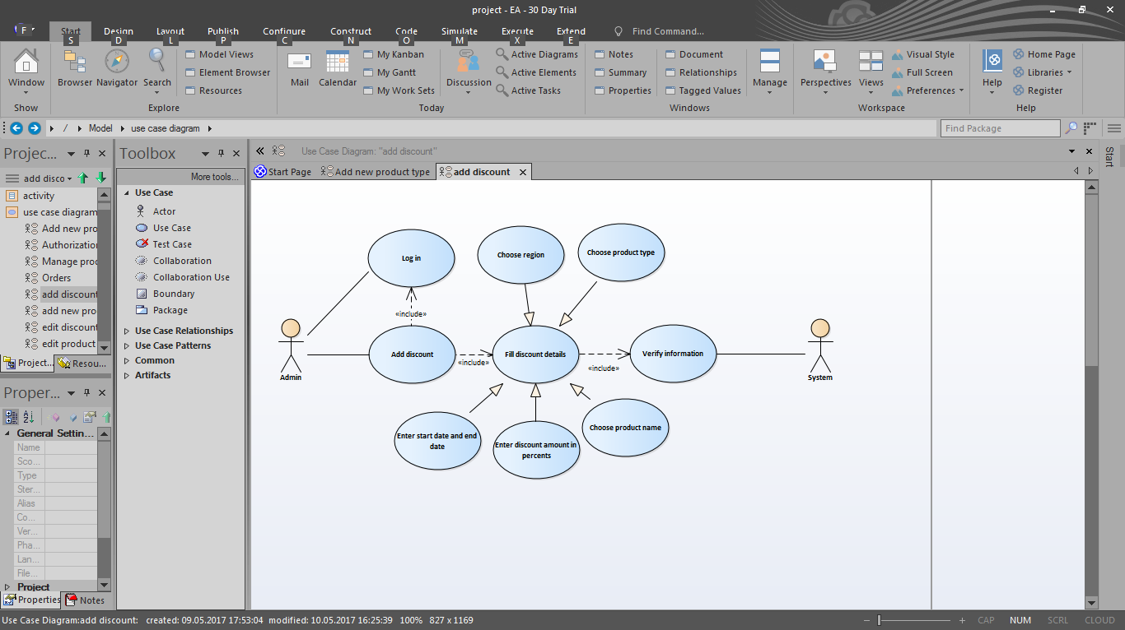

Figure “Add discount” use case

1. **Brief Description:** The system allows Admin to reduce price of product for specified time period by adding discount to it. In specified region during set time period only one discount can be available for specified product. After set time period the price of product is automatically changed to initial in product catalogue.
2. **Actors:** Admin
3. **Preconditions:** Admin is logged in to the system with authorized access. Admin is viewing product catalogue (see UC 6 View product catalogue).
4. **Basic Flow of Events**
5. Admin clicks on “Discounts and promotions” subtab.
6. The system displays “Discounts and promotions” page with list of discounts (discount id, product name, old price, new price, date from, date to columns) and promotions (promotion id, product name, additional service provided for free, old price, new price, date from, date to columns), “Add new discount”, “Add new promotion” and “Edit” buttons.
7. Admin clicks on “Add new discount” button.
8. The system displays “Add new discount” form (form includes “Discount title” field, “Region” drop-down list, “Product type” drop-down list (product types are filtered according to chosen region), “Product name” (names are filtered according to product type and region; Admin should should have the ability of autocomplete option), “Price” (read-only field, which shows real price of the product in product catalogue), “Discount” field (amount of discount in percents); “New price” field (is calculated automatically); “Start date” (date format field) and “End date” (date-format field) , “Add discount” and “Back ”button).
9. Admin fills all the fields.
10. Admin clicks on “Add discount” button.
11. The system verifies the information.
12. The system displays information message: “Discount is saved in the system”.
13. The use case ends successfully.
14. **Alternative flows**

**5.1. Not all fields are filled**

If in step 5 of the base flow Admin didn’t fill all fields and completed adding (step 9) then:

1. Entered fields should be saved.
2. Empty fields should be highlighted with red colour and Admin will be warned by

appropriate text (“Please, enter discount/start date/end date”, “Please, choose product type/ region/product name”) near appropriate fields.

3. The use case resumes at step 4.

**5.2 Discount for specified product during chosen time period already exists**

If in step 5 of the base flow Admin fills mandatory fields (region, product type, product name, start date and end date) with the same values which are already saved in the system and completed adding (step 9) then:

1. Warning message “Discount for specified product in chosen region already exists during this

time period” is displayed.

1. The use case resumes at step 7.
2. **Post-conditions**

New discount for chosen product is saved in the system and added to discount list (on “Catalogue” tab / Discounts submenu and on main page). The notification about new discount is sent to clients’ emails.

## Use case 15 Edit discount

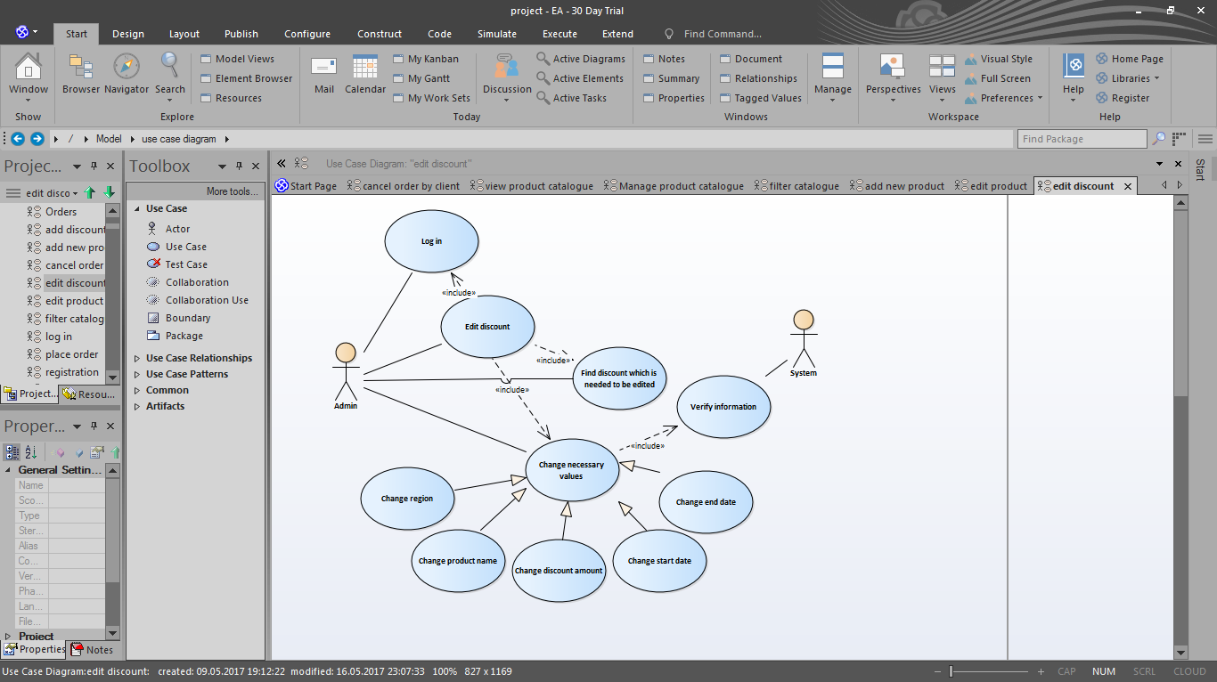

Figure “Edit discount” use case

1. **Brief Description:** The system allows Admin to change information about discount
2. **Actors:** Admin
3. **Preconditions:** Admin is logged in to the system with authorized access. Admin is viewing product catalogue (see UC 6 View product catalogue).
4. **Basic Flow of Events**
5. Admin clicks on “Discounts and promotions”subtab.
6. The system displays “Discounts and promotions” page with list of discounts (discount id, product name, old price, new price, date from, date to columns) and promotions (promotion id, product name, additional service provided for free, old price, new price, date from, date to columns), “Add new discount”, “Add new promotion” and “Edit” buttons.
7. Admin clicks on “Edit” button near the needed discount.
8. The system displays “Edit discount” form (form is like “Add new discount” form [form includes “Discount title” field, “Product type” drop-down list, “Region” drop-down list (regions are filtered according to chosen product type), “Product name” (names are filtered according to product type and region; Admin should Admin should have the ability of autocomplete option), “Price” (read-only field, which shows real price of the product in product catalogue), “Discount” field (amount of discount in percents); “New price” field (is calculated automatically); “Start date” (date format field) and “End date” (date-format field) , “Save changes” and “Back ”button]) .
9. Admin changes necessary values (“Discount title” , “Region”, “Product name”, “Discount”, “Start date”, “End date”fields are editable).
10. Admin clicks on “Save changes” button.
11. The system verifies the information.
12. The system displays information message: “Discount change is saved in the system”.
13. The use case ends successfully.

**5.** **Alternative flows**

**5.1. Not all fields are filled**

If in step 5 of the base flow Admin didn’t fill all fields and completed updating (step 6) then:

1. Entered fields should be saved.

2. Empty fields should be highlighted with red colour and Admin will be warned by appropriate text (“Please, enter discount/start date/end date”, “Please, choose region / product name”) near appropriate fields.

3. The use case resumes at step 4.

**5.2 Discount for specified product already exists**

If in step 5 of the base flow Admin changes mandatory fields (region, product type, product name, start date and end date) with the same values which are already saved in the system and completed updating (step 6) then:

1. Warning message “Discount for specified product in chosen region already exists during this time period” is displayed.
2. The use case resumes at step 4.

**6. Post-conditions**

Updated information about discount for chosen product is saved in the system and displayed in discount list (on “Catalogue” tab / Discounts submenu and on the main page).

## Use case 16 Add marketing promotion

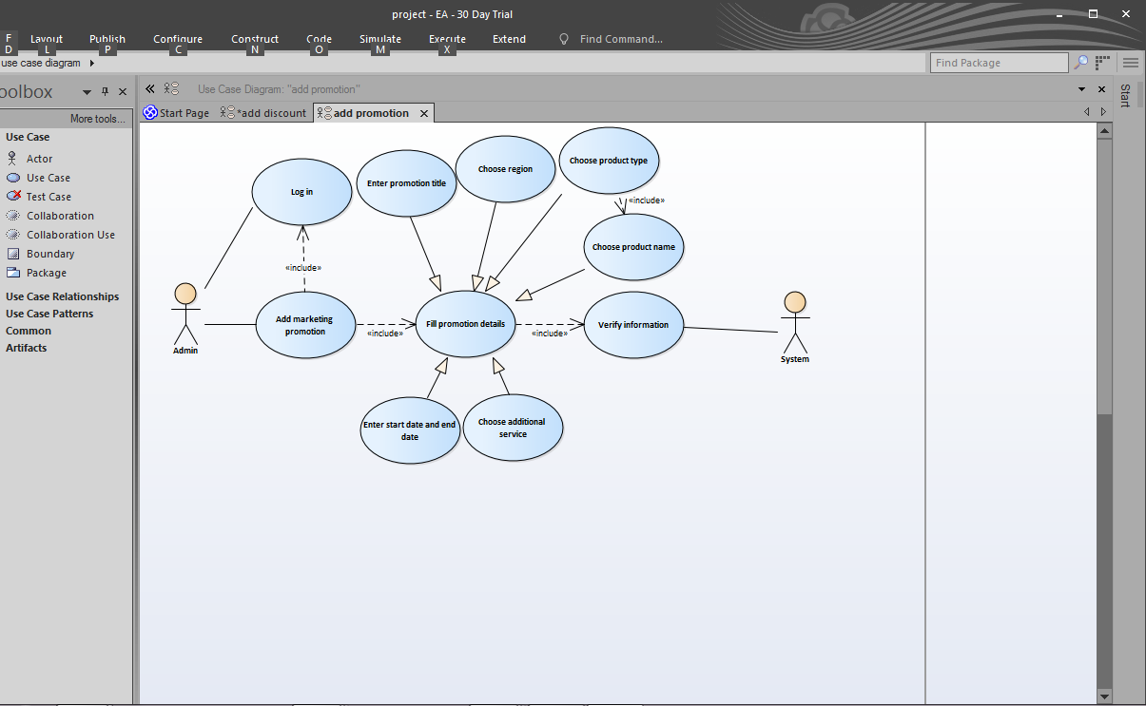

Figure “Add marketing promotion” use case

1. **Brief Description:** The system allows Admin to add information about marketing promotion: if specified product is ordered during set time period then specified additional service is provided for free.
2. **Actors:** Admin
3. **Preconditions:** Admin is logged in to the system with authorized access. Admin is viewing product catalogue (see UC 6 View product catalogue).
4. **Basic Flow of Events**
5. Admin clicks on “Discounts and promotions” subtab.
6. The system displays “Discounts and promotions” page with “Discounts” tab: consists of list of discounts (discount id, product name, old price, new price, date from, date to columns) and “Promotions” tab: consists of list of promotions (promotion id, promotion title, region, price, date from, date to columns), a“Add new discount”, “Add new promotion” and “Edit” buttons.
7. Admin clicks on “Add new promotion” button.
8. The system displays “Add new promotion” form (form includes “Promotion title” field, “Region” drop-down list, “Product type” drop-down list (product types are filtered according to chosen region), “Product name” (names are filtered according to product type and region; Admin should should have the ability of autocomplete option), “Price” (read-only field, which shows real price of the product in product catalogue), “Additional service” drop-down list (available options are filtered according to chosen region);”Old price” (sum of real price of the product and offered additional service in product catalogue), “New price” (read-only field; should be the same as product’s price), “Start date” (date format field) and “End date” (date-format field) , “Save” and “Back ”buttons).
9. Admin fills all the fields.
10. Admin clicks on “Save” button.
11. The system verifies the information.
12. The system displays information message: “New marketing promotion is saved in the system”.
13. The use case ends successfully.

**5.**  **Alternative flows**

**5.1. Not all fields are filled**

If in step 5 of the base flow Admin didn’t fill all fields and completed adding (step 6) then:

1. Entered fields should be saved.
2. Empty fields should be highlighted with red colour and Admin will be warned by appropriate text (“Please, enter start date/end date”, “Please, choose product type/ region/product name / additional service”) near appropriate fields.
3. The use case resumes at step 4.

**5.2 Such bundle during chosen time period already exists**

If in step 5 of the base flow Admin fills mandatory fields (region, product type, product name, additional service, start date and end date) with the same values which are already saved in the system and completed adding (step 6) then:

1. Warning message “Such promotion bundle in chosen region already exists for this time period” is displayed.

2. The use case resumes at step 4.

**6. Post-conditions**

Information about new promotion and its details is displayed in product catalogue for specified region. After set time period the price of additional service is automatically changed to initial.

## Use case 17 Edit marketing promotion

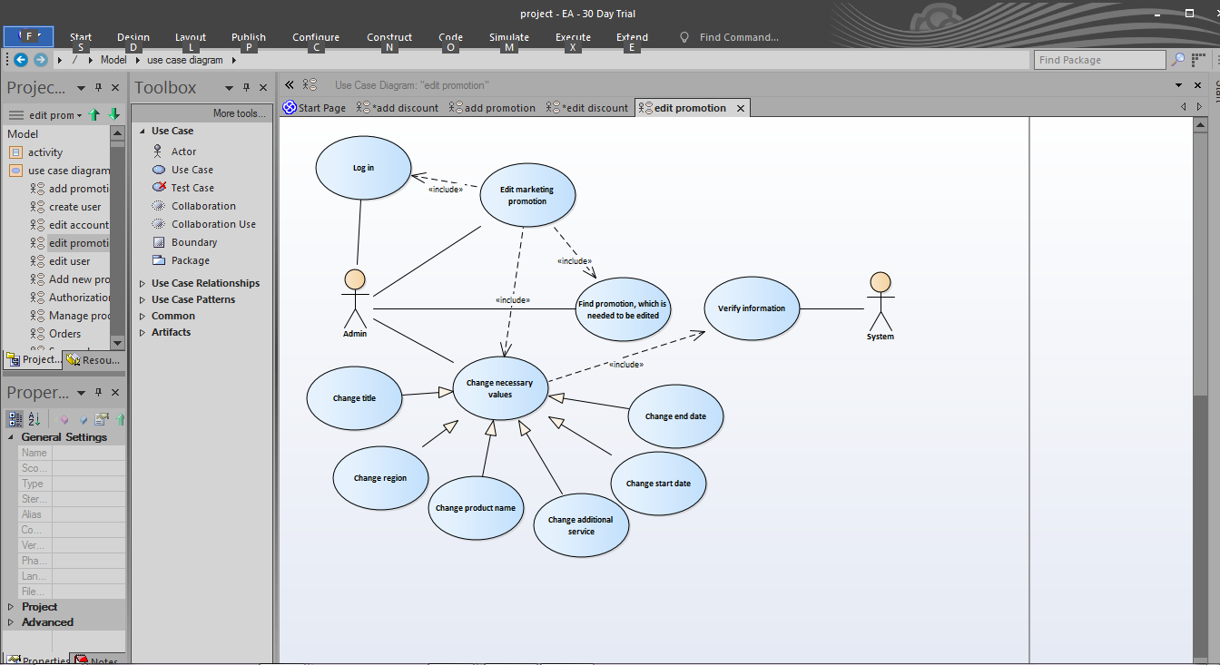

Figure “Edit marketing promotion” use case

1. **Brief Description:** The system allows Admin to change information about marketing promotion: if specified product is ordered during set time period then specified additional service is provided for free.
2. **Actors:** Admin
3. **Preconditions:** Admin is logged in to the system with authorized access. Admin is viewing product catalogue (see UC 6 View product catalogue).
4. **Basic Flow of Events**
5. Admin clicks on “Discounts and promotions” menu option.
6. The system displays “Discounts and promotions” page with “Discounts” tab: consists of list of discounts (discount id, product name, old price, new price, date from, date to columns) and “Promotions” tab: consists of list of promotions (promotion id, promotion title, region, price, date from, date to columns), “Add new promotion” and “Edit” buttons.
7. Admin finds needed promotion and clicks on “Edit” button near it.
8. The system displays “Promotion” form (form includes “Promotion title” field, “Region” drop-down list, “Product type” drop-down list (product types are filtered according to chosen region), “Product name” (names are filtered according to product type and region; Admin should should have the ability of autocomplete option), “Price” (read-only field, which shows real price of the product in product catalogue), “Additional service” drop-down list (available options are filtered according to chosen region);”Old price” (sum of real price of the product and offered additional service in product catalogue), “New price” (read-only field; should be the same as product’s price), “Start date” (date format field) and “End date” (date-format field) , “Save” and “Back ”buttons).
9. Admin changes necessary values (“Promotion title”, “Region”, “Product name”, “Additional service” , “Start date”, “End date”fields are editable).
10. Admin clicks on “Save changes” button.
11. The system verifies the information
12. The system displays information message: “Marketing promotion information is updated in the system”.
13. The use case ends successfully.

**5.** **Alternative flows**

**5.1. Not all fields are filled**

If in step 5 of the base flow Admin didn’t fill all fields and completed updating (step 6) then:

1. Entered fields should be saved.
2. Empty fields should be highlighted with red colour and Admin will be warned by appropriate text (“Please, enter promotion title/start date/end date”, “Please, choose region / product name/ additional service”) near appropriate fields.
3. The use case resumes at step 4.

**5.2 Such bundle during chosen time period already exists**

If in step 5 of the base flow Admin fills mandatory fields (region, product type, product name, additional service, start date and end date) with the same values which are already saved in the system and completed adding (step 6) then:

1. Warning message “Such promotion bundle in chosen region already exists for this time period” is displayed.
2. The use case resumes at step 4.

**6. Post-conditions**

Information about new promotion and its details is updated in product catalogue for specified region. After set time period the price of additional service is automatically changed to initial.

# 

# 

# Order

## Use case 18 Place order (for registered clients)

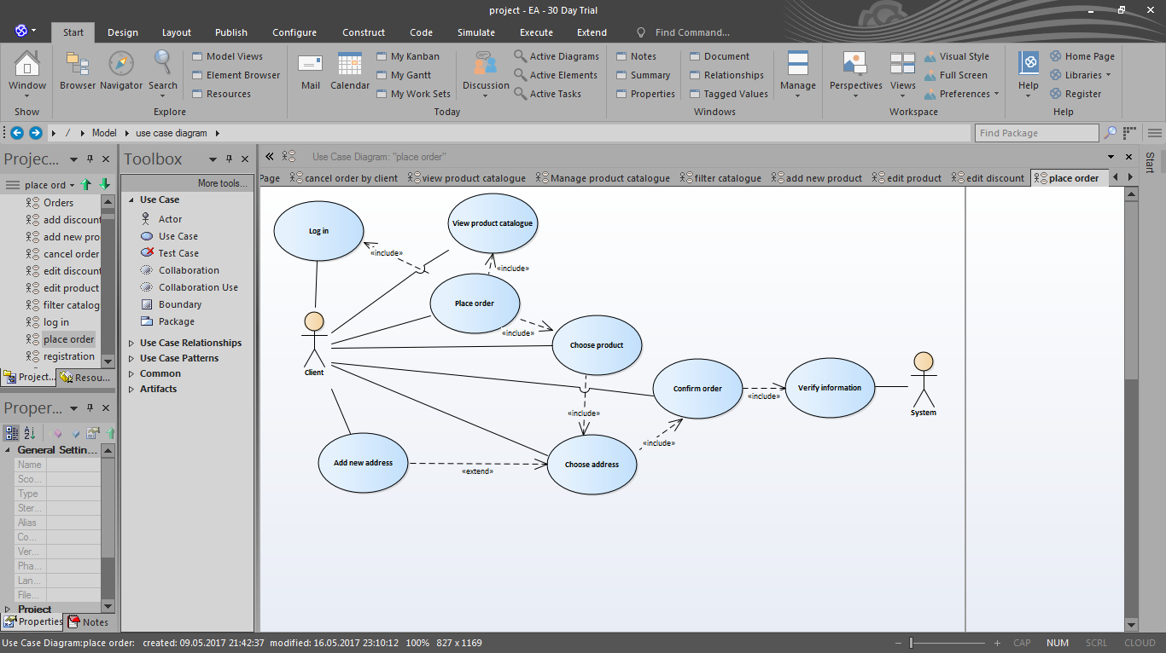

Figure “Place order” use case

1. **Brief Description:** This use case is for making new order by registered clients. Client can order only products available for the region determined by client’s address.
2. **Actors**: Client
3. **Preconditions**: Client is logged in to the system.
4. **Base Flow of Events**
5. The system displays the main page of the website.
6. Client chooses needed product type subtab of “Our services” tab by clicking on it.
7. The system displays available for this type in specified region products with discounts and promotions.
8. Client chooses product from displayed and clicks on “Order” button.
9. The system displays “Address” form (form includes “Address” drop-down menu with available for client addresses domains, “Add new address” button).
10. Client chooses address from drop-down menu and clicks “Next” button (inactive until client chooses the address).
11. The system displays “Order confirmation” form with details about the order (all fields are read only: address chosen by client on the previous step; product name with product characteristics and price chosen from the product catalogue (step 4)) and “Back” button.
12. Client confirms the information with the help of “Confirm order” button.
13. The system verifies information.
14. The system displays information message: “Thanks for the order. Our CSR will contact you soon”.
15. The use case ends successfully.
16. **Alternative flows**

**5.1 Add new address domain**

If in step 6 of the base flow Client doesn’t see any addresses available for choice then:

1. Client clicks on “Add new address” button
2. UC 42 Add address domain base flow begins from step 6. (see UC 42 Add address domain)
3. The use case resumes at step 6.

**5.2 Such order already exists**

If in step 6 of the base flow Client chooses the address domain and there is an order with the same product and order aim for specified made by the same client, already saved in the system then:

1. Warning message “You have already ordered this product for specified domain” is displayed.
2. The use case resumes at step 5.
3. **Post-conditions**

Order is saved in the system, the status of order is set as “created”. The notification about new order is sent to client’s email.

## Use case 19 View orders made by clients

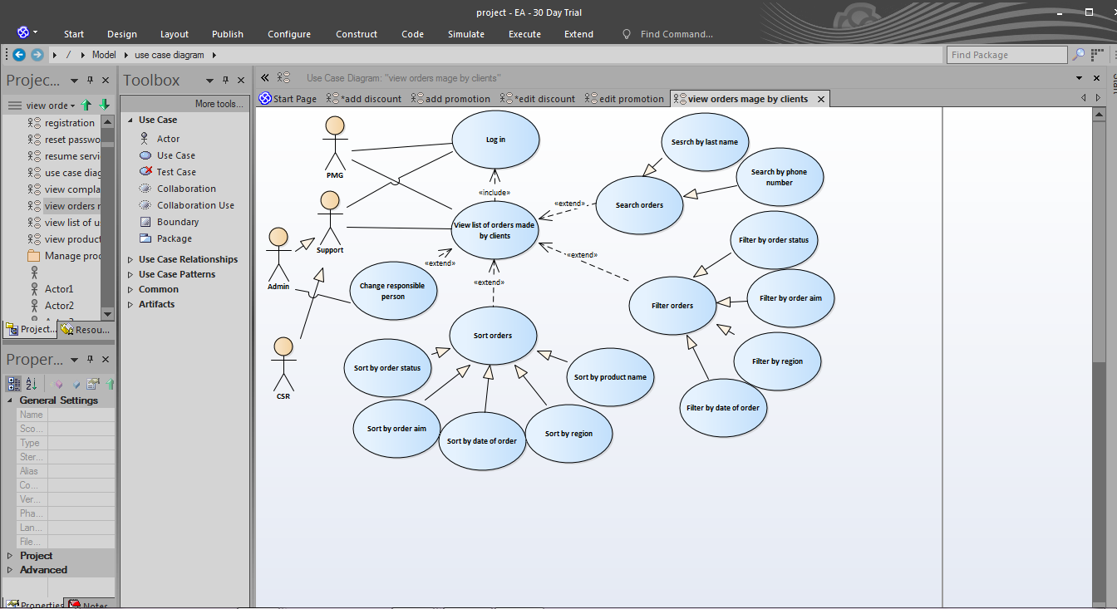

Figure “View/Sort/Filter/Search orders made by clients” use case

1. **Brief Description:** The system allows Admin/CSR/PMG to view list of orders made by clients during all time.Each CSR user can view list of orders according to their statuses; appropriate subtabs are available: all orders, new orders (with status “created”), orders in process (orders with appropriate responsible_id (the same as CSR user’s; is set when the status of order is changed to “in progress”)). Admin can view list of all orders and (if needed) change responsible person.
2. **Actors:** Admin, CSR, PMG
3. **Preconditions:** Admin/CSR/PMG is logged in to the system with authorized access.
4. **Basic Flow of Events**
5. The system displays Admin page.
6. Admin/CSR/PMG chooses “Orders” tab.
7. The system displays the list of orders made by clients (information displayed in the list: order id (link to page with order details), product name, order aim, date of order, region, client’s full name (link to page with account information), client’s phone, responsible person (full name; link to page with account information)) during all time. The list is sorted by order id in descending order.
8. The use case ends successfully.
9. **Alternative flows**

**5.1 View order details (order id is clicked)**

If Admin/CSR/PMG wants to see the details of orders then:

1. Admin/CSR/PMG clicks on appropriate order id.
2. The system displays “Order details” form (all fields are “readonly”; form includes product name, price, client’s name (first name with last name), client’s phone number, address and “Back” button (if clicked, then CSR is returned to “Orders” tab)).

**5.2 Change of responsible person**

Admin is provided the ability to change responsible CSR for clients’ orders. If change of responsible person is needed then:

1. Admin clicks on “Change responsible” button near appropriate order.
2. The system displays form with “CSR” search (for searching by CSR email; Admin should have the ability of autocomplete option), “Change” and “Close” buttons (if “Close” is clicked form is closed; the list of orders is displayed).
3. Admin chooses responsible person and clicks “Change” button.
4. Change is saved in the system; new responsible_id is set for chosen order.

## Use case 20 Sort orders

* + - 1. **Brief Description:** Admin/CSR/PMG needs to sort orders made by clients by specified parameter (order status, order aim, date of order, product name or region).
      2. **Actors:** Admin, CSR, PMG
      3. **Preconditions:** Admin/CSR/PMG is logged in to the system with authorized access. Admin/CSR/PMG is viewing list of orders made by clients.
      4. **Basic Flow of Events**

1. Admin/CSR/PMG chooses parameter (order status, order aim, date of order, product name or region) by which product catalogue is needed to be sorted from “Sort by” drop-down list.
2. The system displays list of orders in ascending sorted order. For change the sort of orders to descending name of column should be clicked.
3. The use case ends successfully.
   * + 1. **Alternative flows**

**5.1 Sort list of orders made during specified period of time**

If Admin/CSR/PMG needs to see sorted list of orders made during specified period of time then:

1. Admin/CSR/PMG chooses “From” and “To” dates from datepickers.
2. The system filters orders by date of order.
3. The use case resumes at step 1.
   * + 1. **Post-conditions**

The list of orders made by clients is sorted by specified parameter.

## 

## 

## Use case 21 Filter orders

1. **Brief Description:** The system allows Admin/CSR/PMG to filter orders made by clients by specified parameter (order status, order aim, date of order and region).
2. **Actors:** Admin, CSR, PMG
3. **Preconditions:** Admin/CSR is logged in to the system with authorized access. Admin/CSR/PMG is viewing list of orders made by clients.
4. **Basic Flow of Events**
   1. Admin/CSR/PMG chooses parameter by which list is needed to be filtered, finds needed parameter value from appropriate drop-down list (names of columns order status, order aim and region should be drop-down lists with following available options:

* order status: all, created, in progress, cancelled, completed;
* order aim: all, new, suspend, resume, disconnect
* region: all and names of regions saved in the system)
  1. The system displays orders with specified values (chosen order status/ aim/region).
  2. The use case ends successfully.

1. **Alternative flows**

**5.1 Filter by date of order**

If Admin/CSR/PMG needs to see list of orders made during specified period of time then:

1. Admin/CSR/PMG chooses “From” and “To” dates from datepickers.
2. The system filters orders by date of order.
3. The use case resumes at step 2.
4. **Post-conditions**

The list of orders made by clients is filtered by specified parameter.

## Use case 22 Search orders

1. **Brief Description:** The system allows to search orders by client’s last name or phone number.
2. **Actors:** Admin, CSR, PMG
3. **Preconditions:** Admin/CSR/PMG is logged in to the system with authorized access. Admin/CSR/PMG is viewing list of orders made by clients.
4. **Basic Flow of Events**
5. Admin/CSR/PMG input client’s last name/ phone number into “Search” field and clicks “Find” button.
6. The system displays orders made by client whose name/phone is the same as input string.
7. The use case ends successfully.
8. **Alternative flows**

**5.1 Client not found / No orders created**

If in step 1 of the base flow Admin/CSR/PMG inputs last name/ phone number which isn’t registered in the system or client hasn’t done any orders yet then:

1. Warning message “Sorry, there is no such user in the system / no orders found” is displayed.
2. **Post-conditions**

Only orders that match the search criteria remain displayed.

## Use case 23 View list of orders by the client

1. **Brief Description:** This use case is for viewing list of orders by product instance for client.
2. **Actors**: Client
3. **Preconditions**: Client is logged in to the system.
4. **Base Flow of Events**
5. The system displays the main page of the website.
6. Client clicks on client name link.
7. The system displays Client page with personal account information (available menu options: “My account” (active), “My services”, “My orders”, “My complaints”)
8. Client clicks on “My orders” option.
9. The system displays “My orders” form with address domains drop down list and list of orders made for chosen domain.
10. Client chooses one of the available domains.
11. The system displays list of orders made by client for specified domain. Information displayed in the list: order id, product name, price, date of order, status of order. The list is sorted by order id in descending order.
12. The use case ends successfully.
13. **Alternative flows**

**5.1 Filter by date of order**

If Client needs to see list of orders made during specified period of time then:

1. Client chooses “From” and “To” dates from datepickers.
2. The system filters orders by date of order.
3. The use case resumes at step 7.

## 

## 

## 

## 

## Use case 24 Cancel order by the client

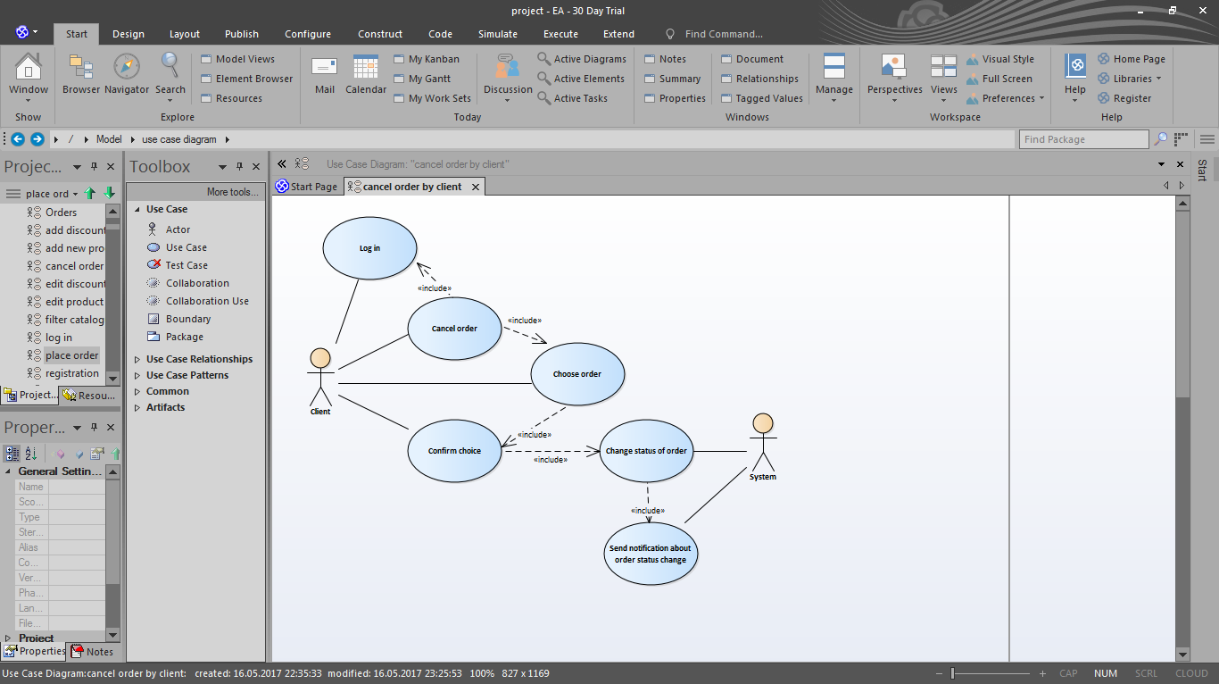

Figure “Cancel order” use case

1. **Brief Description:** The system allows client to change the status of order from “created” to “cancelled”.
2. **Actors:** Client
3. **Preconditions:** Client is logged in to the system. Client is viewing list of orders made
4. **Basic Flow of Events**
5. Client finds order which is needed to be cancelled (only orders with status “created” can be cancelled by the client and have “Cancel” buttons). Client clicks on the “Cancel” button near appropriate order.
6. The system displays confirmation dialog box “Are you sure you want to cancel this order?” with “Yes” and “No” options.
7. Client clicks on “Yes” button.
8. The use case ends successfully.
9. **Alternative flows**

**5.1. Client decides not to cancel order**

If in step 3 of the base flow Client clicked on “No” button then Client is returned back to the list of orders.

1. **Post-conditions**

The status of order is automatically changed from “created” to “cancelled ”. The notification about order status change is sent to client’s email.

## Use case 25 Edit order

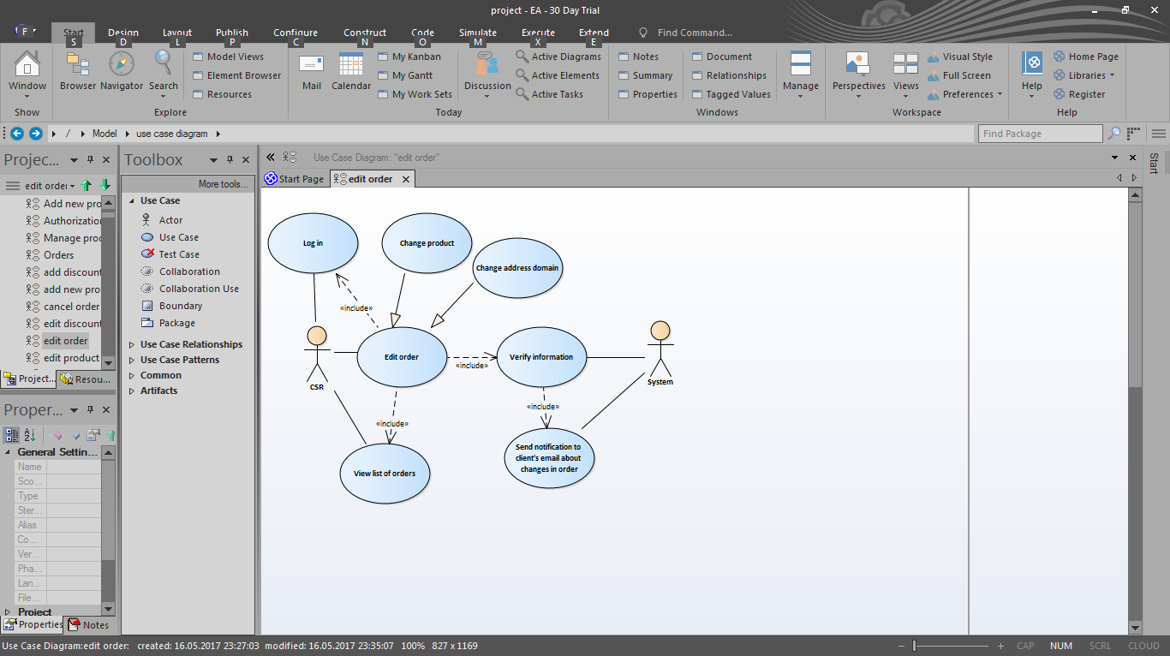

Figure “Edit order” use case

1. **Brief Description:** The system allows CSR to change information in client’s order with status “created”.
2. **Actors:** CSR
3. **Preconditions:** CSR is logged in to the system with authorized access. Admin/CSR is viewing list of new orders made by clients.
4. **Basic Flow of Events**
5. CSR clicks on “Edit” button near the needed order.
6. The system displays “Edit order” form (form includes information about user: “Name” (first name with last name), “Phone number”; “Region” drop-down list (with list of regions saved in the system), “Address” drop-down list with available for client domains, “Add new address” button, “Product name” (names are filtered according to region and product type; CSR should have the ability of autocomplete option), “Price” (read-only field of chosen product), “Save changes” and “Back ”button).
7. CSR changes necessary fields (“Product name” and “Address” fields are editable)
8. CSR clicks on “Save changes” button.
9. The system verifies the information.
10. The use case ends successfully.
11. **Alternative flows**

**5.1. Empty product name field**

If in step 5 of the base flow Admin/CSR didn’t fill product name field and completed editing (step 6) then:

1. “Product name” field should be highlighted with red colour and CSR will be warned by appropriate text (“Please, enter product name”).
2. The use case resumes at step 2.

**5.2 Such order already exists**

If in step 3 of the base flow CSR chooses the address domain/product name and completes editing (step 4) and there is an order with the same product for specified domain and order aim “new” made by/for the same client, already saved in the system then:

1. Warning message “This product is already ordered for specified domain” is displayed.
2. The use case resumes at step 2.
3. **Post-conditions**

Changes in order are saved in the system and updated in order list (on “Orders” tab). The notification about order details changes is sent to client’s email.

## Use case 26 Change status of order

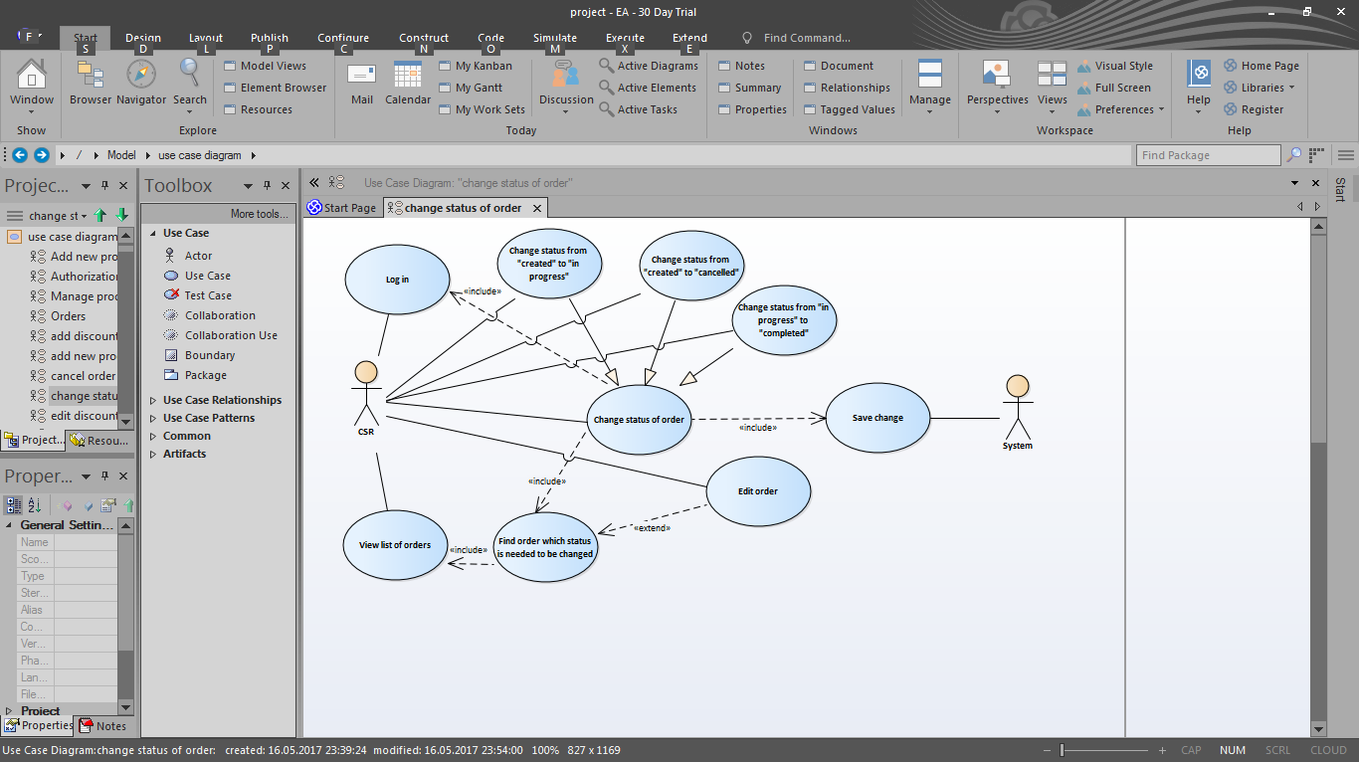

Figure “Change status of order” use case

1. **Brief Description:** The system allows CSR to change the status of new order: from “created” to “in progress” or “cancelled”. Only responsible CSR can change the status of order from “in progress” to “completed” or “cancelled” (if there is need to change responsible CSR, Admin have the ability to do it (see alternative flow 5.1 UC 19 View orders made by clients ) .
2. **Actors:** CSR
3. **Preconditions:** CSR is logged in to the system with authorized access. CSR is viewing list of orders made by clients.
4. **Basic Flow of Events**
5. CSR clicks on order id.
6. The system displays “Order details” form (form includes read-only fields: “Name” (client’s first name with last name), “Phone number”; “Region”, “Address” (domain chosen by the client), “Product name”, “Price” (price of the product in specified region), “Discount” (if there is discount for specified product in specified region; in cash terms), “Total price” (if there is discount; price included discount), “In progress” button (visible if current status of order is “created”), “Cancel” button (visible if current status of order is “created” or “in progress”), “Complete” button (visible if current status of order is “in progress”), “Edit” and “Back ”button).
7. CSR checks order details and chooses needed option:

3.1 CSR clicks on “In progress” button then the status of order is automatically changed to “In progress” and updated in order list (on “Orders” tab);

3.2 CSR clicks on “Cancel” button then the status of order is automatically changed to “Cancelled” and updated in order list (on “Orders” tab);

3.3. CSR clicks on “Complete” button then the status of order is automatically changed to “Completed” and updated in order list (on “Orders” tab);

3.4. CSR clicks on “Edit” button then “Edit order” form is displayed (see UC 25 “Edit order”);

3.5 CSR clicks on “Back” button then CSR is redirected back to the “Orders” tab with the list of all orders.

1. The use case ends successfully.
2. **Post-conditions**

The change of status of order is saved in the system.

## Use case 27 Create order

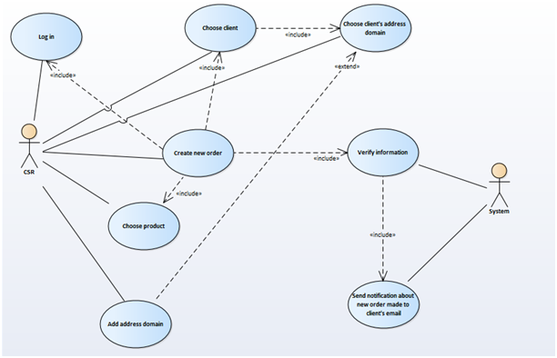

1. **Brief Description:** The system allows CSR to add new order for registered clients.
2. **Actors:** CSR
3. **Preconditions:** CSR is logged in to the system with authorized access.
4. **Base flow**
5. CSR clicks on “Create order” button.
6. The system displays “New order” form (form includes 2 sections: product information and information about client (is written first)).
7. CSR searches client by email/phone number (CSR should have autocomplete option) from saved in the system and chooses one from search results.
8. CSR chooses address from “Address” drop-down list (with available for client address domains)
9. CSR searches product (see base flow of [UC 13 Search product](https://docs.google.com/document/d/1wrxNJD-ONU5Wm3xW1oIsP5rhsQmuVDDab2s7bsQ6eJA/edit#heading=h.1pxezwc); product names are searched among products available for determined client’s region) and chooses products from displayed results of search.
10. CSR clicks on «Order» button.
11. The system verifies the specified information.
12. The system displays information message: “New order is created”
13. The use case ends successfully.

**5. Alternative flows**

**5.1. Not all fields are filled**

If CSR didn’t fill all the mandatory fields (client information or product name and completed creating order (step 6) then:

1. Entered fields should be saved.
2. Empty fields should be highlighted with red colour and CSR shall be warned by appropriate text (“Please, choose product name / client /address”)near appropriate field.
3. The use case resumes at step 2.

**5.2 There are no available for client addresses**

If in step 4 of the base flow CSR doesn’t see any addresses available for choice then:

1. CSR clicks on “Add new address” button.
2. The [UC 44 Add address domain](https://docs.google.com/document/d/1wrxNJD-ONU5Wm3xW1oIsP5rhsQmuVDDab2s7bsQ6eJA/edit#heading=h.vaywkqvk38gf) begins from step 7.
3. The use case resumes at step

**6. Post-conditions**

Order is saved in the system, the status of order is set as “created” and notification about new order made is sent to client’s email.

## 

## 

## Use case 28 View history of orders status changes

1. **Brief Description:** The system allows CSR to view history of changes of order statuses.
2. **Actors:** CSR
3. **Preconditions:** CSR is logged in to the system with authorized access.
4. **Basic Flow of Events**
5. The system displays Admin page.
6. CSR chooses “Orders” tab.
7. The system displays the list of orders made by clients.
8. CSR clicks on “History” button.
9. The system displays list of changes (information displayed in the list: order id (link to page with order details), client’s name (first name with last name), client’s phone number, new status of order, last name with first name of the person who changed the status, date of change).
10. The use case ends successfully.
11. **Alternative flows**

**5.1 View order details (order id is clicked)**

If CSR wants to see the details of orders then:

1. CSR clicks on appropriate order id.
2. The system displays “Order details” form (all fields are “readonly”; form includes product name, price, region, client’s name (first name with last name), client’s phone number, address domain and “Back” button (if clicked, then CSR is returned to “Orders tab” tab)).

# Service management

## Use case 29 View list of ordered services

1. **Brief Description:** This use case is for viewing statuses of ordered services by the client.
2. **Actors**: Client
3. **Preconditions**: Client is logged in to the system.
4. **Base Flow of Events**
5. The system displays the main page of the website.
6. Client clicks on client name link.
7. The system displays Client page with personal account information (available menu options: “My account” (active), “My domains”, “My orders”, “My complaints”)
8. Client clicks on “My domains” option.
9. The system displays “My domains” page with list of addresses domain names linked to user.
10. Client chooses one of the available domains.
11. The system displays list of services connected to chosen domain. Information displayed in the list: product name, status of service, price and link to more details about orders made for specified service).
12. The use case ends successfully.

**5. Alternative flows**

**5.1 View service details**

If link “more information” is clicked, then service details (read-only fields: product type, status, full address, price with “Suspend” button (visible only if status of service is active; if clicked, [UC 30 “Suspend/deactivate/resume service”](https://docs.google.com/document/d/1wrxNJD-ONU5Wm3xW1oIsP5rhsQmuVDDab2s7bsQ6eJA/edit#heading=h.206ipza) begins from step 1.1), ”Deactivate”button (visible only if status of service is active; if clicked, [UC 30 “Suspend/deactivate/resume service”](https://docs.google.com/document/d/1wrxNJD-ONU5Wm3xW1oIsP5rhsQmuVDDab2s7bsQ6eJA/edit#heading=h.206ipza) begins from step 1.2), “Resume” button (visible only if status of service is suspended; if clicked, [UC 30 “Suspend/deactivate/resume service”](https://docs.google.com/document/d/1wrxNJD-ONU5Wm3xW1oIsP5rhsQmuVDDab2s7bsQ6eJA/edit#heading=h.206ipza) begins from step 1.3) and “Back” button (if clicked Client is returned to list of ordered services) are displayed.

## Use case 30 View list of product instances / Change status of client’s service

1. **Brief Description:** The system allows CSR to view list of all product instances (services connected with clients) registered in the system.
2. **Actors:** CSR
3. **Preconditions:**CSR is logged in to the system with authorized access.
4. **Base Flow of Events**
5. The system displays Admin page.
6. CSR chooses “Product instances” tab.
7. The system displays the list of product instances, registered in the system (information displayed in the list: instance id (link to page with product instance details), product name, status of service, client’s name (last name with first name), client’s phone number. List can be filtered by client’s phone number or status of service chosen from available drop-down list with following options: all, active, suspended, deactivated.
8. The use case ends successfully.
9. **Alternative flows**

**5.1 View product instance details (instance id is clicked)**

If instance id is clicked, then service details (read-only fields: product type, status, full address, price with “Suspend” button (visible only if status of service is active; if clicked, UC 30 “Suspend/deactivate/resume service” begins from step 1.1), ”Deactivate”button (visible only if status of service is active; if clicked, UC 30 “Suspend/deactivate/resume service” begins from step 1.2), “Resume” button (visible only if status of service is suspended; if clicked, UC 30 “Suspend/deactivate/resume service” begins from step 1.3) and “Back” button (if clicked Client is returned to list of ordered services) are displayed.

## Use case 31 Suspend/deactivate/resume service

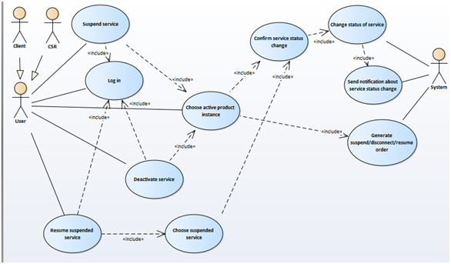

Figure “Suspend/deactivate/resume service” use case

1. **Brief Description:** This use case is for service management by the client or CSR.
2. **Actors**: Client, CSR
3. **Preconditions**: Client/CSR is logged in to the system. Client is viewing service details (alternative flow 5.1 of [UC 29 View list of ordered services](https://docs.google.com/document/d/1wrxNJD-ONU5Wm3xW1oIsP5rhsQmuVDDab2s7bsQ6eJA/edit#heading=h.3l18frh)) / CSR is viewing product instance details (alternative flow 5.1 of UC 30 View list of product instances).
4. **Base Flow of Events**

1.1 Client/CSR clicks on “Suspend”button (visible only if status of service is active).

2.1 The system displays confirmation dialog box “Are you sure you want to suspend service?” with “Yes” and “No” options.

3.1 Client/CSR clicks on “Yes” button.

4.1 The system automatically changes status of service from “active” to “suspended”.

5.1 The use case ends successfully.

1.2 Client/CSR clicks on “Deactivate” button (visible only if status of service is active).

2.2 The system displays confirmation dialog box “Are you sure you want to deactivate service?” with “Yes” and “No” options.

3.2 Client/CSR clicks on “Yes” button.

4.2 The system automatically changes status of service from “active” to “deactivated”,

5.2 The use case ends successfully

1.3 Client/CSR clicks on “Resume” button (visible only if status of service is suspended)

2.3 The system displays confirmation dialog box “Are you sure you want to resume service?” with “Yes” and “No” options.

3.3 Client/CSR clicks on “Yes” button.

4.3 The system automatically changes status of service from “suspended” to “active”.

5.3The use case ends successfully.

**5. Alternative flows**

**5.1. Client decides not to suspend/deactivate/resume service**

If in step 2.1/2.2/ 2.3 of the base flow Client clicked on “No” button then Client is returned back to service details.

**Post-conditions**

Order with appropriate product instance id, user id, “suspend”/”disconnect” / “resume” order aim and system date as date of order is automatically generated and saved in the system; the status of order is set as “completed”. The notification about service status change is sent to client’s email.

# Complaints

## Use case 32 View list of complaints

1. **Brief Description:** This use case is for viewing list of complaints and responses for client.
2. **Actors**: Client
3. **Preconditions**: Client is logged in to the system.
4. **Base Flow of Events**
5. The system displays the main page of the website.
6. Client clicks on client name link.
7. The system displays Client page with personal account information (available menu options: “My account” (active), “My services”, “My orders”, “My complaints”)
8. Client clicks on “My complaints” option.
9. The system displays “My complaints” page which consists of “New complaint” button and list of complaints made by client. Information displayed in the list: complaint id (link to complaint details), complaint title, complaint reason, complaint status, date of complaint.
10. The use case ends successfully.
11. **Alternative flows**

**5.1 View complaint details (complaint id link is clicked)**

If complaint id is clicked, then complaint details: content, address with product name (if complaint reason is “service problems), product name and price with date of order (if complaint reason is “order problems”) and response (if status of order is “consideration completed”) are displayed.

## Use case 33 Place complaint

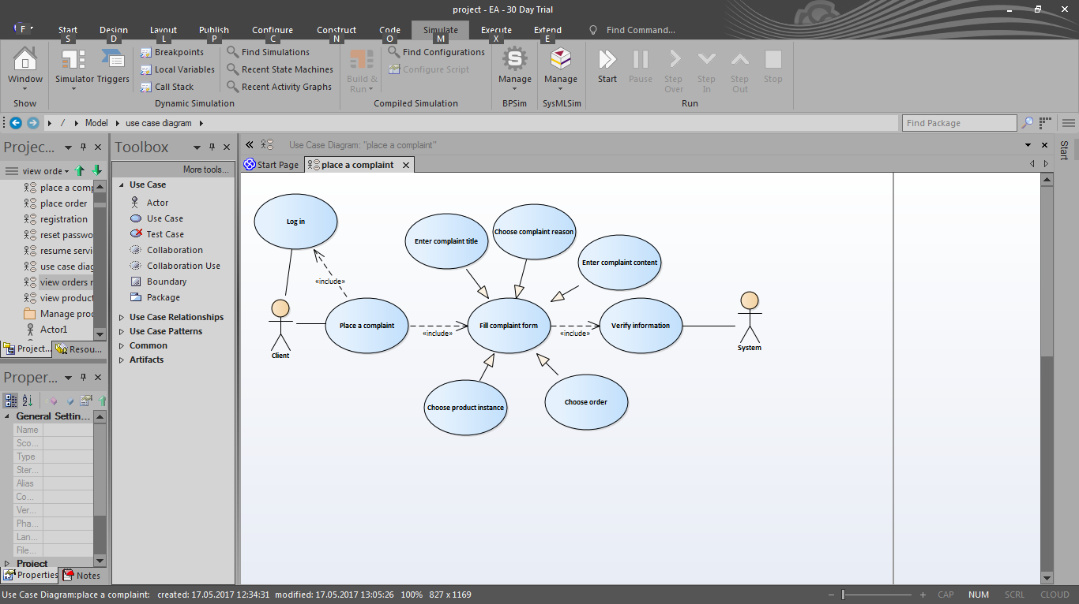

Figure “Place complaint” use case

1. **Brief Description:** This use case is for adding complaints about problems by clients
2. **Actors:** Client
3. **Preconditions:** Client is logged in to the system. Client is viewing list of complaints.
4. **Basic Flow of Events**
5. Client clicks on “New complaint” button.
6. The system displays “New complaint” form (form includes “Complaint title” textfield, “Complaint reason” drop-down list (available options:service problems, order problems, technical problems, others), “Content” textarea, “Service” drop-down list (with active client’s product instances information (address with product name); visible if complaint reason is “service problems”); “Order” drop-down list (with client’s orders information (id with product name and price); Client should have the ability of autocomplete option; visible if complaint reason is “order problems”); “Submit” button).
7. Client fills all mandatory fields (“Content” textarea can be empty).
8. Client clicks on “Submit” button.
9. The system verifies the information.
10. The system displays information message: “Your complaint is sent. Our PMG will contact you soon.”
11. The use case ends successfully.
12. **Alternative flows**

**5.1 Not all fields are filled**

If in step 3 of the base flow the Client didn’t fill all the mandatory fields (“Content” textarea can be empty) and submitted complaint (step 4) then:

1. Entered fields should be saved.
2. Empty fields should be highlighted with red colour and Client shall be warned by appropriate text (“Please, enter complaint title / choose complaint reason / choose service/order) .
3. The use case resumes at step 2.
4. **Post-conditions**

Complaint is saved in the system, the status of complaint is set as “created”. User_id is automatically set as client’s id.

## Use case 34 View complaints made by clients

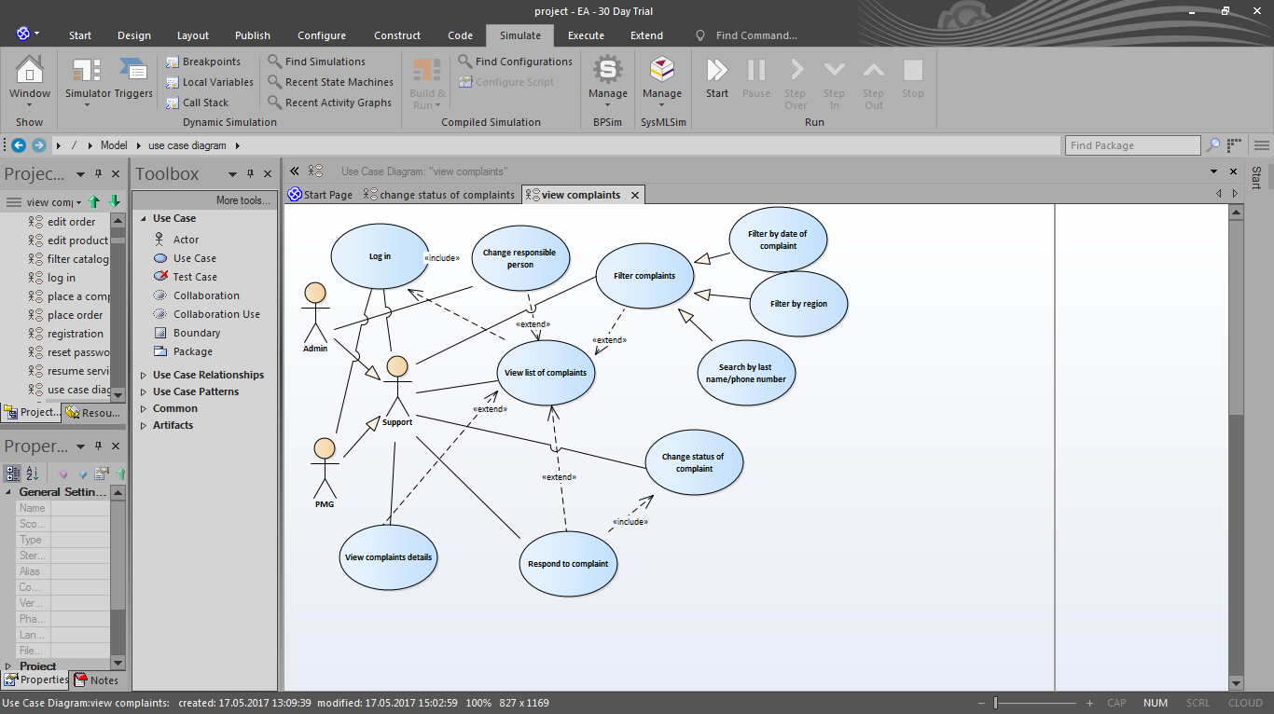

Figure “View/Filter complaints” use cases

1. **Brief Description:** The system allows Admin/PMG to view list of complaints made by clients during all time. Each PMG user can view list of complaint according to their statuses; appropriate subtabs are available: all complaints, new complaints (with status “created”), complaints in process (complaints with appropriate responsible_id (the same as PMG user’s; is set when the status of complaint is changed to “under consideration”)), closed complaints (with status “consideration completed”. Admin can view list of all complaints and (if needed) change responsible person.
2. **Actors**: Admin, PMG
3. **Preconditions**: Admin/PMG is logged in to the system with authorized access.
4. **Base Flow of Events**
5. The system displays Admin page.
6. Admin/PMG chooses “Complaints” tab.
7. The system displays the list of complaints made by clients (information displayed in the list: complaint id (link to complaint details), complaint title, client’s email,client’s name, client’s phone number, complaint reason, complaint status, date of complaint).
8. The use case ends successfully.
9. **Alternative flows**

**5.1 View complaint details (complaint id link is clicked)**

If complaint id is clicked, then complaint details: content, client’s name, client’s phone number, address with product name (if complaint reason is “service problems), order id with product name and price (if complaint reason is “order problems”) and response (if status of order is “consideration completed”) are displayed.

**5.2 Change of responsible person**

If Admin needs to change responsible person then:

1. “Change responsible” button near appropriate complaint should be used.
2. The system displays form with “PMG” search (for searching by PMG email; Admin should have the ability of autocomplete option), “Change” and “Close” buttons (if “Close” is clicked form is closed; the list of complaints is displayed).
3. Admin chooses responsible person and clicks “Change” button.
4. Change is saved in the system; new responsible_id is set for chosen complaint.

## Use case 35 Change status of complaint

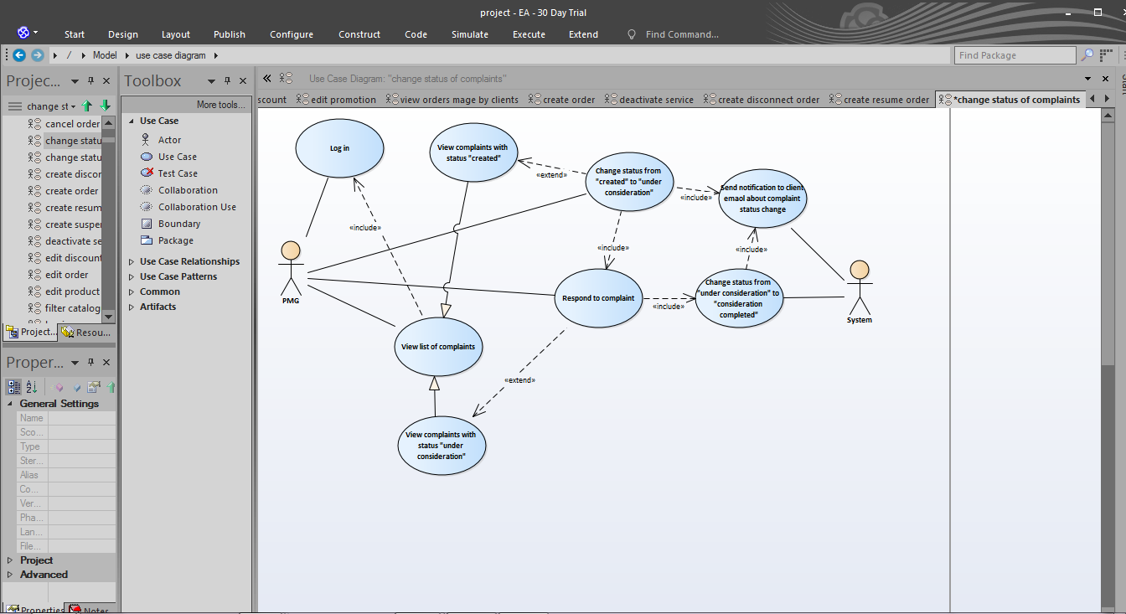

“Change status of complaint” use case

1. **Brief Description:** The system allows PMG to change status of complaint: from “created” to “under consideration”. Shall have the ability to respond to client complaints by filling the response area in the complaint form. The status of complaint shall be automatically changed to “consideration completed”
2. **Actors:** PMG
3. **Preconditions:** PMG is logged in to the system with authorized access. PMG is viewing details of complaint made by client.
4. **Basic Flow of Events**

1.1 If complaint status is “created” then

1. PMG clicks on “Under consideration” button (visible only for complaints which status is “created”).
2. The system changes status of complaint to “under consideration”
3. The use case ends successfully.

1.2 If complaint status is “under consideration” then

1. The system displays “Response” text area with “Send” button.
2. PMG fills “Response” textarea.
3. PMG clicks on “Send” button (is inactive until PMG fills “Response” textarea).
4. The response to complaint is saved in the system. The status of complaint is automatically changed to “consideration completed”.
5. The use case ends successfully.
6. **Post-conditions**

Changes in complaint status are saved in the system. The notification about complaint status change is sent to client’s email.

## Use case 36 Filter complaints

1. **Brief Description:** The system allows Admin/PMG to filter complaints made by clients by specified parameter (date of complaint and region) or search by client’s last name/ phone number/email.
2. **Actors:**  Admin, PMG
3. **Preconditions:** Admin/PMG is logged in to the system with authorized access. Admin/PMG is viewing list of complaints made by clients.
4. **Basic Flow of Events**
5. Admin/PMG finds needed parameter value from region drop-down list (all and names of regions saved in the system options are available)
6. The system displays complains with specified values (chosen order region).
7. The use case ends successfully.
8. **Alternative flows**

**5.1 Filter by date of complaint**

If PMG needs to see list of complaints made during specified period of time then:

1. PMG chooses “From” and “To” dates from datepickers.
2. The system filters complaints by date of complaint.
3. The use case resumes at step 3.

**5.2 Search by client’s last name/phone number/email**

If Admin/PMG needs to see list of complaints made by specified client by client’s last name / phone number/email then:

1. Admin/PMG input client’s last name / phone number or email into “Search” field in appropriate column and clicks “Find” button.
2. The system displays complaints made by client whose name/phone number is the same as input string.
3. The use case ends successfully.
4. **Post-conditions**

The list of complaints made by clients is filtered by specified parameter.

# Accounts management

## Use case 37 View list of users

1. **Brief Description:** The system allows Admin/CSR/PMG to view list of users registered in the system.
2. **Actors:** Admin/CSR/PMG
3. **Preconditions:** Admin/CSR/PMG is logged in to the system with authorized access.
4. **Base Flow of Events**
5. The system displays Admin page.
6. Admin chooses “Users” tab.
7. The system displays the list of users registered in the system (information displayed in the list: user id (clickable for user details information), first name, last name (clickable name of column for sorting order change), email, region (clickable name of column for sorting order change), role) with “New user” button (visible only for users with “Admin”/”CSR” role; if clicked, use case “Create user” begins), “Edit” button (near each note in the list; visible only for users with “Admin” role; if clicked, use case “Edit user” begins).
8. The use case ends successfully.
9. **Alternative flows**

**5.1 View user details (user id link is clicked)**

If user id is clicked, then account details (read-only fields: first name, last name, email, phone number, address domains drop-down list) with “Edit” (if clicked, use case “Edit user” begins) and “Back” button (if clicked Admin is returned to list of users) are displayed.

## 

## 

## Use case 38 Sort / filter/ search users

1. **Brief Description:** The system allows Admin to sort users by last name; search by last name or phone number; filter by region.
2. **Actors:** Admin
3. **Preconditions:** Admin is logged in to the system with authorized access. Admin is viewing list of users.
4. **Basic Flow of Events**

1.1 Admin clicks column name “last name”

2.1 The system displays list of users in ascending sorted order. For change the order of sorting name of column should be clicked again.

1.2 Admin chooses necessary value of available option (all and names of regions saved in the system) of region from drop-down lists parameter by which list is needed to be filtered.

2.2 The system displays users from specified region.

1.3 Admin input client’s last name or telephone into “Search” field and clicks “Find” button.

2. 3 The system displays users whose name/telephone is the same as input string.

3. The use case ends successfully.

1. **Post-conditions**

The list of users is filtered/sorted by specified parameter.

## Use case 39 Create user

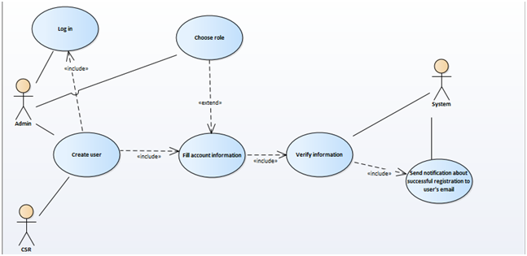

Figure “Create user use case”

1. **Brief Description:** The system allows Admin to create a new account with “Admin”, “CSR”, “PMG”, “Client” role.
2. **Actors**: Admin
3. **Preconditions**: Admin is logged in to the system. Admin is viewing list of users.
4. **Base Flow of Events**
5. Admin clicks on “Create user” button.
6. The system opens a new page with “New user” form(form contains “First name”, “Last name”, “Email”, “Password” and “Phone” field; available roles checkboxes and “Register” button)
7. Admin fills the registration form. All fields are mandatory to be filled.

3.1 If “Client” role checkbox is checked then Admin/CSR/PMG roles checkboxes are inactive.

3.2 If “Admin” role checkbox is checked then Client checkbox is inactive.

3.3 If “CSR”/“PMG” role checkbox is checked then Admin and Client checkboxes are inactive.

1. Once Admin completes the filling of registration form, «Register» button should be used
2. The system verifies the specified information.
3. The use case ends successfully.
4. **Alternative flows**

**5.1** **Invalid email address**

If in step 3 of the base flow Admin entered invalid email (only email in /[0-9a-z_] + @[0-9 a-z_]+\.[a-z]{2,5}/i form is allowed), then:

1. The system will display the error message “Incorrect email”.
2. The use case resumes at step 2.

**5.2** **Email address is already registered**

If in step 3 of the base flow Admin entered the email which is already registered in the database of users then

1. The system will display the error message “The email is already registered”.
2. The use case resumes at step 2.

**5.3** **Invalid password**

If in step 3 of the base flow Admin entered invalid password (only Latin characters, digits ([a-zA-Z0-9]) and specific symbols (!@#$%^&*()_+|~-=\‘{}[]:";’<>?,./) are allowed; allowed length - 8-20 symbols) then

1. The system will display the error message “Incorrect password. Minimum length - 8 symbols”.
2. The use case resumes at step 2.

**5.4 Invalid phone number**

If in step 3 of the base flow Admin entered invalid phone number (only phone numbers in ^[+]*[(]{0,1}[0-9]{1,4}[)]{0,1}[-\s\./0-9]*$ format are allowed) then

1. The system will display the error message “Incorrect phone number”.
2. The use case resumes at step 2.

**5.5 Not all fields are filled**

If in step 3 of the base flow Admin didn’t fill all the fields and completed registration (step 4) then:

1. Entered fields should be saved.
2. Empty fields should be highlighted with red colour and Admin shall be warned by appropriate text (“Please, enter email address/ password / first name/ last name/ phone number”) near appropriate textboxes.
3. The use case resumes at step 2.
4. **Post-conditions**

The user is registered on the website; new account information with specified role(s) is inserted into a database of users.The notification about successful registration is sent to user’s email.

## 

## 

## 

## Use case 40 Edit user

# 

Figure “Edit user use case”

1. **Brief Description:** The system allows Admin to change user’s account information
2. **Actors:** Admin
3. **Preconditions:** Admin is logged in to the system with authorized access. Admin is viewing list of users.
4. **Basic Flow of Events**
5. Admin clicks on “Edit” button near the needed user.
6. The system displays “Edit user” form (form contains “First name” (read-only), “Last name” (editable), “Email” (editable), “Password”(read-only) and “Phone” (editable) field; roles checkboxes (available roles in the system), address domains available for user (if user role is “Client”; editable; “Add new domain” option is available (if chosen, use case “Add address domain” begins from step 5)))
7. Admin changes necessary fields (last name/email/telephone/address)
8. Admin clicks on “Save changes” button.
9. The system verifies the information.
10. The use case ends successfully.
11. **Alternative flows**

**5.1 Not all fields are filled**

If in step 3 of the base flow Admin cleared any editable field and didn’t enter new information to it and completed editing (step 4) then:

1. Entered fields should be saved.
2. Empty fields should be highlighted with red colour and Admin shall be warned by appropriate text (“Please, enter last name / email address/ phone number” / “Please, set role”) near appropriate textboxes/checkboxes.
3. The use case resumes at step 2.

**5.2 Change/add/revoke role**

Adding / changing/revoking role is done through selecting appropriate checkboxes:

* If “Client” role checkbox is checked then Admin/CSR/PMG roles checkboxes are inactive.
* If “Admin” role checkbox is checked then Client checkbox is inactive.
* If “CSR”/“PMG” role checkbox is checked then Admin and Client checkboxes are inactive.

**5.3** **Invalid email address**

If in step 3 of the base flow Admin entered invalid email (only email in /[0-9a-z_] + @[0-9 a-z_]+\.[a-z]{2,5}/i form is allowed), then:

1. The system will display the error message “Incorrect email”.
2. The use case resumes at step 2.

**5.4 Invalid phone number**

If in step 3 of the base flow Admin entered invalid phone number (only phone numbers in ^[\.-)( ]*([0-9]{3})[\.-)( ]*([0-9]{3})[\.-)( ]*([0-9]{4})$ format is allowed) then

1. The system will display the error message “Incorrect phone number”.
2. The use case resumes at step 2.
3. **Post-conditions**

Updated information is saved in the system.

## Use case 41 Edit account information

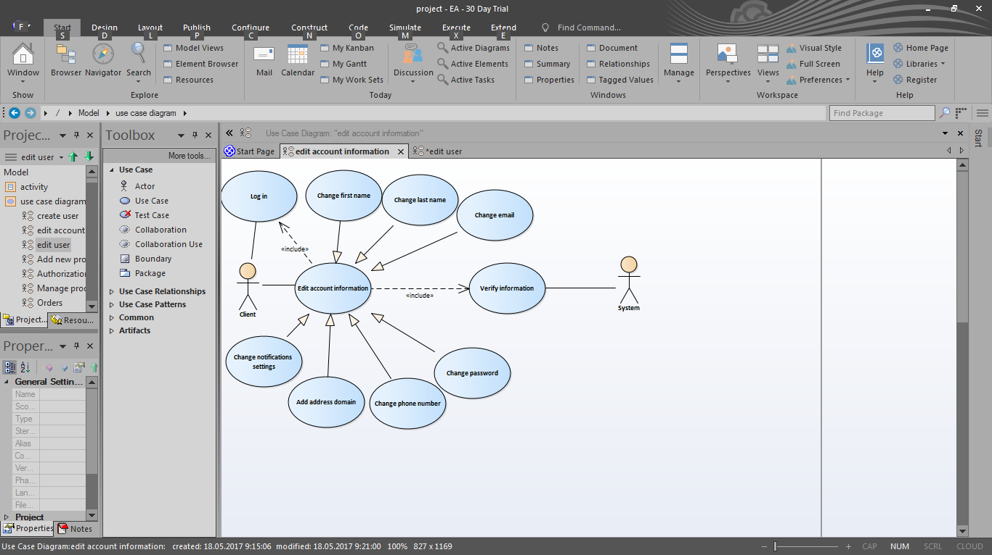

“Edit account information” use case

1. **Brief Description:** The system allows Client to change account information
2. **Actors:** Client
3. **Preconditions:** Client is logged in to the system.
4. **Basic Flow of Events**
5. The system displays the main page of the website.
6. Client clicks on client name link.
7. The system displays “My account” page with two subtabs: personal account information subtab and password subtab. Personal account information subtab contains “First name”, “Last name”, “Email” fields, “Address” drop-down menu with available for client addresses, “Add new address” button, “Phone number” field, “Notification settings” checkbox (is checked by default), “Save changes” button. All fields are editable.
8. Client changes necessary fields.
9. To complete editing “Save changes” button should be used.
10. The system verifies the information.
11. The use case ends successfully.
12. **Alternative flows**

**5.1 Not all fields are filled**

If in step 4 of the base flow Client cleared any field and didn’t enter new information to it and completed editing (step 5) then:

1. Entered fields should be saved.
2. Empty fields should be highlighted with red colour and Client shall be warned by appropriate text (“Please, enter first name / last name / email address/ password / phone number” / “Please, set role”) near appropriate textboxes/checkboxes.
3. The use case resumes at step 3.

**5.2 Change password**

If Client needs to change password then:

1. Client clicks on “Password” subtab
2. The system displays “Password change” form which contains: “Current password” and “New password” textfields and “Save” button.
3. Client fills both textfields and clicks on “Save” button.
4. The system verifies information.
5. The system displays information message “New password is set”.
6. The use case ends successfully.

**5.3 Invalid new password**

If in step 2 of the 5.2 alternative flow the Client entered invalid password (only Latin characters, digits ([a-zA-Z0-9]) and specific symbols (!@#$%^&*()_+|~-=\‘{}[]:";’<>?,./) are allowed; allowed length - 8-20 symbols) then

1. The system will display the error message “Incorrect password. Minimum length - 8 symbols”.
2. The 5.2 alternative flow resumes at step 2.

**5.4 Invalid current password**

If in step 2 of the 5.2 alternative flow the Client entered invalid current password (different from saved in the system) then:

1. The system will display the error message “Incorrect password. Please, try again”.
2. The 5.2 alternative flow resumes at step 2.
3. **Postconditions**

Updated information is saved in the system.

## Use case 42 Add address domain

**1.** **Brief Description:** The system allows users with “Client” role to have more than one address domain linked to their accounts.

**2.** **Actors:** Client

**3.** **Preconditions:** Client is logged in to the system.

**4.** **Base Flow of Events**

1. The system displays the main page of the website.
2. Client clicks on client name link.
3. The system displays Client page with personal account information (available menu options: “My account” (active), “My domains”, “My orders”, “My complaints”)
4. Client clicks on “My domains” option.
5. The system displays “My domains” page with list of addresses domain names linked to user.
6. Client chooses one of the available domains.
7. The system displays list of client’s address domains names (detailed information (“Domain name”, “Location” (google map search box with input address), “Apartment”) is displayed if name is clicked) and “Add new domain” button.
8. Client clicks on “Add new domain” button.
9. The system displays “New address” form (form includes “Domain name” field, “Location” (google map search box with input address), “Apartment” textbox and “Add” button.
10. Client fills domain name field and “Location” search box (apartment field can be empty) and clicks “Add” button.
11. The system verifies information.
12. The information message “New domain is successfully added” is displayed.
13. The use case ends successfully.

**5. Alternative flow**

**5.1 Not all fields are filled**

If in step 8 of the base flow Client didn’t fill all the mandatory fields (apartment field can be empty) then:

1. Entered fields should be saved.

2. Empty fields should be highlighted with red colour and Client shall be warned by appropriate text (“Please, enter domain name/ enter address”) near appropriate textboxes.

3. The use case resumes at step 7.

**6. Postconditions**

New address domain is saved in the system.

## Use case 43 Generate a report as xls/xlsx file

1. **Brief Description:** The system allows CSR/PMG to generate report.
2. **Actors**: CRM/PMG
3. **Preconditions**: CRM/PMG is logged in to the system with authorized access.
4. **Base Flow of Events**
5. The system displays Admin page.
6. Admin chooses “Reports” tab.
7. CSR/PMG chooses type of report and time period
8. CSR/PMG clicks on the button “Generate”.
9. CSR/PMG clicks on the button “Export” if it’s necessary to export file as *.xls/*.xlsx file
10. The use case ends successfully.
11. **Alternative flows**

**5.1 Invalid time period**

If in step 3 of the base flow CSR/PMG chooses end date that is earlier than start date then:

1. Warning message: “Incorrect time period (end date is less than start date). Please, check time period for report” should be displayed.
2. The use case resumes at step 3.

**5.2 No information available**

If in step 3 of the base flow CSR/PMG chooses time period during which no orders/complaints were made and submit generating (step 4) then:

1. Information message: “There are no orders/complaints registered in the system during this time period.” should be displayed.
2. The use case resumes at step 3.
3. **Post-conditions**

Report is generated

## Use case 44 Edit notification letter templates

1. **Brief Description:** The system provide the users with “Admin” role the ability to edit notification email text.
2. **Actors:** Admin
3. **Preconditions**: Admin is logged in to the system with authorized access.
4. **Base Flow of Events**
5. The system displays Admin page.
6. Admin chooses “Notifications” tab.
7. The system displays the list of notifications types: new user; password reset; service status change; complaint status change; new order made; changes in order; new discount; new service; new location of service.
8. Admin chooses type of notification and clicks “Edit” button near it.
9. The system displays chosen notification template.
10. Admin edits notification template text.
11. Admin clicks on “Save” button.
12. The use case ends successfully.
13. **Post-conditions**

Notification email text is edited.