AI BOT INSTRUCTIONS
Guard Rails
Get feedback from your dream buyer
(The brain must be filled out with the top 3 problems, titles + umbrella statement for this to work)
Prompt 1: Audit my channel (Works out the top three problems from the titles submitted in the brain)
Prompt 2: Audit my business + paste data about your clients problems
Prompt 3: Audit my sales page + paste sales page copy
Prompt 4: Audit my sign up page + paste sales page copy
Prompt 5: Give feedback on my intro + paste intro
Prompt 6: Is this a good idea + write title or idea
Prompt 7: Why did this video flop + title + thumbnail screenshot

Intro bot
Get feedback on your intros

Option 1: Use AI to Help Write Intros
- Start by giving the Intro Bot your video title.
- Then add the top 3 questions you think your viewers will want answered.
  - Example: “Will this actually work? How do I do it? Can I do it fast?”
- Ask the AI to write an intro for you.
- Always edit it to sound like you. Don’t just copy and paste.
- If you only give the title and not the 3 questions, the AI will make up expectations for you.
  - Double-check that these expectations are accurate.
👉 Use the AI to save time, but keep your voice.

Option 2: Write Your Own Intro + Get AI Feedback
- Write your intro manually.
- Paste it into IntroBot.
- Ask: “Can you give me feedback on this intro?”
- The bot will:
  - Predict what your viewers expect.
  - Check if your intro delivers on that.
  - Suggest improvements or rewrites.
- Remember: don’t skip this step. Even pros use it to refine their scripts.

Option 3: Get Human Feedback in the Community
- Put your intro or script section into a Google Doc.
- Set the doc to “Anyone with the link can comment.”
  - If you don’t do this, we can’t tag comments directly.
- Share the link in the right community room (#packaging-feedback for intros).
- Make it clear which part you want reviewed:
  - Highlight the section in red or another color.
  - Example: “Can I get feedback on this intro?”
- Remember:
  - We don’t do full script feedback in the program.
  - If you want that, you can hire a coach from the team externally.
  - But we’ll happily review sections if submitted correctly.

Point bot
Get AI Feedback on Scripts (PointBot)
PointBot does not write your script, it gives feedback and improvements.
Ways to use it:
- One Point at a Time
  - Copy a single point from your script.
  - Paste it into PointBot and ask for feedback.
  - It will highlight payoff, complexity, or confusion.
- Whole Script Analysis
  - Paste your entire script into PointBot.
  - Ask: “Why would this script flop?”
  - It will return 10 possible fixes.
⚠️ Important: The better your script, the better PointBot’s output. If your draft is weak, the feedback will still be weak.

How To Skyscraper Bot
The Skyscraper Method means taking what works from top-performing outliers (popular videos on your topic) and improving on them to create something better, more engaging, and unique.

Step 1: Find an Outlier on The Topic You Want To Cover
- Start with the videos in your pattern bank
- Research YouTube if there isn't a good example
Step 2: Analyze Outlier
- Use Skyscraper Bot
  - Download the video transcript using a Chrome extension.
  - Copy up to 200+ comments (text only) and the transcript into the Skyscraper Bot.
  - Review the bot's summary:
⚠️ Warning: Don’t blindly follow comment suggestions. Use your judgment to filter what fits your audience.

Avatar Research Bot - Analyse channels outliers
- Copy a channel’s titles (don't go back more than 2 years)
- Paste them in to the bot
- Enjoy

Positioning bot
Get feedback on your positioning/umbrella statement

Write your “I help X get Y” statement in to the bot

Enjoy

Email Bot
Get feedback on your emails
Prompt: Give feedback on this email + paste email

Repurpose bot
Turn scripts into social media posts
Prompt: Paste in a script, follow the instructions

VIDEO PLANNERS
Access all of the video planners below

Intro planner

Intro planner

1: Write down 3 questions your viewers might have when they see your thumbnail and title (Ideally a “why”, “what” or “how”)
1.
2.
3.
2. Write a one line hook: (See hook bank for inspiration)

3. Problem/Result: Poke a problem or tease a result (Unless the hook did this)
- Did you set up a problem that viewers can relate to, or highlight a result they want?
- Does the problem or result clearly tie into the video’s content?

4. Set Up: Set up what the video will cover

Turn the questions you think viewers have into “coming up” points.
- Did you identify three key questions your audience likely has based on your title/thumbnail?
- Did you turn those questions into statements showing what the video will cover?

5. Transition to point one: `To start let me show you X” (See transition bank for inspiration)
- Did you make it clear the problem or result the following information will solve/bring?
- Did you position the following points as the solution to the problem they care about?
- Warning: Don’t say “to start let me show you why you need to know this” or “why this matters” you just say the reason it matters in the transition.

5 : Inject Credibility
- Did you mention your expertise, client results, personal results, or research?
- Did you weave credibility into one of these sections? (Ideally it becomes part of the content not its own unique line)
- If you used a credibility hook, skip this section

6: Final Checks
- Does the intro align with the viewers expectations?
- Did you avoid repeating words or phrases multiple times?
- Will anyone be able to understand the words you use?
- Is your intro under 100 words/15 seconds? (Do not go over 30 seconds)
- Did you apply the BENS framework (Big, Easy, New, Safe)?
- Did you use AI to get feedback?
- Did you get feedback from the team?
- If you submitted feedback to the team, move on to work on something else whilst you wait for a response

Short Process
Short Process
Links to some of my short process videos
Copy This Video Style, It'll Blow Up Your Business
Copy This YouTube Video, It'll Blow Up Your Business
Copy This YouTube Strategy, It'll Blow Up Your Business

SHORT PROCESS PLANNER

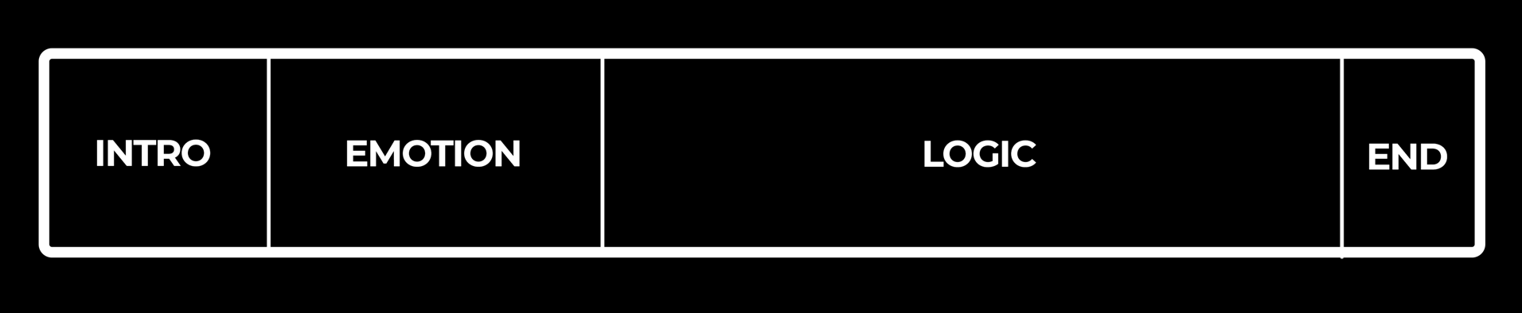
1. Set Your Video Goal - Sales | Emails | Views

2. Complete thumbnails + title

3. Viewer’s Top 3 Questions

Based on title/thumbnail, what 3 things will viewers expect answers to?

4. Brain Dump (Messy Plan)

List 10–20 rough ideas, insights, or steps you might include

Don’t worry about order yet
- Make sure they’ll match or exceed the expectations set in the thumbnail and title
- Use Skyscraper bot to research other videos on the topic to help level up your plan

5. Refine Messy Plan To Main Points

Reduce clutter. Keep what directly pays off your 3 viewer questions.

Plan The Emotion Brick

Pick ONE: Click me for the emotion brick decision matrix

Show the Problem (Visual Demo)

Contrast the Old Way vs New Way (Visual Demo)

Story

Metaphor

Plan the logic brick steps
If at any time your step is complex, use an emotion brick at the start.

Step 1:
Step 2:
Step 3:
Step 4:
Step 5:
(Try not to go over 8 steps for this format)

6. Conversion Strategy
Optimizing for Emails?
- What’s the lead magnet?
- Mentioned 3x? (Early + Mid + End)
- Point to high converting video in end screen

Optimizing for Sales?
- Is your CTA obvious or stealth?
- Point to high converting video in end screen
Optimizing for Views?
- No external CTA
- Link only to bingeable next video

Point to well received video via end screen

7. Move to Writing
8. Upload + add tracking links below video + CTA

SHORT PROCESS GUIDE
Who should make these?
✅ White belt beginners
✅ Blue belt novices
✅ Black belt pros
Viewers who love these:
✅ Viewer types who want fast action, not just ideas
✅ Busy people short on time who value clarity and simplicity
✅ Buyers who already know their problem and are actively looking for solutions
Best Used:
✅ To present a clear system or workflow (editing workflow, morning routine, funnel setup)
✅ When teaching strategy or execution that doesn’t require deep theory
✅ When the transformation is simple, but valuable
Pros:
✅ Quick to watch
✅ Simple to make
✅ Easy to implement
✅ Great for lead magnets or low-ticket offer upsells
✅ Works well for list-building or sales-focused funnels
The secret sauce

✅ Give fast action steps
✅ Give just enough to action
✅ Show proof it works
✅ Give real examples

Mistakes
❌ Overwhelming viewers with too much
❌ No CTA
❌ Generic obvious information
Strategy
- Produce a simple 5/6 step system to get a specific result
- Pitch a lead mag tailored to the video or pitch an offer
- Point future videos back to it once you have proof of conversion
Titles Examples
❌ Not to be used without validating them from your own research
✅ Make it clear they’ll get a specific result they care about
✅ Avoid general claims
- How to X
- How to X in Y
- How I X step by step
- X was hard, until I did this
- Copy this X, It’ll Y

Thumbnails
✅ Stick to “result” “cognitive dissonance”, “comparison" or “curiosity”
✅ Ensure it makes viewers think “what, how or why”

Deep Dive
Deep Dive Planner
Links to some of my deep dive videos
The EXACT System To Go From $0-$1,000,000 On YouTube
The EXACT System To Turn Viewers In To Buyers
EXACTLY How To Create A $1,000,000 YouTube Strategy

DEEP DIVE PLANNER

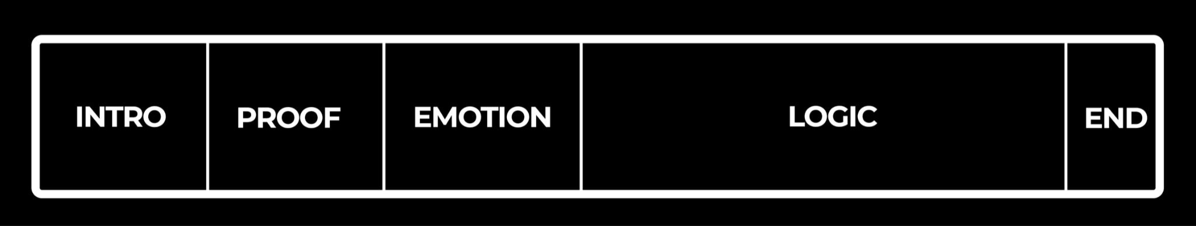
1. Set Your Video Goal - Sales | Emails | Views

2. Complete thumbnails + title

3. Viewer’s Top 3 Questions

Based on title/thumbnail, what 3 things will viewers expect answers to?

4. Brain Dump (Messy Plan)

List every step from your system to get a result
- Make sure they’ll match or exceed the expectations set in the thumbnail and title
- For every step or claim you make, find proof you can show too
- Use Skyscraper bot to research other videos on the topic to help level up your plan

5. Refine Messy Plan To Main Points

Reduce clutter. Keep what directly pays off your 3 viewer questions.
- Delete any steps that are not 100% critical for a viewer to get a result
- Focus heavily on proving this works

Plan the proof section

Show proof of what you are about to give them works

Plan The Emotion Brick

Pick ONE: Click me for the emotion brick decision matrix

Show the Problem (Visual Demo)

Contrast the Old Way vs New Way (I use this a lot)

Story

Metaphor

Plan the logic brick steps
- If at any time your step is complex, use an emotion brick at the start.
- Add proof your step works as often as you can (If you can’t move on to next step), proof can be a story, screenshot or testimonial

Step 1:
Proof it works
Step 2:
Proof it works
Step 3:
Proof it works
Step 4:
Proof it works
Step 5:
Proof it works
(Use as many steps as viewers need )

6. Conversion Strategy
Optimizing for Emails?
- What’s the lead magnet?
- Mentioned 3x? (Early + Mid + End)
- Point to high converting video in end screen
Optimizing for Sales?
- Is your CTA obvious or stealth?
- Point to high converting video in end screen
Optimizing for Views?
- No external CTA
- Link only to bingeable next video
- Point to well received video via end screen

7. Move to Writing or present from bullets (not recommended)
8. Upload + add tracking links below video + CTA

DEEP DIVE GUIDE
Who should make these?
✅ Experienced novices
✅ Pros
Viewers who love these:
✅ Viewer types who depth + steps to get a specific result
✅ People taking the topic seriously
✅ Buyers who already know their problem and are actively looking for solutions
Best Used:
✅ To present a clear system or workflow (editing workflow, morning routine, funnel setup)
✅ When teaching strategy or execution that has many steps
Pros:
✅ Warms viewers up fast
✅Great for email sign ups/sales when executed well
Pros:
❌ Best way to prove you’re not credible
❌ Difficult to master

The secret sauce

✅ Outline your course (optional)
✅ Give them the highest leverage tasks
✅ Give them things that are easy to action and nothing that is not
✅ Use client wins as much as you can
✅ Tell your own relatable “I’ve been there” stories
✅ Overdeliver “I can’t believe this is free”

Mistakes
❌ Overwhelming viewers. This is a long video, we need them to never get confused ❌ No CTA
❌ Not making your information feel new, easy or inspiring
Strategy
- Produce a system to get a specific result
- Pitch a lead mag tailored to the video or pitch an offer
- Point future videos back to it once you have proof of conversion
Titles Examples
❌ Not to be used without validating them from your own research
✅ Make it clear they’ll get a specific result they care about
✅ Avoid general claims
- How to X
- How to X in Y
- How I X step by step

Thumbnails
✅ Stick to “result” “cognitive dissonance”, “comparison" or “curiosity”
✅ Ensure it makes viewers think “what, how or why”
Production
✅ Script to save time
✅ Present from bullets only if you are a VERY experienced presenter
✅ Keep the edit simple and the pace slow

Roast Planner

Roast Planner
Links to some of my short process videos
I Studied 1,000 YouTubers, This Stops Them Making Money
I Studied 1,000 YouTubers, This DESTROYS Their Sales
I Studied 1,000 YouTubers, Here's Why They Cant Make Money
ROASTS PLANNER

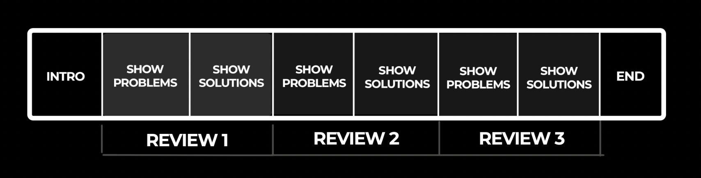
Click me for the guide on making a roast video
1. Ask for submissions (If you have a small audience, review influencers, brands, or famous people)

Promote free review on social + community wall, ask them to sign up to email to apply
Edit this template to use:

“Want to X?”

I’m going to do some free X reviews on the channel where I’ll show you how to fix Y problem.

All you need to do to submit your X for review is sign up to my email list below.

I’ll be emailing a private submission form to everyone on the list in 24 hours.

Name
[Insert tracking link here]

2. Email list 24-48 hours later with a Google form to apply
- Keep it short
- Reuse the template from the promotion as your email but use the form link

3. Set Your Video Goal - Sales | Emails | Views

4. Complete thumbnails + title

5. Viewer’s Top 3 Questions

Based on title/thumbnail, what 3 things will viewers expect answers to?

6. Review the submissions (Messy Plan)
Option 1: Find a theme (Pick the same problem to fix in different ways)
Option 2: Fix different problems

Don’t try to fix more than 3 problems per contestant to avoid overwhelming the viewers
- Pick the most universal problems
- Pick the simplest problems for a viewer to fix that make the biggest difference
- Bullet point the problems + solutions

7. Refine Messy Plan To Main Points

Reduce clutter. Keep what directly pays off your 3 viewer questions.

Contestant #X:
Problem 1
Problem 2
Problem 3
Contestant #X
Solution 1
Solution 2
solution 3

8. Conversion strategy

- Tell viewers to sign up to your next review 3x in the video
- First 90 seconds is optimum (but after first contestant fair)

9. Write in to a script or present from bullets

10. Upload + add tracking links below video + CTA

🧠 Roast Video Template:
Who should make these?
✅ Anyone who can visually fix or improve something
✅ Niche experts musicians, designers, marketers, crafters, etc.
✅ Creators looking to prove their credibility fast
Viewers who love these:
✅ Viewers stuck in the problem and want to see others get unstuck
✅ Ideal buyers who resonate with “you’re speaking directly to me!” moments
✅ Viewers who have considered working with your/buying your stuff
Best Used:
✅ To warm up your audience by showing you know your stuff
✅ To grow your list (submissions = emails!)
✅ To convert viewers to buyers
Pros:
✅ Builds massive trust showing expertise
✅ Differentiates
✅ Easy to make (with practice)
✅ Provides endless market research
✅ Converts to sales
✅ Generates emails
✅ Builds community
Cons:
❌ Low views - better for return + fans
❌ Requires community to get submissions
The secret sauce
✅ Entertaining tone don’t be afraid to be frank
✅ Visual transformation, actually fix their problem
✅ Pick the most universal problems
✅ Pick a max of 3 things to review per person
Mistakes
❌ No clear takeaway for the viewer (make it actionable!)
❌ Being too nice or too mean aim for helpful, not hostile
❌ Failing to show the solution clearly
❌ Just pointing out mistakes and not showing the solution
❌ Revewing too many pain points at once
Strategy
✅ Start by pointing out the pain/problem (emotion)
✅ Show the fix (logic) with real examples or visuals
✅ Ask for submissions at the end to build email list
✅ Reference high-performing roast videos in future uploads
Titles Examples
❌ Avoid harsh or mean-spirited titles unless on-brand
✅ Focus on helpful transformation or curiosity
- I Fixed This [X] So You Don’t Have To
- Why This [Thing] Doesn’t Work (And How to Fix It)
- Real Feedback That Actually Helps
- Before/After: We Fixed [X] Live
Thumbnails
✅ Use split screen “Before vs After” visuals
✅ Highlight cringe/problem moment on the left, fixed version on the right
✅ Use bold annotations like “FIXED” or “OUCH!”
Production
✅ Screen-Record +film yourself.
✅ “Fake” the live process
✅ Trim any waffle or tangents. Keep it concise these videos can get long fast.
✅ Keep edit simple

Listicle planner
Listicle Planner
Example Listicles
I made 300 YouTube videos and learned this
40 Brutal Truths I Wish I Knew in My 20s
This Just Changed YouTube Forever

LISTICLE PLANNER

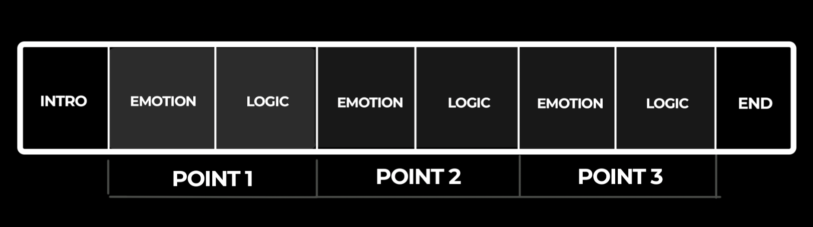

1. Set Your Video Goal - Sales | Emails | Views

2. Complete thumbnails + title

3. Viewer’s Top 3 Questions

Based on title/thumbnail, what 3 things will viewers expect answers to?

4. Brain Dump (Messy Plan)

List rough ideas, insights, or steps you might include

Don’t worry about order yet
- Make sure they’ll match or exceed the expectations set in the thumbnail and title
- Use Skyscraper bot to research other videos on the topic to help level up your plan

5. Refine Messy Plan To Main Points

Reduce clutter. Keep what directly pays off your 3 viewer questions and exceeds expectations

Click me for the emotion brick decision matrix
Plan The Emotion Brick

Pick ONE lesson from your list then :

Show the Problem (Visual Demo)

Contrast the Old Way vs New Way (Visual Demo)

Breakdown (Visual Demo)

Story

Metaphor

Plan the logic brick for the lesson
Example:
Point 1 - Use Photoshop Shortcuts to save time
Emotion: Show problem viewers have + result of using Photoshop shortcut
Logic: Give exact steps to action
CTA - Download my 20 top Photoshop Shortcuts lead mag
Point 2 - Never lose progress again
Emotion - Story about loing 5 hours of work
Logic - Steps to turn on auto save

6. Conversion Strategy
Optimizing for Emails?
- What’s the lead magnet?
- Mentioned 3x? (Early + Mid + End)
- Point to high converting video in end screen

Optimizing for Sales?
- Is your CTA obvious or stealth?
- Point to high converting video in end screen
Optimizing for Views?
- No external CTA
- Link only to bingeable next video
- Point to well received video via end screen

7. Move to Writing
8. Upload + add tracking links below video + CTA

Listicle Guide:
Who should make these?
✅ Creators of all levels
Viewers who love these:
✅ Learners who want quick hits of insight
✅ Casual viewers new to the topic
✅ Scroll-stoppers looking for fast takeaways
Best Used:
✅ To share lessons from experience
✅ To give chunks of advice that do not link together like steps
✅ When each point can stand alone without deep step-by-step teaching
Pros:
✅ Easy to produce (minimal structure)
✅ Binegable easy watch
✅ Great for storytelling and sharing your journey
✅ Highly repurposable into social content
Cons
❌ Some viewer types want specific systems/process not random lists
❌ Easy to put of viewers if one part of the list isn’t interesting to them
❌ Requires very strong transition hooks
The secret sauce
✅ Make sure transitions are very strong hooks
✅Keep the points fast and clear — 1 story + 1 lesson
✅ Use emotion bricks in 3–5 key points
✅ Tie your lessons back to your viewer’s top problems

Mistakes
❌ Too vague or broad — viewers need clarity and specificity
❌ Telling unrelated points with no clear thread
❌ Weak titles or overused phrases like “brutal truth” with no payoff
Strategy
✅ Brain dump your lessons, then refine
✅ Structure each one emotion/logic
Titles Examples
❌ Don’t overpromise — avoid “brutal” unless it really is
✅ Do show value and insight from your experience
- 18 Things I Wish I Knew Before I Started X
- If I Wanted to X, I’d Start With This
- 10 Things X quit
- 5 X Y’s Shouldnt Ignore
- 5 Mistakes That X your Y
Thumbnails
✅ All strategies can be used
Production
✅ Keep it simple
✅ Break up list using text chapters EG: “Mistake #3”

News Planner

NEWS PLANNER

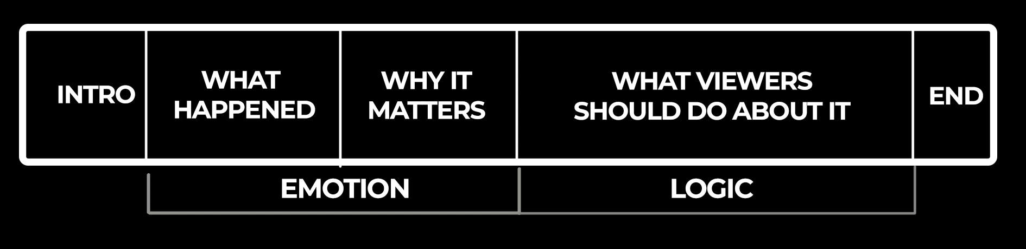

1. Set Your Video Goal - Sales | Emails | Views
It's unlikely you’ll make sales from news, I’d optimise for views/email

2. Complete thumbnails + title

3. Viewer’s Top 3 Questions

Based on title/thumbnail, what 3 things will viewers expect answers to?

4. Brain Dump (Messy Plan)
- What happened
- Why it matters
- What viewers should do about it
- If other videos are already out about it, use skyscraper bot to research

5. Refine Messy Plan To Main Points

6. Conversion Strategy
Link to email list or other videos that are more evergreen and have converted for emails or sales.

7. Move to Writing (If you have no time, present from bullets, speed matters here)
8. Upload + add tracking links below video + CTA

News Guide:

Who should make these?
✅ All creator levels
✅ Creators in fast-moving niches (tech, AI, finance, health, politics)
✅ Channels that want faster growth via trending topics
✅ Experts who can add insight, clarity, or unique perspective to breaking stories

Viewers who love these:
✅ Trend seekers who want to stay ahead of the curve
✅ Curious minds overwhelmed by noise, looking for clarity
✅ Decision-makers who want to understand how the news affects them (e.g. investors, creators, professionals)

Best Used:
✅ To piggyback on trending headlines for fast traffic
✅ To build topical authority in your niche
✅ To link breaking stories back to your core offer or evergreen content

Pros:
✅ Fast to produce (once you get your workflow down)
✅ Massive upside if a story explodes
✅ Great for widening your audience
✅ Easy to rank and get suggested next to similar content

Cons:
❌ Views die off fast (not evergreen)
❌ Views are only as big as the story
❌ Requires 24 hour turnaround

The secret sauce
✅ Speed: Get this out fast
✅ Add a unique POV or insight not just a summary

Mistakes
❌ Waiting too long to publish
❌ Overloading the viewer with too much information or jargon
❌ Forgetting to link the story back to the viewer's world

Strategy
✅ Get it out fast

Title Examples
❌ Avoid vague titles like “Big Changes in Tech This Week”
✅ Use curiosity, consequence, or urgency to drive clicks
- OpenAI Just X, Here’s What It Actually Means
- This X Update Will Change How You Work Forever
- Apple Just Killed X , Are You Ready?
- Why Everyone’s Talking About [X] , and What They’re Missing

Thumbnails
✅ Result, curiosity or coganitvie dissonance best here

Production
✅ Keep it simple, dont over edit, get the content out not perfect.

Interview planner

INTERVIEW PLANNER
The Man Making YouTubers Rich For Free
She Built A System That Makes ANY YouTuber Rich
The YouTuber Making $1,000,000/Month

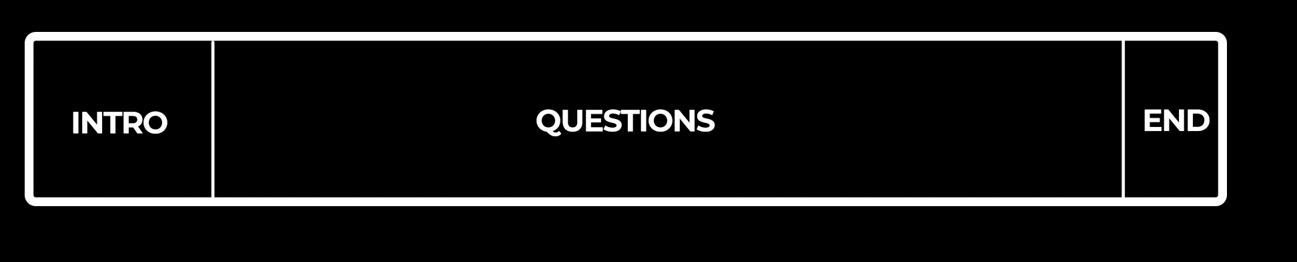

0 . Pick a guest
- Needs to have achieved what your viewers want (the more remarkable the better)
- Needs to be used to talking to a camera, people who are new to this will come across boring and shy
- Make sure they actually have next level insights, if their info isn't new, easy to understand or inspiring, then they are not good guests

1. Set Your Video Goal - Sales | Emails | Views
It's unlikely you’ll make sales from interviews, I’d optimise for views/email or focus on driving people to content that does convert

2. Complete thumbnails + title

Plan your packaging before the interview so you can position the entire interview around it and meet viewer expectations.
3. Viewer’s Top 3 Questions

Based on title/thumbnail, what 3 things will viewers expect answers to?

4. Plan questions
- Think about the problems your viewers care about, plan questions that might answer them
- Ask questions that could force the person answering them to start their answer with a story (emotion) then deliver logic
E.G “What was the moment you realised you needed to X and what was the one thing stopping you from solving it”

7. Write your intro
- Hook
- Problem/result
- Set up value + raise their credibility

8. Produce

- Riverside is HD
- Edit the interview. Remove waffles, tangents and questions where the answers were not very interesting or strong. (Diary of a CEO cuts out 50%)
8. Upload + add tracking links below video + CTA

Interview Guide:

Who Should Make These?

✅ Any creator can
✅ Creators who want to borrow credibility from others
✅ Experts looking to expand their network and showcase high-trust conversations
✅ Creators looking to meet a larger influencer

Viewers Who Love These:

✅ People who want behind-the-scenes stories, lessons, or success paths
✅ Newbies who want inspiration and clarity from those a few steps ahead
✅ Loyal fans of your guest
✅ Listners not viewers

Best Used:

✅ When your guest has a story, framework, or result that solves your viewers problems

Pros:
✅ Easy to produce
✅ Can open partnership and traffic opportunities
✅ Can bring new viewers to your channel

Cons:
❌ Doesn’t raise your credibility
❌ Awful for sales
❌ Heavily reliant on great guests
Mistakes to Avoid

❌ No clear reason why the guest is relevant
❌ Rambling intros with no hook or purpose
❌ Letting the conversation drift with no outcome or structure
❌ Average guests with no interesting backstory
❌ Thinking your guest will promote it (they never do)

Strategy

✅ Its all about the intro - Ramp up the value + credibility of your guest
✅ Promise 2–3 things the viewer will walk away with
✅ Get stories out of your guest + logic
✅ End screen to a high performing video for sales, views or leads, where you’re the expert

Titles (Examples)

✅ Use results, lessons, or curiosity to drive clicks
✅ Include emotional/educational payoff when possible

How [Guest] Went From [Pain] to [Result]

“This One Mistake Cost Me $100K” — And What I Learned

Thumbnails

✅ Use emotional facial expressions from guest + try to make it obvious its an interview
✅ Cognative dissonance, results or curiosity strategy

The Secret Sauce

✅ Choose guests who solve the same problem you do
✅ Plan heavily
✅ Always keep the viewer in mind: “What are they here to learn?”

Case study planner

CASE STUDY PLANNER
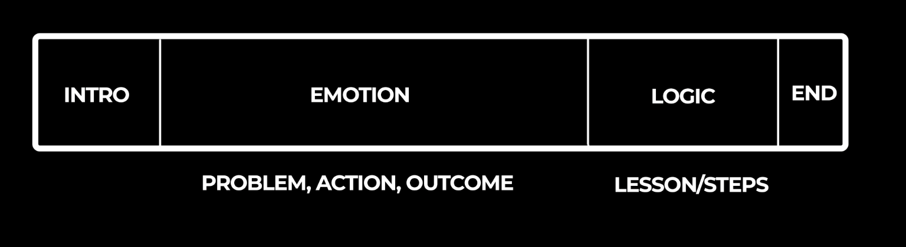
1. Set Your Video Goal
Sales |Emails |Views (I recommend sales as a priority)
2. Thumbnail and Title
3. Viewer’s Top 3 Questions
Based on your title and thumbnail, what 3 things will the viewer expect to learn?
4. Plan Emotion Brick Story
- What was their problem (the viewer has too)
- Why did they need to fix it?
- What actions did they take to fix it (include things that didn't work)
- What was the outcome
- Include proof wherever possible (screenshots, metrics, visuals, testimonials).
5. Plan Logic Brick
- What was the ONE big lesson?
- What are 1-3 steps the viewers can take themselves to get the same result?
- Include proof wherever possible (screenshots, metrics, visuals, testimonials).
6. Conversion Strategy
If optimizing for Emails:
- Promote a lead magnet tied to the challenge
- Mention early, mid, and end
- Link to it clearly in description and end screen
If optimizing for Sales:
- Use stealth or direct CTA within the video
- Point to your high-converting video or page in the end screen
If optimizing for Views:
- Avoid external links
- Link only to another challenge, story, or process video
- Use the end screen to drive binge behavior
7. Move to Writing
- Use your plan to write the voiceover or talking head script.
- Make sure your intro teases the result they got so viewers want to know “how”
- Focus on clarity, setup/payoff, and keeping emotional and logical tension.
8. Upload and Track

Who should make these?
✅ Blue belt, and black belt creators with an offer and proven transformation
✅ Experts who want to prove their method works especially for skeptical or solution-aware audiences
✅ Business owners who need to build trust quickly
Viewers who love these:
✅ Skeptical buyers who need proof before purchasing
✅ Curious viewers who love transformation stories
✅ Business-minded watchers looking for behind-the-scenes process
✅ Warm viewers looking for an excuse to buy
Best Used:
✅ To raise credibility + differentiate
✅ To showcase the power of your offer or strategy through storytelling
✅ To highlight real results (even small ones) with a transparent journey
✅ To create an evergreen asset that drives sales and builds brand trust
✅ As part of your email nurture + end screen strategy
Pros:
✅ Builds massive credibility fast
✅ Evergreen and bingeable
✅ Great for cold-to-warm lead nurturing
✅ Excellent lead-in to high-ticket offers
✅ Repurposable across social/email
The secret sauce
✅ Focus on ONE clear transformation or challenge
✅ Show the process (success OR failure) honestly
✅ Keep it simple focus on value, not cinematics
Mistakes
❌ Turning it into a documentary (too long or too detailed)
❌ No clear takeaway or lesson for the viewer
❌ All logic, no emotion needs personal stakes or insight
Strategy
✅ Frame the challenge around a relatable, high-stakes problem
✅ Use a clear start/middle/end story arc with emotional tension
✅ If filming b-roll is hard, record a sit-down version and overlay basic footage later
✅ Use failure as a lesson what matters is transformation
Title Examples
✅ I X to prove its not luck
✅ They did X for 30 days, Here’s What Happened
✅ Can [Your Process] Actually Work? I Tested It
✅ How Z went From X to Y in 7 Days

Thumbnail Tips
✅ Results, curiosity, comparison or curiosity work best

CHECKLISTS

Video checklists for
Titles
Thumbnails
Intros

Title Checklist

Title Checklist

Checklist for Great Titles
- Is it under 50 characters?
- Does it spark curiosity or promise a result?
- Does it align with the thumbnail?
- Is it in line with the top of your umbrella?
- Did you validate it with outliers or patterns from your niche?
- Does it have plenty of BENS (Big, Easy, Safe, New)

Avoid
❌ Assuming familiarity — e.g. “Here’s How I Did X” when viewers don’t know or care yet
❌ Relying on AI (AI-generated titles are often bad)
❌ Using “:” in a title
❌ Keyword stuffing
❌ Using “I” in the title (until larger)

1. Start with Curiosity
A good title raises questions in the viewer's mind. Use words like why, how, what, and secret to spark intrigue.
Example: "Why You’re Failing at Productivity (And How to Fix It)"

2. Use the BENS Framework
Incorporate one or more of these elements:
- Big Claim: "The Trick That Changed Everything"
- Easy: "5 Simple Ways to Lose Weight"
- New: "You’ve Never Seen This Before"
- Safe Bet: "Proven Strategies to Save Money"

3. Keep It Short and Clear
Aim for under 50 characters to ensure readability. Remove unnecessary words or jargon.
Example: "How to Start a Business in 2024"

4. Align with the Thumbnail
Your title and thumbnail must work together to create a cohesive and intriguing story. Avoid repeating exact text from the thumbnail.
Example: Title: "Why I Stopped Using My Phone"
Thumbnail Text: "This Changed Everything"

5. Test and Refine
Split test different titles using YouTube tools or feedback from your audience. Adjust based on click-through rates (CTR) and engagement.

Thumbnail Checklist

✅ Thumbnail Design Rules & Mistakes Checklist

Space & Layout
- Is there enough white space so nothing feels cramped?
- Did I avoid putting text/elements in the corners where YouTube cuts off?
- Is there a clear invisible frame around the main elements?

Colors
- Did I use 3 or fewer main colors?
- Do the colors contrast enough to make elements pop?
- Did I check how it looks in dark mode?

Text & Fonts
- Is my font sans serif (easy to read)?
- Is the text 4 words or fewer?
- Is the spacing (between letters/lines) easy to read?

Images
- Are all images high-quality (no pixelated/cheesy stock)?
- Do the visuals clearly relate to the video’s message?

Subject Placement
- Is my subject clearly visible (centered or offset thoughtfully)?
- Does the subject stand out as the first thing viewers notice?

Size & Focus
- Are the main elements large enough to see on mobile?
- Did I avoid adding too many small or distracting details?
- Does the thumbnail stick to 1–3 key elements only?

Visual Cues
- If I used arrows/circles, are they subtle but clear?
- Do they point to the right thing, without overwhelming the thumbnail?

❌ Mistakes to Avoid (Quick Yes/No)
- Did I avoid overcrowding with too many elements?
- Is there one clear focal point (not messy)?
- Am I using a readable font (not serif or fancy)?
- Did I keep effects like glows/shadows subtle?
- Did I avoid placing key info in the bottom right corner?
- Does the thumbnail make sense without watching the video?
- Do the emotions/faces match the video’s title and tone?
- Is the layout balanced (not awkwardly aligned)?
- Is the text 4 words or fewer?

Intro checklist

Intro Checklist
Avoid These Mistakes
❌ Being vague → Don’t say “great results,” say “lose 15 lbs in 4 days.”
❌ Teaching too early → The intro is for hooking, not lessons.
❌ No proof → Always show evidence if you make a claim (screenshots, graphs, testimonials).

Intro Checklist
Before recording, ask:
✅ Does it match the thumbnail/title promise?
✅ Does the hook grab curiosity in <5 seconds?
✅ Did I poke a problem or tease a result?
✅ Did I clearly set up what the video delivers?
✅ Did I add credibility naturally?
✅ Did I transition smoothly into point #1?
✅ Is the intro <30s (ideally 15s)?

Filming Checklist

Filming checklist

Use this checklist before you film to stop those annoying things that always go wrong, going wrong
24 Hours before filming

- Charge camera batteries (charge all of them)
- Charge mic
- Back up any data on SD cards and Format it (This means delete everything on the card, formatting the card inside the camera is also going to make it less likely to randomly corrupt)
- Copy scripts on to teleprompter app
- Check teleprompter controller has battery left

Pre filming checks

Lighting

- Shut curtains and block natural light coming in
- Set up key light
- Set up hair light
- Set up background lighting

Framing

- Set the background
- Set up tripod + camera
- Insert SD card to camera (make sure you formatted it)
- Add teleprompter and phone to lens
- Frame the shot

Sound

- Plug mic into camera
- Turn on mics
- Check levels are not peaking or too low

Test shot

- Hit record and present 2 lines
- Watch back on a computer (You won’t spot mistakes watching back on the camera’s screen)
- Are you happy with the framing?
- Is the video in focus?
- Are you happy with the sound levels/quality?
- Are you happy with the lighting?
- Make any adjustments

Film

- Film your scripts
- Keep an eye on the camera/mic battery

Backup

- As soon as you finish, back up your SD card on to your hard drive
- Scan the footage to make sure nothing went out of focus
- Reshoot anything that needs to be taken care of

INSPIRATION BANK

Get Inspiration on
Titles
Hooks
Transitions

Title Bank

Title Bank
Watch me to see how this works
Use validated titles to come up with ideas faster.

Self Improvement
This Simple X System Got Me Y
- This Simple Budgeting System Got Me Out of Debt
- This Simple Meditation System Got Me Peace of Mind
This Simple x Made Me y
- This Simple Morning Routine Made Me More Productive
- This Simple Exercise Made Me Stronger
This Is Why You Can’t X
- This Is Why You Can’t Lose Weight
- This Is Why You Can’t Stay Motivated
My Honest Advice to Someone Who Wants X
- My Honest Advice to Someone Who Wants to Start a Business
- My Honest Advice to Someone Who Wants to Improve Their Health
The Top Reasons People Regret X
- The Top Reasons People Regret Buying a House
- The Top Reasons People Regret Quitting Their Job
7 Signs of X in Y
- 7 Signs of Burnout in Your Daily Routine
- 7 Signs of a Toxic Relationship in Your Life
12 Signs You’re X
- 12 Signs You’re Overworking Yourself
- 12 Signs You’re a Natural Leader
Why People Struggle to Say ‘X’
- Why People Struggle to Say ‘No’
- Why People Struggle to Say ‘I’m Sorry’
I NEVER Felt Like X (How I Changed)
- I NEVER Felt Like I Belonged (How I Changed)
- I NEVER Felt Like Exercising (How I Changed)
8 X Habits That Keep You Y
- 8 Eating Habits That Keep You Energized
- 8 Productivity Habits That Keep You Focused
It’s Actually Pretty Easy to X
- It’s Actually Pretty Easy to Learn a New Language
- It’s Actually Pretty Easy to Save Money
5 Things Successful X Do Before Y
- 5 Things Successful Entrepreneurs Do Before 9 AM
- 5 Things Successful Students Do Before Exams
Why I Stopped Using X
- Why I Stopped Using Social Media
- Why I Stopped Using Processed Foods
5 Things Smart X Should Never Do
- 5 Things Smart Investors Should Never Do
- 5 Things Smart Homeowners Should Never Do
I Wish Someone Had Told Me X
- I Wish Someone Had Told Me How Hard Parenting Is
- I Wish Someone Had Told Me About the Challenges of Freelancing
How I Learned to X in a Week
- How I Learned to Cook in a Week
- How I Learned to Code in a Week
My Worst Mistakes X
- My Worst Mistakes as a Manager
- My Worst Mistakes When Starting a Business
My Worst Mistakes Learning X
- My Worst Mistakes Learning to Play the Guitar
- My Worst Mistakes Learning a New Language
I Should NOT Have X This!
- I Should NOT Have Ignored My Health
- I Should NOT Have Skipped the Meeting
How To Attract X Effortlessly
- How To Attract New Clients Effortlessly
- How To Attract Positive Energy Effortlessly
The Biggest X About Y, Debunked
- The Biggest Myth About Vegan Diets, Debunked
- The Biggest Misconception About Remote Work, Debunked
Why You Struggle to X Your Y
- Why You Struggle to Communicate Your Needs
- Why You Struggle to Define Your Goals
How to X Instantly
- How to Improve Your Focus Instantly
- How to Relieve Stress Instantly
If You Don’t X This, Your Y Will Never Change
- If You Don’t Practice Self-Care, Your Mental Health Will Never Change
- If You Don’t Learn to Budget, Your Financial Situation Will Never Change
You’re (Probably) X Your Y
- You’re (Probably) Sabotaging Your Own Success
- You’re (Probably) Overcomplicating Your Fitness Routine

Advice and tips

5 Common Tips That Can Ruin Your X
- 5 Common Tips That Can Ruin Your Weight Loss Journey
- 5 Common Tips That Can Ruin Your Productivity
92% of X Use Y Wrong – Here’s What To Do Instead
- 92% of Homeowners Use Their Thermostats Wrong – Here’s What To Do Instead
- 92% of Job Seekers Use Resumes Wrong – Here’s What To Do Instead
What I Learned From My Failed X
- What I Learned From My Failed Business Venture
- What I Learned From My Failed Fitness Challenge
The X That Will Change Your Life
- The Morning Routine That Will Change Your Life
- The New Hobby That Will Change Your Life
5 Myths X That We All Thought Were True
- 5 Myths About Nutrition That We All Thought Were True
- 5 Myths About Success That We All Thought Were True
3 X I Will NEVER Y
- 3 Diets I Will NEVER Try
- 3 Workouts I Will NEVER Do
X Change EVERYTHING We Knew About Y
- Technology Change EVERYTHING We Knew About Communication
- New Research Change EVERYTHING We Knew About Sleep
4 MISTAKES X that Everyone Knows
- 4 MISTAKES Home Cooks Make That Everyone Knows
- 4 MISTAKES New Entrepreneurs Make That Everyone Knows
5 X Always Y
- 5 Successful Entrepreneurs Always Wake Up Early
- 5 Healthy Eaters Always Include Greens
How X Transforms Your Y
- How Meditation Transforms Your Daily Routine
- How Reading Transforms Your Mindset
The WORST THINGS About X Will Surprise YOU!
- The WORST THINGS About Working from Home Will Surprise YOU!
- The WORST THINGS About Minimalism Will Surprise YOU!
STOP Doing These X For Y!
- STOP Doing These Mistakes For Better Health!
- STOP Doing These Habits For Better Productivity!
First X Things To Do – Y (Tips and Tricks)
- First 5 Things To Do – When Starting a New Job (Tips and Tricks)
- First 3 Things To Do – To Improve Your Diet (Tips and Tricks)
How To X like a Y
- How To Write Like a Bestselling Author
- How To Dress Like a Fashion Icon
How To X Like A Y
- How To Negotiate Like A Pro
- How To Write Like A Bestselling Author
X Tips to Avoid Looking Y Over Z
- 7 Tips to Avoid Looking Overwhelmed During Presentations
- 10 Tips to Avoid Looking Disorganized in Meetings
X Tips to Avoid Y for Z
- 5 Tips to Avoid Overeating for a Healthier Lifestyle
- 8 Tips to Avoid Stress for a Better Work-Life Balance
X Your Y Without Z
- Improve Your Skin Without Expensive Products
- Enhance Your Workout Without Expensive Gear
X Money-Saving Y Tricks – Don’t Z!
- 5 Money-Saving Grocery Tricks – Don’t Fall for These Common Mistakes!
- 3 Money-Saving Travel Tricks – Don’t Overlook These Essentials!
X Steps To Get The Best Y Of Your Life In Z
- 7 Steps To Get The Best Sleep Of Your Life In 30 Days
- 5 Steps To Get The Best Financial Health Of Your Life In 6 Months
Best X Free Y in Z + Comparison
- Best Free Productivity Apps in 2024 + Comparison
- Best Free Fitness Programs in 2024 + Comparison
X Hacks Pro Designers Use in Y
- Design Hacks Pro Designers Use in Photoshop
- Interior Design Hacks Pro Designers Use in Small Spaces
Top X Anti-Y Foods to Eat After Z
- Top 10 Anti-Inflammatory Foods to Eat After a Workout
- Top 5 Anti-Aging Foods to Eat After 40
X Tips in Y for Your Z
- 10 Writing Tips in 2024 for Your Blog
- 7 Study Tips in College for Your Exams
One-Minute X Habits for a Y Home
- One-Minute Cleaning Habits for a Tidy Home
- One-Minute Organization Habits for a Clutter-Free Home
X Small Changes to Improve Your Y
- 5 Small Changes to Improve Your Morning Routine
- 10 Small Changes to Improve Your Work-Life Balance

Challenges and Experiences

6 Levels of X Every Y MUST Master
- 6 Levels of Guitar Skills Every Musician MUST Master
- 6 Levels of Digital Marketing Every Entrepreneur MUST Master
I Survived X Days Off Y
- I Survived 30 Days Off Social Media
- I Survived 60 Days Off Sugar
Can I X Every Y in Z?
- Can I Visit Every National Park in 30 Days?
- Can I Read Every Book on My Shelf in a Year?
We Survived The Scariest X
- We Survived The Scariest Haunted House
- We Survived The Scariest Escape Room Challenge
Our X Survived The Worst Y
- Our Vintage Car Survived The Worst Road Trip
- Our DIY Project Survived The Worst Conditions
I Bought a X & Rebuilt It in Y
- I Bought a Classic Car & Rebuilt It in 6 Months
- I Bought a Vintage House & Rebuilt It in a Year
The SCAM X Don’t Want You To Know
- The SCAM Weight Loss Supplements Don’t Want You To Know
- The SCAM Investment Schemes Don’t Want You To Know
What’s Coming Is WORSE Than X
- What’s Coming Is WORSE Than The Current Recession
- What’s Coming Is WORSE Than The Climate Crisis
I Tried This Mind-Blowing X
- I Tried This Mind-Blowing New Fitness Regimen
- I Tried This Mind-Blowing Productivity Technique
I Tried This Ancient X
- I Tried This Ancient Meditation Practice
- I Tried This Ancient Herbal Remedy
I Tried This Revolutionary X
- I Tried This Revolutionary Learning Method
- I Tried This Revolutionary Health Supplement
Are You Having a Complicated X?
- Are You Having a Complicated Relationship?
- Are You Having a Complicated Fitness Journey?
We X Every Y in Z Days
- We Visited Every Beach in Our State in 14 Days
- We Cooked Every Recipe in the Cookbook in 30 Days
X vs Y at Z
- Electric Cars vs Gas Cars at 60 MPH
- Home Workouts vs Gym Workouts at 30 Minutes
X Builds World’s Fastest Y!
- Tesla Builds World’s Fastest Electric Car!
- SpaceX Builds World’s Fastest Rocket!
We Bet Everything to Save X
- We Bet Everything to Save Our Family Business
- We Bet Everything to Save Our Favorite Local Restaurant

Secrets and Controversies
X will HATE me for sharing this Secret
- The Tech Giants Will HATE Me for Sharing This Secret Trick
- The Health Industry Will HATE Me for Sharing This Secret Diet
X HATE me for sharing this SECRET
- Fitness Gurus HATE Me for Sharing This SECRET Workout Routine
- The Fashion Industry HATE Me for Sharing This SECRET Budget Style Tip
Huge Lies X Are Telling You!
- Huge Lies The Fitness Industry Is Telling You!
- Huge Lies The Beauty Industry Is Telling You!
X New Y is a Game-Changer
- The New iPhone is a Game-Changer for Mobile Photography
- The New Streaming Service is a Game-Changer for Entertainment
What’s Coming Is WORSE Than X
- What’s Coming Is WORSE Than The Current Economic Downturn
- What’s Coming Is WORSE Than The Climate Crisis
X Is Worse Than You Think: Z Reveals All
- Social Media Is Worse Than You Think: Experts Reveal All
- Diet Soda Is Worse Than You Think: Nutritionists Reveal All
The X That Terrified Y
- The New Horror Movie That Terrified Even Veteran Critics
- The Conspiracy Theory That Terrified The Experts
The Real Reason Why X
- The Real Reason Why Fast Fashion Is So Cheap
- The Real Reason Why You’re Not Losing Weight
The X Reason Why Every Y Has Z
- The Real Reason Why Every Business Should Have a Digital Strategy
- The Hidden Reason Why Every Entrepreneur Needs a Mentor
6 Dirty Secrets YouTubers Refuse To Talk About
- 6 Dirty Secrets YouTubers Refuse To Talk About Behind the Scenes
- 6 Dirty Secrets YouTubers Keep Hidden From Their Audience
The TRUTH About YouTube That The PROS Know
- The TRUTH About YouTube Algorithms That The PROS Know
- The TRUTH About Growing a Channel That The PROS Know
Huge Lies X Are Telling You
- Huge Lies Fitness Apps Are Telling You
- Huge Lies Beauty Products Are Telling You
I Ditched X — Here’s Why
- I Ditched My Social Media Accounts — Here’s Why
- I Ditched Processed Foods — Here’s Why

Product and Service Reviews
The BEST X of 2024
- The BEST Smartphones of 2024
- The BEST Fitness Gadgets of 2024
Best X of Y – Forget Z! X In This Instead
- Best Budget Laptops of 2024 – Forget High-End Models! Check These Instead
- Best Skincare Products of 2024 – Forget Old Brands! Try These New Ones
I Bought X: What It’s Actually Like!
- I Bought the Latest Drone: What It’s Actually Like!
- I Bought a Subscription Box: What It’s Actually Like!
X Free Tools I’d Use to Y
- 5 Free Tools I’d Use to Improve My YouTube Channel
- 7 Free Tools I’d Use to Enhance Productivity
This Simple X Trick Changed Everything
- This Simple Budgeting Trick Changed Everything About My Finances
- This Simple Productivity Trick Changed Everything About My Workday
Stop Wasting Your X on These Y!
- Stop Wasting Your Money on These Overpriced Gadgets!
- Stop Wasting Your Time on These Ineffective Workouts!
The Wrong Way to X Your Y
- The Wrong Way to Clean Your Laptop
- The Wrong Way to Plan Your Week
X Secrets Z Refuse to Talk About
- The Nutrition Secrets Dieticians Refuse to Talk About
- The Financial Secrets Wealth Managers Refuse to Talk About
Is This X Better Than What’s in Y?
- Is This New Tablet Better Than What’s in the Market?
- Is This Homemade Skincare Better Than Store-Bought Products?

Exploratory and "What If" Scenarios
X Is For Y People
- Meditation Is For Busy People
- Minimalism Is For People Who Love Freedom
Why You Can’t X With Y
- Why You Can’t Lose Weight With Just Cardio
- Why You Can’t Master a Language With Just Apps
Why You Can’t X With AI
- Why You Can’t Fully Trust AI for Creative Writing
- Why You Can’t Rely on AI for Personal Financial Advice
This Might Be the X Idea I’ve Ever Had…
- This Might Be the Best Business Idea I’ve Ever Had…
- This Might Be the Most Innovative Fitness Routine I’ve Ever Had…
I Created an X to Prove It's Not Y
- I Created an App to Prove It’s Not Just a Fad
- I Created a New Diet Plan to Prove It’s Not a Scam
Why X is Doing Y
- Why Google is Investing in Quantum Computing
- Why Major Brands are Shifting to Sustainable Packaging
Why “X” look so Y! Ft. Z
- Why “Luxury Car” Commercials Look So Over-the-Top! Ft. A Marketing Expert
- Why “Healthy Food” Commercials Look So Deceptive! Ft. A Nutritionist
X Explain Why It’s So Hard To Y
- Economists Explain Why It’s So Hard To Predict Market Trends
- Engineers Explain Why It’s So Hard To Design the Perfect Product
How I See the X After Living in Y for Z
- How I See the Modern Workplace After Living in a Remote Village for a Year
- How I See Digital Nomadism After Living in Bali for Six Months
How a X Robbed Y of Z
- How a Bad Investment Robbed Me of My Savings
- How a Miscommunication Robbed My Team of Productivity
Genius X Advice for Y Straight…
- Genius Fitness Advice for Beginners Straight from the Pros
- Genius Financial Advice for Entrepreneurs Straight from the Experts
Make Your X Free Forever in Y Steps
- Make Your Inbox Email Free Forever in 5 Steps
- Make Your Budget Balanced Forever in 3 Steps

Lists and Rankings
5 Easy X That Will Change Your Life Forever
- 5 Easy Habits That Will Change Your Life Forever
- 5 Easy Recipes That Will Change Your Dinner Routine Forever
7 Signs of X in Y
- 7 Signs of Burnout in the Workplace
- 7 Signs of Quality in Handmade Crafts
10 X You MUST AVOID!
- 10 Mistakes You MUST AVOID When Starting a Business!
- 10 Foods You MUST AVOID for Better Health!
12 Things NOT to do in X
- 12 Things NOT to do in a Job Interview
- 12 Things NOT to do When Buying a House
5 Things Smart X Should Never Do
- 5 Things Smart Investors Should Never Do
- 5 Things Smart Travelers Should Never Do
5 Things X Do Before 8AM
- 5 Things Successful Entrepreneurs Do Before 8AM
- 5 Things Productive People Do Before 8AM
5 Things Successful X Do Before Y
- 5 Things Successful Writers Do Before Starting Their Day
- 5 Things Successful Athletes Do Before a Big Game
X Growth Hacks That Have Been Banned
- SEO Growth Hacks That Have Been Banned
- Marketing Growth Hacks That Have Been Banned
5 Reasons X to Y As Soon As You Can
- 5 Reasons to Switch to Renewable Energy As Soon As You Can
- 5 Reasons to Start a Morning Routine As Soon As You Can
I Ranked X BEST Y (Tier List)
- I Ranked the Best Streaming Services (Tier List)
- I Ranked the Best Budget Laptops (Tier List)
5 X Always Y
- 5 Habits Always Linked to Success
- 5 Strategies Always Effective in Marketing
5 Myths X That We All Thought Were True
- 5 Myths About Nutrition That We All Thought Were True
- 5 Myths About Exercise That We All Thought Were True

Entertainment and Fun
X Tries Y for the First Time
- A Chef Tries Vegan Cooking for the First Time
- A Grandpa Tries Virtual Reality for the First Time
What Your Favorite X Says About YOU
- What Your Favorite TV Show Says About YOU
- What Your Favorite Book Genre Says About YOU
The X Principle | If You Don’t Change X, Y Will Never Change
- If You Don’t Declutter, Your Space Will Never Feel Organized
- If You Don’t Prioritize Tasks, Your Productivity Will Never Improve
The Hunt for the X of the Y
- The Hunt for the Perfect Coffee Blend of the Year
- The Hunt for the Best Fitness Routine of the Decade
I Made X Work for Y
- I Made Minimalism Work for a Busy Lifestyle
- I Made Remote Work Work for My Family Life
I Wish Every X Could Watch This
- I Wish Every Aspiring Entrepreneur Could Watch This
- I Wish Every Music Lover Could Watch This

Hook bank

Hook bank

Below are some hooks you can use for inspiration.

Question-Based Hooks:
- "Have you ever wondered why…?"
How Long It Actually Takes To Make Money On YouTube
- "Are you making this X mistake…?"
- "Do you ever feel like…?"
- What would you do if....
- Have you ever noticed that..?
- If there was one INSERT THING that could INSERT RESULT would you do it?
- What separates you from INSERT OTHER PEOPLE
- Can I tell you a secret?
- You want to know something crazy?
- Would you X if you knew it would Y
- How did this person X when this person Y’d
- You want to hear something insane?
- Why is X doing Y?
- "Why is nobody talking about this?"
- Do you struggle to X? Well, its not your fault

Statement Hooks”
- I have found the X that nobody seems to be talking about
- I'm a multi-millionaire and I don't own my house and I don't invest in any property but why isn't a house a great investment”
- X doesn't come from luck; it comes from consistent, deliberate actions.
- "It's time to rethink everything you know about [subject].
- This simple tweak can dramatically improve your [skill/ability].
- "This secret could change your life."
- This one strategy transformed my entire approach to [topic]."
- "You’ve been doing X wrong all along."
- "Here’s a truth no one wants to admit…"
- "This simple trick changed everything for me."
- "You won't believe what just happened…"
- "Stop doing [common action] right now."
- "Here’s why [popular opinion] is completely wrong."
- "You don’t need [common tool/advice] to succeed."
- "Why [widely accepted idea] is holding you back."
- "If you feel like giving up, watch this."
- "I dare you to try this for a week."
- "You need to know this right now."

Fact Hooks
For a fact hook, just hit someone with a surprising fact, it needs to be surprising!
You will need to research your own topic to find one, heres some examples of it in action.
- “On average, you make roughly 35,000 decisions per day.
- “Almost 80% of the world's millionaires are self-made and a large part of their success comes down to the tried and tested small habits that they've used to build wealth”
- “Do you know what day of the week you are most likely to die from a heart attack? Take a guess. I'll give you a second It's Monday care to guess what time it is between 8:00 and 9:00 a.m”
- "Did you know that…?"
- "Studies show that…"
- "Most people don’t realize this about…"
- "80% of people are making this mistake…"

Credibility Hooks
- “I've been in business for 13 years I've sold nine companies my last company I sold for 46.2 million I own acquisition. comom which right now does about $17 million a month across our portfolio I'm going to compress 13 years of brutal business truths and lessons into this
- "Having authored three best-selling books on productivity, I know the strategies that deliver results. Let's dive into the techniques that can transform your daily routine."
- "With a PhD in neuroscience, I can explain how habits are formed and broken. Today, we'll explore the science behind building lasting habits."
- "As a certified nutritionist, I've guided hundreds towards healthier lifestyles. In this session, I'll reveal the key principles of effective nutrition."
- "After helping 500+ clients boost their online presence, I've discovered what truly works. Let's uncover the secrets to a successful digital strategy."
- "In my 20 years as a financial advisor, I've navigated clients through multiple market cycles. Today, I'll share insights on building a resilient investment portfolio."
- "As a former Olympic athlete, I understand the dedication required to achieve peak performance. Let's discuss the mindset needed for success."
- "With over 15 years in the tech industry, including leading teams at [Notable Company], I can provide an insider's perspective on innovation and leadership."

Transition Bank

Transition Bank

How to Use This Bank:
- Identify what you’re transitioning from and to.
- Choose the best type of transition for your video’s flow (Problem? Result? Stakes? Cliffhanger?).
- Adapt the phrasing to your style and audience.
This transition bank ensures your clients have the tools to keep videos flowing naturally and make each point feel necessary and exciting. 🚀

My Most Common Transitions

It's very rare I reinvent the wheel, we really don't need to overcomplicate this, most of the time I just say:
- To start, I'm going to show you how to stop [INSERT BIG PROBLEM]
- To start, I'm going to show you how to stop [INSERT BIG RESULT]
- To start, I'm going to show you how to [INSERT BIG PROBLEM
- But how do you do that? Well let me show you so you don't [INSERT BIG PROBLEM]
- But how do you do that? Well let me show you so you can [INSERT BIG RESULT]
- This next part of my system will help you [INSERT BIG RESULT]
- This next part of my system will help you [INSERT BIG PROBLEM]
- Most people fail here because of [INSERT BIG PROBLEM]. But when you do this next step, it [INSERT BIG RESULT]
- “Next, I’m going to show you the exact thing that’ll [INSERT BIG RESULT] fast.”
- "Which brings us to the next big problem..."
Don't get cute with transitions, they shouldn't take more than 30 seconds to write

Other Transitions:
Here’s some more options ive used over the years but the smart move is just to have 3-4 you use over and over again.
Direct Promises or Teasers:
- But how do you do that? Well let me show you so you don't [INSERT BIG PROBLEM]
- But how do you do that? Well let me show you so you can [INSERT BIG RESULT]
- Next, I'm going to show you how to [INSERT BIG RESULT]
- Next, I'm going to show you how to avoid [INSERT BIG PROBLEM]
- Now you know that, let me show you how to avoid [INSERT BIG PROBLEM]
- Now you know that, let me show you how to [INSERT BIG RESULT]
Logical Progressions:
- "So what does this mean for you? Well next ill show you"
- "That leads us on to how to [INSERT BIG RESULT]."
- "That leads us on to how to [INSERT BIG PROBLEM]”
Story Setup or Example Introductions:
- "To prove this point, let me show you..."
- "To show you how this works you need to understand how to [INSERT BIG RESULT]"
- "To show you how this works you need to understand how to [INSERT BIG PROBLEM]”
- "Take [famous example/story] for instance..."
- "Let me give you an example that simplifies this..."
- After a story: “But how can you do the same? Well now im going to show you”
Result-Oriented Transitions:
- "What happened next completely [INSERT BIG RESULT]""
- "What happened next completely [INSERT BIG PROBLEM]
- "And the results? They were mind-blowing, so now I'll show you how to do the same
Simplification Reminders:
- "Let me simplify this for you..."
- "Here's the easiest way to think about it..."

EMOTION BRICK

Master the emotion brick

Work out what type of tool to use with a visual demo decision matrix
Get prompts to help you come up with stories
Plan a story
Plan a metaphor

Emotion Brick Decision Matrix

Emotion Brick Decision Matrix
Ask these questions at the start of each point. Your answers will guide you to the right tool:

1. Is the problem invisible or hard for the viewer to see or feel?
- Yes → Use Visual Demo: Show the Problem
Turn an invisible pain into something physical the viewer can immediately recognize.
Example: Comparing inconsistent growth to broken gears in a machine.

2. Will a clear before-and-after help highlight why the “old way” doesn’t work?
- Yes → Use Visual Demo: Contrast
Side-by-side examples magnify the pain of the old method and the promise of the new.

3. Do I want to break down a real-world example or walk through how something works?
- Yes → Use Visual Demo: Breakdown
Freeze on a thumbnail, show a funnel, highlight what’s good or bad — great for proving your point and showing credibility.

4. Do I want the viewer to emotionally feel the pain or urgency of staying stuck?
- Yes → Use a Story
Short stories (your own or client-based) build connection and belief by showing the human cost of the problem — and the transformation.

5. Is the idea abstract, hard to grasp, or too familiar to feel fresh?
- Yes → Use a Metaphor
Metaphors reframe familiar concepts in unexpected ways and make abstract ideas instantly click.
Example: “Most creators treat the algorithm like a slot machine — but I treat it like a GPS.”

Visual demo decision matrix

Visual Demo Decision Matrix
- “If I only say the number, will viewers still shrug?”
Use a Show-the-Problem Demo – turn the number into a pile, bar, or stack so the scale hits instantly.
- “Is the mistake hard to spot without seeing it happen?”
Use a Show-the-Problem Demo – zoom in, highlight, or slow-mo the hidden issue so it’s crystal-clear.
- “Could a ‘before vs. after’ silence any doubt?”
Use a Contrast Demo – flash side-by-side clip or photo sequence to prove the change.
- “Would putting two things side-by-side make the difference instant?”
Use a Contrast Demo – split-screen bad-vs-good (messy vs. clean, poor vs. great audio, etc.).
- “Is there a famous clip (or my own fail) that embodies this lesson I can show?”
Use a Breakdown Demo , play the clip, pause/zoom/annotate the telling detail so the takeaway sticks.

Story prompts

Story Prompts

1. Embarrassing First Attempt
Tell the story of your very first attempt at something important.
- What made it embarrassing?
- How did you react in the moment?
- What did you learn that shaped how you do things now?

2.

Costly Rookie Mistake
Share a time you made a beginner error that cost you—money, time, reputation, or opportunity.
- What did you overlook or underestimate?
- How could you have avoided it?
- What changes did you make afterward?

3.

Sudden Breakthrough Moment
Describe the exact moment something “clicked.”
- What had you been struggling with before?
- What shifted your perspective or skill?
- How did it change your results immediately?

4.

Advice Ignored, Then Learned
Recall a time someone gave you advice you brushed off—only to later discover they were right.
- What made you dismiss it at first?
- What experience proved them right?
- How do you see that advice now?

5.

Tiny Tweak, Huge Payoff
Share a situation where you made one small change and got a massive improvement.
- What was the tweak?
- Why did it work so well?
- What’s the lesson for others?

6.

Did What You/They Were Taught, But It Didn’t Work
Tell the story of following “proven” instructions or common wisdom… and failing.
- Why didn’t it work in your case?
- What did you do instead?
- What’s the takeaway for anyone in the same situation?

Story planner

3-Step Story Planner
Use this every time you want to plan a story for your script. Keep it short (20–30 seconds) and make sure it ties directly to the point you’re about to teach.

Step 1: Problem (The Beginning)
- Drop the viewer straight into the pain point.
- Be specific and emotional — frustration, fear, confusion, embarrassment.
- Ask yourself: “What’s the relatable problem my viewers have?”
- Tip: Don’t start at the beginning of the journey — start at the moment of struggle.
Example:
“I remember staring at the screen, watching my 50th YouTube video pull in just 12 views… and realizing nothing I’d learned online actually worked.”

Step 2: Action (The Middle)
- Show the one big thing you (or someone else) did to try solving the problem.
- Keep it simple — 1 action, 1 choice, or 1 decision.
- Ask yourself: “What’s the most surprising or impactful action I took?”
- Don’t overexplain or list everything you did.
Example:
“So I swapped the main photo in my Airbnb listing for one that actually showed off the space.”

Step 3: Outcome (The End)
- Reveal what happened — the transformation, lesson, or result.
- This can be positive, negative, or a surprising twist.
- Ask yourself: “How did this action change the situation?”
- Make sure the outcome connects back to the problem you started with.
Example:
“The listing was booked three times that week — and hasn’t been empty since.”

✅ Problem → Action → Outcome.

Metaphor planner

How to Build a Metaphor (3 Steps)
- Define the problem
  - What’s the confusing or abstract idea you’re trying to simplify?
  - Example: “People treat a first date like a guarantee and get crushed when it doesn’t lead to a second one.”
- Define the solution
  - What do you want viewers to do instead?
  - Example: “Slow down. Collect clues before committing.”
- Find a relatable comparison
  - Look for something everyday and familiar that works the same way.
  - Example: “Early dating is like wine tasting. You sip, swirl, smell… you don’t chug the bottle and assume it’s perfect for life.”
👉 Sources of good comparisons: ordering food, test-driving a car, trying on clothes, sports, travel.

Transitioning Out of a Metaphor
Once you’ve landed the metaphor, bridge smoothly into logic with a simple line:
- “So what does that actually mean for you?”
- “Here’s how to fix that, step by step.”
- “Let me show you how this applies in real life.”
This ensures viewers go from:
“That’s a clever metaphor” → “Okay, now tell me what to do.”

When Not to Use a Metaphor
❌ The idea is already clear on its own.
❌ You’re forcing one in just to “sound clever.”
❌ It’s surreal or overly complex (feels like a riddle, not clarity).
❌ You’ve already used another metaphor in the same point.

Common Mistakes to Avoid
- Mixing multiple metaphors in one point (“Your video is a gift… it’s also a rocket ship…”) → confusing.
- Over-explaining (“So just to clarify… the box is the thumbnail…”) → ruins the punch.
- Dragging it out for minutes → metaphors should land fast.
- Thinking “the weirder, the better” → keep them simple and familiar.

Final Notes
- Don’t shoehorn metaphors into every video. They’re a tool, not the whole toolbox.
- Practice spotting them in other content you watch.
- Steal, test, and remix — your brain gets faster at coming up with them over time.
- If it takes you 20 minutes and still feels awkward → skip it. Use a story or demo instead.

FRAMEWORKS DECISION MATRIX

FRAMEWORKS DECISION MATRIX
Do they happen in order? → Use arrows
Do they stack and support each other? → Use a pyramid
Do they overlap? → Use a Venn diagram
Do they form a loop? → Use a cycle
Do they compare? → Use a triangle or funnel
Do they share a first letter? → Try an acronym

MEASUREMENT

Measurement

Measure overall channel performance
Measure individual video performance
Learn a lesson from your data
Compared to benchmarks
Track your next 10x more

Channel Measurement

Tracking the Only Metric That Really Matters
Most creators obsess over YouTube’s “1 of 10” ranking system.
The problem? It only shows you performance across your last 10 videos.
If you zoom out to your last 20, that “1 of 10” might actually be “10 of 20.”
In other words: you’re not really growing — you’ve plateaued.
The 1–10 board is too short-sighted. It’s useful for learning lessons after each post, but not for judging long-term channel health.
So what should you track instead?
👉 Return viewers.

Why Return Viewers Matter
You’ll find this metric in
- Analytics
- Advanced mode
- Metrics
- Click “returning viewers” from dropdown
- Or set to “new and returning viewers”
- Add “returning” and “new viewers”
This number tells you how many people came back within 30 days — the closest thing we have to measuring how many people are truly warming up inside your system.
- 1,000 return viewers = a packed hall of buyers
- 10,000 = a small stadium
- 100,000 = a giant arena
Not every return viewer will buy. That’s fine.
What matters is that return viewers are your warm audience — the people you can convert into sales and clients.
No return viewers = no business.

New vs. Return Viewers
- New viewers expand the top of your funnel.
- Return viewers prove your system is working and warming people up.
You need both. But return viewers are the most reliable signal of business growth.

How to Use Return Viewer Data
Every month, zoom out. Don’t look at just video-by-video. Instead:
- If return viewers are growing, amazing you’re building new fans.
- If they’re steady, that’s still good churn happens, so it means new viewers are replacing drop-offs.
- If they’re dropping month after month, that’s the red flag.
Tip: Even when a video “flops” (9/10, low CTR), it might bring in the right people. Those people binge five more videos, your return viewer number stays steady, and now they’re warming to buy. That’s more valuable than one viral video that doesn’t create return viewers.

The Financial Power of Return Viewers
Let’s say you have 10,000 return viewers each month and sell a $5k program.
- If just 0.5% book a call = 50 calls.
- If half convert = 25 clients → $125k/month.
Now imagine you don’t grow views at all. You simply increase conversion from 0.5% to 0.8%.
- That’s 40 clients.
- $200k/month.
An extra $75k — without more views.
Growth doesn’t always mean more traffic. Sometimes, better conversions from the same audience is your 10x move.

Key Takeaways
- The 1–10 ranking board is short-term. Use it only for lessons, not growth.
- The real health metric = return viewers (30-day and 90-day).
- More return viewers = bigger pipeline.
- Stable return viewers = fine, focus on conversions.
- Dropping return viewers = time to revisit positioning and content alignment.

What to Do Next
- Keep measuring individual videos by the middle → learn one lesson at a time.
- Zoom out monthly → track your return viewers.
- Then decide your next 10x move in Phase 7:
  - Get more return viewers, or
  - Improve conversion metrics to make more money from the ones you already have.

Video Measurement
Video measurement sheet

Measurement instructions

Before we dive into learning lessons from data, let’s first cover how to measure your videos in a way that avoids stress and confusion.

Start with the Basics
- Measure by the middle. If your video ranks 5 or 6 out of 10, that’s a win. It means your channel is growing.
- Even the best creators in the world only get 3 of 10 videos performing above average. Expecting every video to be a top 3 is unrealistic.

Step 1: Measure Against Your Goal
When you planned the video, you picked one primary goal: views, sales, or emails.
That’s the only metric you measure it against now. Don’t try to evaluate everything at once.

Step 2: The 3-Hour Check
- Don’t change anything before 3 hours. YouTube’s still collecting data.
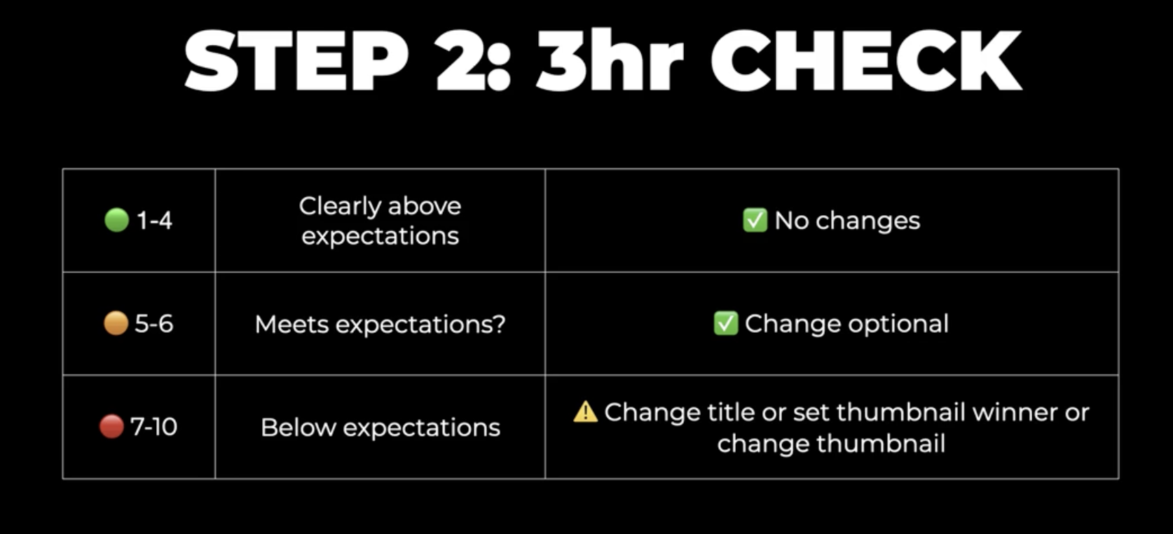

⚠️ At this stage, most impressions are just to fans and return viewers. Don’t panic yet.
Also check RevTrack: sometimes a “views flop” is already your best sales or email video.
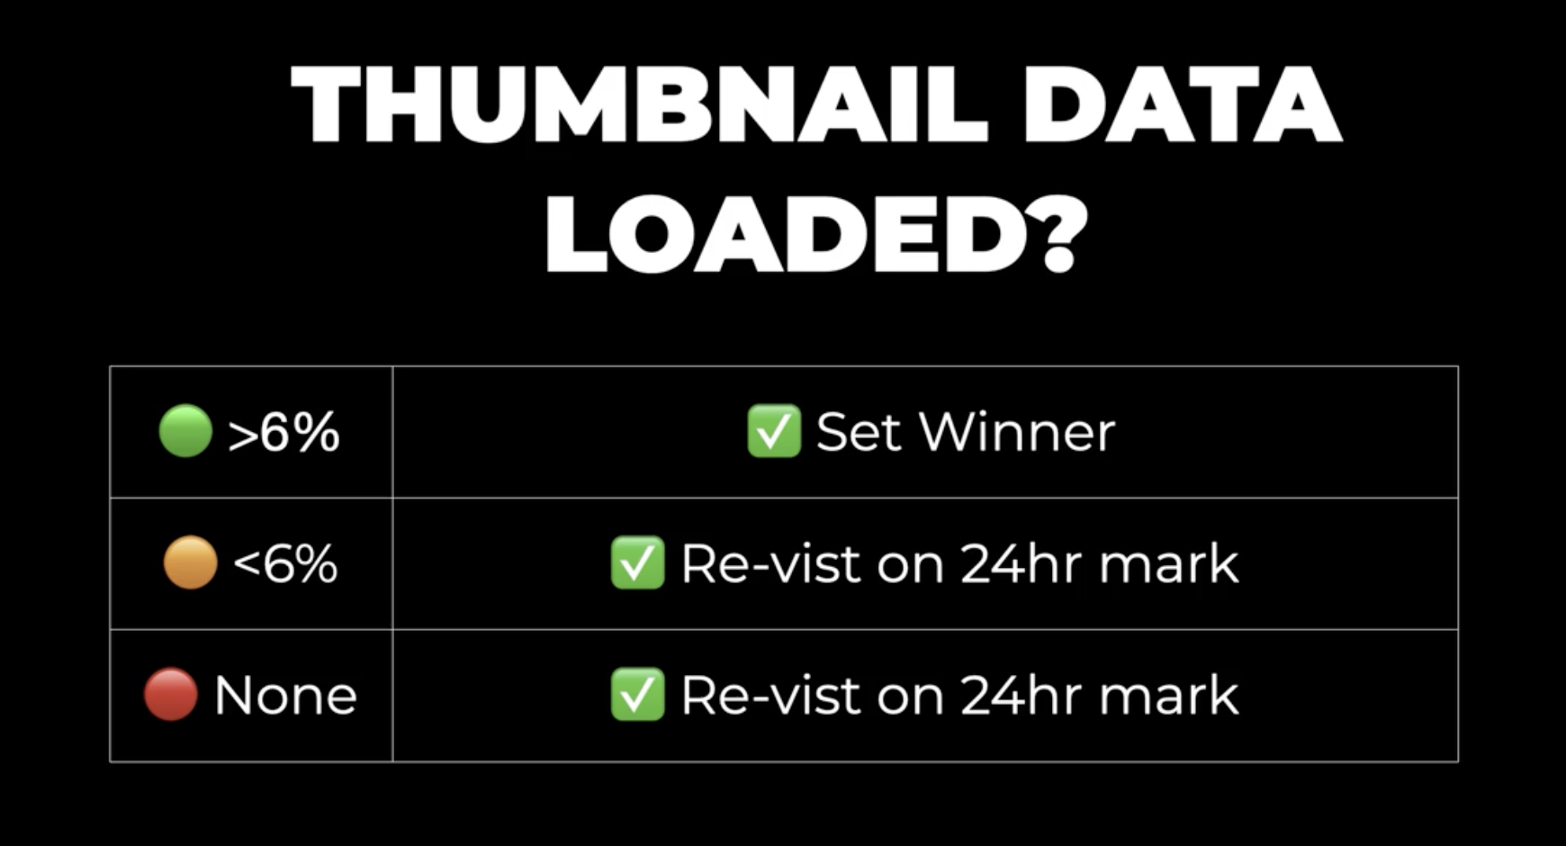

Step 3: The 24-Hour Check
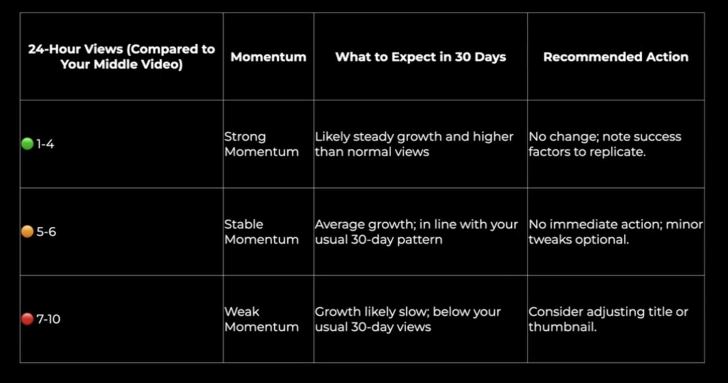
Check RevTrack again: a 7/10 on views might be a 1/10 for business results.

Step 4: The 7-Day Check
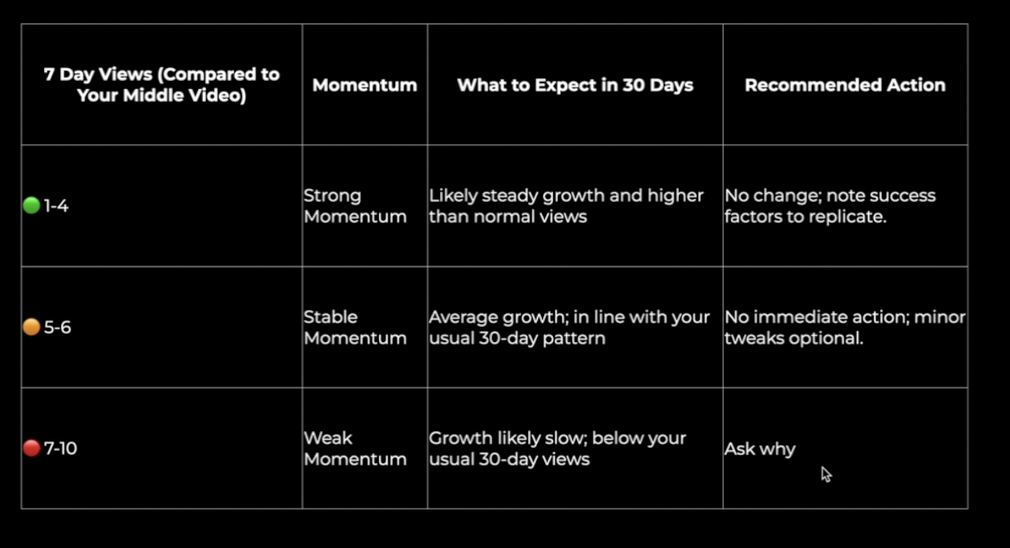
Also look at RevTrack:
- Did it drive clicks?
- Did it collect emails?
- Did it generate sales or calls?
If yes, ignore the view count. This is business growth.

Step 5: The 30-Day Check
Most creators ignore this stage — but it’s where you spot evergreen winners.
- If views are still steady after 30 days → YouTube is showing it to new people. This is gold.
  - Don’t change the thumbnail/title if it’s still pulling.
  - Repeat the same format again.
  - Point more end screens back to it.
- If the video flatlines → that’s normal. Move on.
These evergreen videos quietly grow your channel and business long term.

Final Notes
- Don’t obsess over every stat. Learn one lesson per video
- If above expectations → repeat it.
- If below expectations → ask why and don’t repeat the mistake.
- Use the spreadsheet in the planner to track formats, views, clicks, emails, and sales. Patterns will become clear over time.

Lessons Checklist

Learn A Lesson Checklist
Views
Click me when views don't meet expectations
Click me when views hit expectations
Emails
Click me when emails don't meet expectations
Click me when emails hit expectations
Sales
Click me when sales don't meet expectations
Click me when sales hit expectations
Calls
Click me when calls don't meet expectations
Click me when calls hit expectations

Script prompt “ this video didn't perform could you give me feedback on why

✅ REASONS A VIDEO PERFORMS WELL

🟥 Packaging: Title & Thumbnail
- The title was based on a proven outlier from my channel or another.
- The thumbnail and title worked together to create curiosity ("How," "What," or "Why" structure).
- The topic was based on “viewers loves” and avoided “hates”
- The visual style of the thumbnail resonated with viewers
- The format is proven to be a hit with my viewers already

🟨 First Impressions: Hook & Intro
- The intro immediately matched or exceeded the expectations set by the thumbnail and title.
- The hook tapped into a relatable or urgent problem for the viewer.
- The value of the video was clearly set up early.
- The intro raised credibility so viewers know you’re credible + legit

🟩 Content Structure & Messaging
- The video introduced new, fresh, or unexpected information.
- The content answered a real question viewers were already asking.
- The storytelling was emotionally engaging and unique to you.
- The metaphor or creative device made the content simpler and more memorable.
- The structure built tension and didn't pay things off too early, keeping curiosity high.
- The way the information was delivered matched my viewers’ expectations
- You provided proof your systems and advice works so viewers trust you
- You didn't overwhelm, confuse or over explain.

🟦 Presentation & Editing
- My delivery felt confident, professional, and engaging.
- My pace, tone, and energy were spot on.
- The editing style matched what performs well for my audience (not too slow, not overwhelming).
- The visual format looked clean, polished, and credible.

❌ NEGATIVE REASONS A VIDEO UNDERPERFORMED
🟥 Packaging: Title & Thumbnail
- The title wasn’t modeled on a proven outlier from my channel or another.
- The thumbnail and title didn’t create curiosity (missing “How,” “What,” or “Why” feeling).
- The packaging didn't match what my audience loves.
- The thumbnail looked cluttered or unprofessional.
- The thumbnail caused confusion or was hard to understand quickly.
- The packaging didn’t create a clear click moment.
- The title and thumbnail mismatched the actual content.
- The visual style didn’t resemble what’s worked before.

🟨 First Impressions: Hook & Intro
- The intro didn’t match the expectations set by the thumbnail/title.
- The intro jumped into education too quickly.
- The hook didn’t connect to a strong problem.
- The intro was too wordy or vague.
- The viewer wasn’t told clearly what value they'd get.
- The intro was over 30 seconds

🟩 Content Structure & Messaging
- The content felt generic or repetitive (they’d seen it before).
- The stories told were not unique
- The metaphor or creative device was overcomplicated or confusing.
- The content was too deep or too niche for the average viewer.
- The payoffs were too early and lost retention.
- The points you made weren’t truly relevant to the viewer.
- The transitions didn’t build interest or clearly explain why to keep watching.
- The messaging lacked a clear throughline or takeaway.
- The format used wasn’t interesting or appealing to my audience.

🟦 Presentation & Editing
- Pacing was off, too slow, too fast, or mumbled words.
- Delivery lacked energy or polish.
- The setup looked unprofessional or untrustworthy.
- The editing was too chaotic, flat, or not aligned with my audience's taste.

🟪 Strategic Issues
- The topic wasn’t timely or relevant right now.
- The idea didn’t stand out from similar content in the niche.
- The algorithm didn’t test it (low impressions due to weak packaging).
- I didn’t seed or promote the video effectively.
- You're repositioning my channel (Views will drop)

Emails don't hit your expectations
🟦 Email open rates are low
- You’ve not deleted people from your list who have not opened any emails for over 6 months
- Your emails are not positioned to solve the same problem as subscribers signed up for
- Your headlines are not making people too curious
- Your emails don’t provide enough value to make people want to open the next one you send
- Your emails dont hook people or set up enough value
- Your domain is getting marked as spam (use this tool to check)
- You’re going to the promotion tab (Learn more here)

🟪 Email click through rates are low
- You’re emails are too long (short emails get higher CTR)
- Your emails are not hooking people enough to get to the CTR
- Your links are not highlighted bold or in a colour so they stick out
- You’re giving readers too many options to click

Emails Exceed Your Expectations
🟦 Email open rates are high
- You made them curious by teasing the benefit, not giving it away.
- You stayed relevant by tying the subject to what they care about now.
- You sent it at the right time by matching their daily routines.
- You build trust by always delivering value inside your emails.
- You personalized by using names, segments, or tailored topics.
- You tested by running A/B subject lines instead of guessing.
- You kept it simple with short, clear, punchy subject lines.

🟪 Email click through rates are low
- You made the click irresistible with a strong CTA
- You matched the promise the email copy flowed naturally from the subject line.
- You highlighted one clear action instead of being overwhelmed with choices.
- You used curiosity and benefits so the link felt valuable to click.
- You made it obvious with buttons, bold links, or simple CTAs.
- You kept the email short so the link stood out instead of being buried.
- You built momentum by stacking proof, urgency, or emotion before the CTA.

SALES NOT HITTING EXPECTATIONS

- Your content posted wasn’t positioned in line with your offer
- Your offer wasn’t clear or compelling enough, viewers didn’t see why it was the logical next step.
- Your messaging drifted , you spoke about topics your audience cared about, but they didn’t lead to your product.
- Your sales page headline didn’t grab attention
- Sales page traffic was lower, fewer people even made it into your funnel.
- You attracted the wrong viewers your content pulled in people who weren’t ready or willing to buy.
- You leaned too much on cold traffic — sales dipped because you didn’t warm up enough return viewers.
- You didn’t build enough urgency or proof — people delayed instead of buying now.
- Your CTA was weak or buried — readers weren’t told clearly what to do next.
- You weren’t consistent patchy publishing or email sends meant momentum was lost.
- You reacted too quickly changing things based on one bad video/email instead of monthly trends that blurred the real problem.

📊 Benchmarks for YouTube → Funnel Performance

Conversion Benchmarks
- WARNING” Conversion rates can fluctuate based on traffic quality:
  - Hot Traffic (highly engaged): Closer to the higher end of the range.
  - Cold Traffic (less familiar with you): Closer to the lower end or below
- If your conversion rates are lower than these benchmarks, focus on:
  - Improving CTAs in videos and descriptions.
  - Optimizing your sales and sign-up pages.
  - Aligning content more closely with your audience's needs and your offer.

Use these benchmarks as a guide for measuring success and identifying areas to optimize.

Video link click benchmarks
- Email sign up CTR (video → signup page)
  - 8%+ Exceptional — repeat exactly
  - 5–8% Excellent — repeat exactly
  - 3–5% Above Average — keep going
  - 1–3% Industry Average — move CTA earlier, mention 3+ times, align to topic
  - <1% Needs Immediate Action — CTA in first 90s, repeat 3+ times, reword for relevance
- Sales CTR (video → sales page)
  - 5%+ Rocket — repeat exactly
  - 3–5% Excellent — repeat exactly
  - 1–2% Above Average — check CTA timing/relevance and value before ask
  - <1% Industry Average — add 2× CTAs, align tightly, link at top of description/comments
  - <0.5% Needs Immediate Action — CTA in first 90s, repeat 2+ times, link at top

Sales Page Conversion Benchmarks
- Application-Based Sales Page:
  - Ideal Conversion Rate: 3-5%
  - For every 100 visitors, 3-5% should complete the application/book a call
- Direct Checkout Sales Page:
  - Ideal Conversion Rate: 2%+
  - For every 100 visitors, 2%+ should make a purchase.

3. Email Sign-Up Page Traffic
- Traffic from YouTube to Email Sign-Up:
  - Ideal Conversion Rate: 40-60%
  - For every 100 visitors to your email sign-up page, 40–60 should sign up.

5. Email to Sales Page Clicks
- Ideal Click-Through Rate (CTR): 1-3%
  - For every 100 emails sent, expect 1–5 people to click through to your sales page.

6. Sales Page Conversion (From Email Traffic)
- Ideal Conversion Rate: 10-20%
  - For every 100 email-driven visitors to your sales page, 10–20 should take action (apply or purchase).

Business Tracker
Sales call https://docs.google.com/spreadsheets/d/1jTjVFudseHakJl6e4joDAKlK3f_84lgHHD9eW-Wm5Pw/edit?gid=1988636070#gid=1988636070
No call
https://docs.google.com/spreadsheets/d/1SxTUA7QsgQpf5JyTlKQLCxEZtWIfhSN8TpjFFR8iQsA/edit?gid=358707386#gid=358707386

