Gergely Daróczi
Minimal example for Pandoc.brew

Introduction
We have two meta-information above:
- author
- title
A third field could be there too: date. For details, please check out Pandoc's homepage or just use pandoc.title function of this package.
As you can see writing and formatting paragraphs cannot be easier :)
But what about R? Let us return pi: 3.142

R objects
Pander.brew would transform any returned R object to Pandoc's markdown in each code block.
For example mtcars's first 5 cases look like:
 | mpg | cyl | disp | hp | drat | wt | qsec | vs | am
Mazda RX4 | 21.0 | 6 | 160 | 110 | 3.90 | 2.620 | 16.46 | 0 | 1
Mazda RX4 Wag | 21.0 | 6 | 160 | 110 | 3.90 | 2.875 | 17.02 | 0 | 1
Datsun 710 | 22.8 | 4 | 108 | 93 | 3.85 | 2.320 | 18.61 | 1 | 1
Hornet 4 Drive | 21.4 | 6 | 258 | 110 | 3.08 | 3.215 | 19.44 | 1 | 0
Hornet Sportabout | 18.7 | 8 | 360 | 175 | 3.15 | 3.440 | 17.02 | 0 | 0
Table continues below
 | gear | carb
Mazda RX4 | 4 | 4
Mazda RX4 Wag | 4 | 4
Datsun 710 | 4 | 1
Hornet 4 Drive | 3 | 1
Hornet Sportabout | 3 | 2
As you can see some formatting was added to the returned table and was also split up as the original table would have been too wide to fit on the screen (any panderer still using a VT100 terminal?) or standard paper. If you do not like that split up, just set the according panderOption!
We could try other R objects too, for example let us check chisq.test on some variables of mtcars:
Test statistic | df | P value
20.94 | 2 | * * *
Pearson's Chi-squared test: mtcars$am and mtcars$gear
WARNING
And we got a warning above!

Returning plot
Plots are automatically grabbed between brew tags and some custom formatting applied (if evalsOptions('graph.unify') is set to TRUE):
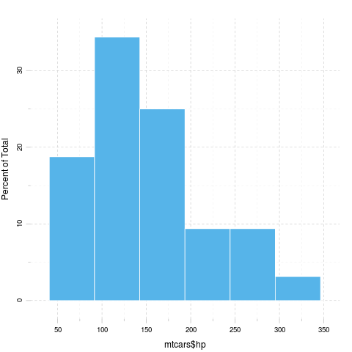
The above lattice looks (IMHO) pretty cool, but what about using base plot?
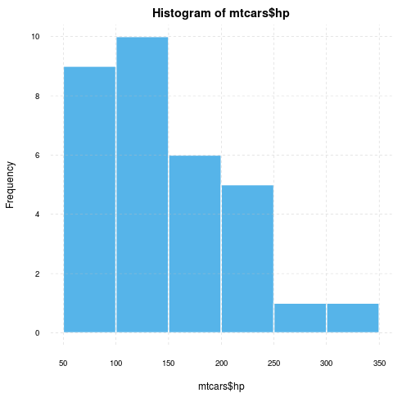 WARNING
This should be quite similar by my intention :)
What about ggplot2?
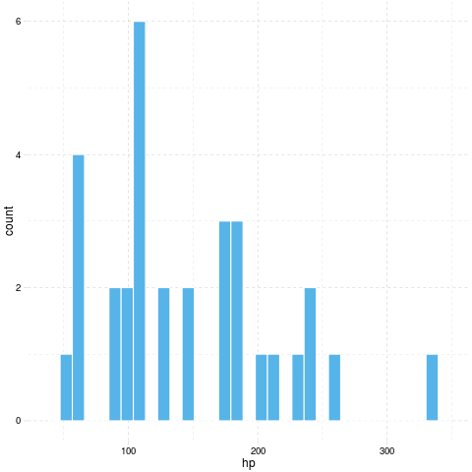
And adding a caption is easy with even some modified panderOptions:
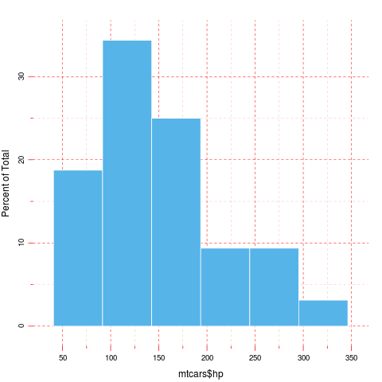

Captions
Just like with tables:
 | Murder | Assault | UrbanPop | Rape
Alabama | 13.2 | 236 | 58 | 21.2
Alaska | 10.0 | 263 | 48 | 44.5
Here goes the first two lines of USArrests

Multiple results
And the chunks can result in multiple R objects of course:
- 1, 2, 3, 4 and 5
- 3.142
- 110, 110, 93, 110, 175, 105, 245, 62, 95, 123, 123, 180, 180, 180, 205, 215, 230, 66, 52, 65, 97, 150, 150, 245, 175, 66, 91, 113, 264, 175, 335 and 109

It happens
ERROR

Chi-squared approximation may be incorrect
Applying default formatting to image is somehow compromised (the result could differ from what you specified in panderOptions). Hints: printing lattice/ggplot2 is not needed and tweaking base plots with par might have some side-effects!
object 'unknown.R.object' not found

