Gergely Daróczi
Looong report
Mon Aug 17 21:32:28 2015
I have written the below report in 10 mins :)

Dataset
Here I will do a pretty fast report on mtcars which is:
 | mpg | cyl | disp | hp | drat | wt | qsec | vs | am
Mazda RX4 | 21.0 | 6 | 160.0 | 110 | 3.90 | 2.620 | 16.46 | 0 | 1
Mazda RX4 Wag | 21.0 | 6 | 160.0 | 110 | 3.90 | 2.875 | 17.02 | 0 | 1
Datsun 710 | 22.8 | 4 | 108.0 | 93 | 3.85 | 2.320 | 18.61 | 1 | 1
Hornet 4 Drive | 21.4 | 6 | 258.0 | 110 | 3.08 | 3.215 | 19.44 | 1 | 0
Hornet Sportabout | 18.7 | 8 | 360.0 | 175 | 3.15 | 3.440 | 17.02 | 0 | 0
Valiant | 18.1 | 6 | 225.0 | 105 | 2.76 | 3.460 | 20.22 | 1 | 0
Duster 360 | 14.3 | 8 | 360.0 | 245 | 3.21 | 3.570 | 15.84 | 0 | 0
Merc 240D | 24.4 | 4 | 146.7 | 62 | 3.69 | 3.190 | 20.00 | 1 | 0
Merc 230 | 22.8 | 4 | 140.8 | 95 | 3.92 | 3.150 | 22.90 | 1 | 0
Merc 280 | 19.2 | 6 | 167.6 | 123 | 3.92 | 3.440 | 18.30 | 1 | 0
Merc 280C | 17.8 | 6 | 167.6 | 123 | 3.92 | 3.440 | 18.90 | 1 | 0
Merc 450SE | 16.4 | 8 | 275.8 | 180 | 3.07 | 4.070 | 17.40 | 0 | 0
Merc 450SL | 17.3 | 8 | 275.8 | 180 | 3.07 | 3.730 | 17.60 | 0 | 0
Merc 450SLC | 15.2 | 8 | 275.8 | 180 | 3.07 | 3.780 | 18.00 | 0 | 0
Cadillac Fleetwood | 10.4 | 8 | 472.0 | 205 | 2.93 | 5.250 | 17.98 | 0 | 0
Lincoln Continental | 10.4 | 8 | 460.0 | 215 | 3.00 | 5.424 | 17.82 | 0 | 0
Chrysler Imperial | 14.7 | 8 | 440.0 | 230 | 3.23 | 5.345 | 17.42 | 0 | 0
Fiat 128 | 32.4 | 4 | 78.7 | 66 | 4.08 | 2.200 | 19.47 | 1 | 1
Honda Civic | 30.4 | 4 | 75.7 | 52 | 4.93 | 1.615 | 18.52 | 1 | 1
Toyota Corolla | 33.9 | 4 | 71.1 | 65 | 4.22 | 1.835 | 19.90 | 1 | 1
Toyota Corona | 21.5 | 4 | 120.1 | 97 | 3.70 | 2.465 | 20.01 | 1 | 0
Dodge Challenger | 15.5 | 8 | 318.0 | 150 | 2.76 | 3.520 | 16.87 | 0 | 0
AMC Javelin | 15.2 | 8 | 304.0 | 150 | 3.15 | 3.435 | 17.30 | 0 | 0
Camaro Z28 | 13.3 | 8 | 350.0 | 245 | 3.73 | 3.840 | 15.41 | 0 | 0
Pontiac Firebird | 19.2 | 8 | 400.0 | 175 | 3.08 | 3.845 | 17.05 | 0 | 0
Fiat X1-9 | 27.3 | 4 | 79.0 | 66 | 4.08 | 1.935 | 18.90 | 1 | 1
Porsche 914-2 | 26.0 | 4 | 120.3 | 91 | 4.43 | 2.140 | 16.70 | 0 | 1
Lotus Europa | 30.4 | 4 | 95.1 | 113 | 3.77 | 1.513 | 16.90 | 1 | 1
Ford Pantera L | 15.8 | 8 | 351.0 | 264 | 4.22 | 3.170 | 14.50 | 0 | 1
Ferrari Dino | 19.7 | 6 | 145.0 | 175 | 3.62 | 2.770 | 15.50 | 0 | 1
Maserati Bora | 15.0 | 8 | 301.0 | 335 | 3.54 | 3.570 | 14.60 | 0 | 1
Volvo 142E | 21.4 | 4 | 121.0 | 109 | 4.11 | 2.780 | 18.60 | 1 | 1
Table continues below
 | gear | carb
Mazda RX4 | 4 | 4
Mazda RX4 Wag | 4 | 4
Datsun 710 | 4 | 1
Hornet 4 Drive | 3 | 1
Hornet Sportabout | 3 | 2
Valiant | 3 | 1
Duster 360 | 3 | 4
Merc 240D | 4 | 2
Merc 230 | 4 | 2
Merc 280 | 4 | 4
Merc 280C | 4 | 4
Merc 450SE | 3 | 3
Merc 450SL | 3 | 3
Merc 450SLC | 3 | 3
Cadillac Fleetwood | 3 | 4
Lincoln Continental | 3 | 4
Chrysler Imperial | 3 | 4
Fiat 128 | 4 | 1
Honda Civic | 4 | 2
Toyota Corolla | 4 | 1
Toyota Corona | 3 | 1
Dodge Challenger | 3 | 2
AMC Javelin | 3 | 2
Camaro Z28 | 3 | 4
Pontiac Firebird | 3 | 2
Fiat X1-9 | 4 | 1
Porsche 914-2 | 5 | 2
Lotus Europa | 5 | 2
Ford Pantera L | 5 | 4
Ferrari Dino | 5 | 6
Maserati Bora | 5 | 8
Volvo 142E | 4 | 2

Descriptives
 | Average | Median | Standard.deviation | Variance
mpg | 20.0906 | 19.200 | 6.0269 | 3.632e+01
cyl | 6.1875 | 6.000 | 1.7859 | 3.190e+00
disp | 230.7219 | 196.300 | 123.9387 | 1.536e+04
hp | 146.6875 | 123.000 | 68.5629 | 4.701e+03
drat | 3.5966 | 3.695 | 0.5347 | 2.859e-01
wt | 3.2172 | 3.325 | 0.9785 | 9.574e-01
qsec | 17.8487 | 17.710 | 1.7869 | 3.193e+00
vs | 0.4375 | 0.000 | 0.5040 | 2.540e-01
am | 0.4062 | 0.000 | 0.4990 | 2.490e-01
gear | 3.6875 | 4.000 | 0.7378 | 5.444e-01
carb | 2.8125 | 2.000 | 1.6152 | 2.609e+00

In details

mpg
We found the folloing values here:
21, 21, 22.8, 21.4, 18.7, 18.1, 14.3, 24.4, 22.8, 19.2, 17.8, 16.4, 17.3, 15.2, 10.4, 10.4, 14.7, 32.4, 30.4, 33.9, 21.5, 15.5, 15.2, 13.3, 19.2, 27.3, 26, 30.4, 15.8, 19.7, 15 and 21.4
The mean of mpg is 20.09 while the standard deviation is: 6.027. The most frequent value in mpg is 10.4, but let us check out the frequency table too:
Internal pander error: Wrong number of parameters (11 instead of *12*) passed: justify while running: table(mtcars[, v])
Please report the issue with a reproducible example to help developers fix this ASAP.
Tables are boring, let us show the same with a histogram:
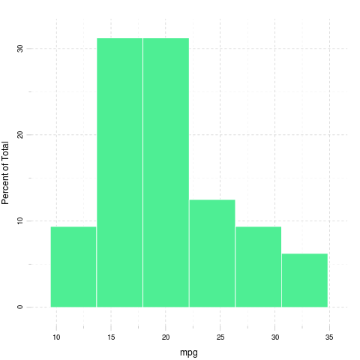

cyl
We found the folloing values here:
6, 6, 4, 6, 8, 6, 8, 4, 4, 6, 6, 8, 8, 8, 8, 8, 8, 4, 4, 4, 4, 8, 8, 8, 8, 4, 4, 4, 8, 6, 8 and 4
The mean of cyl is 6.188 while the standard deviation is: 1.786. The most frequent value in cyl is 8, but let us check out the frequency table too:
4 | 6 | 8
11 | 7 | 14
Tables are boring, let us show the same with a histogram:
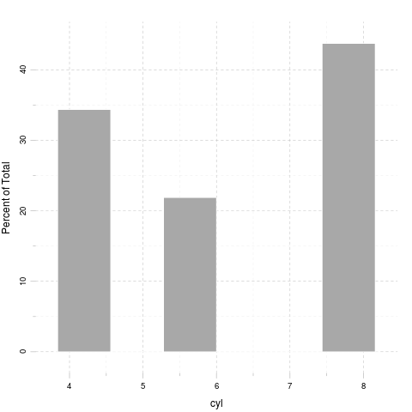

disp
We found the folloing values here:
160, 160, 108, 258, 360, 225, 360, 146.7, 140.8, 167.6, 167.6, 275.8, 275.8, 275.8, 472, 460, 440, 78.7, 75.7, 71.1, 120.1, 318, 304, 350, 400, 79, 120.3, 95.1, 351, 145, 301 and 121
The mean of disp is 230.7 while the standard deviation is: 123.9. The most frequent value in disp is 275.8, but let us check out the frequency table too:
Internal pander error: Wrong number of parameters (11 instead of *12*) passed: justify while running: table(mtcars[, v])
Please report the issue with a reproducible example to help developers fix this ASAP.
Tables are boring, let us show the same with a histogram:
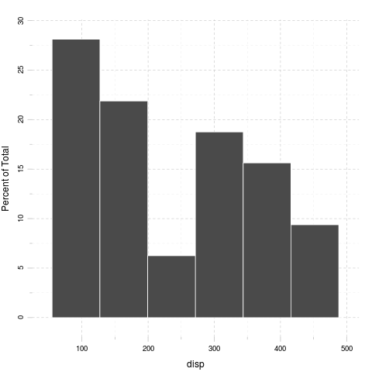

hp
We found the folloing values here:
110, 110, 93, 110, 175, 105, 245, 62, 95, 123, 123, 180, 180, 180, 205, 215, 230, 66, 52, 65, 97, 150, 150, 245, 175, 66, 91, 113, 264, 175, 335 and 109
The mean of hp is 146.7 while the standard deviation is: 68.56. The most frequent value in hp is 110, but let us check out the frequency table too:
Internal pander error: Wrong number of parameters (14 instead of *15*) passed: justify while running: table(mtcars[, v])
Please report the issue with a reproducible example to help developers fix this ASAP.
Tables are boring, let us show the same with a histogram:
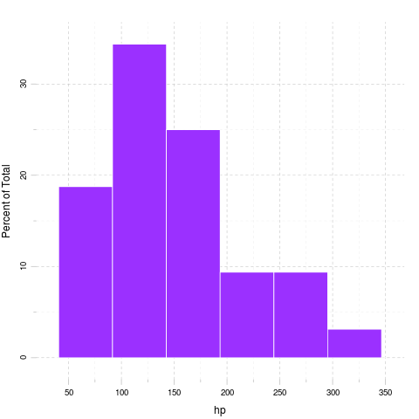

drat
We found the folloing values here:
3.9, 3.9, 3.85, 3.08, 3.15, 2.76, 3.21, 3.69, 3.92, 3.92, 3.92, 3.07, 3.07, 3.07, 2.93, 3, 3.23, 4.08, 4.93, 4.22, 3.7, 2.76, 3.15, 3.73, 3.08, 4.08, 4.43, 3.77, 4.22, 3.62, 3.54 and 4.11
The mean of drat is 3.597 while the standard deviation is: 0.5347. The most frequent value in drat is 3.07, but let us check out the frequency table too:
Internal pander error: Wrong number of parameters (12 instead of *13*) passed: justify while running: table(mtcars[, v])
Please report the issue with a reproducible example to help developers fix this ASAP.
Tables are boring, let us show the same with a histogram:
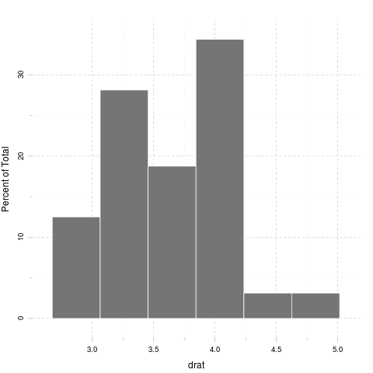

wt
We found the folloing values here:
2.62, 2.875, 2.32, 3.215, 3.44, 3.46, 3.57, 3.19, 3.15, 3.44, 3.44, 4.07, 3.73, 3.78, 5.25, 5.424, 5.345, 2.2, 1.615, 1.835, 2.465, 3.52, 3.435, 3.84, 3.845, 1.935, 2.14, 1.513, 3.17, 2.77, 3.57 and 2.78
The mean of wt is 3.217 while the standard deviation is: 0.9785. The most frequent value in wt is 3.44, but let us check out the frequency table too:
Internal pander error: Wrong number of parameters (11 instead of *12*) passed: justify while running: table(mtcars[, v])
Please report the issue with a reproducible example to help developers fix this ASAP.
Tables are boring, let us show the same with a histogram:
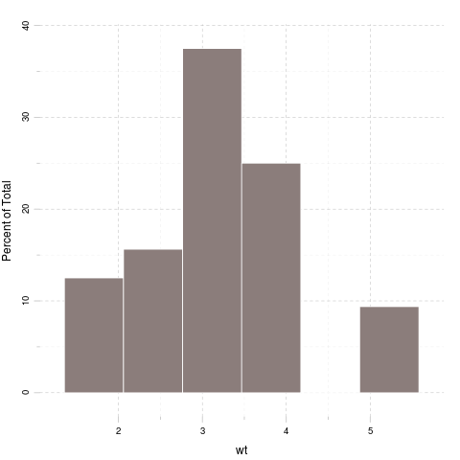

qsec
We found the folloing values here:
16.46, 17.02, 18.61, 19.44, 17.02, 20.22, 15.84, 20, 22.9, 18.3, 18.9, 17.4, 17.6, 18, 17.98, 17.82, 17.42, 19.47, 18.52, 19.9, 20.01, 16.87, 17.3, 15.41, 17.05, 18.9, 16.7, 16.9, 14.5, 15.5, 14.6 and 18.6
The mean of qsec is 17.85 while the standard deviation is: 1.787. The most frequent value in qsec is 17.02, but let us check out the frequency table too:
Internal pander error: Wrong number of parameters (10 instead of *11*) passed: justify while running: table(mtcars[, v])
Please report the issue with a reproducible example to help developers fix this ASAP.
Tables are boring, let us show the same with a histogram:
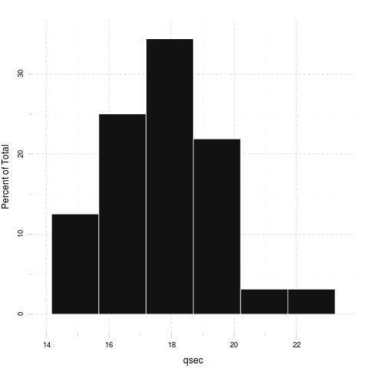

vs
We found the folloing values here:
0, 0, 1, 1, 0, 1, 0, 1, 1, 1, 1, 0, 0, 0, 0, 0, 0, 1, 1, 1, 1, 0, 0, 0, 0, 1, 0, 1, 0, 0, 0 and 1
The mean of vs is 0.4375 while the standard deviation is: 0.504. The most frequent value in vs is 0, but let us check out the frequency table too:
0 | 1
18 | 14
Tables are boring, let us show the same with a histogram:
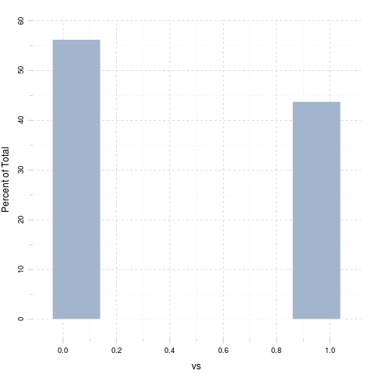

am
We found the folloing values here:
1, 1, 1, 0, 0, 0, 0, 0, 0, 0, 0, 0, 0, 0, 0, 0, 0, 1, 1, 1, 0, 0, 0, 0, 0, 1, 1, 1, 1, 1, 1 and 1
The mean of am is 0.4062 while the standard deviation is: 0.499. The most frequent value in am is 0, but let us check out the frequency table too:
0 | 1
19 | 13
Tables are boring, let us show the same with a histogram:
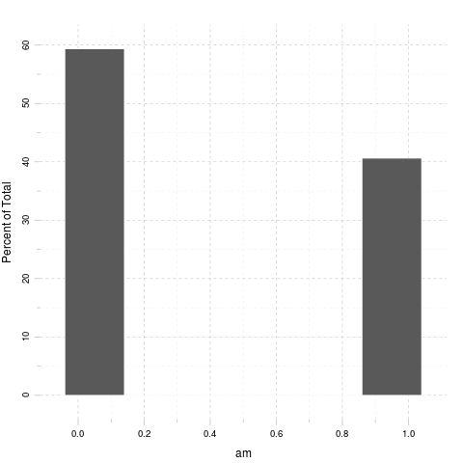

gear
We found the folloing values here:
4, 4, 4, 3, 3, 3, 3, 4, 4, 4, 4, 3, 3, 3, 3, 3, 3, 4, 4, 4, 3, 3, 3, 3, 3, 4, 5, 5, 5, 5, 5 and 4
The mean of gear is 3.688 while the standard deviation is: 0.7378. The most frequent value in gear is 3, but let us check out the frequency table too:
3 | 4 | 5
15 | 12 | 5
Tables are boring, let us show the same with a histogram:
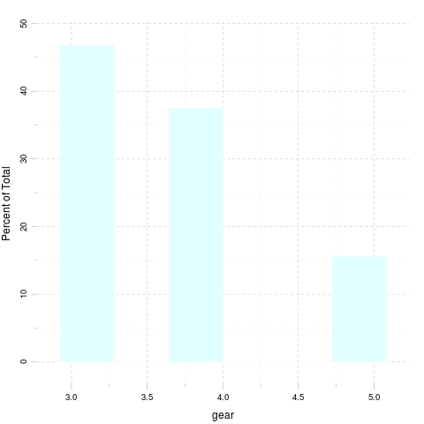

carb
We found the folloing values here:
4, 4, 1, 1, 2, 1, 4, 2, 2, 4, 4, 3, 3, 3, 4, 4, 4, 1, 2, 1, 1, 2, 2, 4, 2, 1, 2, 2, 4, 6, 8 and 2
The mean of carb is 2.812 while the standard deviation is: 1.615. The most frequent value in carb is 2, but let us check out the frequency table too:
1 | 2 | 3 | 4 | 6 | 8
7 | 10 | 3 | 10 | 1 | 1
Tables are boring, let us show the same with a histogram:
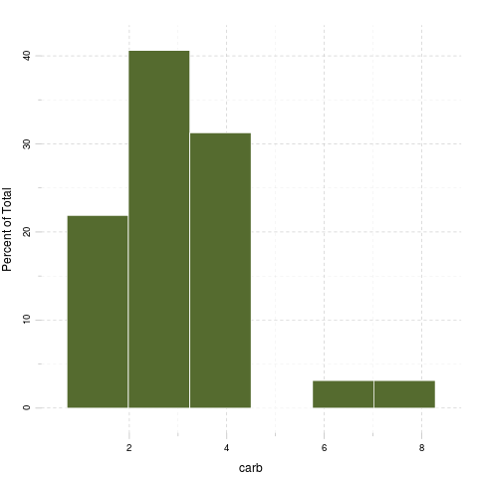

Correlation
And here goes a correlation table:
 | mpg | cyl | disp | hp | drat | wt | qsec | vs
mpg | 1.0000 | -0.8522 | -0.8476 | -0.7762 | 0.68117 | -0.8677 | 0.4187 | 0.6640
cyl | -0.8522 | 1.0000 | 0.9020 | 0.8324 | -0.69994 | 0.7825 | -0.5912 | -0.8108
disp | -0.8476 | 0.9020 | 1.0000 | 0.7909 | -0.71021 | 0.8880 | -0.4337 | -0.7104
hp | -0.7762 | 0.8324 | 0.7909 | 1.0000 | -0.44876 | 0.6587 | -0.7082 | -0.7231
drat | 0.6812 | -0.6999 | -0.7102 | -0.4488 | 1.00000 | -0.7124 | 0.0912 | 0.4403
wt | -0.8677 | 0.7825 | 0.8880 | 0.6587 | -0.71244 | 1.0000 | -0.1747 | -0.5549
qsec | 0.4187 | -0.5912 | -0.4337 | -0.7082 | 0.09120 | -0.1747 | 1.0000 | 0.7445
vs | 0.6640 | -0.8108 | -0.7104 | -0.7231 | 0.44028 | -0.5549 | 0.7445 | 1.0000
am | 0.5998 | -0.5226 | -0.5912 | -0.2432 | 0.71271 | -0.6925 | -0.2299 | 0.1683
gear | 0.4803 | -0.4927 | -0.5556 | -0.1257 | 0.69961 | -0.5833 | -0.2127 | 0.2060
carb | -0.5509 | 0.5270 | 0.3950 | 0.7498 | -0.09079 | 0.4276 | -0.6562 | -0.5696
Table continues below
 | am | gear | carb
mpg | 0.59983 | 0.4803 | -0.55093
cyl | -0.52261 | -0.4927 | 0.52699
disp | -0.59123 | -0.5556 | 0.39498
hp | -0.24320 | -0.1257 | 0.74981
drat | 0.71271 | 0.6996 | -0.09079
wt | -0.69250 | -0.5833 | 0.42761
qsec | -0.22986 | -0.2127 | -0.65625
vs | 0.16835 | 0.2060 | -0.56961
am | 1.00000 | 0.7941 | 0.05753
gear | 0.79406 | 1.0000 | 0.27407
carb | 0.05753 | 0.2741 | 1.00000
And the same on a graph:
Yeah, that latter took a while to render in an image file :)
That's not a pander issue.

Some models
Okay, let us find out how weight affects other variables:

mpg
A simple linear model: mtcars$wt ~ mtcars$mpg
 | Estimate | Std. Error | t value | Pr(>|t|)
Independent | -0.1409 | 0.01474 | -9.559 | 1.294e-10
(Intercept) | 6.0473 | 0.30869 | 19.590 | 1.204e-18
Fitting linear model: mtcars$wt ~ Independent

cyl
A simple linear model: mtcars$wt ~ mtcars$cyl
 | Estimate | Std. Error | t value | Pr(>|t|)
Independent | 0.4287 | 0.06228 | 6.883 | 1.218e-07
(Intercept) | 0.5646 | 0.40062 | 1.409 | 1.690e-01
Fitting linear model: mtcars$wt ~ Independent

disp
A simple linear model: mtcars$wt ~ mtcars$disp
 | Estimate | Std. Error | t value | Pr(>|t|)
Independent | 0.00701 | 0.0006629 | 10.576 | 1.222e-11
(Intercept) | 1.59981 | 0.1729964 | 9.248 | 2.738e-10
Fitting linear model: mtcars$wt ~ Independent

hp
A simple linear model: mtcars$wt ~ mtcars$hp
 | Estimate | Std. Error | t value | Pr(>|t|)
Independent | 0.009401 | 0.00196 | 4.796 | 4.146e-05
(Intercept) | 1.838247 | 0.31652 | 5.808 | 2.389e-06
Fitting linear model: mtcars$wt ~ Independent

drat
A simple linear model: mtcars$wt ~ mtcars$drat
 | Estimate | Std. Error | t value | Pr(>|t|)
Independent | -1.304 | 0.2345 | -5.561 | 4.784e-06
(Intercept) | 7.906 | 0.8522 | 9.277 | 2.547e-10
Fitting linear model: mtcars$wt ~ Independent

qsec
A simple linear model: mtcars$wt ~ mtcars$qsec
 | Estimate | Std. Error | t value | Pr(>|t|)
Independent | -0.09567 | 0.09843 | -0.9719 | 0.338868
(Intercept) | 4.92479 | 1.76541 | 2.7896 | 0.009081
Fitting linear model: mtcars$wt ~ Independent

vs
A simple linear model: mtcars$wt ~ mtcars$vs
 | Estimate | Std. Error | t value | Pr(>|t|)
Independent | -1.077 | 0.2949 | -3.654 | 9.798e-04
(Intercept) | 3.689 | 0.1950 | 18.913 | 3.203e-18
Fitting linear model: mtcars$wt ~ Independent

am
A simple linear model: mtcars$wt ~ mtcars$am
 | Estimate | Std. Error | t value | Pr(>|t|)
Independent | -1.358 | 0.2583 | -5.258 | 1.125e-05
(Intercept) | 3.769 | 0.1646 | 22.895 | 1.490e-20
Fitting linear model: mtcars$wt ~ Independent

gear
A simple linear model: mtcars$wt ~ mtcars$gear
 | Estimate | Std. Error | t value | Pr(>|t|)
Independent | -0.7735 | 0.1967 | -3.933 | 4.587e-04
(Intercept) | 6.0697 | 0.7392 | 8.212 | 3.632e-09
Fitting linear model: mtcars$wt ~ Independent

carb
A simple linear model: mtcars$wt ~ mtcars$carb
 | Estimate | Std. Error | t value | Pr(>|t|)
Independent | 0.259 | 0.09998 | 2.591 | 1.464e-02
(Intercept) | 2.489 | 0.32300 | 7.705 | 1.353e-08
Fitting linear model: mtcars$wt ~ Independent

