Gergely Daróczi

Unified plots

This document demonstrates the features of unifying plots in pander. First, if you do not want to deal with styling each of your images, just activate it: evalsOptions('graph.unify', TRUE).

*Note*: please install lattice and ggplot2 on your computer prior to trying to run all examples of this document.

# Options

There are a bunch of options you might want to check out, these are:

* graph.nomargin
* graph.fontfamily
* graph.fontcolor
* graph.fontsize
* graph.grid
* graph.grid.minor
* graph.grid.color
* graph.grid.lty
* graph.boxes
* graph.legend.position
* graph.background
* graph.panel.background
* graph.colors
* graph.color.rnd
* graph.axis.angle
* graph.symbol

Find more details on [pander's homepage](http://rapporter.github.com/pander/#pander-options).

# Default options

Not touching the above ones, let us check out how different plots look like by calling base R graphing function, lattice or ggplot2!

## Histogram

### Base R plot

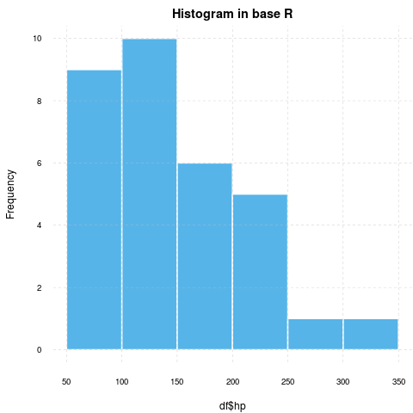 **WARNING**[1]

### lattice

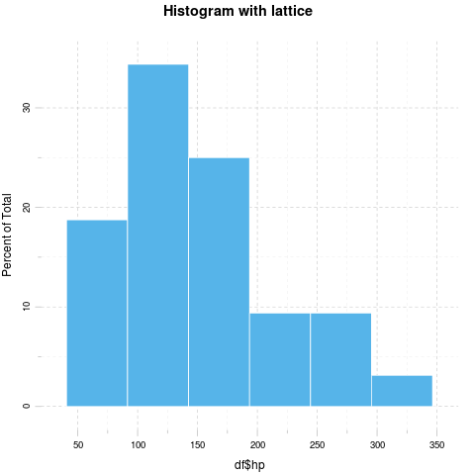

### ggplot2

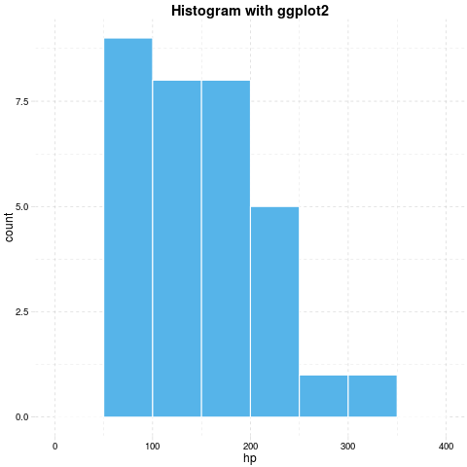

## Barplot

### Base R plot

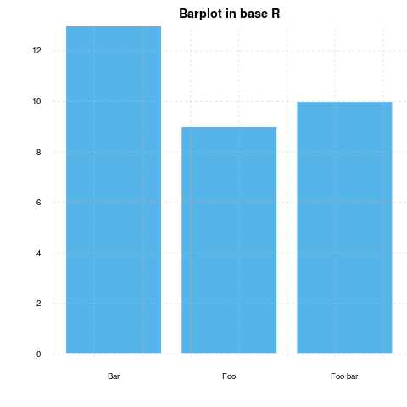 **WARNING**[2]

### lattice

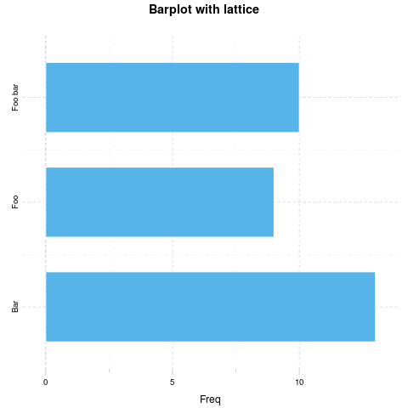

### ggplot2

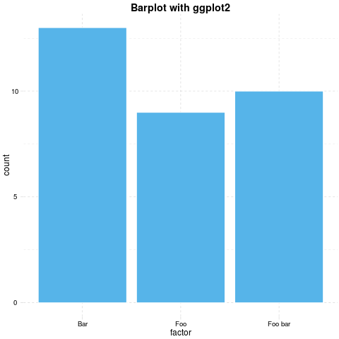

## Points

### Base R plot

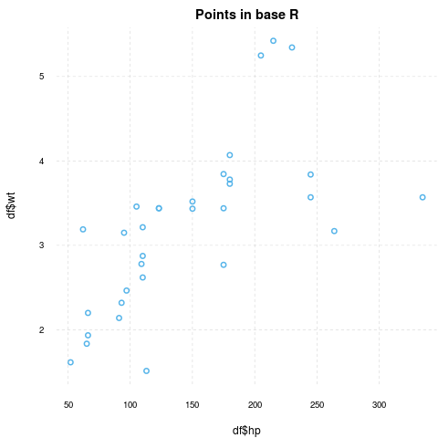 **WARNING**[3]

### lattice

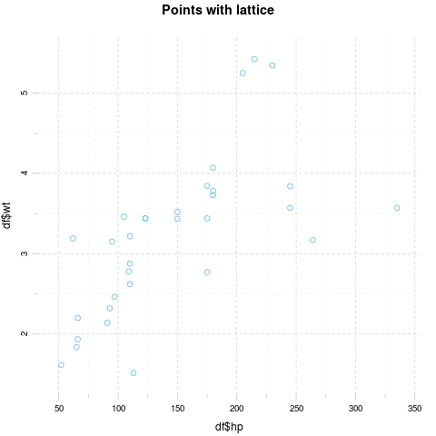

### ggplot2

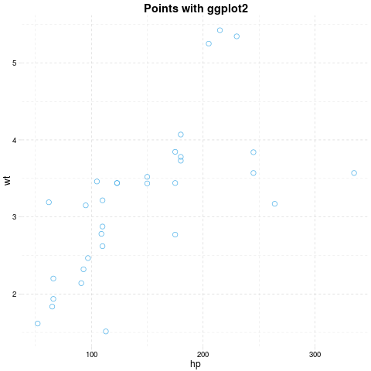

## Grouped plot

### Base R plot

I have no idea how to do that besides manually adding points.

### lattice

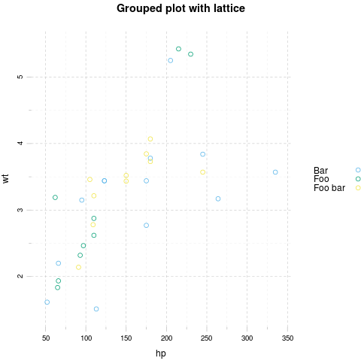

### ggplot2

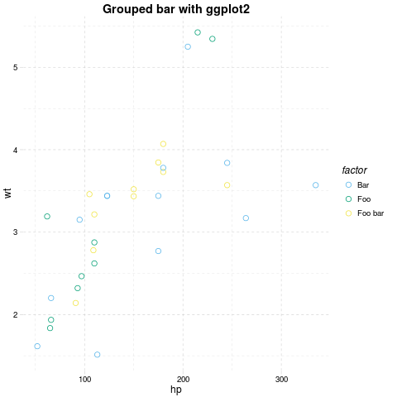

## Facets

### Base R plot

I have no idea how to do that besides par(mfrow=c(foo, bar)).

### lattice

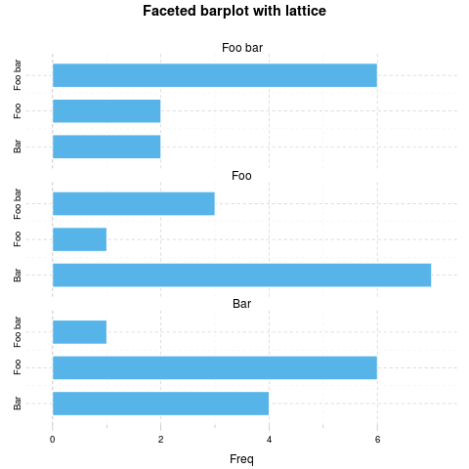

### ggplot2

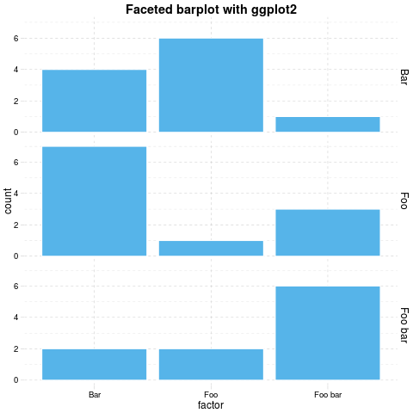

## Boxplot

### Base R plot

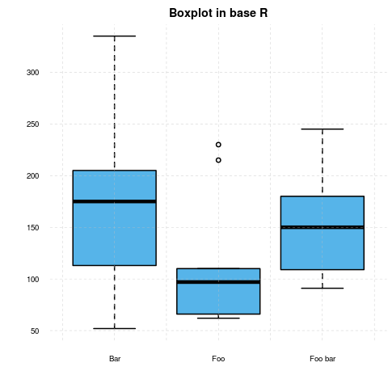 **WARNING**[4]

### lattice

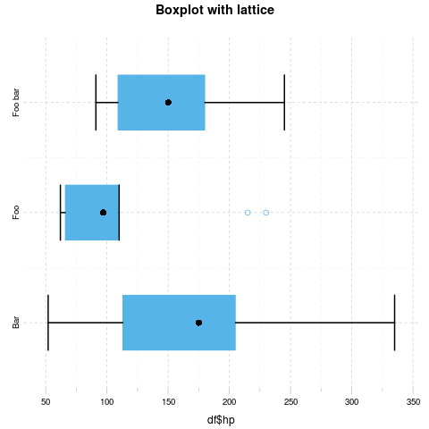

### ggplot2

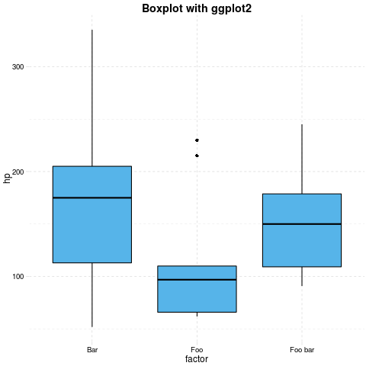

## Lines

### Base R plot

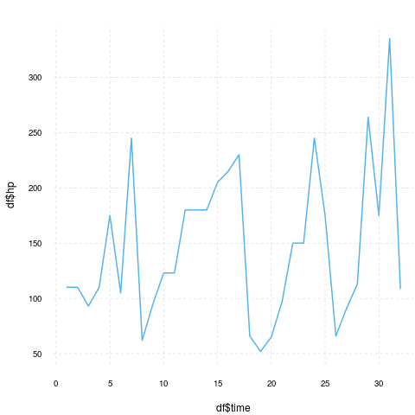 **WARNING**[5]

### lattice

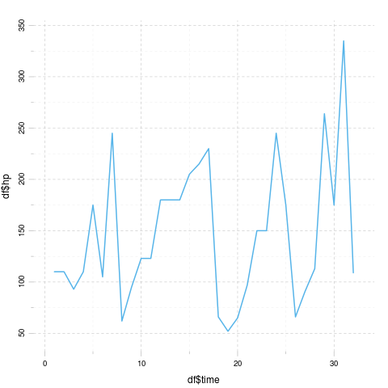

### ggplot2

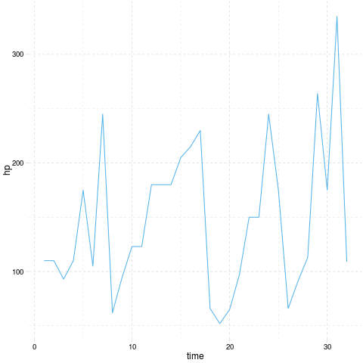

# Custom options

Below you can find some images generated by the exact same commands but with some modified panderOptions:

panderOptions('graph.fontfamily', "Comic Sans MS")  
panderOptions('graph.fontsize', 18)  
panderOptions('graph.fontcolor', 'blue')  
panderOptions('graph.grid.color', 'blue')  
panderOptions('graph.axis.angle', 3)  
panderOptions('graph.boxes', T)  
panderOptions('graph.legend.position', 'top')  
panderOptions('graph.colors', rainbow(5))  
panderOptions('graph.grid', FALSE)  
panderOptions('graph.symbol', 22)

## Histogram

### Base R plot

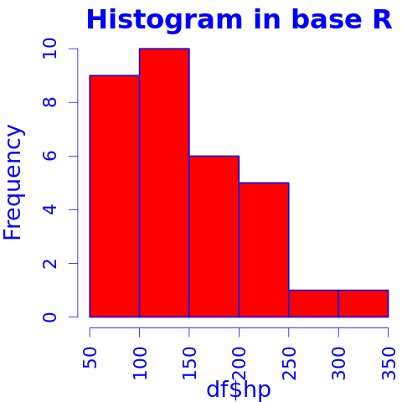

### lattice

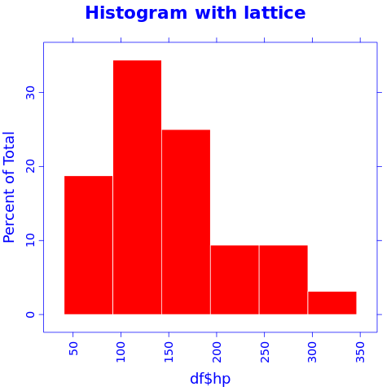

### ggplot2

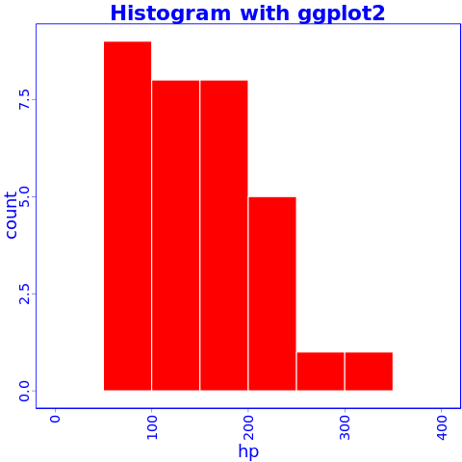

## Barplot

### Base R plot

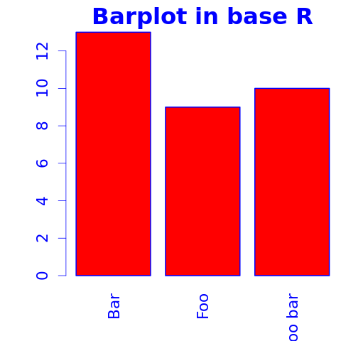

Yeah, the "Foo bar" label is cropped. We need a custom mar option here:



But wait, we lost the color! Right: unfortunately coloring base R plots is really hackish, pander is adding the col attribute to the calls. If you start to tweak par in a chunk, you should prepare to some unwanted side-effects. Solution:



### lattice

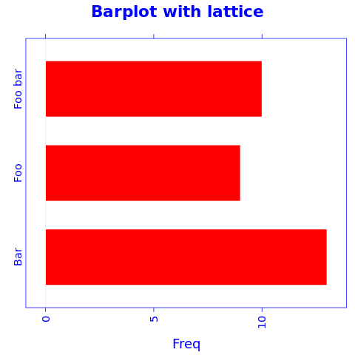

### ggplot2

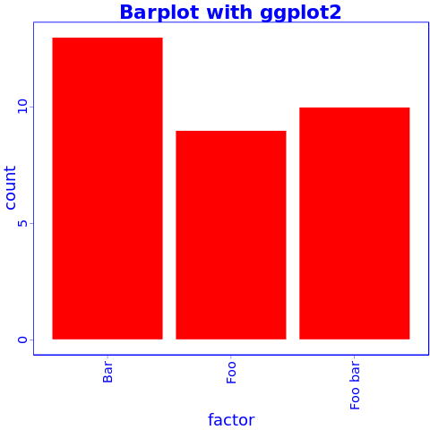

## Points

### Base R plot

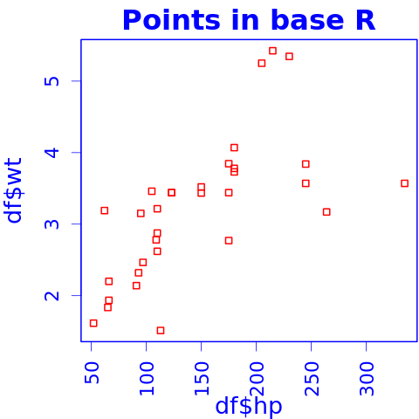

### lattice

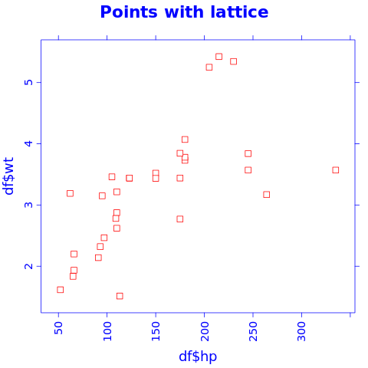

### ggplot2

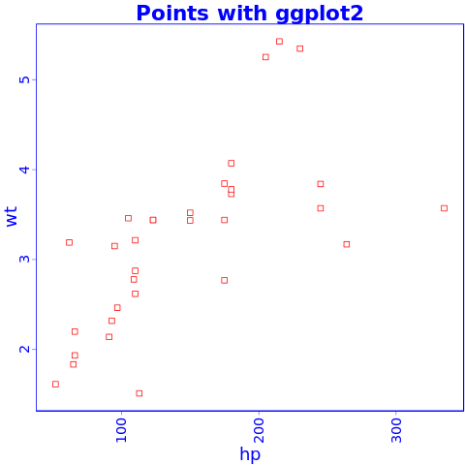

## Grouped plot

### Base R plot

I have no idea how to do that besides manually adding points.

### lattice

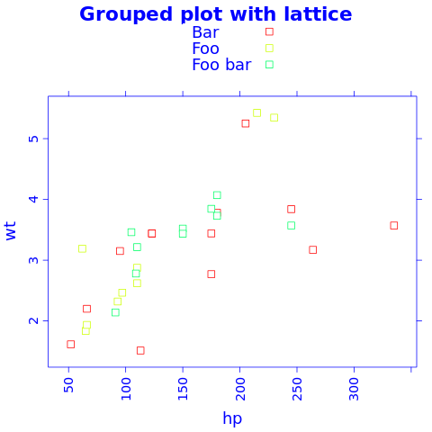

### ggplot2

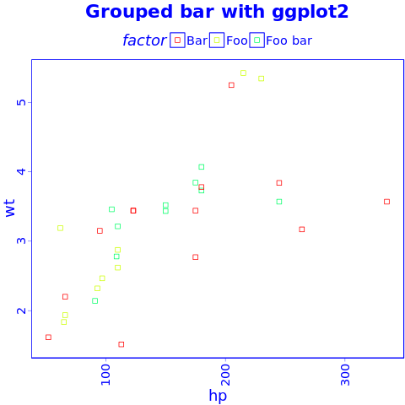

## Facets

### Base R plot

I have no idea how to do that besides par(mfrow=c(foo, bar)).

### lattice

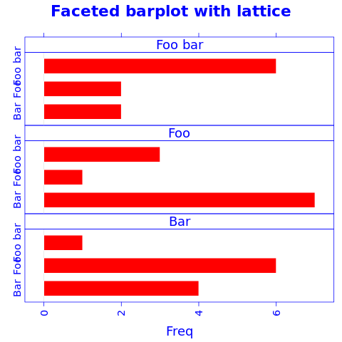

### ggplot2

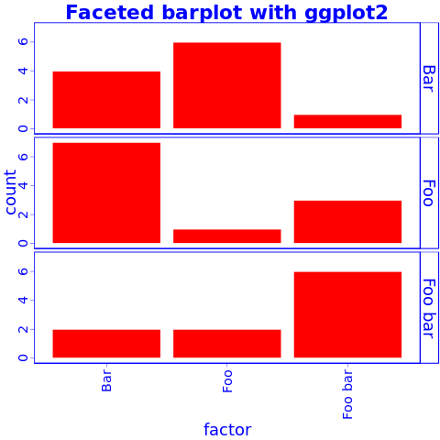

## Boxplot

### Base R plot

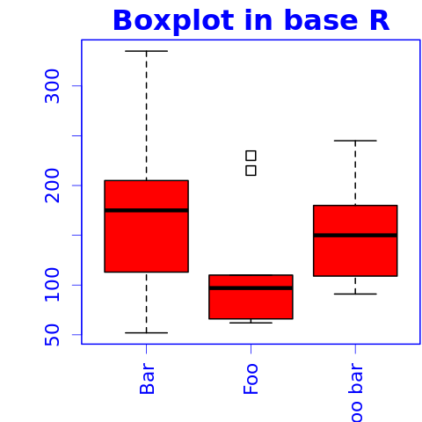

### lattice

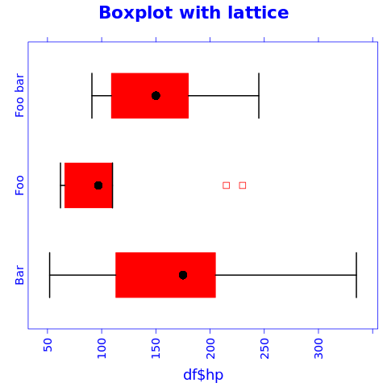

### ggplot2

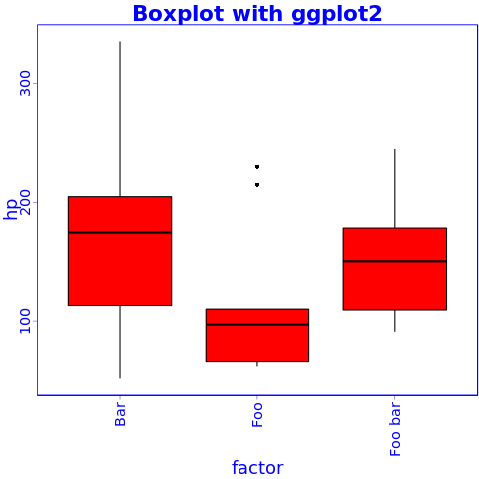

## Lines

### Base R plot

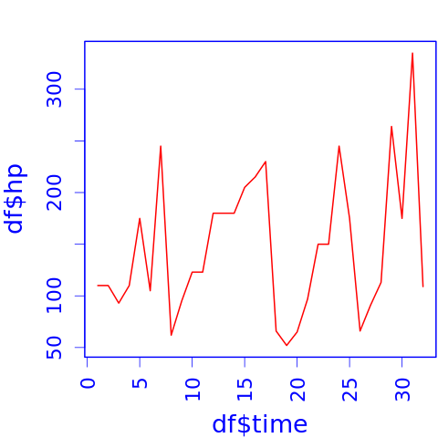

### lattice

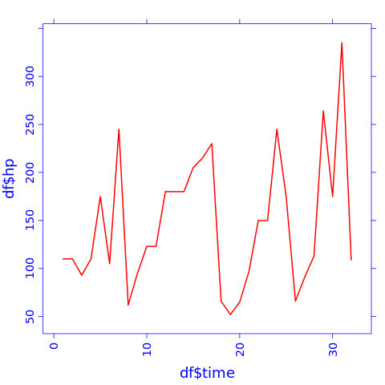

### ggplot2

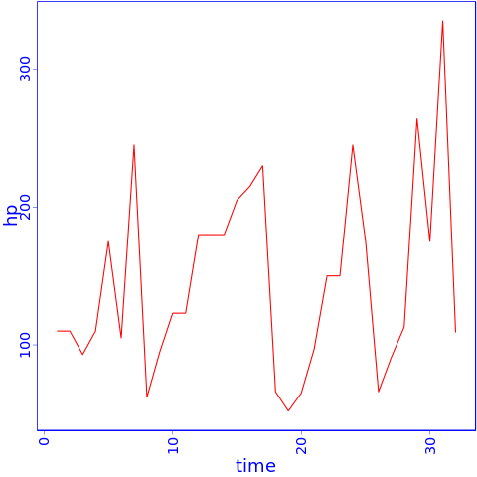

1. Applying default formatting to image is somehow compromised (the result could differ from what you specified in panderOptions). Hints: printing lattice/ggplot2 is not needed and tweaking base plots with par might have some side-effects!
2. Applying default formatting to image is somehow compromised (the result could differ from what you specified in panderOptions). Hints: printing lattice/ggplot2 is not needed and tweaking base plots with par might have some side-effects!
3. Applying default formatting to image is somehow compromised (the result could differ from what you specified in panderOptions). Hints: printing lattice/ggplot2 is not needed and tweaking base plots with par might have some side-effects!
4. Applying default formatting to image is somehow compromised (the result could differ from what you specified in panderOptions). Hints: printing lattice/ggplot2 is not needed and tweaking base plots with par might have some side-effects!
5. Applying default formatting to image is somehow compromised (the result could differ from what you specified in panderOptions). Hints: printing lattice/ggplot2 is not needed and tweaking base plots with par might have some side-effects!