Gergely Daróczi

Looong report

Mon Aug 17 21:32:28 2015

I have written the below report in 10 mins :)

# Dataset

Here I will do a pretty fast report on mtcars which is:

|  |  |  |  |  |  |  |  |  |  |
| --- | --- | --- | --- | --- | --- | --- | --- | --- | --- |
|  | mpg | cyl | disp | hp | drat | wt | qsec | vs | am |
| **Mazda RX4** | 21.0 | 6 | 160.0 | 110 | 3.90 | 2.620 | 16.46 | 0 | 1 |
| **Mazda RX4 Wag** | 21.0 | 6 | 160.0 | 110 | 3.90 | 2.875 | 17.02 | 0 | 1 |
| **Datsun 710** | 22.8 | 4 | 108.0 | 93 | 3.85 | 2.320 | 18.61 | 1 | 1 |
| **Hornet 4 Drive** | 21.4 | 6 | 258.0 | 110 | 3.08 | 3.215 | 19.44 | 1 | 0 |
| **Hornet Sportabout** | 18.7 | 8 | 360.0 | 175 | 3.15 | 3.440 | 17.02 | 0 | 0 |
| **Valiant** | 18.1 | 6 | 225.0 | 105 | 2.76 | 3.460 | 20.22 | 1 | 0 |
| **Duster 360** | 14.3 | 8 | 360.0 | 245 | 3.21 | 3.570 | 15.84 | 0 | 0 |
| **Merc 240D** | 24.4 | 4 | 146.7 | 62 | 3.69 | 3.190 | 20.00 | 1 | 0 |
| **Merc 230** | 22.8 | 4 | 140.8 | 95 | 3.92 | 3.150 | 22.90 | 1 | 0 |
| **Merc 280** | 19.2 | 6 | 167.6 | 123 | 3.92 | 3.440 | 18.30 | 1 | 0 |
| **Merc 280C** | 17.8 | 6 | 167.6 | 123 | 3.92 | 3.440 | 18.90 | 1 | 0 |
| **Merc 450SE** | 16.4 | 8 | 275.8 | 180 | 3.07 | 4.070 | 17.40 | 0 | 0 |
| **Merc 450SL** | 17.3 | 8 | 275.8 | 180 | 3.07 | 3.730 | 17.60 | 0 | 0 |
| **Merc 450SLC** | 15.2 | 8 | 275.8 | 180 | 3.07 | 3.780 | 18.00 | 0 | 0 |
| **Cadillac Fleetwood** | 10.4 | 8 | 472.0 | 205 | 2.93 | 5.250 | 17.98 | 0 | 0 |
| **Lincoln Continental** | 10.4 | 8 | 460.0 | 215 | 3.00 | 5.424 | 17.82 | 0 | 0 |
| **Chrysler Imperial** | 14.7 | 8 | 440.0 | 230 | 3.23 | 5.345 | 17.42 | 0 | 0 |
| **Fiat 128** | 32.4 | 4 | 78.7 | 66 | 4.08 | 2.200 | 19.47 | 1 | 1 |
| **Honda Civic** | 30.4 | 4 | 75.7 | 52 | 4.93 | 1.615 | 18.52 | 1 | 1 |
| **Toyota Corolla** | 33.9 | 4 | 71.1 | 65 | 4.22 | 1.835 | 19.90 | 1 | 1 |
| **Toyota Corona** | 21.5 | 4 | 120.1 | 97 | 3.70 | 2.465 | 20.01 | 1 | 0 |
| **Dodge Challenger** | 15.5 | 8 | 318.0 | 150 | 2.76 | 3.520 | 16.87 | 0 | 0 |
| **AMC Javelin** | 15.2 | 8 | 304.0 | 150 | 3.15 | 3.435 | 17.30 | 0 | 0 |
| **Camaro Z28** | 13.3 | 8 | 350.0 | 245 | 3.73 | 3.840 | 15.41 | 0 | 0 |
| **Pontiac Firebird** | 19.2 | 8 | 400.0 | 175 | 3.08 | 3.845 | 17.05 | 0 | 0 |
| **Fiat X1-9** | 27.3 | 4 | 79.0 | 66 | 4.08 | 1.935 | 18.90 | 1 | 1 |
| **Porsche 914-2** | 26.0 | 4 | 120.3 | 91 | 4.43 | 2.140 | 16.70 | 0 | 1 |
| **Lotus Europa** | 30.4 | 4 | 95.1 | 113 | 3.77 | 1.513 | 16.90 | 1 | 1 |
| **Ford Pantera L** | 15.8 | 8 | 351.0 | 264 | 4.22 | 3.170 | 14.50 | 0 | 1 |
| **Ferrari Dino** | 19.7 | 6 | 145.0 | 175 | 3.62 | 2.770 | 15.50 | 0 | 1 |
| **Maserati Bora** | 15.0 | 8 | 301.0 | 335 | 3.54 | 3.570 | 14.60 | 0 | 1 |
| **Volvo 142E** | 21.4 | 4 | 121.0 | 109 | 4.11 | 2.780 | 18.60 | 1 | 1 |

Table continues below

|  |  |  |
| --- | --- | --- |
|  | gear | carb |
| **Mazda RX4** | 4 | 4 |
| **Mazda RX4 Wag** | 4 | 4 |
| **Datsun 710** | 4 | 1 |
| **Hornet 4 Drive** | 3 | 1 |
| **Hornet Sportabout** | 3 | 2 |
| **Valiant** | 3 | 1 |
| **Duster 360** | 3 | 4 |
| **Merc 240D** | 4 | 2 |
| **Merc 230** | 4 | 2 |
| **Merc 280** | 4 | 4 |
| **Merc 280C** | 4 | 4 |
| **Merc 450SE** | 3 | 3 |
| **Merc 450SL** | 3 | 3 |
| **Merc 450SLC** | 3 | 3 |
| **Cadillac Fleetwood** | 3 | 4 |
| **Lincoln Continental** | 3 | 4 |
| **Chrysler Imperial** | 3 | 4 |
| **Fiat 128** | 4 | 1 |
| **Honda Civic** | 4 | 2 |
| **Toyota Corolla** | 4 | 1 |
| **Toyota Corona** | 3 | 1 |
| **Dodge Challenger** | 3 | 2 |
| **AMC Javelin** | 3 | 2 |
| **Camaro Z28** | 3 | 4 |
| **Pontiac Firebird** | 3 | 2 |
| **Fiat X1-9** | 4 | 1 |
| **Porsche 914-2** | 5 | 2 |
| **Lotus Europa** | 5 | 2 |
| **Ford Pantera L** | 5 | 4 |
| **Ferrari Dino** | 5 | 6 |
| **Maserati Bora** | 5 | 8 |
| **Volvo 142E** | 4 | 2 |

# Descriptives

|  |  |  |  |  |
| --- | --- | --- | --- | --- |
|  | Average | Median | Standard.deviation | Variance |
| **mpg** | 20.0906 | 19.200 | 6.0269 | 3.632e+01 |
| **cyl** | 6.1875 | 6.000 | 1.7859 | 3.190e+00 |
| **disp** | 230.7219 | 196.300 | 123.9387 | 1.536e+04 |
| **hp** | 146.6875 | 123.000 | 68.5629 | 4.701e+03 |
| **drat** | 3.5966 | 3.695 | 0.5347 | 2.859e-01 |
| **wt** | 3.2172 | 3.325 | 0.9785 | 9.574e-01 |
| **qsec** | 17.8487 | 17.710 | 1.7869 | 3.193e+00 |
| **vs** | 0.4375 | 0.000 | 0.5040 | 2.540e-01 |
| **am** | 0.4062 | 0.000 | 0.4990 | 2.490e-01 |
| **gear** | 3.6875 | 4.000 | 0.7378 | 5.444e-01 |
| **carb** | 2.8125 | 2.000 | 1.6152 | 2.609e+00 |

## In details

### mpg

We found the folloing values here:

*21*, *21*, *22.8*, *21.4*, *18.7*, *18.1*, *14.3*, *24.4*, *22.8*, *19.2*, *17.8*, *16.4*, *17.3*, *15.2*, *10.4*, *10.4*, *14.7*, *32.4*, *30.4*, *33.9*, *21.5*, *15.5*, *15.2*, *13.3*, *19.2*, *27.3*, *26*, *30.4*, *15.8*, *19.7*, *15* and *21.4*

The mean of mpg is *20.09* while the standard deviation is: *6.027*. The most frequent value in mpg is 10.4, but let us check out the frequency table too:

Internal pander error: Wrong number of parameters (11 instead of *12*) passed: justify while running: table(mtcars[, v])

Please [report the issue](https://github.com/Rapporter/pander/issues/new) with a reproducible example to help developers fix this ASAP.

Tables are boring, let us show the same with a histogram:

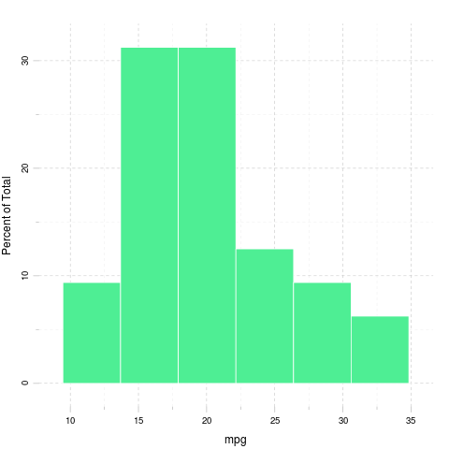

### cyl

We found the folloing values here:

*6*, *6*, *4*, *6*, *8*, *6*, *8*, *4*, *4*, *6*, *6*, *8*, *8*, *8*, *8*, *8*, *8*, *4*, *4*, *4*, *4*, *8*, *8*, *8*, *8*, *4*, *4*, *4*, *8*, *6*, *8* and *4*

The mean of cyl is *6.188* while the standard deviation is: *1.786*. The most frequent value in cyl is 8, but let us check out the frequency table too:

|  |  |  |
| --- | --- | --- |
| 4 | 6 | 8 |
| 11 | 7 | 14 |

Tables are boring, let us show the same with a histogram:

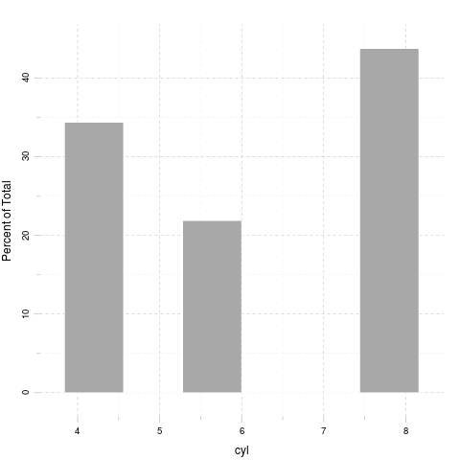

### disp

We found the folloing values here:

*160*, *160*, *108*, *258*, *360*, *225*, *360*, *146.7*, *140.8*, *167.6*, *167.6*, *275.8*, *275.8*, *275.8*, *472*, *460*, *440*, *78.7*, *75.7*, *71.1*, *120.1*, *318*, *304*, *350*, *400*, *79*, *120.3*, *95.1*, *351*, *145*, *301* and *121*

The mean of disp is *230.7* while the standard deviation is: *123.9*. The most frequent value in disp is 275.8, but let us check out the frequency table too:

Internal pander error: Wrong number of parameters (11 instead of *12*) passed: justify while running: table(mtcars[, v])

Please [report the issue](https://github.com/Rapporter/pander/issues/new) with a reproducible example to help developers fix this ASAP.

Tables are boring, let us show the same with a histogram:

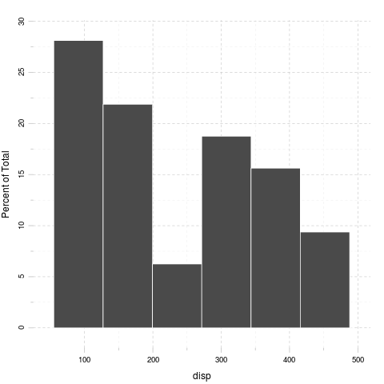

### hp

We found the folloing values here:

*110*, *110*, *93*, *110*, *175*, *105*, *245*, *62*, *95*, *123*, *123*, *180*, *180*, *180*, *205*, *215*, *230*, *66*, *52*, *65*, *97*, *150*, *150*, *245*, *175*, *66*, *91*, *113*, *264*, *175*, *335* and *109*

The mean of hp is *146.7* while the standard deviation is: *68.56*. The most frequent value in hp is 110, but let us check out the frequency table too:

Internal pander error: Wrong number of parameters (14 instead of *15*) passed: justify while running: table(mtcars[, v])

Please [report the issue](https://github.com/Rapporter/pander/issues/new) with a reproducible example to help developers fix this ASAP.

Tables are boring, let us show the same with a histogram:

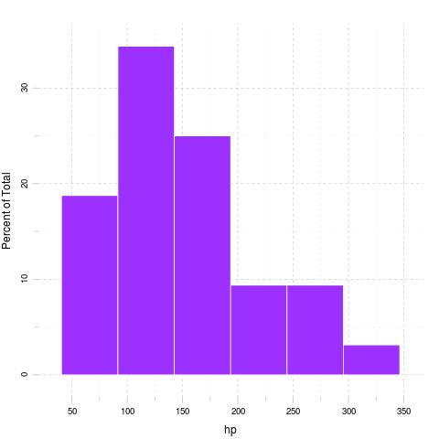

### drat

We found the folloing values here:

*3.9*, *3.9*, *3.85*, *3.08*, *3.15*, *2.76*, *3.21*, *3.69*, *3.92*, *3.92*, *3.92*, *3.07*, *3.07*, *3.07*, *2.93*, *3*, *3.23*, *4.08*, *4.93*, *4.22*, *3.7*, *2.76*, *3.15*, *3.73*, *3.08*, *4.08*, *4.43*, *3.77*, *4.22*, *3.62*, *3.54* and *4.11*

The mean of drat is *3.597* while the standard deviation is: *0.5347*. The most frequent value in drat is 3.07, but let us check out the frequency table too:

Internal pander error: Wrong number of parameters (12 instead of *13*) passed: justify while running: table(mtcars[, v])

Please [report the issue](https://github.com/Rapporter/pander/issues/new) with a reproducible example to help developers fix this ASAP.

Tables are boring, let us show the same with a histogram:

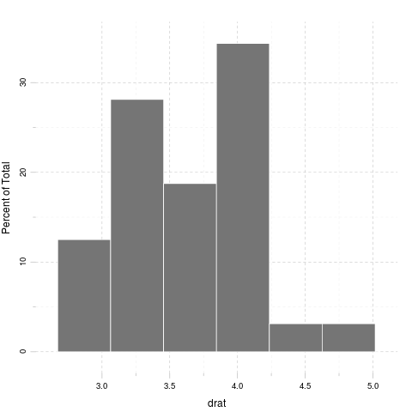

### wt

We found the folloing values here:

*2.62*, *2.875*, *2.32*, *3.215*, *3.44*, *3.46*, *3.57*, *3.19*, *3.15*, *3.44*, *3.44*, *4.07*, *3.73*, *3.78*, *5.25*, *5.424*, *5.345*, *2.2*, *1.615*, *1.835*, *2.465*, *3.52*, *3.435*, *3.84*, *3.845*, *1.935*, *2.14*, *1.513*, *3.17*, *2.77*, *3.57* and *2.78*

The mean of wt is *3.217* while the standard deviation is: *0.9785*. The most frequent value in wt is 3.44, but let us check out the frequency table too:

Internal pander error: Wrong number of parameters (11 instead of *12*) passed: justify while running: table(mtcars[, v])

Please [report the issue](https://github.com/Rapporter/pander/issues/new) with a reproducible example to help developers fix this ASAP.

Tables are boring, let us show the same with a histogram:

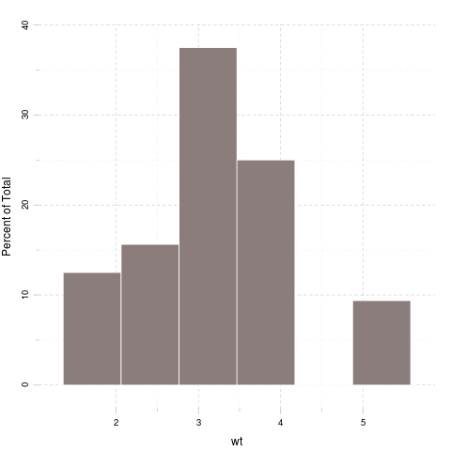

### qsec

We found the folloing values here:

*16.46*, *17.02*, *18.61*, *19.44*, *17.02*, *20.22*, *15.84*, *20*, *22.9*, *18.3*, *18.9*, *17.4*, *17.6*, *18*, *17.98*, *17.82*, *17.42*, *19.47*, *18.52*, *19.9*, *20.01*, *16.87*, *17.3*, *15.41*, *17.05*, *18.9*, *16.7*, *16.9*, *14.5*, *15.5*, *14.6* and *18.6*

The mean of qsec is *17.85* while the standard deviation is: *1.787*. The most frequent value in qsec is 17.02, but let us check out the frequency table too:

Internal pander error: Wrong number of parameters (10 instead of *11*) passed: justify while running: table(mtcars[, v])

Please [report the issue](https://github.com/Rapporter/pander/issues/new) with a reproducible example to help developers fix this ASAP.

Tables are boring, let us show the same with a histogram:

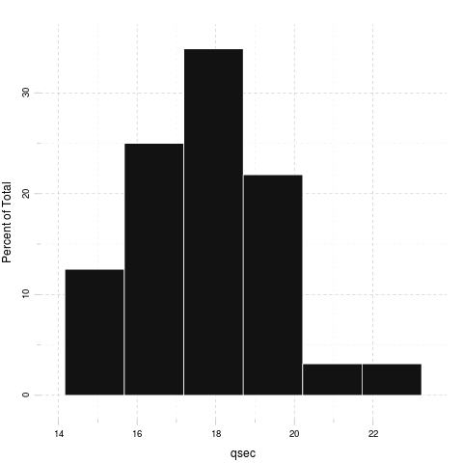

### vs

We found the folloing values here:

*0*, *0*, *1*, *1*, *0*, *1*, *0*, *1*, *1*, *1*, *1*, *0*, *0*, *0*, *0*, *0*, *0*, *1*, *1*, *1*, *1*, *0*, *0*, *0*, *0*, *1*, *0*, *1*, *0*, *0*, *0* and *1*

The mean of vs is *0.4375* while the standard deviation is: *0.504*. The most frequent value in vs is 0, but let us check out the frequency table too:

|  |  |
| --- | --- |
| 0 | 1 |
| 18 | 14 |

Tables are boring, let us show the same with a histogram:

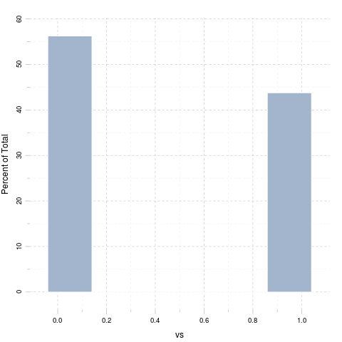

### am

We found the folloing values here:

*1*, *1*, *1*, *0*, *0*, *0*, *0*, *0*, *0*, *0*, *0*, *0*, *0*, *0*, *0*, *0*, *0*, *1*, *1*, *1*, *0*, *0*, *0*, *0*, *0*, *1*, *1*, *1*, *1*, *1*, *1* and *1*

The mean of am is *0.4062* while the standard deviation is: *0.499*. The most frequent value in am is 0, but let us check out the frequency table too:

|  |  |
| --- | --- |
| 0 | 1 |
| 19 | 13 |

Tables are boring, let us show the same with a histogram:

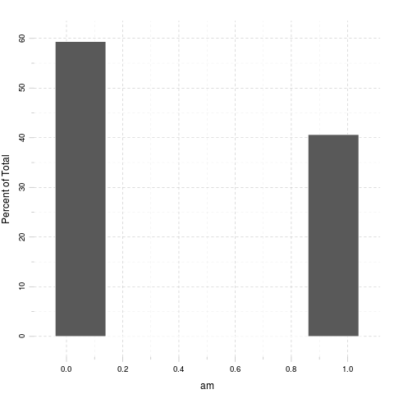

### gear

We found the folloing values here:

*4*, *4*, *4*, *3*, *3*, *3*, *3*, *4*, *4*, *4*, *4*, *3*, *3*, *3*, *3*, *3*, *3*, *4*, *4*, *4*, *3*, *3*, *3*, *3*, *3*, *4*, *5*, *5*, *5*, *5*, *5* and *4*

The mean of gear is *3.688* while the standard deviation is: *0.7378*. The most frequent value in gear is 3, but let us check out the frequency table too:

|  |  |  |
| --- | --- | --- |
| 3 | 4 | 5 |
| 15 | 12 | 5 |

Tables are boring, let us show the same with a histogram:

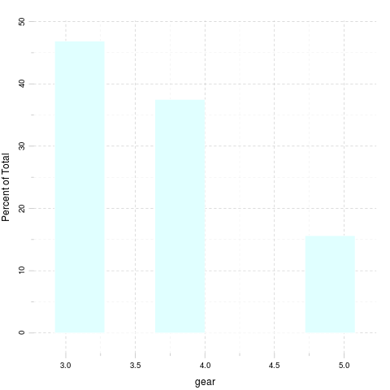

### carb

We found the folloing values here:

*4*, *4*, *1*, *1*, *2*, *1*, *4*, *2*, *2*, *4*, *4*, *3*, *3*, *3*, *4*, *4*, *4*, *1*, *2*, *1*, *1*, *2*, *2*, *4*, *2*, *1*, *2*, *2*, *4*, *6*, *8* and *2*

The mean of carb is *2.812* while the standard deviation is: *1.615*. The most frequent value in carb is 2, but let us check out the frequency table too:

|  |  |  |  |  |  |
| --- | --- | --- | --- | --- | --- |
| 1 | 2 | 3 | 4 | 6 | 8 |
| 7 | 10 | 3 | 10 | 1 | 1 |

Tables are boring, let us show the same with a histogram:

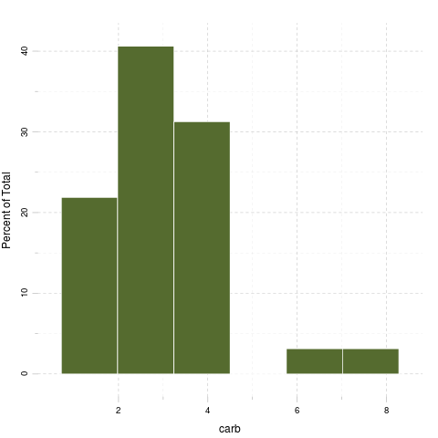

# Correlation

And here goes a correlation table:

|  |  |  |  |  |  |  |  |  |
| --- | --- | --- | --- | --- | --- | --- | --- | --- |
|  | mpg | cyl | disp | hp | drat | wt | qsec | vs |
| **mpg** | 1.0000 | -0.8522 | -0.8476 | -0.7762 | 0.68117 | -0.8677 | 0.4187 | 0.6640 |
| **cyl** | -0.8522 | 1.0000 | 0.9020 | 0.8324 | -0.69994 | 0.7825 | -0.5912 | -0.8108 |
| **disp** | -0.8476 | 0.9020 | 1.0000 | 0.7909 | -0.71021 | 0.8880 | -0.4337 | -0.7104 |
| **hp** | -0.7762 | 0.8324 | 0.7909 | 1.0000 | -0.44876 | 0.6587 | -0.7082 | -0.7231 |
| **drat** | 0.6812 | -0.6999 | -0.7102 | -0.4488 | 1.00000 | -0.7124 | 0.0912 | 0.4403 |
| **wt** | -0.8677 | 0.7825 | 0.8880 | 0.6587 | -0.71244 | 1.0000 | -0.1747 | -0.5549 |
| **qsec** | 0.4187 | -0.5912 | -0.4337 | -0.7082 | 0.09120 | -0.1747 | 1.0000 | 0.7445 |
| **vs** | 0.6640 | -0.8108 | -0.7104 | -0.7231 | 0.44028 | -0.5549 | 0.7445 | 1.0000 |
| **am** | 0.5998 | -0.5226 | -0.5912 | -0.2432 | 0.71271 | -0.6925 | -0.2299 | 0.1683 |
| **gear** | 0.4803 | -0.4927 | -0.5556 | -0.1257 | 0.69961 | -0.5833 | -0.2127 | 0.2060 |
| **carb** | -0.5509 | 0.5270 | 0.3950 | 0.7498 | -0.09079 | 0.4276 | -0.6562 | -0.5696 |

Table continues below

|  |  |  |  |
| --- | --- | --- | --- |
|  | am | gear | carb |
| **mpg** | 0.59983 | 0.4803 | -0.55093 |
| **cyl** | -0.52261 | -0.4927 | 0.52699 |
| **disp** | -0.59123 | -0.5556 | 0.39498 |
| **hp** | -0.24320 | -0.1257 | 0.74981 |
| **drat** | 0.71271 | 0.6996 | -0.09079 |
| **wt** | -0.69250 | -0.5833 | 0.42761 |
| **qsec** | -0.22986 | -0.2127 | -0.65625 |
| **vs** | 0.16835 | 0.2060 | -0.56961 |
| **am** | 1.00000 | 0.7941 | 0.05753 |
| **gear** | 0.79406 | 1.0000 | 0.27407 |
| **carb** | 0.05753 | 0.2741 | 1.00000 |

And the same on a graph:

Yeah, that latter took a while to render in an image file :)

That's not a pander issue.

# Some models

Okay, let us find out how weight affects other variables:

### mpg

A simple linear model: mtcars$wt ~ mtcars$mpg

|  |  |  |  |  |
| --- | --- | --- | --- | --- |
|  | Estimate | Std. Error | t value | Pr(>|t|) |
| **Independent** | -0.1409 | 0.01474 | -9.559 | 1.294e-10 |
| **(Intercept)** | 6.0473 | 0.30869 | 19.590 | 1.204e-18 |

Fitting linear model: mtcars$wt ~ Independent

### cyl

A simple linear model: mtcars$wt ~ mtcars$cyl

|  |  |  |  |  |
| --- | --- | --- | --- | --- |
|  | Estimate | Std. Error | t value | Pr(>|t|) |
| **Independent** | 0.4287 | 0.06228 | 6.883 | 1.218e-07 |
| **(Intercept)** | 0.5646 | 0.40062 | 1.409 | 1.690e-01 |

Fitting linear model: mtcars$wt ~ Independent

### disp

A simple linear model: mtcars$wt ~ mtcars$disp

|  |  |  |  |  |
| --- | --- | --- | --- | --- |
|  | Estimate | Std. Error | t value | Pr(>|t|) |
| **Independent** | 0.00701 | 0.0006629 | 10.576 | 1.222e-11 |
| **(Intercept)** | 1.59981 | 0.1729964 | 9.248 | 2.738e-10 |

Fitting linear model: mtcars$wt ~ Independent

### hp

A simple linear model: mtcars$wt ~ mtcars$hp

|  |  |  |  |  |
| --- | --- | --- | --- | --- |
|  | Estimate | Std. Error | t value | Pr(>|t|) |
| **Independent** | 0.009401 | 0.00196 | 4.796 | 4.146e-05 |
| **(Intercept)** | 1.838247 | 0.31652 | 5.808 | 2.389e-06 |

Fitting linear model: mtcars$wt ~ Independent

### drat

A simple linear model: mtcars$wt ~ mtcars$drat

|  |  |  |  |  |
| --- | --- | --- | --- | --- |
|  | Estimate | Std. Error | t value | Pr(>|t|) |
| **Independent** | -1.304 | 0.2345 | -5.561 | 4.784e-06 |
| **(Intercept)** | 7.906 | 0.8522 | 9.277 | 2.547e-10 |

Fitting linear model: mtcars$wt ~ Independent

### qsec

A simple linear model: mtcars$wt ~ mtcars$qsec

|  |  |  |  |  |
| --- | --- | --- | --- | --- |
|  | Estimate | Std. Error | t value | Pr(>|t|) |
| **Independent** | -0.09567 | 0.09843 | -0.9719 | 0.338868 |
| **(Intercept)** | 4.92479 | 1.76541 | 2.7896 | 0.009081 |

Fitting linear model: mtcars$wt ~ Independent

### vs

A simple linear model: mtcars$wt ~ mtcars$vs

|  |  |  |  |  |
| --- | --- | --- | --- | --- |
|  | Estimate | Std. Error | t value | Pr(>|t|) |
| **Independent** | -1.077 | 0.2949 | -3.654 | 9.798e-04 |
| **(Intercept)** | 3.689 | 0.1950 | 18.913 | 3.203e-18 |

Fitting linear model: mtcars$wt ~ Independent

### am

A simple linear model: mtcars$wt ~ mtcars$am

|  |  |  |  |  |
| --- | --- | --- | --- | --- |
|  | Estimate | Std. Error | t value | Pr(>|t|) |
| **Independent** | -1.358 | 0.2583 | -5.258 | 1.125e-05 |
| **(Intercept)** | 3.769 | 0.1646 | 22.895 | 1.490e-20 |

Fitting linear model: mtcars$wt ~ Independent

### gear

A simple linear model: mtcars$wt ~ mtcars$gear

|  |  |  |  |  |
| --- | --- | --- | --- | --- |
|  | Estimate | Std. Error | t value | Pr(>|t|) |
| **Independent** | -0.7735 | 0.1967 | -3.933 | 4.587e-04 |
| **(Intercept)** | 6.0697 | 0.7392 | 8.212 | 3.632e-09 |

Fitting linear model: mtcars$wt ~ Independent

### carb

A simple linear model: mtcars$wt ~ mtcars$carb

|  |  |  |  |  |
| --- | --- | --- | --- | --- |
|  | Estimate | Std. Error | t value | Pr(>|t|) |
| **Independent** | 0.259 | 0.09998 | 2.591 | 1.464e-02 |
| **(Intercept)** | 2.489 | 0.32300 | 7.705 | 1.353e-08 |

Fitting linear model: mtcars$wt ~ Independent