ECS 170 — Artificial Intelligence — Spring 2026
Course Project: Stage 3 Report
CNN-Based Image Classification on MNIST, ORL, and CIFAR-10
Roman Vasilyev | ID: 920502918 | rvasilyev@ucdavis.edu

Section 1: Task Description
The main task of this stage is to train a Convolutional Neural Network (CNN) model to classify image data for object recognition. Three distinct datasets were used: MNIST (handwritten digits), ORL (human faces), and CIFAR-10 (colored objects). The CNN model was built from scratch using PyTorch's nn.Module framework, following the standard CNN architecture of stacked convolutional blocks followed by fully connected classification layers.
The goal for each dataset was to train the model on the provided training split, then evaluate its performance on a held-out test split using accuracy, precision, recall, and F1 score as metrics.

Section 2: Model Description
The CNN architecture consists of two convolutional blocks followed by a fully connected classifier. The design follows the standard pattern of: convolution, activation, convolution, activation, then max pooling — repeated twice to extract increasingly abstract features before classification.

Architecture summary:
Block 1: Conv2d(in_channels, 32, kernel=3) → LeakyReLU → Conv2d(32, 32, kernel=3) → LeakyReLU → MaxPool2d(2x2)
Block 2: Conv2d(32, 64, kernel=3) → LeakyReLU → Conv2d(64, 64, kernel=3) → LeakyReLU → MaxPool2d(2x2)
Classifier: Flatten → LazyLinear(512) → LeakyReLU → Linear(512, 128) → LeakyReLU → Linear(128, num_classes)

The convolutional layers use learnable filters that slide across the image to detect local spatial patterns such as edges and textures. LeakyReLU activations introduce non-linearity while avoiding the dying ReLU problem by allowing a small negative gradient. Max pooling reduces spatial dimensions by keeping only the maximum value in each 2x2 region, making the model more robust to small translations. The flattening step converts the 3D feature maps into a 1D vector for the fully connected layers, which learn to map the extracted features to class probabilities.

Section 3: Experiment Settings

3.1 Dataset Description
All three datasets were provided pre-partitioned into training and test sets — no additional splitting was required.

Dataset | Description | Train Size | Test Size | Image Size
MNIST | Handwritten digits (0-9), grayscale | 60,000 | 10,000 | 28x28x1
ORL | Human face photos, 40 subjects, grayscale | 360 | 40 | 112x92x1
CIFAR-10 | Colored object images, 10 classes | 50,000 | 10,000 | 32x32x3

3.2 Detailed Experimental Setup
The same CNN architecture was used for all three datasets, with two parameters adjusted per dataset: in_channels (1 for grayscale MNIST/ORL, 3 for color CIFAR-10) and num_classes (10 for MNIST/CIFAR-10, 40 for ORL). ORL labels were shifted from 1-40 to 0-39 to match PyTorch's 0-indexed class convention.

Hyperparameter | MNIST | ORL | CIFAR-10
Optimizer | Adam | Adam | Adam
Learning Rate | 0.001 | 0.001 | 0.001
Loss Function | CrossEntropyLoss | CrossEntropyLoss | CrossEntropyLoss
Epochs | 30 | 30 | 30
Batch Size | 64 | 64 | 64
in_channels | 1 | 1 | 3
num_classes | 10 | 40 | 10
Activation | LeakyReLU | LeakyReLU | LeakyReLU

3.3 Evaluation Metrics
Four metrics were used to evaluate model performance. Accuracy measures the overall proportion of correctly classified samples. Precision measures how many of the predicted positives were actually positive. Recall measures how many actual positives were correctly identified. F1 Score is the harmonic mean of precision and recall, balancing both. All metrics used the weighted average across classes to account for class imbalance.

3.4 Source Code
The source code is located in the stage_3_code and stage_3_script directories of the project repository, specifically in Method_CNN.py and script_cnn.py.

3.5 Training Convergence Plots
The plots below show the training loss and accuracy over 30 epochs for each dataset. All three models converge successfully with loss decreasing and accuracy increasing over time.

MNIST — Training Loss and Accuracy:
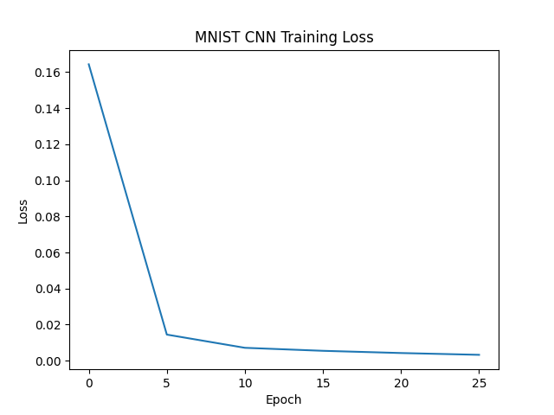
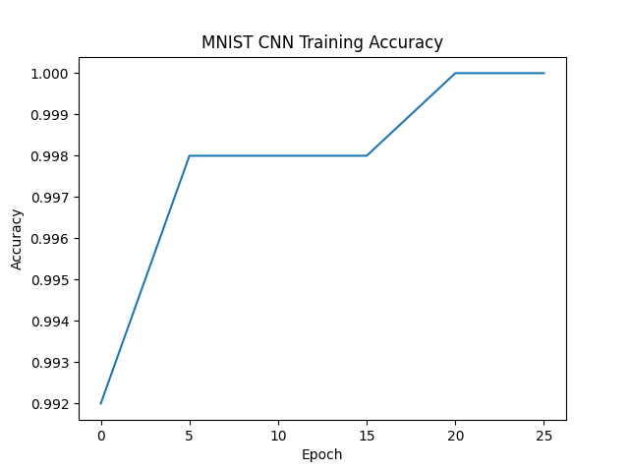

ORL — Training Loss and Accuracy:
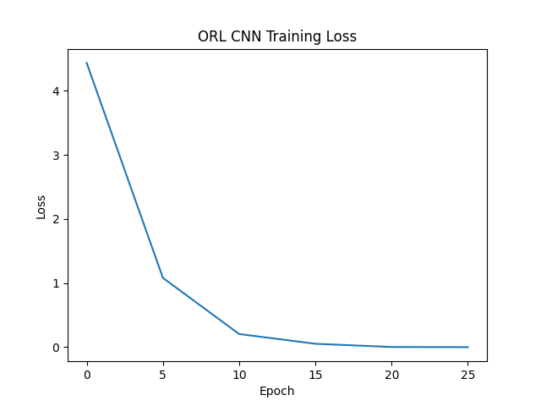
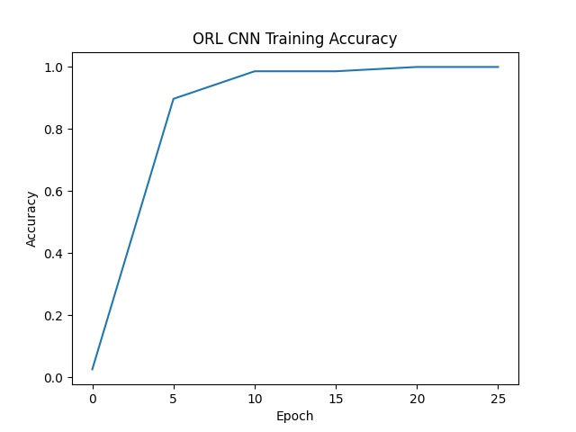

CIFAR-10 — Training Loss and Accuracy:



3.6 Model Performance
Final test set results for all three datasets:

Dataset | Accuracy | F1 Score | Precision | Recall
MNIST | 99.27% | 0.9927 | 0.9927 | 0.9927
ORL | 100% | 1.0000 | 1.0000 | 1.0000
CIFAR-10 | 74.22% | 0.7423 | 0.7449 | 0.7422

MNIST achieved 99.27% test accuracy, demonstrating that the CNN is well-suited to digit recognition. ORL achieved 100% accuracy, which is expected given the very small dataset size (360 training images) — the model can effectively memorize the distinct features of each of the 40 subjects. CIFAR-10 achieved 74.22% test accuracy. Notably, training accuracy reached 99% while test accuracy was only 74.22%, indicating overfitting — the model memorized training patterns but did not generalize as well to unseen color images.

3.7 Ablation Studies
All ablation experiments were conducted on the CIFAR-10 dataset since it is the most challenging and showed the most room for improvement. The baseline model achieved 74.22% test accuracy but suffered from severe overfitting, with training accuracy reaching 99%. Six configurations were tested by modifying one or more hyperparameters at a time to understand each change's impact.

Configuration | LR | Kernel | Epochs | Test Accuracy
Baseline (no dropout, no BN) | 1e-3 | 3 | 30 | 74.22%
+ Dropout (p=0.5) | 1e-3 | 3 | 30 | 79.21%
+ Dropout, larger kernel | 1e-4 | 5 | 30 | 71.67%
+ Dropout, smaller LR | 1e-4 | 3 | 30 | 69.81%
+ Dropout, larger kernel, more epochs | 1e-4 | 5 | 100 | 77.66%
+ Dropout + BatchNorm, more epochs | 1e-4 | 3 | 100 | 82.51%

Key findings: Dropout (p=0.5) was the single most impactful change, improving test accuracy from 74.22% to 79.21% by reducing overfitting — training and test accuracy became much closer together. Reducing the learning rate to 1e-4 alone hurt performance with only 30 epochs since the model did not have enough time to converge, but combining it with 100 epochs and batch normalization produced the best result of 82.51%. Increasing kernel size to 5 did not help at 30 epochs but improved slightly with 100 epochs, suggesting larger kernels need more training time. Batch normalization combined with dropout gave the largest overall gain — an 8.29 percentage point improvement over the baseline — by stabilizing training and allowing better generalization on the complex CIFAR-10 color images.

