COMPETENCY-BASED LEARNING MATERIALS


Sector
{{sector}}
Qualification Title
{{qualification_title}}
Unit of Competency
{{unit_of_competency_x}}
Module Title
{{module_title}}
Prepared By:
KYLE JOSEPH G. FABIAN, LPT

HOW TO USE THIS COMPETENCY- BASED LEARNING MATERIALS

Welcome!
The unit of competency, “{{unit_of_competency_x}}”, is one of the competencies of {{qualification_title}}, a course which comprises the knowledge, skills and attitudes required for a TVET trainer to possess.
The module, {{module_title}}, contains training materials and activities related to identifying learner’s requirements, preparing session plan, preparing basic instructional materials and organizing learning and teaching activities for you to complete.
In this module, you are required to go through a series of learning activities in order to complete each learning outcome. In each learning outcome are KEY FACTS, LET’S EXERCISE, LET’S APPLY and Job Sheets. Follow and perform the activities on your own. If you have questions, do not hesitate to ask for assistance from your facilitator.
Remember to:
- Read information sheets and complete the let’s exercise. Suggested references are included to supplement the materials provided in this module.
- Perform the let’s apply and Job Sheets until you are confident that your outputs conform to the Performance Criteria Checklist that follows the sheets.
- Submit outputs of the let’s apply and Job Sheets to your facilitator for evaluation and recording in the Accomplishment Chart. Output shall serve as your portfolio during the Institutional Competency Evaluation. When you feel confident that you have had sufficient practice, ask your trainer to evaluate you. The results of your assessment will be recorded in your Progress Chart and Accomplishment Chart.
You must pass the Institutional Competency Evaluation for this competency before moving to another competency. A Certificate of Achievement will be awarded to you after passing the evaluation.
You need to complete this module before you can perform the module on, {{next_unit_of_competency}}

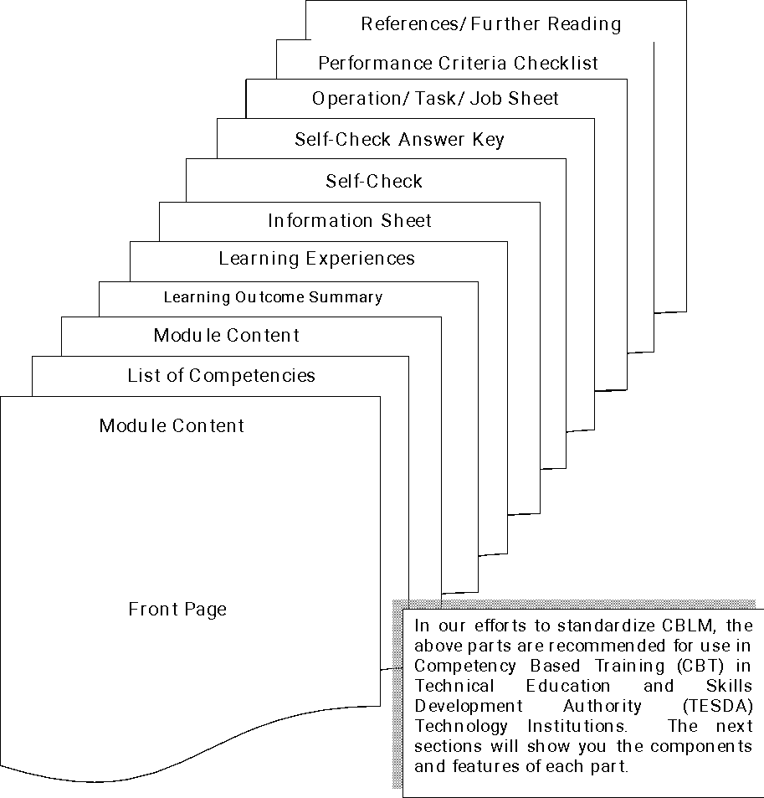
{{qualification_title}}
COMPETENCY-BASED LEARNING MATERIALS

List of Competencies
No. | Unit of Competency | Module Title | Code
1 | {{unit_of_competency_x}} | {{module_title_x}} | {{unit_of_competency_code_x}}
2 | {{unit_of_competency_x}} | {{module_title_x}} | {{unit_of_competency_code_x}}
3 | {{unit_of_competency_x}} | {{module_title_x}} | {{unit_of_competency_code_x}}
4 | {{unit_of_competency_x}} | {{module_title_x}} | {{unit_of_competency_code_x}}
6 | {{unit_of_competency_x}} | {{module_title_x}} | {{unit_of_competency_code_x}}
7 | {{unit_of_competency_x}} | {{module_title_x}} | {{unit_of_competency_code_x}}
8 | {{unit_of_competency_x}} | {{module_title_x}} | {{unit_of_competency_code_x}}
9 | {{unit_of_competency_x}} | {{module_title_x}} | {{unit_of_competency_code_x}}
10 | {{unit_of_competency_x}} | {{module_title_x}} | {{unit_of_competency_code_x}}
11 | {{unit_of_competency_x}} | {{module_title_x}} | {{unit_of_competency_code_x}}
12 | {{unit_of_competency_x}} | {{module_title_x}} | {{unit_of_competency_code_x}}
13 | {{unit_of_competency_x}} | {{module_title_x}} | {{unit_of_competency_code_x}}
14 | {{unit_of_competency_x}} | {{module_title_x}} | {{unit_of_competency_code_x}}

MODULE CONTENT
UNIT OF COMPETENCY | {{unit_of_competency_x}}
MODULE TITLE | {{module_title}}
MODULE DESCRIPTOR:
{{Module_Descriptor}}

NOMINAL DURATION: 6 Hours
Learning Outcomes:
At the end of this module, you MUST be able to:
- {{LO_X}}
- {{LO_X}}
- {{LO_X}}
- {{LO_X}}
- {{LO_X}}
- {{LO_X}}
- {{LO_X}}
- {{LO_X}}
- {{LO_X}}
- {{LO_X}}
- {{LO_X}}
- {{LO_X}}
- {{LO_X}}
ASSESSMENT CRITERIA:
- Specific and relevant information is accessed from appropriate sources
- Effective questioning , active listening and speaking skills are used to gather and convey information
- Appropriate medium is used to transfer information and ideas
- Appropriate non- verbal communication is used
- Appropriate lines of communication with supervisors and colleagues are identified and followed
- Defined workplace procedures for the location and storage of information are used
- Personal interaction is carried out clearly and concisely
- Specific and relevant information is accessed from appropriate sources
- Effective questioning , active listening and speaking skills are used to gather and convey information
- Appropriate medium is used to transfer information and ideas
- Appropriate non- verbal communication is used

- Appropriate lines of communication with supervisors and colleagues are identified and followed
- Defined workplace procedures for the location and storage of information are used
- Personal interaction is carried out clearly and concisely
- Range of forms relating to conditions of employment are completed accurately and legibly
- Workplace data is recorded on standard workplace forms and documents
- Basic mathematical processes are used for routine calculations
- Errors in recording information on forms/ documents are identified and properly acted upon
- Reporting requirements to supervisor are completed according to organizational guidelines

