COMPETENCY-BASED LEARNING MATERIALS


Sector
{{sector}}
Qualification Title
{{course_title}}
Unit of Competency
{{learning_outcome}}
Module Title
{{module_title}}
Prepared By:
{{name}}

HOW TO USE THIS COMPETENCY- BASED LEARNING MATERIALS

Welcome!
The unit of competency, “{{learning_outcome}}”, is one of the competencies of {{course_title}}, a course which comprises the knowledge, skills and attitudes required for a TVET trainer to possess.
The module, {{module_title}}, contains training materials and activities related to identifying learner’s requirements, preparing session plan, preparing basic instructional materials and organizing learning and teaching activities for you to complete.
In this module, you are required to go through a series of learning activities in order to complete each learning outcome. In each learning outcome are KEY FACTS, LET’S EXERCISE, and LET’S APPLY. Follow and perform the activities on your own. If you have questions, do not hesitate to ask for assistance from your facilitator.
Remember to:
- Read information sheets and complete the let’s exercise. Suggested references are included to supplement the materials provided in this module.
- Perform the let’s apply until you are confident that your outputs conform to the Performance Criteria Checklist that follows the sheets.
- Submit outputs of the let’s apply to your facilitator for evaluation and recording in the Accomplishment Chart. Output shall serve as your portfolio during the Institutional Competency Evaluation. When you feel confident that you have had sufficient practice, ask your trainer to evaluate you. The results of your assessment will be recorded in your Progress Chart and Accomplishment Chart.
You must pass the Institutional Competency Evaluation for this competency before moving to another competency. A Certificate of Achievement will be awarded to you after passing the evaluation.
You need to complete this module before you can perform the module on, {{next_learning_outcome}}

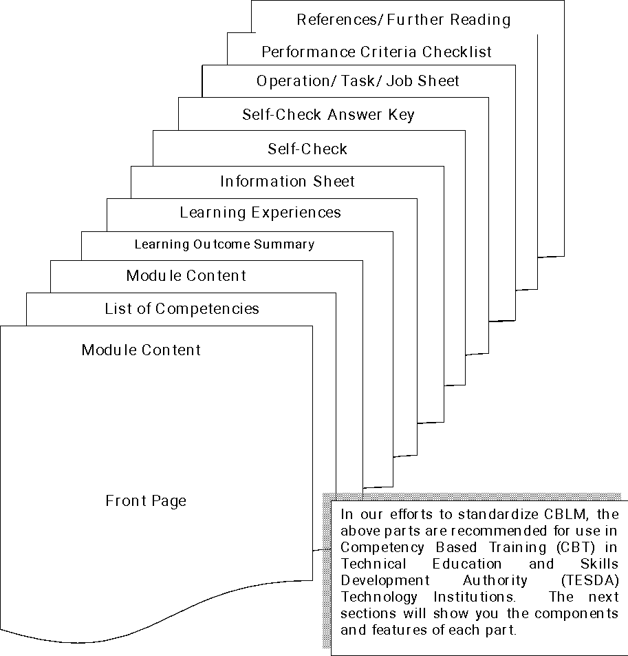
{{course_title}}
COMPETENCY-BASED LEARNING MATERIALS

List of Competencies
No. | Unit of Competency | Module Title | Code
1 | {{learning_outcome}} | {{module_title}} | {{course_code}}

MODULE CONTENT
UNIT OF COMPETENCY | {{learning_outcome}}
MODULE TITLE | {{module_title}}
MODULE DESCRIPTOR:
{{module_descriptor}}

NOMINAL DURATION: {{duration}}
Learning Outcomes:
At the end of this module, you MUST be able to:
- {{learning_outcome_specific}}
ASSESSMENT CRITERIA:
- {{assessment_criteria}}

