**Checking insulation thickness (2015-05-20) – H16EC0188A**

**Measurements by E. Cavanna and L. G. Fajardo**

**Data processing by E. Cavanna**

**Cable info:**

MQXFS Coil #201

Strand material: Nb3Sn PIT

Production length: 155 m

Fabrication date: 23/03/2015

Side external: A

Run identification: 142A

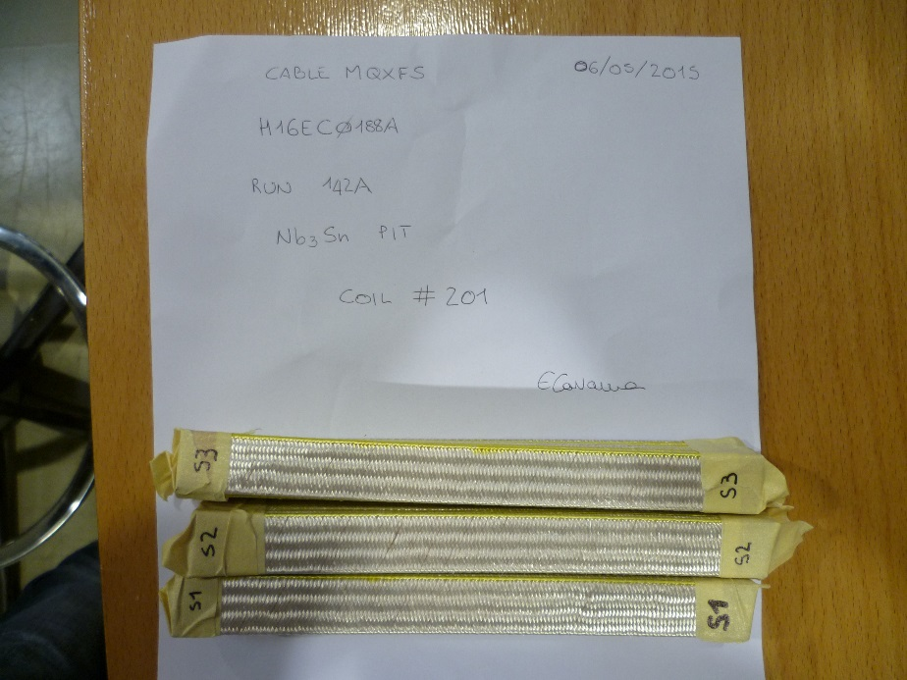

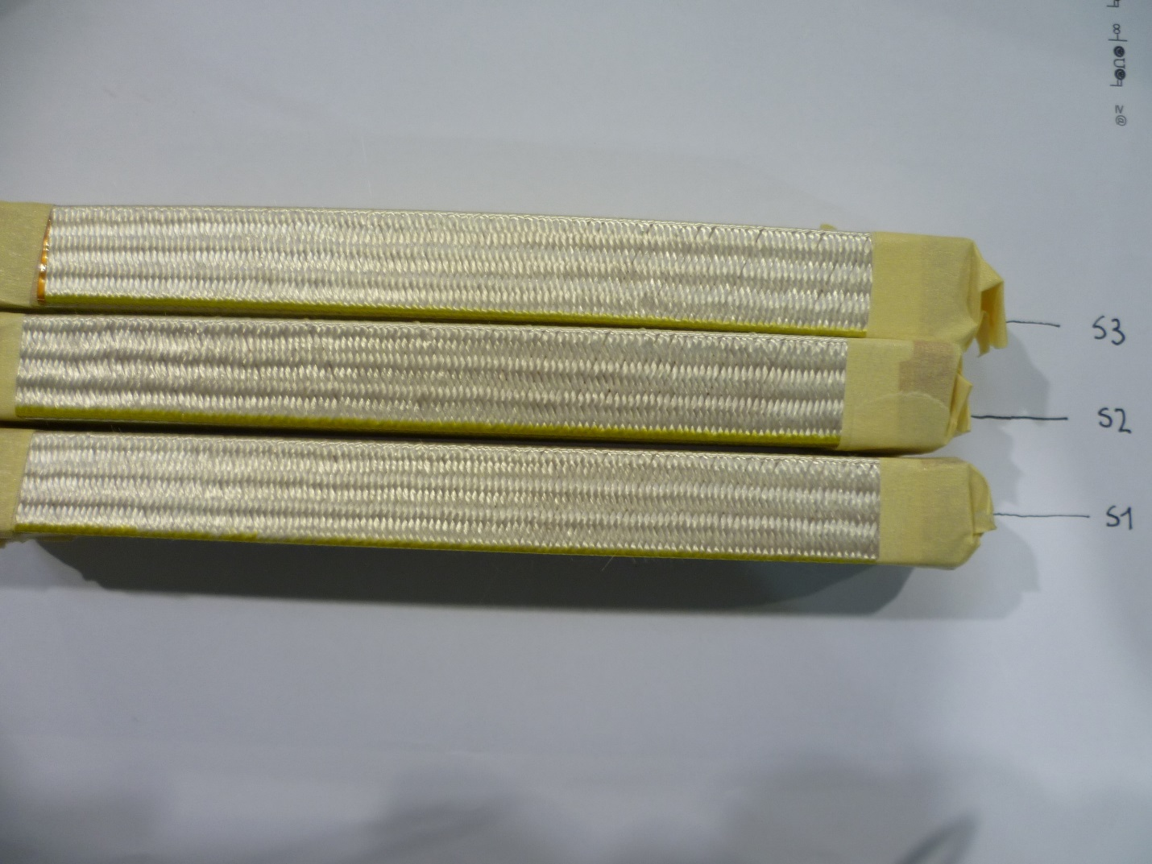

**Calibration curve**

Calibration aluminium bar.

Dimensions (width x length x height): 19 x 120 x 13.95 mm.

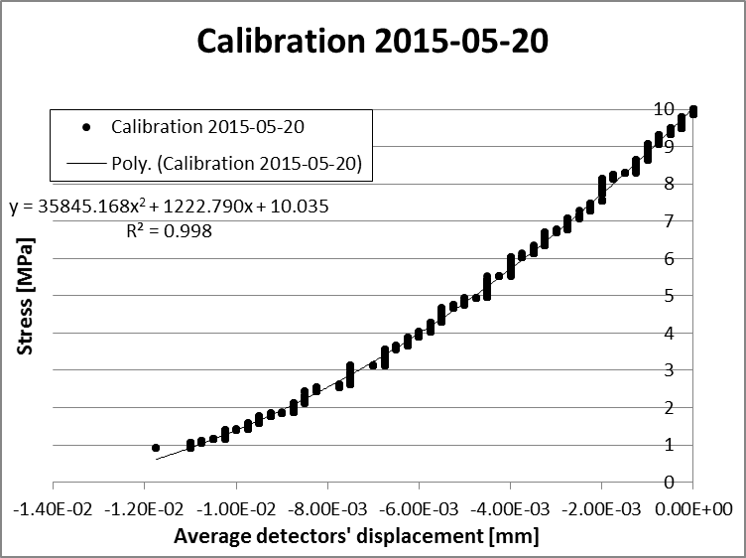

**Table 1: Detailed results S1**

|  |  |  |  |
| --- | --- | --- | --- |
|  | **Average displacement of detectors (mm)** | **Stress (MPa)** | **10-stack thickness (mm)** |
| **S1-UI** | -4.457 | 5.007 | 18.401 |
| -4.430 | 5.003 | 18.374 |
| -4.414 | 5.004 | 18.358 |
| **Average** | **-4.434** | **5.005** | **18.378** |
| **S1-UB** | -1.509 | 5.007 | 15.453 |
| -1.506 | 4.996 | 15.450 |
| -1.505 | 5.002 | 15.449 |
| **Average** | **-1.507** | **5.002** | **15.451** |

**Table 2: Detailed results S2**

|  |  |  |  |
| --- | --- | --- | --- |
|  | **Average displacement of detectors (mm)** | **Stress (MPa)** | **10-stack thickness (mm)** |
| **S2-UI** | -4.443 | 5.002 | 18.388 |
| -4.414 | 5.005 | 18.358 |
| -4.397 | 4.996 | 18.341 |
| **Average** | **-4.418** | **5.001** | **18.362** |
| **S2-UB** | -1.501 | 4.992 | 15.445 |
| -1.497 | 5.006 | 15.441 |
| -1.495 | 4.999 | 15.439 |
| **Average** | **-1.498** | **4.999** | **15.442** |

**Table 3: Detailed results S3**

|  |  |  |  |
| --- | --- | --- | --- |
|  | **Average displacement of detectors (mm)** | **Stress (MPa)** | **10-stack thickness (mm)** |
| **S3-UI** | -4.441 | 5.015 | 18.385 |
| -4.409 | 5.007 | 18.353 |
| -4.392 | 4.996 | 18.336 |
| **Average** | **-4.414** | **5.006** | **18.358** |
| **S3-UB** | -1.523 | 5.002 | 15.467 |
| -1.521 | 5.006 | 15.465 |
| -1.519 | 4.998 | 15.463 |
| **Average** | **-1.521** | **5.002** | **15.465** |

## **Summary**

|  |  |  |  |  |
| --- | --- | --- | --- | --- |
|  | Insulated cable thickness (mm) |  | Bare cable thickness (mm) | Insulation thickness (μm) |
| S1-UI | **1.838** | **S1-UB** | **1.545** | **146** |
| S2-UI | **1.836** | **S2-UB** | **1.544** | **146** |
| S3-UI | **1.836** | **S3-UB** | **1.547** | **145** |

