**Cable RMC1 FRESCA - Report**

**Report-Laura, 2014/06/04**

Contents

RMC-H11EC0116A (2014/05/30) 2

Results 3

Summary 4

# RMC-H11EC0116A (2014/05/30)

Aim: To check the insulation thickness of cable RMC1 FRESCA at 5 and 10MPa.

Samples’ description:

S1:

S2:

Measurements’ description:

Two 10-stacks from each sample were cut. The thickness of the insulated and bare cables was measured under compression from 1 to 5MPa, 3 times, and then from 1 to 10MPa, 3 times.

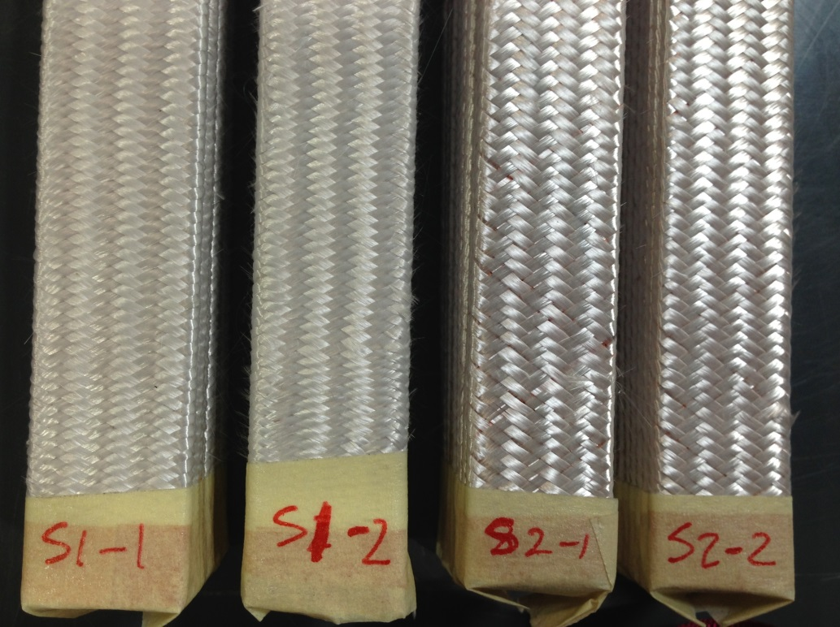

**Figure 1: Samples RMC 1 and RMC 2**

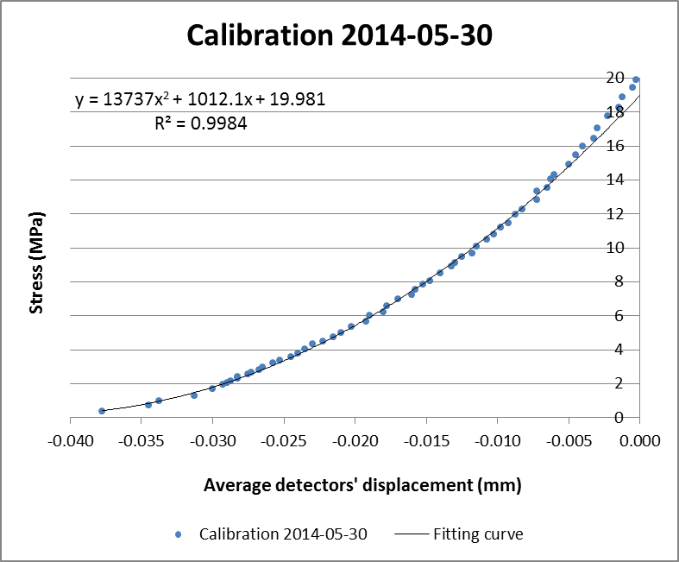

**Figure 2: Calibration curve**

Calibration bar dimensions (length x with x height): 120 x 14.7 x 15.5mm

Calibration bar material: aluminium

## Results

**Table 1: Detailed results of S1-1**

|  |  |  |  |
| --- | --- | --- | --- |
|  | **Average displacement of detectors (mm)** | **Stress (MPa)** | **10-stack thickness (mm)** |
|  | 2.468 | 5.004 | 22.509 |
| **S1-1_UI** | 2.499 | 4.999 | 22.478 |
|  | 2.524 | 5.005 | 22.453 |
| **Average** | **2.497** | **5.003** | **22.480** |
|  | 2.698 | 10.001 | 22.287 |
|  | 2.720 | 9.994 | 22.265 |
|  | 2.742 | 10.007 | 22.243 |
| **Average** | **2.720** | **10.001** | **22.265** |
|  | 6.602 | 5.007 | 18.375 |
| **S1-1_UB** | 6.610 | 5.003 | 18.368 |
|  | 6.610 | 5.008 | 18.367 |
| **Average** | **6.607** | **5.006** | **18.370** |
|  | 6.638 | 10.003 | 18.347 |
|  | 6.642 | 9.999 | 18.342 |
|  | 6.643 | 10.005 | 18.341 |
| **Average** | **6.641** | **10.002** | **18.343** |

**Table 2: Detailed results of S1-2**

|  |  |  |  |
| --- | --- | --- | --- |
|  | **Average displacement of detectors (mm)** | **Stress (MPa)** | **10-stack thickness (mm)** |
|  | 2.525 | 4.997 | 22.452 |
| **S1-2_UI** | 2.558 | 5.000 | 22.419 |
|  | 2.584 | 5.000 | 22.394 |
| **Average** | **2.555** | **4.999** | **22.422** |
|  | 2.737 | 10.000 | 22.248 |
|  | 2.767 | 9.981 | 22.218 |
|  | 2.787 | 9.993 | 22.198 |
| **Average** | **2.763** | **9.991** | **22.221** |
|  | 6.664 | 4.996 | 18.314 |
| **S1-2_UB** | 6.667 | 4.998 | 18.311 |
|  | 6.669 | 5.000 | 18.308 |
| **Average** | **6.666** | **4.998** | **18.311** |
|  | 6.697 | 9.999 | 18.288 |
|  | 6.699 | 10.001 | 18.286 |
|  | 6.700 | 9.999 | 18.285 |
| **Average** | **6.698** | **10.000** | **18.286** |

## Summary

|  |  |  |  |  |  |  |
| --- | --- | --- | --- | --- | --- | --- |
| Sample | Stress (MPa) | Insulated cable thickness (mm) | Sample | Stress (MPa) | Bare cable thickness (mm) | Insulation thickness (μm) |
| S1-1_UI | 5.003 | **2.248** | **S1-1_UB** | 5.006 | **1.837** | **206** |
|  | 10.001 | **2.227** |  | 10.002 | **1.834** | **196** |
| S1-2_UI | 4.999 | **2.242** | **S1-2_UB** | 4.998 | **1.831** | **206** |
|  | 9.991 | **2.222** |  | 10.000 | **1.829** | **197** |

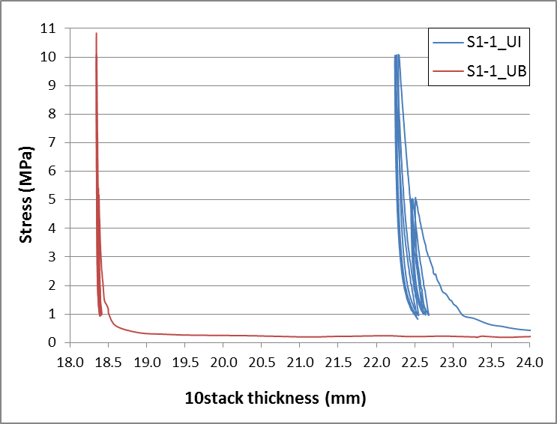

**Figure 3: S1-1 results**

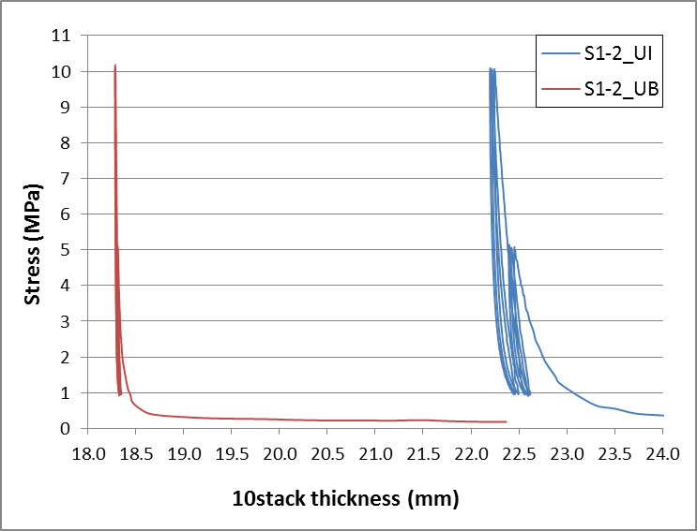

**Figure 4: S1-2 results**