**Checking insulation thickness (2015-06-11) – H16EC0188B**

**Measurements by E. Cavanna and L. G. Fajardo**

**Data processing by E. Cavanna**

**Cable info:**

MQXFS Coil #202

Strand material: Nb3Sn PIT

Run identification: 142A

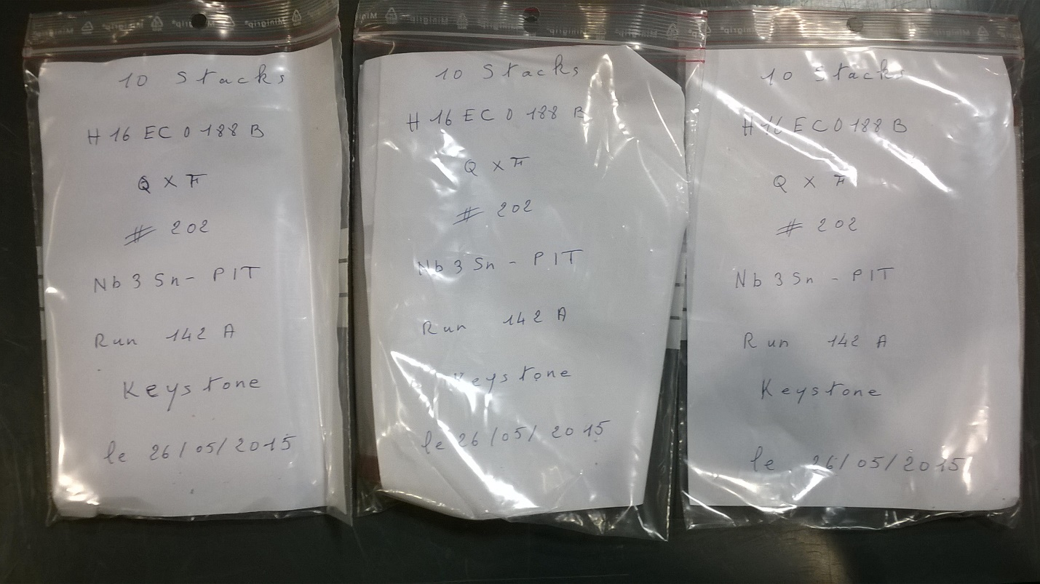

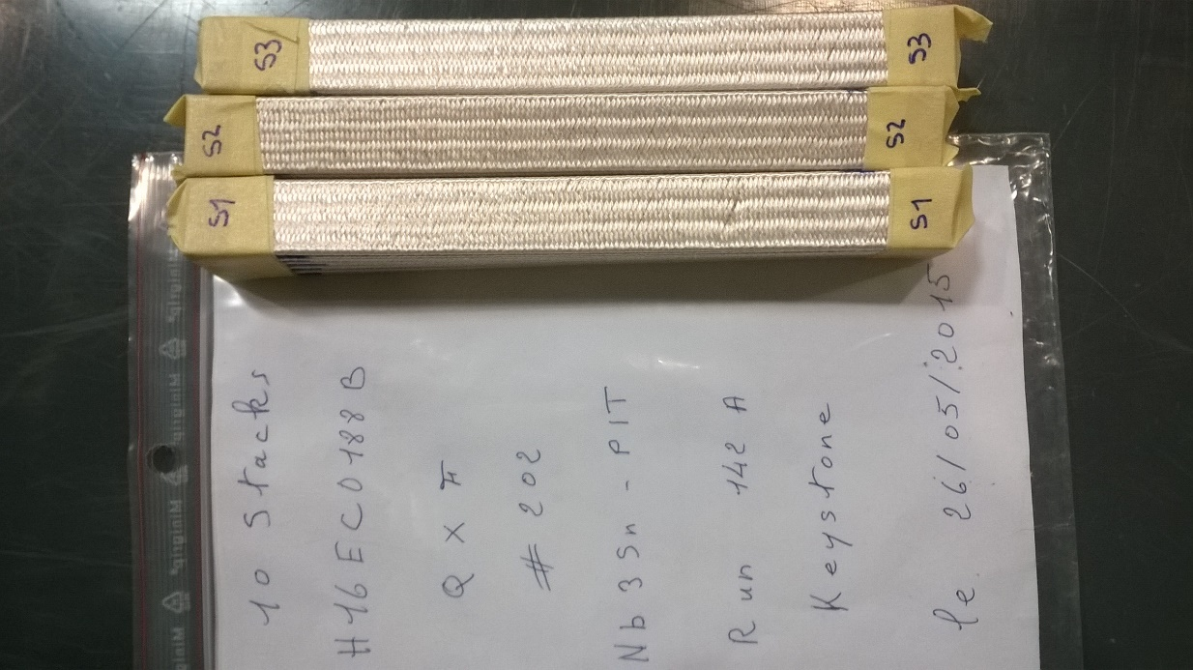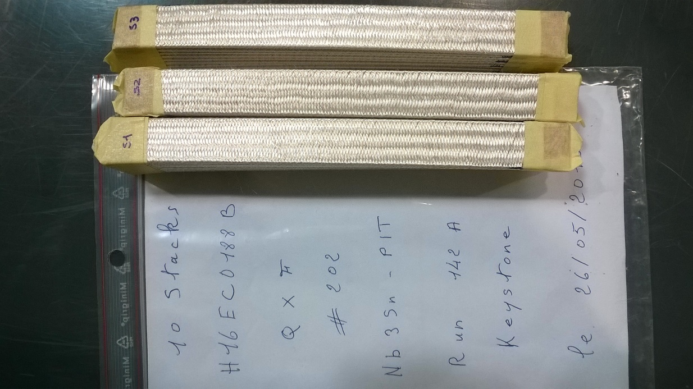

**Calibration curve**

Calibration aluminium bar.

Dimensions (width x length x height): 19 x 120 x 13.95 mm.

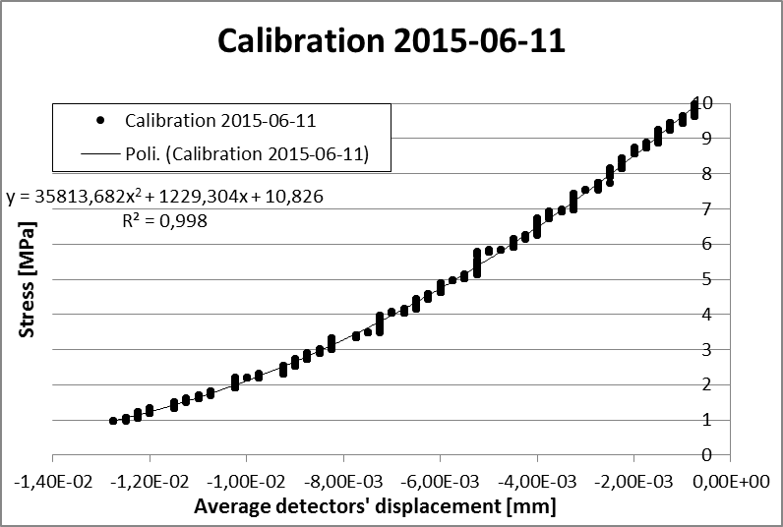

**Table 1: Detailed results S1**

|  |  |  |  |
| --- | --- | --- | --- |
|  | **Average displacement of detectors (mm)** | **Stress (MPa)** | **10-stack thickness (mm)** |
|  |
|  |
| **S1-UI** | -4,339 | 4,999 | 18,282 |
| -4,314 | 5,002 | 18,257 |
| -4,292 | 5,003 | 18,235 |
| **Average** | **-4,315** | **5,001** | **18,258** |
| **S1-UB** | -1,322 | 4,996 | 15,266 |
| -1,321 | 4,996 | 15,264 |
| -1,320 | 5,006 | 15,263 |
| **Average** | **-1,321** | **4,999** | **15,264** |

**Table 2: Detailed results S2**

|  |  |  |  |
| --- | --- | --- | --- |
|  | **Average displacement of detectors (mm)** | **Stress (MPa)** | **10-stack thickness (mm)** |
|  |
|  |
| **S2-UI** | -4,337 | 4,998 | 18,281 |
| -4,309 | 5,007 | 18,252 |
| -4,295 | 5,001 | 18,238 |
| **Average** | **-4,314** | **5,002** | **18,257** |
| **S2-UB** | -1,317 | 4,999 | 15,260 |
| -1,314 | 4,998 | 15,258 |
| -1,314 | 4,995 | 15,257 |
| **Average** | **-1,315** | **4,998** | **15,258** |

**Table 3: Detailed results S3**

|  |  |  |  |
| --- | --- | --- | --- |
|  | **Average displacement of detectors (mm)** | **Stress (MPa)** | **10-stack thickness (mm)** |
|  |
|  |
| **S3-UI** | -4,315 | 5,008 | 18,258 |
| -4,288 | 4,995 | 18,231 |
| -4,269 | 4,994 | 18,213 |
| **Average** | **-4,291** | **4,999** | **18,234** |
| **S3-UB** | -1,319 | 4,999 | 15,262 |
| -1,315 | 5,000 | 15,259 |
| -1,315 | 5,000 | 15,258 |
| **Average** | **-1,316** | **5,000** | **15,259** |

## **Summary**

|  |  |  |  |  |
| --- | --- | --- | --- | --- |
|  | **Insulated cable thickness (mm)** |  | **Bare cable thickness (mm)** | **Insulation thickness (μm)** |
|
|
| **S1-UI** | **1,826** | **S1-UB** | **1,526** | **150** |
| **S2-UI** | **1,826** | **S2-UB** | **1,526** | **150** |
| **S3-UI** | **1,823** | **S3-UB** | **1,526** | **149** |

