**Cable RMC2 FRESCA - Report**

**Report-Laura, 2014/06/04**

Contents

RMC- H11OC0147A (2014/05/30) 2

Results 3

Summary 4

# RMC- H11OC0147A (2014/05/30)

Aim: To check the insulation thickness of the cable RMC2 FRESCA at 5 and 10MPa.

Samples’ description:

S1:

S2:

Measurements’ description:

Two 10-stacks from each sample were cut. The thickness of the insulated and bare cables was measured under compression from 1 to 5MPa, 3 times, and then from 1 to 10MPa, 3 times.

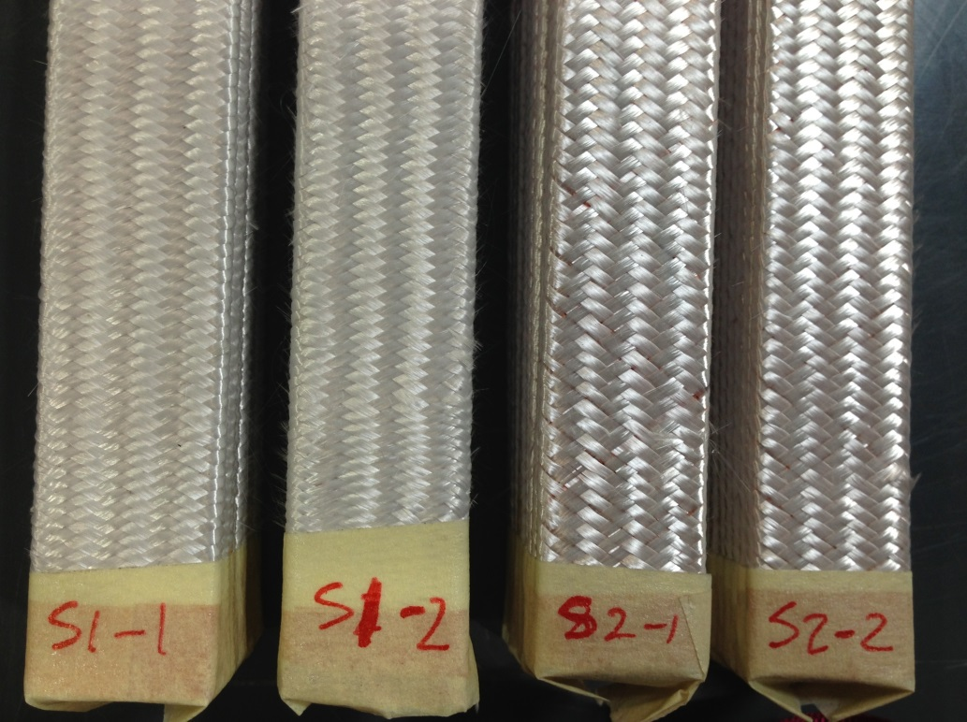

**Figure 1: RMC 1 and RMC 2**

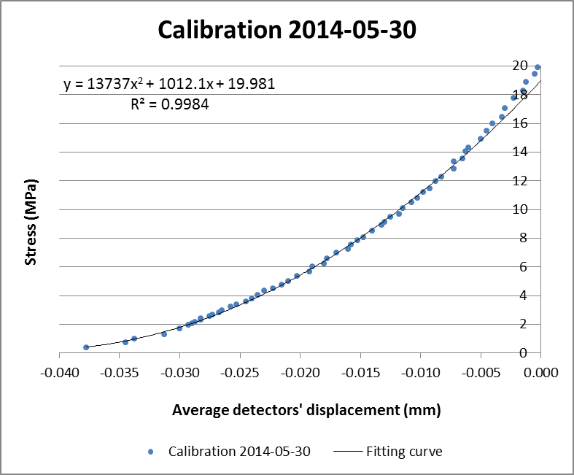

**Figure 2: Calibration curve**

Calibration bar dimensions (length x with x height): 120 x 14.7 x 15.5mm

Calibration bar material: aluminium

## Results

**Table 3: Detailed results of S2-1**

|  |  |  |  |
| --- | --- | --- | --- |
|  | **Average displacement of detectors (mm)** | **Stress (MPa)** | **10-stack thickness (mm)** |
|  | 3.780 | 5.003 | 21.198 |
| **S2-1_UI** | 3.820 | 5.005 | 21.157 |
|  | 3.840 | 5.001 | 21.137 |
| **Average** | **3.813** | **5.003** | **21.164** |
|  | 3.978 | 9.988 | 21.007 |
|  | 4.006 | 10.005 | 20.979 |
|  | 4.026 | 9.995 | 20.959 |
| **Average** | **4.003** | **9.996** | **20.982** |
|  | 6.658 | 4.995 | 18.319 |
| **S2-1_UB** | 6.662 | 5.002 | 18.315 |
|  | 6.665 | 4.999 | 18.312 |
| **Average** | **6.662** | **4.999** | **18.315** |
|  | 6.691 | 9.998 | 18.294 |
|  | 6.692 | 10.002 | 18.292 |
|  | 6.693 | 9.996 | 18.291 |
| **Average** | **6.692** | **9.999** | **18.293** |

**Table 4: Detailed results of S2-2**

|  |  |  |  |
| --- | --- | --- | --- |
|  | **Average displacement of detectors (mm)** | **Stress (MPa)** | **10-stack thickness (mm)** |
|  | 3.797 | 4.994 | 21.180 |
| **S2-2_UI** | 3.826 | 4.999 | 21.151 |
|  | 3.844 | 5.001 | 21.133 |
| **Average** | **3.822** | **4.998** | **21.155** |
|  | 3.977 | 10.003 | 21.008 |
|  | 4.002 | 10.003 | 20.983 |
|  | 4.019 | 10.007 | 20.966 |
| **Average** | **3.999** | **10.004** | **20.985** |
|  | 6.668 | 4.999 | 18.309 |
| **S2-2_UB** | 6.671 | 5.002 | 18.306 |
|  | 6.672 | 5.001 | 18.305 |
| **Average** | **6.671** | **5.001** | **18.307** |
|  | 6.700 | 10.003 | 18.285 |
|  | 6.701 | 9.999 | 18.284 |
|  | 6.702 | 10.001 | 18.283 |
| **Average** | **6.701** | **10.001** | **18.284** |

## Summary

|  |  |  |  |  |  |  |
| --- | --- | --- | --- | --- | --- | --- |
| Sample | Stress (MPa) | Insulated cable thickness (mm) | Sample | Stress (MPa) | Bare cable thickness (mm) | Insulation thickness (μm) |
| S2-1_UI | 5.003 | **2.116** | **S2-1_UB** | 4.999 | **1.832** | **142** |
|  | 9.996 | **2.098** |  | 9.999 | **1.829** | **134** |
| S2-2_UI | 4.998 | **2.116** | **S2-2_UB** | 5.001 | **1.831** | **142** |
|  | 10.004 | **2.099** |  | 10.001 | **1.828** | **135** |

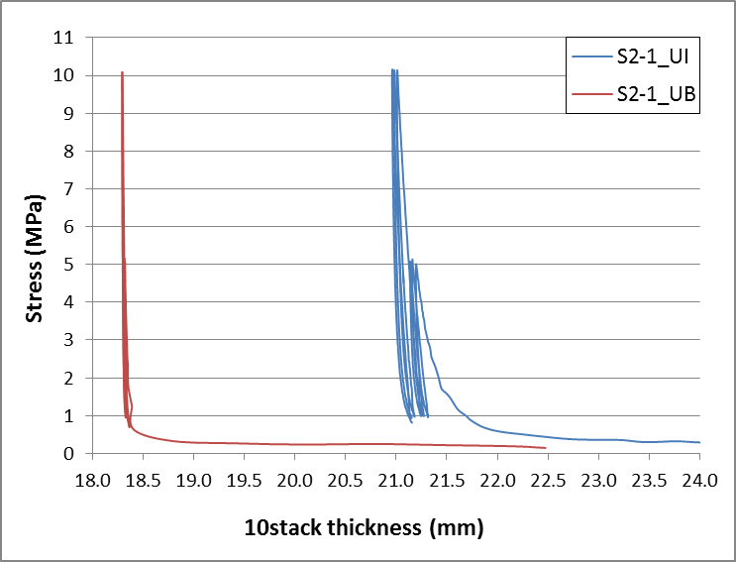

**Figure 3: S2-1 results**

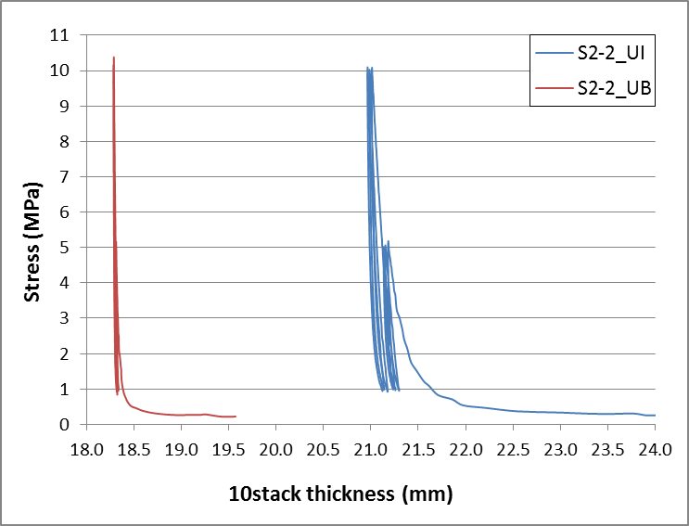

**Figure 4: S2-2 results**