# 9) Checking insulation thickness (2014-10-27) – H16OC0164A and H16OC0164B

**Measurements by Eugenio Cavanna and Laura Garcia Fajardo**

**Data processing by Laura Garcia Fajardo**

Cable info:

MQXF H16OC0164A and H16OC0164B

Strand material: Nb3Sn RRP 132/169?

Production length:

Fabrication date:

Side external:

Run identification: 121A and 121B

Braiding:

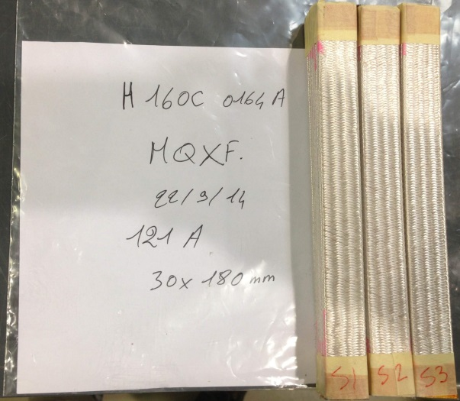

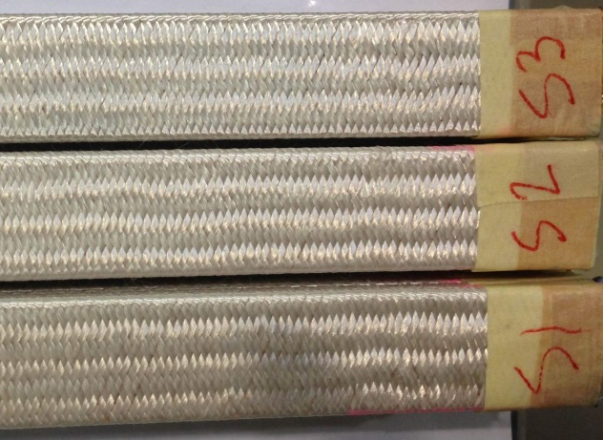

**H16OC0164A**

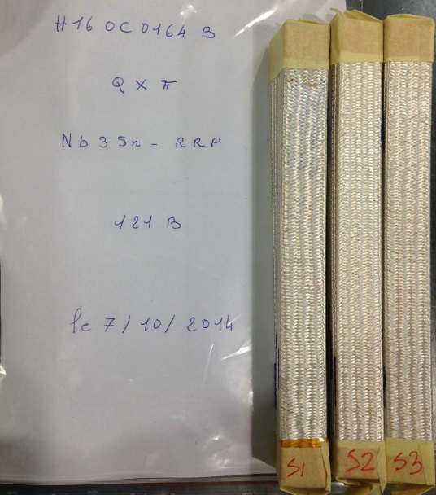

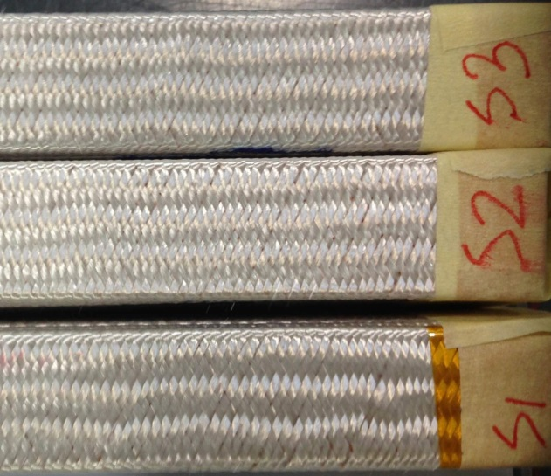

**H16OC0164B**

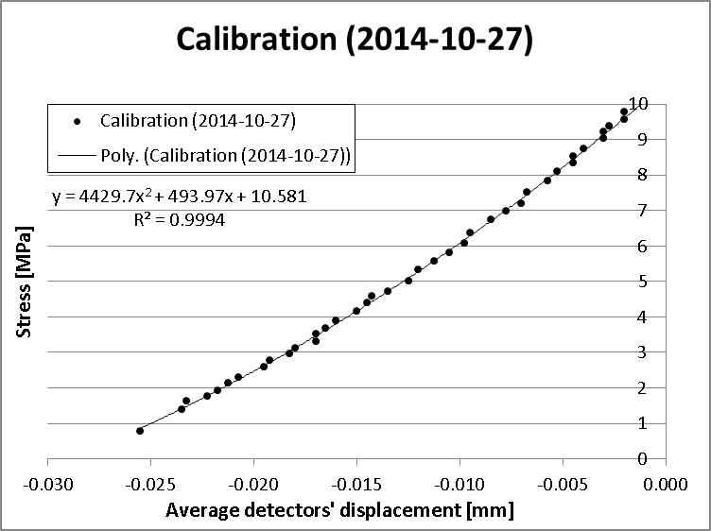

**Calibration curve**

Calibration aluminium bar dimensions (width x length x height): 20 x 120 x 25 mm.

## a) H16OC0164A

**Table 29: Detailed results S1**

|  |  |  |  |
| --- | --- | --- | --- |
|  | **Average displacement of detectors (mm)** | **Stress (MPa)** | **10-stack thickness (mm)** |
| **S1-UI** | 6.487 | 4.999 | 18.499 |
| 6.521 | 4.996 | 18.465 |
| 6.541 | 5.000 | 18.444 |
| **Average** | **6.516** | **4.998** | **18.469** |
| **S1-UB** | 9.570 | 5.010 | 15.415 |
| 9.573 | 4.997 | 15.412 |
| 9.574 | 4.998 | 15.411 |
| **Average** | **9.572** | **5.002** | **15.413** |

**Table 30: Detailed results S2**

|  |  |  |  |
| --- | --- | --- | --- |
|  | **Average displacement of detectors (mm)** | **Stress (MPa)** | **10-stack thickness (mm)** |
| **S1-UI** | 6.471 | 5.005 | 18.514 |
| 6.506 | 5.009 | 18.479 |
| 6.527 | 4.999 | 18.458 |
| **Average** | **6.501** | **5.004** | **18.484** |
| **S1-UB** | 9.540 | 5.002 | 15.445 |
| 9.543 | 5.009 | 15.442 |
| 9.544 | 4.968 | 15.441 |
| **Average** | **9.543** | **4.993** | **15.443** |

**Table 31: Detailed results S3**

|  |  |  |  |
| --- | --- | --- | --- |
|  | **Average displacement of detectors (mm)** | **Stress (MPa)** | **10-stack thickness (mm)** |
| **S1-UI** | 6.488 | 4.999 | 18.497 |
|  |  |  |
|  |  |  |
| **Average** | **6.488** | **4.999** | **18.497** |
| **S1-UB** | 9.557 | 4.996 | 15.428 |
| 9.562 | 5.003 | 15.423 |
| 9.564 | 5.008 | 15.422 |
| **Average** | **9.561** | **5.002** | **15.424** |

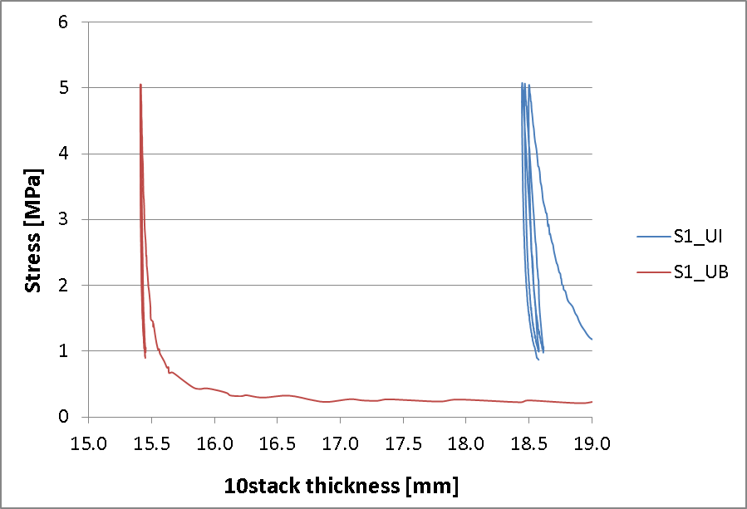

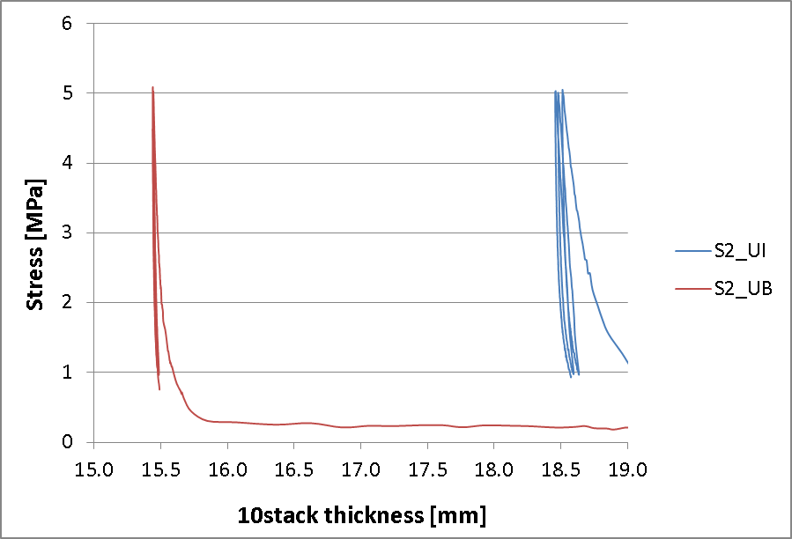

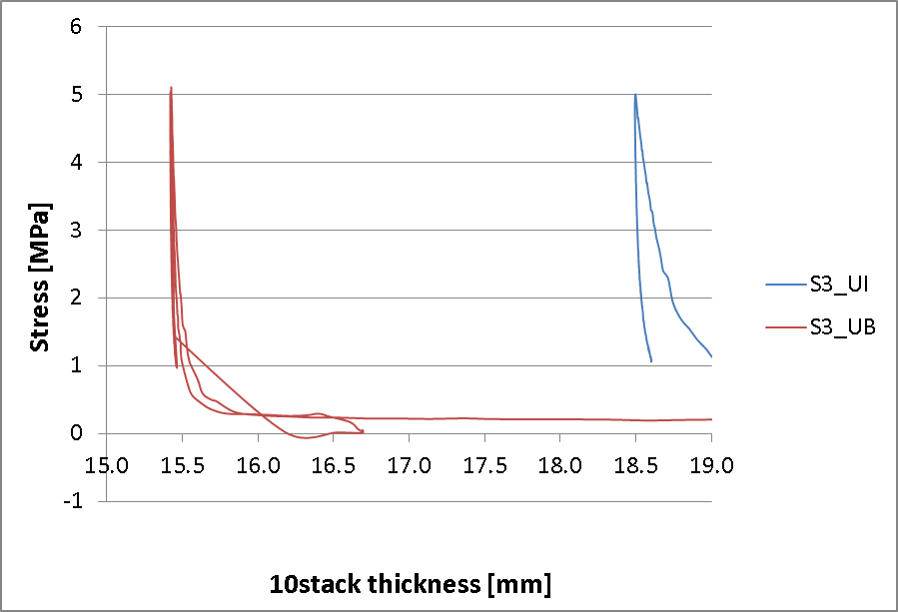

## b) H16OC0164B

**Table 32: Detailed results S1**

|  |  |  |  |
| --- | --- | --- | --- |
|  | **Average displacement of detectors (mm)** | **Stress (MPa)** | **10-stack thickness (mm)** |
| **S1-UI** | 6.812 | 4.999 | 18.174 |
| 6.839 | 5.007 | 18.147 |
| 6.854 | 5.017 | 18.131 |
| **Average** | **6.835** | **5.007** | **18.151** |
| **S1-UB** | 9.666 | 4.997 | 15.319 |
| 9.670 | 5.013 | 15.315 |
| 9.673 | 5.008 | 15.313 |
| **Average** | **9.670** | **5.006** | **15.316** |

**Table 33: Detailed results S2**

|  |  |  |  |
| --- | --- | --- | --- |
|  | **Average displacement of detectors (mm)** | **Stress (MPa)** | **10-stack thickness (mm)** |
| **S1-UI** | 6.792 | 5.002 | 18.194 |
| 6.814 | 5.002 | 18.171 |
| 6.839 | 4.980 | 18.146 |
| **Average** | **6.815** | **4.995** | **18.170** |
| **S1-UB** | 9.709 | 4.999 | 15.277 |
| 9.712 | 5.000 | 15.273 |
| 9.714 | 5.000 | 15.272 |
| **Average** | **9.712** | **5.000** | **15.274** |

**Table 34: Detailed results S3**

|  |  |  |  |
| --- | --- | --- | --- |
|  | **Average displacement of detectors (mm)** | **Stress (MPa)** | **10-stack thickness (mm)** |
| **S1-UI** | 6.840 | 4.998 | 18.145 |
| 6.869 | 5.006 | 18.117 |
| 6.887 | 5.016 | 18.099 |
| **Average** | **6.865** | **5.007** | **18.120** |
| **S1-UB** | 9.726 | 4.998 | 15.259 |
| 9.731 | 5.001 | 15.255 |
| 9.733 | 5.001 | 15.252 |
| **Average** | **9.730** | **5.000** | **15.255** |

After removing the insulation of S1 we found this:

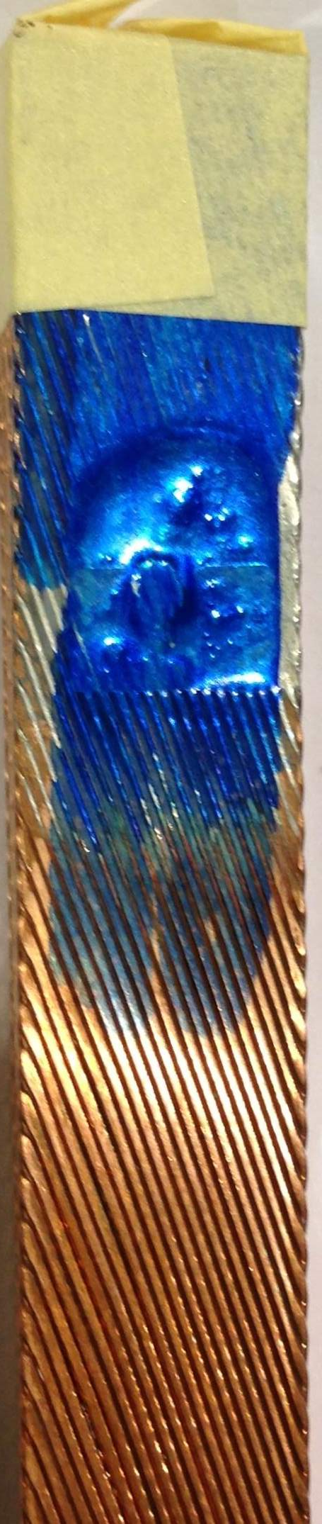

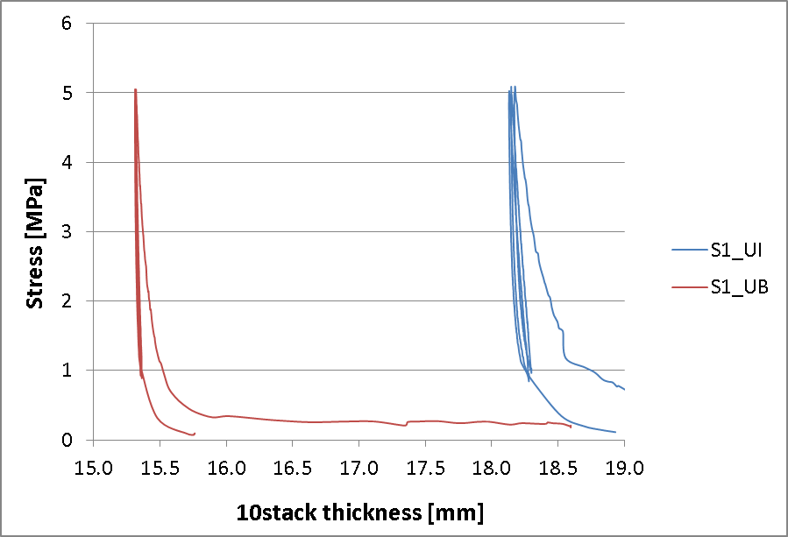

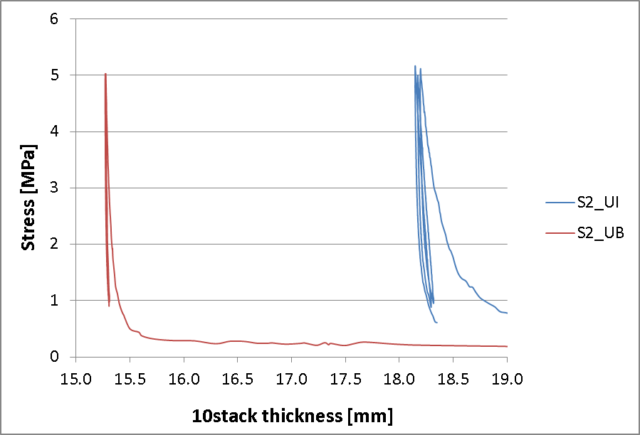

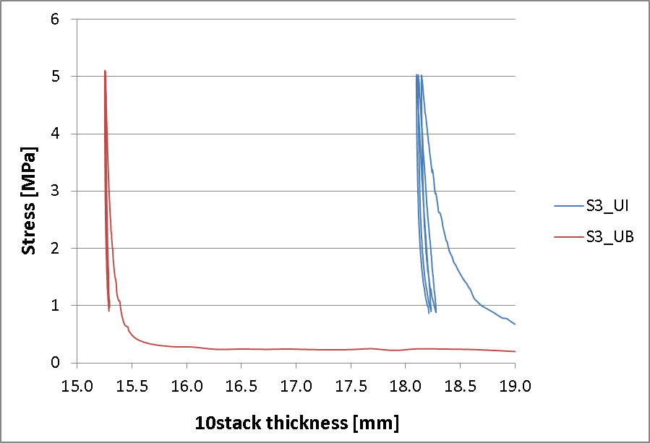

## Summary

|  |  |  |  |  |
| --- | --- | --- | --- | --- |
| H16OC0164A | Insulated cable thickness (mm) |  | Bare cable thickness (mm) | Insulation thickness (μm) |
| S1-UI | **1.847** | **S1-UB** | **1.541** | **153** |
| S2-UI | **1.848** | **S2-UB** | **1.544** | **152** |
| S3-UI | **1.850** | **S3-UB** | **1.542** | **154** |
| H16OC0164B |  |  |  |  |
| S1-UI | **1.815** | **S1-UB** | **1.532** | **142** |
| S2-UI | **1.817** | **S2-UB** | **1.527** | **145** |
| S3-UI | **1.812** | **S3-UB** | **1.526** | **143** |