**Ground insulation Kapton foils**

**For one coil we need Ground insulation of:**

|  |  |  |  |  |  |  |  |  |
| --- | --- | --- | --- | --- | --- | --- | --- | --- |
| **Patrone** | **A** | **B** | **C** | **D** | **E** | **F** | **G** | **H** |
| Patron 2 bis V4 | **6,9** | **35,8** | **291** | **1950** | **129,3** | **161** | **35,6** | **NO** |
| Patron 3 bis V4 | **35,8** | **7,1** | **291,5** | **1950** | **100,9** | **160,5** | **NO** | **35,9** |
| Patron 4 bis V4 | **1,1** | **43,4** | **301** | **1950** | **120,6** | **171** | **36** | **NO** |
| Patron 5 bis V4 | **42,5** | **-0,45** | **301,5** | **1950** | **111** | **170,5** | **NO** | **35,75** |
| Patron 2  V4 | **7** | **35,8** | **160,5** | **1950** | **100,7** | **291,5** | **35,8** | **NO** |
| Patron 3  V4 | **35,8** | **6,7** | **161** | **1950** | **129,6** | **291** | **NO** | **35,7** |
| Patron 4  V4 | **-0,3** | **42,5** | **170,5** | **1950** | **111** | **301,5** | **36** | **NO** |
| Patron 5  V4 | **43,6** | **1,1** | **171** | **1950** | **120,7** | **301** | **NO** | **35,8** |

**A**

**F**

**C**

**D**

**E**

**B**

**G**

**H**

To cut the Kapton foils we have special templates to use.

The templates are marked on the sheet. First of all place (Standard 0.125mm) Kapton foil and put a template on top.  
The mark with TOP should be visible for you during cutting, which means you copy the same form as the template in this orientation.

Cut all versions as showed in the table (measures just for checking).  
Patron 2 bis V4 - Patron 5 bis V4 and Patron 2 V4 - Patron 5 V4 are for one coil.   
> For a whole assembly we need two!

Don’t forget to mark them and cut a diameter 4mm in all foils on two edges (compare with old one as I did)!

Transport the foils in a dust-free storage to LAB 101.

If the forming mould is disassembled, start to put the first Layer (e.g. Patron 2 bis V4) into the tool and place until the last (Patron 5 bis V4).

One impregnation should be built with 4 foils to one pack, after that do the other pack.

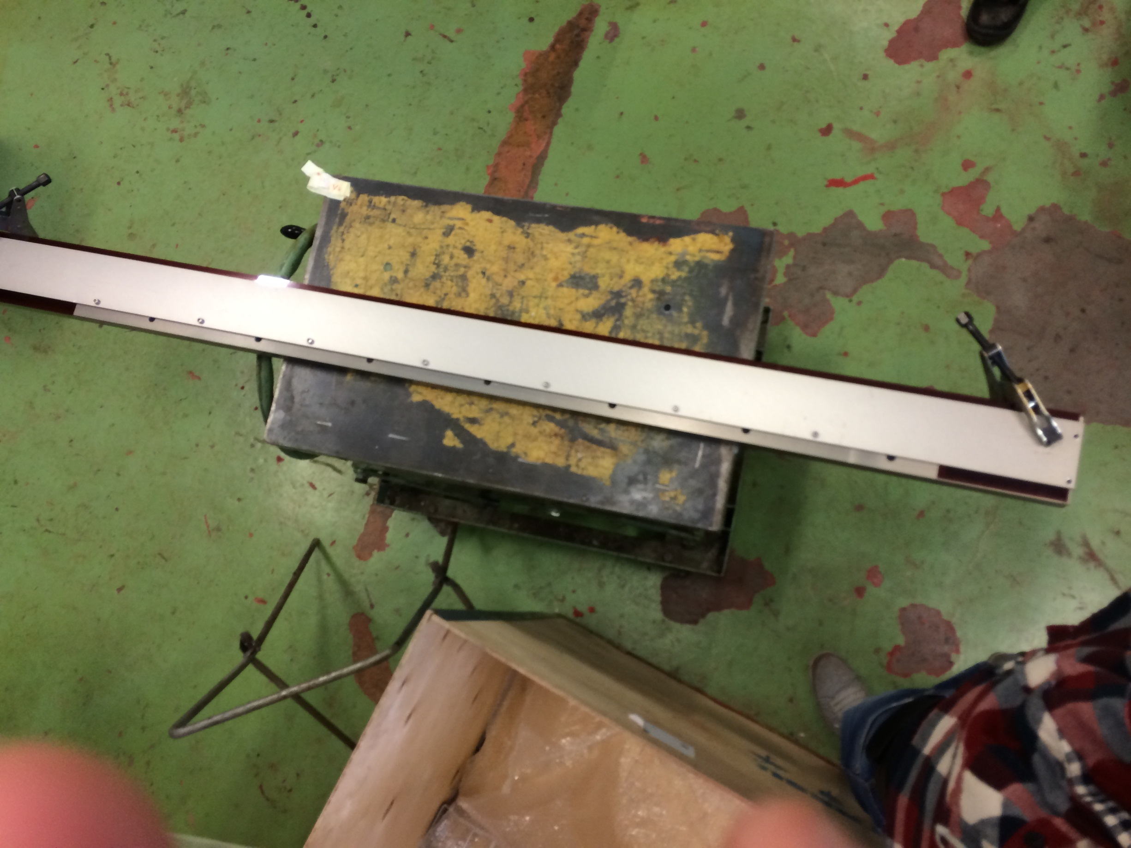The bis foil should have the short cut-out on the marked side and the other version without bis should have the long cut-out there.

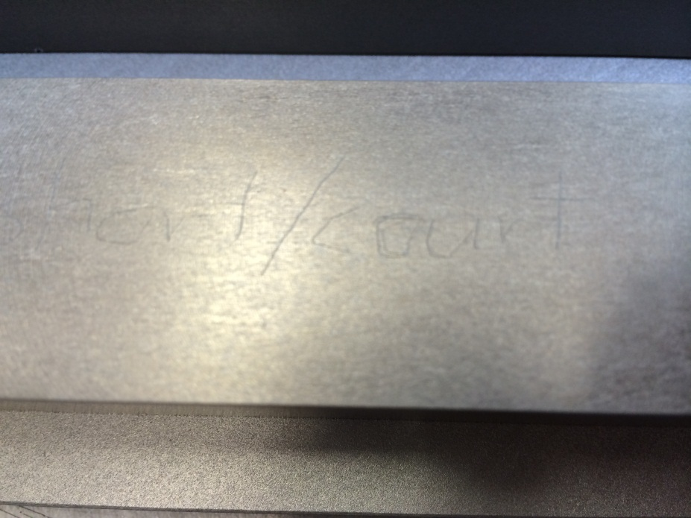

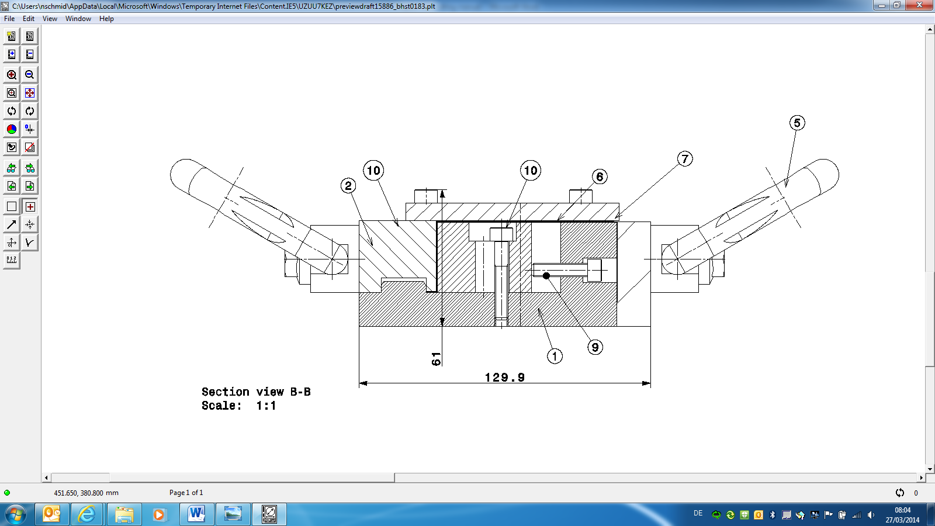Align the foils here

Screw & Part11

(The dark black line is the Kapton foil)

After that place the part 10 on it and don´t forget to put the cut-out straps out of the mould (see picture below-circle) and clamp them well. If the foil is clamped insert the part 11 and fix it with the screws in part 11 and 9.

Then apply part 7 on top and fix it also.

Due to the oversizing you cannot screw the outer screws on part 7, for that use these clamps on both sides.

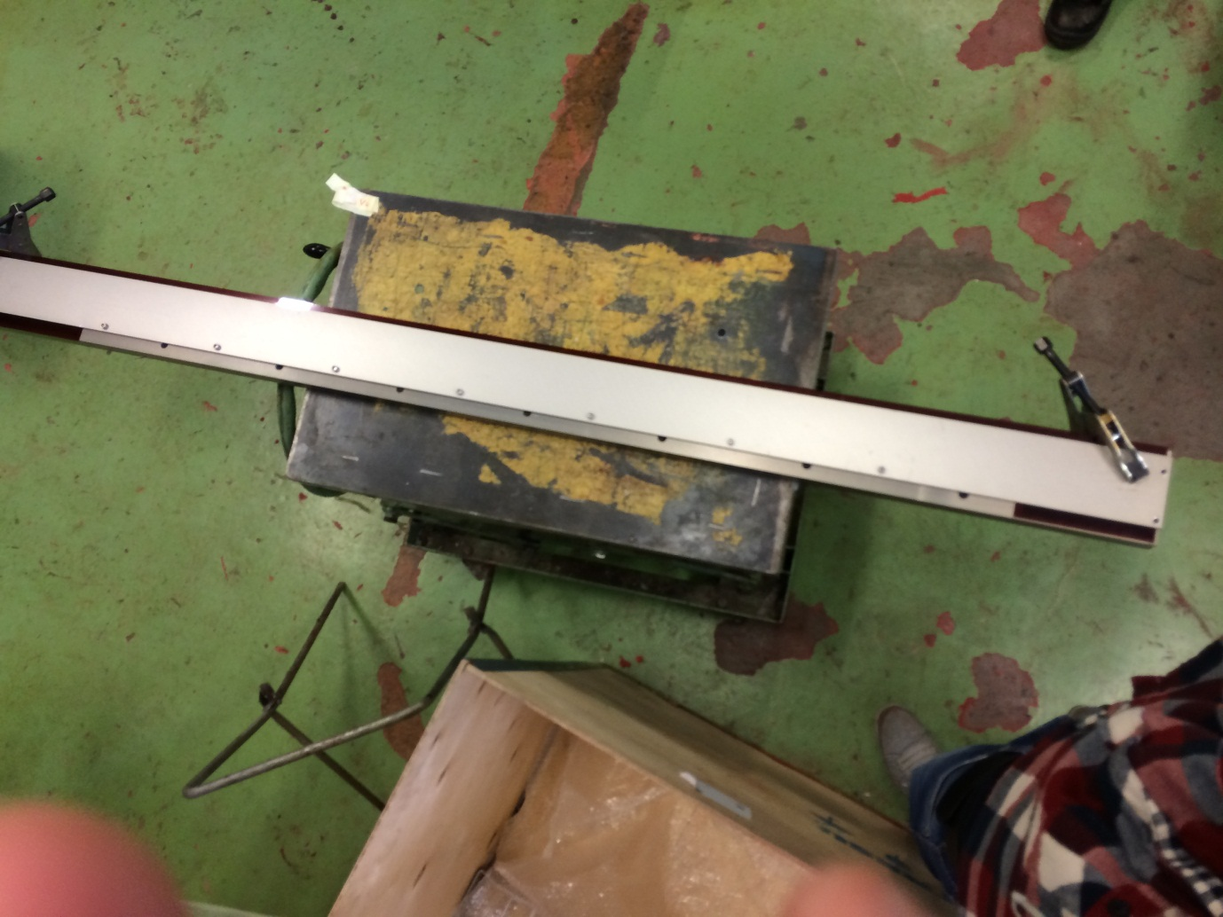

After that it´s ready for the oven.

* After the impregnation disassemble the tool and store the foils in the transparent plastic tube to avoid dust accumulation.