Vincent ROMANET Courdimanche, November 15th, 2018
22 rue des Perdrix
95800 Courdimanche
FRANCE
+33(0)6.66.57.91.97
romanetvin@eisti.eu

Object : Application for Applied Research Scientist Intern at ElementAI (Montréal, Toronto)

Dear Mrs, Mr,

I am currently taking courses for my senior year of Engineering School at Ecole Internationale des Sciences du Traitement de l’Information (EISTI), Cergy-Préfecture, FRANCE and I chose Artificial Intelligence as my major. I met Jean-Philippe LAFORTUNE, User Experience Designer at ElementAI Montréal (jp@elementai.com) during my trip to Montréal and he advised me to apply for an internship for 2019.
Within the framework of my scholarship, I wish to do an end-of-studies internship (6 months) in Artificial Intelligence starting in April 2019.
Having an open mind and being a man of conviction led me to Toronto, ON, CANADA for a volunteering experience in a community-based association and later to Singapore for a student exchange. I also went to MontréaI, QC, CANADA to visit my sister and discover the province of Québec. I deepened my knowledge about Management as I took courses at GEM for a double diploma. I am rigorous in my work and respect very much punctuality. I have an advanced level in English that I try to improve by watching English series without subtitles and also speak Chinese thanks to my mother. For my courses, I mostly code in Python; therefore, I learned to operate many Python libraries such as OpenCV, Scikit-learn, Tensorflow and Keras. I think Deep Learning and Computer Vision are my most preferred topics to work on. I look forward to apply my knowledge on Machine Learning on real datasets. Working for ElementAI would be for me an excellent learning experience to strengthen my future prospects and learn about a new culture; and for you to profit from the perspective of an aspiring-to-become computer science engineer.
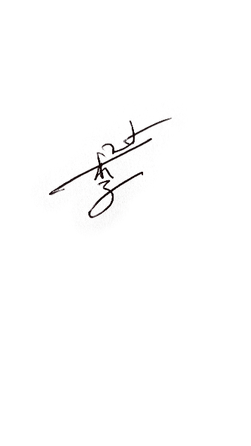
I would appreciate hearing from you; I can be reached at romanetvin@eisti.eu to provide any additional information you might require. Enclosed you will find my résumé. Thank you for your consideration.
Yours sincerely,
Vincent ROMANET

