Vincent ROMANET Courdimanche, November 28th, 2018
22 rue des Perdrix
95800 Courdimanche
FRANCE
+33(0)6.66.57.91.97
romanetvin@eisti.eu

Object : Computer Vision/Graphics Engineer at Nytilus (Montréal, QC)

Dear Mrs, Mr,
I am currently taking courses for my senior year of Engineering School at Ecole Internationale des Sciences du Traitement de l’Information (EISTI), Cergy-Préfecture, FRANCE and I chose Artificial Intelligence as my major.
Within the framework of my scholarship, I wish to do an end-of-studies internship (6 months) in Artificial Intelligence starting in April 2019.
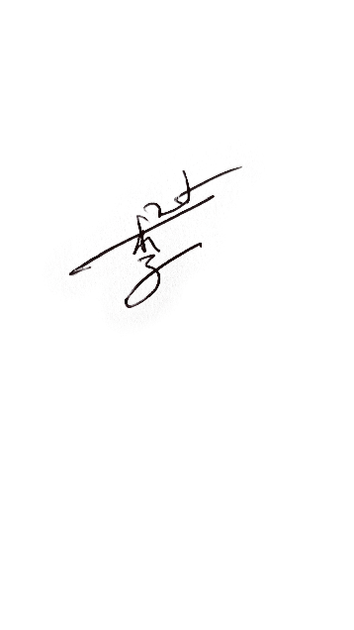
Having an open mind and being a man of conviction led me to Toronto, ON, CANADA for a volunteering experience in a community-based association and later to Singapore for a student exchange. I also went to MontréaI, QC, CANADA to visit my sister and discover the province of Québec. I deepened my knowledge about Management as I took courses at Grenoble Ecole de Management (GEM) for a double diploma. I am rigorous in my work and respect very much punctuality. I have an advanced level in English (TOEIC : 935) that I try to improve by watching English series without subtitles and also speak Chinese thanks to my mother. During the summer 2018, I became an entrepreneur to create a language learning tool app and I was in charge of the marketing, the communication, the graphic design and the IT development. For my courses, I mostly code in Python; therefore, I learned to operate many Python libraries such as OpenCV, Scikit-learn, Tensorflow and Keras. I think Deep Learning and Computer Vision are my most preferred topics to work on. I look forward to apply my knowledge on Machine Learning on real datasets. Working for Nytilus would be for me an excellent learning experience to strengthen my future prospects and learn about a new culture; and for you to profit from the perspective of an aspiring-to-become Artificial Intelligence engineer.
I would appreciate hearing from you; I can be reached at romanetvin@eisti.eu to provide any additional information you might require. Enclosed you will find my résumé. Thank you for your consideration.
Yours sincerely,
Vincent ROMANET

