**Project Log Document**

*(add logo)*

**CSUSM Blog**

Team 2

Romanie Marie Nadia DE MEYER, Kyle BECK, Noah LOPEZ, Bryce TULLER

Description of the document

| **Title** | Project Log Document |
| --- | --- |
| **Objective** | Planning for development objectives |
| **Authors** | Romanie Marie Nadia DE MEYER  Kyle BECK  Noah LOPEZ  Bryce TULLER |
| **Manager** | Romanie Marie Nadia DE MEYER |
| **Email** | demey001@csusms.edu |
| **Keywords** | Brainstorming, Reflection, Story Mapping, Evolution |
| **Last Updated** | 04/15/2024 |
| **Version** | 1.1.1 |

Revision Table

| **Date** | **Version** | **Author** | **Sections** | **Comments** |
| --- | --- | --- | --- | --- |
| 03/04/2024 | 1.0.0 | Romanie De Meyer  Kyle Beck  Bryce Tuller | All | Creation of the document |
| 04/09/2024 | 1.1.0 | Romanie De Meyer | All | Improvement of the document and addition of all requested information |
| 04/15/2024 | 1.1.1 | Romanie De Meyer  Kyle Beck  Bryce Tuller | Database  Meeting minutes | Add the database information  Add the last meeting minutes |
|  |  |  |  |  |

## 

**1. Real-Life Problem Description** **4**

**2. Advantages Over Existing Sites** **4**

**3. Potential Users** **5**

**4. Web Pages and Functionality** **6**

a. Home Page: 6

b. Article Page: 6

c. Categories Page: 7

d. Registration Page: 7

e. Login Page: 8

f. Profile Page: 8

g. Edit Profile Page: 9

h. New Article Page: 9

i. Edit Article Page: 10

j. Delete Article Option: 10

**5. User Interaction** **11**

a. Home Page: 11

b. Article Page: 11

c. Categories Page: 11

d. Registration Page: 11

e. Login Page: 12

f. Profile Page: 12

g. Edit Profile Page: 12

h. New Article Page: 12

i. Edit Article Page: 12

j. Delete Article Option: 12

**6. Data Flow and Interactions** **13**

**7. Design** **17**

**8. Database** **17**

a. ER diagram 17

b. Database schema 18

c. Queries 19

i. CREATE: 19

ii. INSERT: 20

iii. SELECT: 20

iv. UPDATE: 20

v. DELETE: 20

1. 20

d. Content of the tables 20

**9. Team Meeting Minutes** **20**

Mar 4, 2024 20

Mar 13, 2024 21

Mar 20, 2024 21

Mar 27, 2024 22

Apr 3, 2024 22

Apr 10, 2024 22

Apr 15, 2024 23

## 

## Real-Life Problem Description

The internet is saturated with information, making it challenging for users to find relevant and high-quality content. Existing blog platforms often lack user-friendly interfaces and effective engagement features, resulting in a fragmented user experience. Additionally, many users struggle to discover content that aligns with their interests and preferences due to limited categorization and search functionalities.

Our project aims to address these challenges by creating a blog platform that offers intuitive navigation, robust engagement features, and diverse content categories. We aim to provide users with a seamless browsing experience where they can easily discover, engage with, and contribute to a wide range of content tailored to their interests.

## Advantages Over Existing Sites

Our proposed website offers several advantages over other similar existing sites. Firstly, we have implemented a user-friendly interface that enhances the overall browsing experience. With intuitive navigation and clear categorization, users can easily find the content they are looking for without any hassle.

Secondly, our website incorporates a robust upvote/downvote system that allows users to engage with the content more effectively. This feature not only promotes user interaction but also helps in surfacing the most relevant and high-quality content to the top, thereby enhancing the overall user experience.

Furthermore, our platform provides users with the ability to publish a wide range of content types, including articles, personal reflections, reviews, tutorials, and more. This diversity in content ensures that users have access to a rich and varied collection of information, catering to their diverse interests and preferences.

Additionally, our website prioritizes user privacy and security by implementing stringent measures to safeguard user data. We ensure that users have full control over their personal information and provide secure login and registration processes to protect against unauthorized access.

Overall, our proposed website stands out from other similar existing sites due to its user-friendly interface, robust engagement features, diverse content offerings, and emphasis on user privacy and security.

## Potential Users

Our blog platform caters to a diverse range of potential users, including:

1. Regular Users: Individuals seeking informative articles, personal reflections, reviews, tutorials, and other engaging content across various topics.

Regular users can expect to receive curated content tailored to their interests, seamless navigation through intuitive interfaces, and the ability to engage with articles through comments and voting mechanisms.

1. Content Creators: Users interested in publishing their own articles, sharing their expertise, and contributing to the platform's content.

Content creators will benefit from a user-friendly publishing interface, access to a broad audience, and the ability to track the performance of their articles.

1. Administrators: Site administrators responsible for managing user accounts, monitoring content quality, and ensuring the smooth operation of the platform.

Administrators will have access to tools and features for user management, content moderation, and platform optimization, enabling them to maintain a high-quality and engaging user experience.

## Web Pages and Functionality

### Home Page:

* Article Display: The page presents a list of article cards with their titles, publication dates, and excerpts, allowing users to quickly browse through the content offered.
* Intuitive Navigation: The navigation bar enables users to easily navigate between different sections of the blog, such as categories, the home page, and the search page.
* Voting System: Users have the option to vote for articles using the upvote/downvote features, allowing them to express appreciation for the content or flag articles of lesser quality.
* Full Article Display: Users can click on the article cards to view the full content, enabling them to read the entire article and participate in the discussion by leaving comments.

### Article Page:

* Title: The title of the article is prominently displayed at the top of the page, making it easy for users to identify the content they are viewing.
* Content: The main body of the article is presented below the title, allowing users to read the full content. The content is formatted in a visually appealing manner to enhance readability.
* Author: The name or username of the article's creator is provided, giving credit to the author for their contribution to the platform.
* Publication Date: The date when the article was published is included to provide context and indicate the recency of the content.
* Voting Options: Users have the ability to upvote or downvote the article directly from the article page. This feature allows users to express their appreciation for the content or provide feedback on its quality.

### Categories Page:

* Dynamic Category Listing: The page dynamically generates a list of all available categories of articles present on the site. This ensures that users have access to an up-to-date and comprehensive list of categories to choose from.
* Clickable Categories: Each category listed on the page is clickable, allowing users to select a category of interest and view a list of articles associated with that category.
* Associated Articles: Upon clicking on a category, users are redirected to a new page where they can view a list of articles associated with that category. This enables users to easily navigate to content that aligns with their interests.
* Navigation Options: Navigation options, such as a back button or breadcrumb navigation, may be provided to allow users to easily return to the categories page or navigate to other sections of the site.

### Registration Page:

* User Registration Form: The page displays a user registration form where users can input their desired username, email address, password, and any other required information.
* Validation Checks: The registration form may include validation checks to ensure that users provide valid and unique information, such as a valid email address and a strong password.
* Error Handling: If any errors occur during the registration process, such as incomplete or incorrect information, appropriate error messages are displayed to guide users on how to correct their input.
* Submit Button: Once users have completed the registration form, they can click on a submit button to create their account and become registered users of the platform.
* Confirmation Message: After successful registration, users may receive a confirmation message indicating that their account has been successfully created.

### Login Page:

* User Login Form: The page displays a user login form where users can input their username or email address and password.
* Remember Me Option: Users may have the option to select a "Remember Me" checkbox to enable automatic login on subsequent visits, reducing the need to re-enter login credentials.
* Error Handling: If any errors occur during the login process, such as incorrect username/password combination or inactive accounts, appropriate error messages are displayed to guide users on how to proceed.
* Submit Button: Once users have entered their login credentials, they can click on a submit button to log in to their account and access the platform.
* Registration Link: For new users who do not yet have an account, a registration link may be provided on the login page to redirect them to the registration page.

### Profile Page:

* Profile Information: The user profile page displays basic information about the user, such as their username, profile picture, and any additional details they have provided.
* List of User's Articles: A section of the profile page lists all the blog articles created by the user. Each article is displayed as a card or in a structured list format, showing key details such as the article title, publication date, and a brief excerpt.
* Article Interactions: Next to each article listed, there may be options for users to interact with the content, such as liking, commenting, or sharing the article with others.
* Edit and Delete Options: For each article listed, there are options available to edit or delete the article. These options allow users to modify their existing content or remove it from the platform as needed.
* New Article Button: Additionally, the user profile page may include a prominent button labeled "New Article" or "Create Article," allowing users to initiate the blog article creation process directly from their profile.
* Navigation Links: Navigation links or buttons are provided to allow users to easily access other sections of the platform, such as the home page, categories page, or search functionality.

### Edit Profile Page:

* Profile Information Form: The page displays a form where users can edit their profile information, such as their username, email address, profile picture, and any additional details they provided during registration.
* Change Password Option: Users may have the option to change their password by entering their current password and specifying a new one.
* Update Profile Picture: Users can upload a new profile picture or change their existing one by selecting an image file from their device.
* Save Changes Button: Once users have made their desired modifications to their profile information, they can click on a "Save Changes" button to update their account settings.
* Cancel Option: Users may also have the option to cancel the editing process without saving any changes, returning them to their profile page.
* Validation Checks: The edit profile form may include validation checks to ensure that users provide valid and correctly formatted information, such as a valid email address or properly formatted profile picture.

### New Article Page:

* Access via User Profile: The article blog functionality is accessible within the user profile page, providing users with a centralized location to manage their account and create new content.
* New Article Button: Within the user profile page, a prominent button labeled "New Article" or "Create Article" allows users to initiate the blog article creation process.
* Article Creation Form: Clicking on the "New Article" button opens a article creation form where users can input the title, content, category, tags, and any other relevant information for their new blog article.
* Publish Button: Once users have completed the article creation form and are satisfied with their blog article, they can click on a "Publish" button to make their article live and visible to other users on the platform.

### Edit Article Page:

* Access via User Profile: The edit blog functionality is accessible within the user profile page, where users can view a list of articles they have created.
* List of User's Articles: Within the user profile page, a section displays a list of all the blog articles created by the user. Each article is accompanied by options to edit or delete it.
* Edit Option: Next to each article listed, there is an "Edit" icon or button, allowing users to initiate the editing process for that particular article.
* Edit Blog Article Form: Clicking on the "Edit" option opens a blog article editing form pre-filled with the existing content of the selected article. Users can make changes to the title, content, category, tags, or any other information as needed.
* Save Changes Button: Once users have made their desired modifications to the article, they can click on a "Save Changes" button to update the article with the edited content.
* Cancel Option: Users may also have the option to cancel the editing process without saving any changes, returning them to the user profile page.

### Delete Article Option:

* Access via User Profile: Similar to the edit blog functionality, the delete blog option is accessible within the user profile page, where users can view a list of articles they have created.
* Delete Option: Next to each article listed in the user profile page, there is a "Delete" icon or button, allowing users to initiate the deletion process for that particular article.
* Confirmation Prompt: When users click on the "Delete" option, a confirmation prompt appears asking users to confirm their decision to delete the article. This helps prevent accidental deletions.
* Delete Confirmation: After confirming the deletion, the selected article is permanently removed from the platform, and users are redirected back to the user profile page.

## User Interaction

Our home page, article page, category page, and the results of the category page are accessible to everyone, including non-registered users. However, in order to add an article, users need to create an account on our platform.

### Home Page:

* Users' Input: In addition to navigation, users will be able to vote (upvote/downvote) for articles directly from the home page and article page.
* Users' Output: Along with the articles themselves, users will see options to vote for each article, influencing their visibility and ranking on the site.

### Article Page:

* Users' Input: No input from users is expected on this page, as it simply displays the content of an existing article.
* Users' Output: Users will see the title, content, author, and publication date of the selected article.

### Categories Page:

* Users' Input: No direct input from users is expected on this page. They can simply select a category to view associated articles.
* Users' Output: Users will see a list of available categories, and when they click on a category, they will be directed to a page displaying articles from that category.

### Registration Page:

* Users' Input: Users need to enter their username, email address, and password to register.
* Users' Output: After submitting the registration form, users will receive a confirmation of their registration or be redirected to their newly created user profile.

### Login Page:

* Users' Input: Users need to enter their username or email address and password to log in.
* Users' Output: After submitting the login form, users will be redirected to their user profile if they provided valid login information.

### Profile Page:

* Users' Input: No direct input from users is expected on this page. They can simply view their created articles and edit their profile.
* Users' Output: Users will see a list of their created articles and can access options to edit or delete them, as well as their profile form to make changes.

### Edit Profile Page:

* Users' Input: On this page, users can edit their username, email address, profile picture, and other profile details.
* Users' Output: After submitting the changes, users will see their profile updated with the modifications made.

### New Article Page:

* Users' Input: In addition to title, content, and category, users will also be able to upload a photo to accompany their article.
* Users' Output: Once the article is submitted, users will see their article published with the uploaded photo displayed.

### Edit Article Page:

* Users' Input: Users can edit the title, content, or other details of an existing article.
* Users' Output: After submitting the edits, users will see their article updated with the changes made.

### Delete Article Option:

* Users' Input: Users need to confirm their decision to delete an article.
* Users' Output: Once confirmed, the article will be permanently deleted from the site.

## Data Flow and Interactions

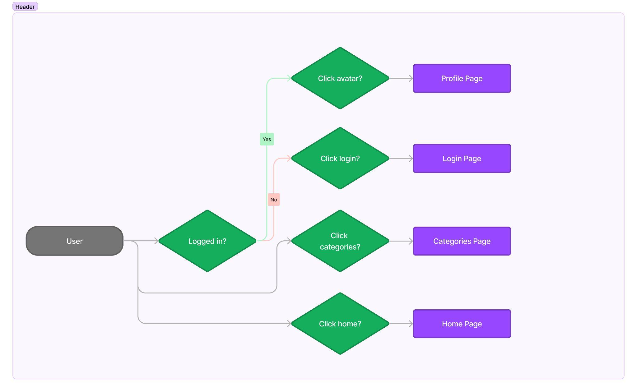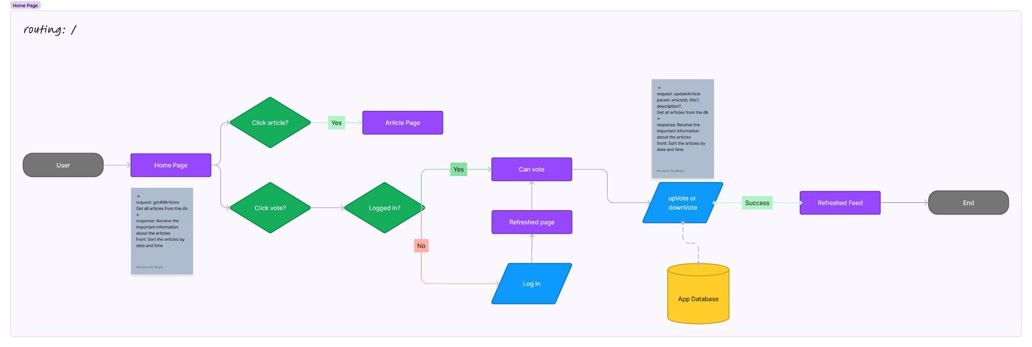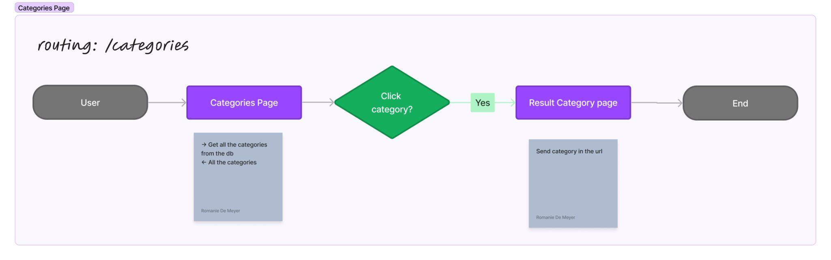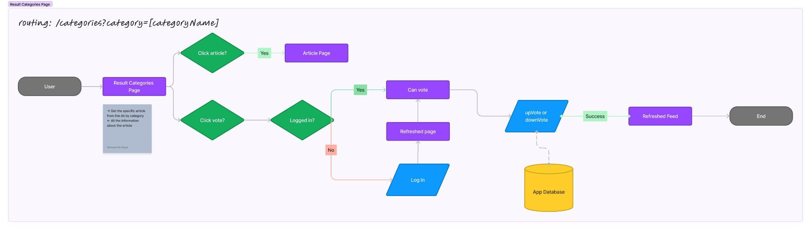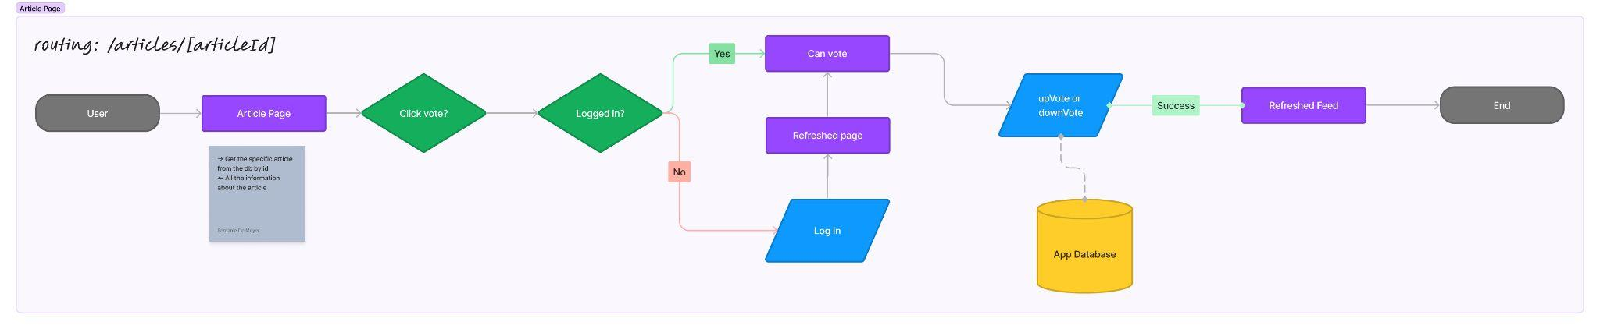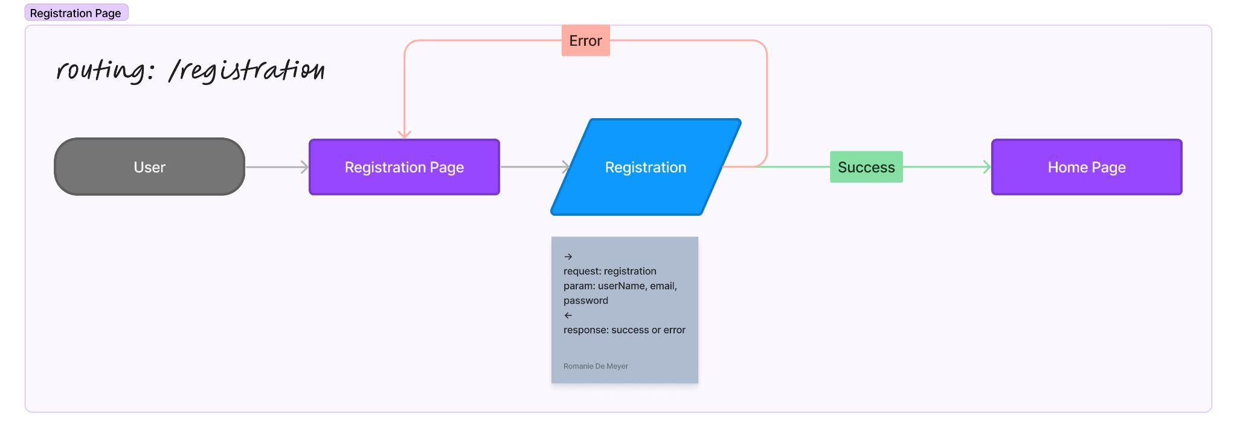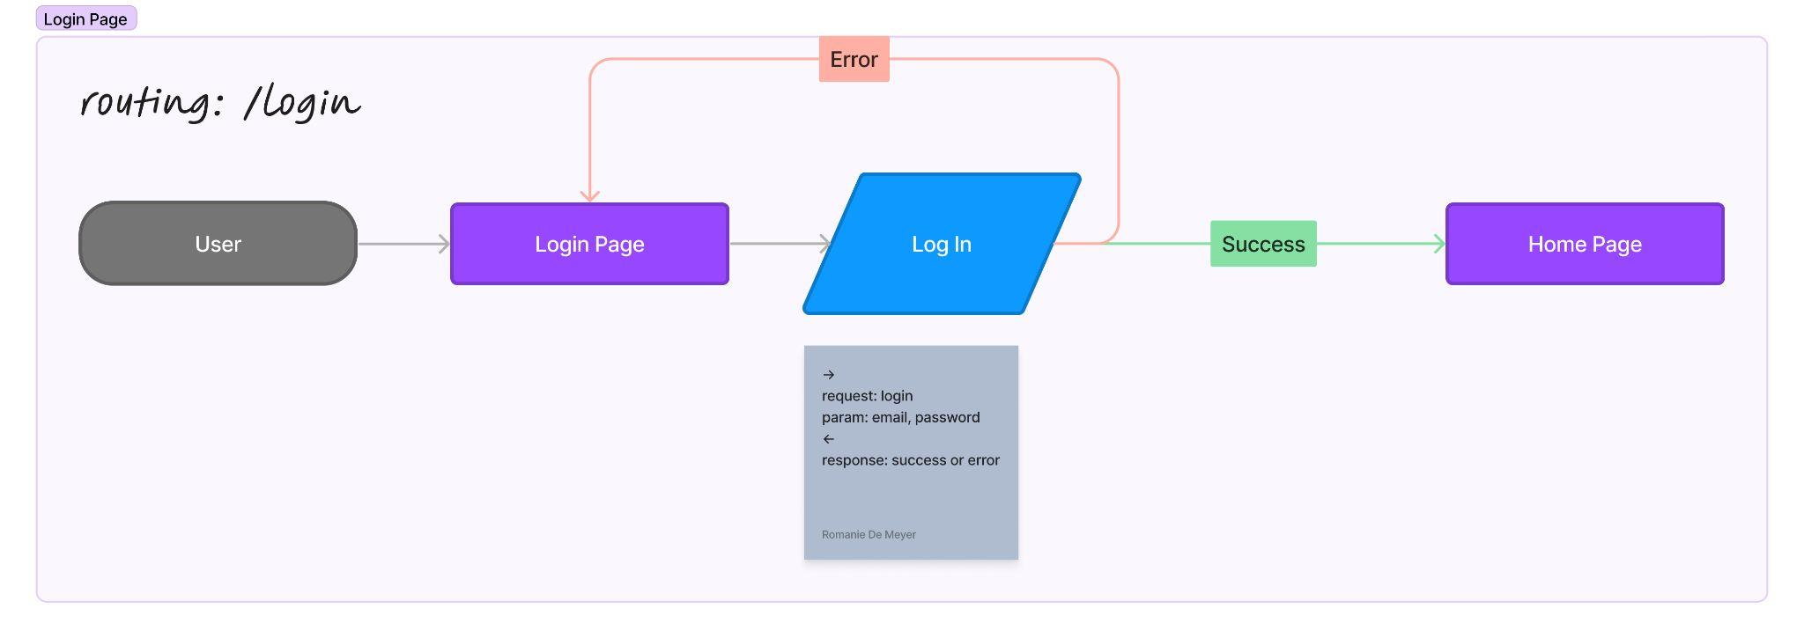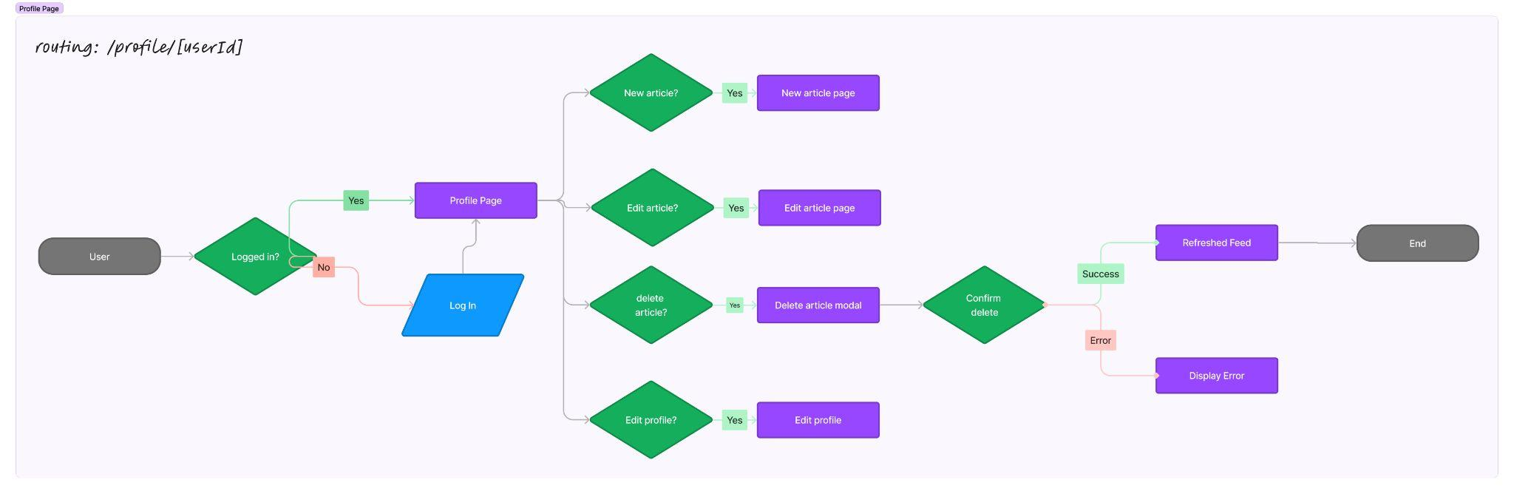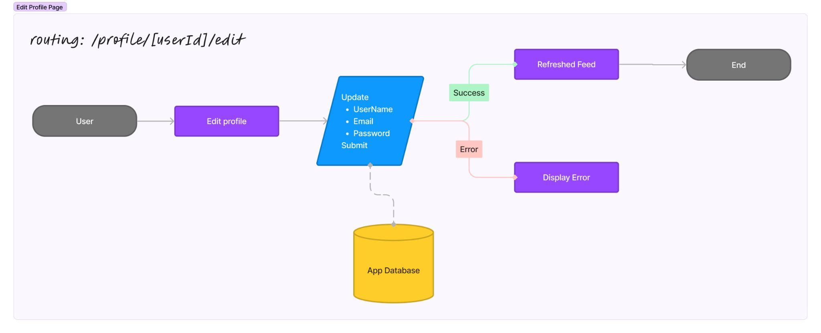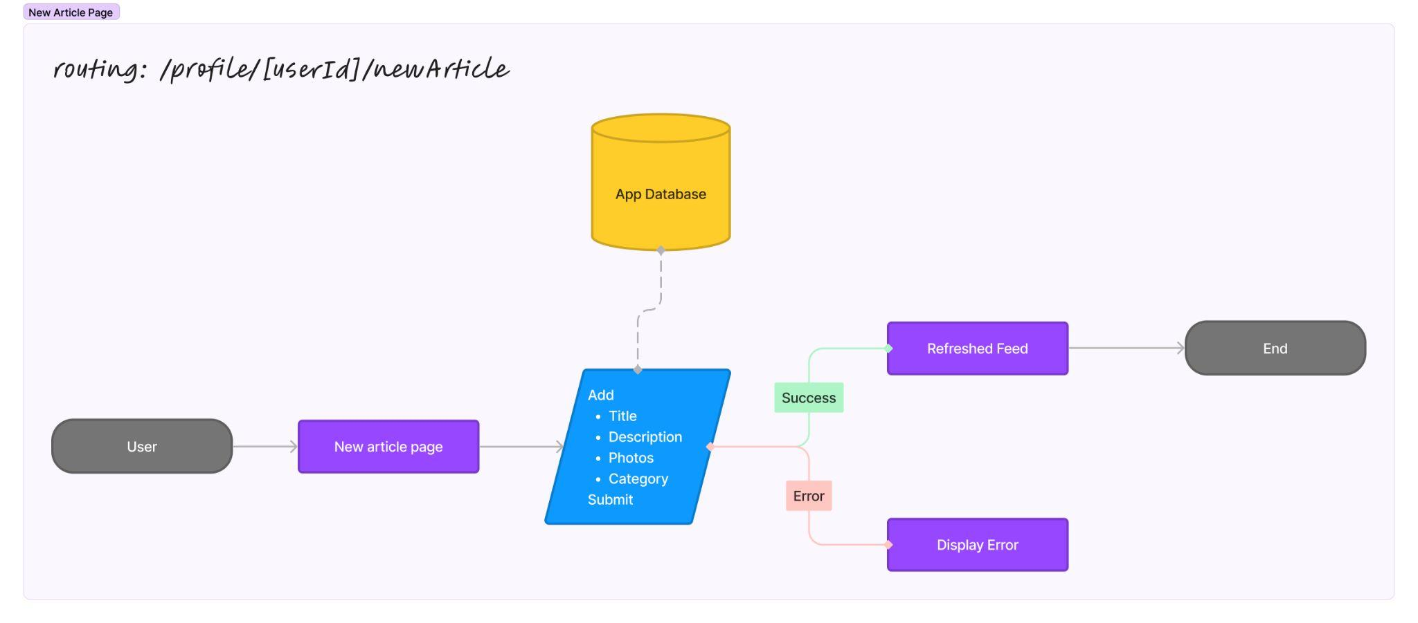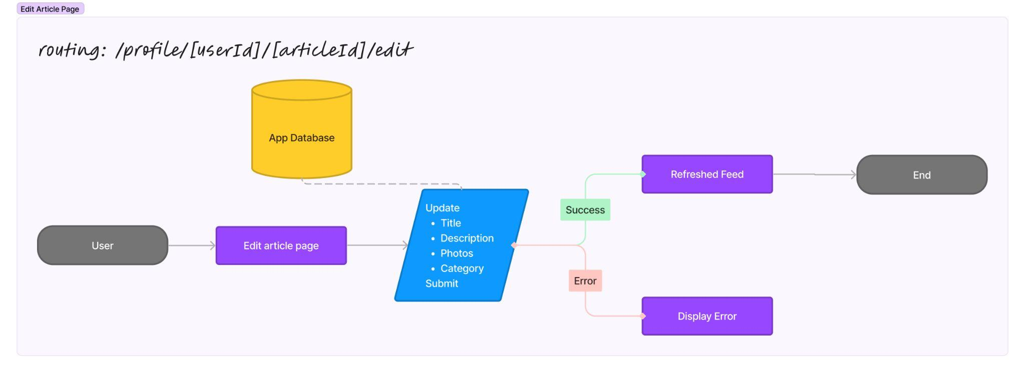

## Design

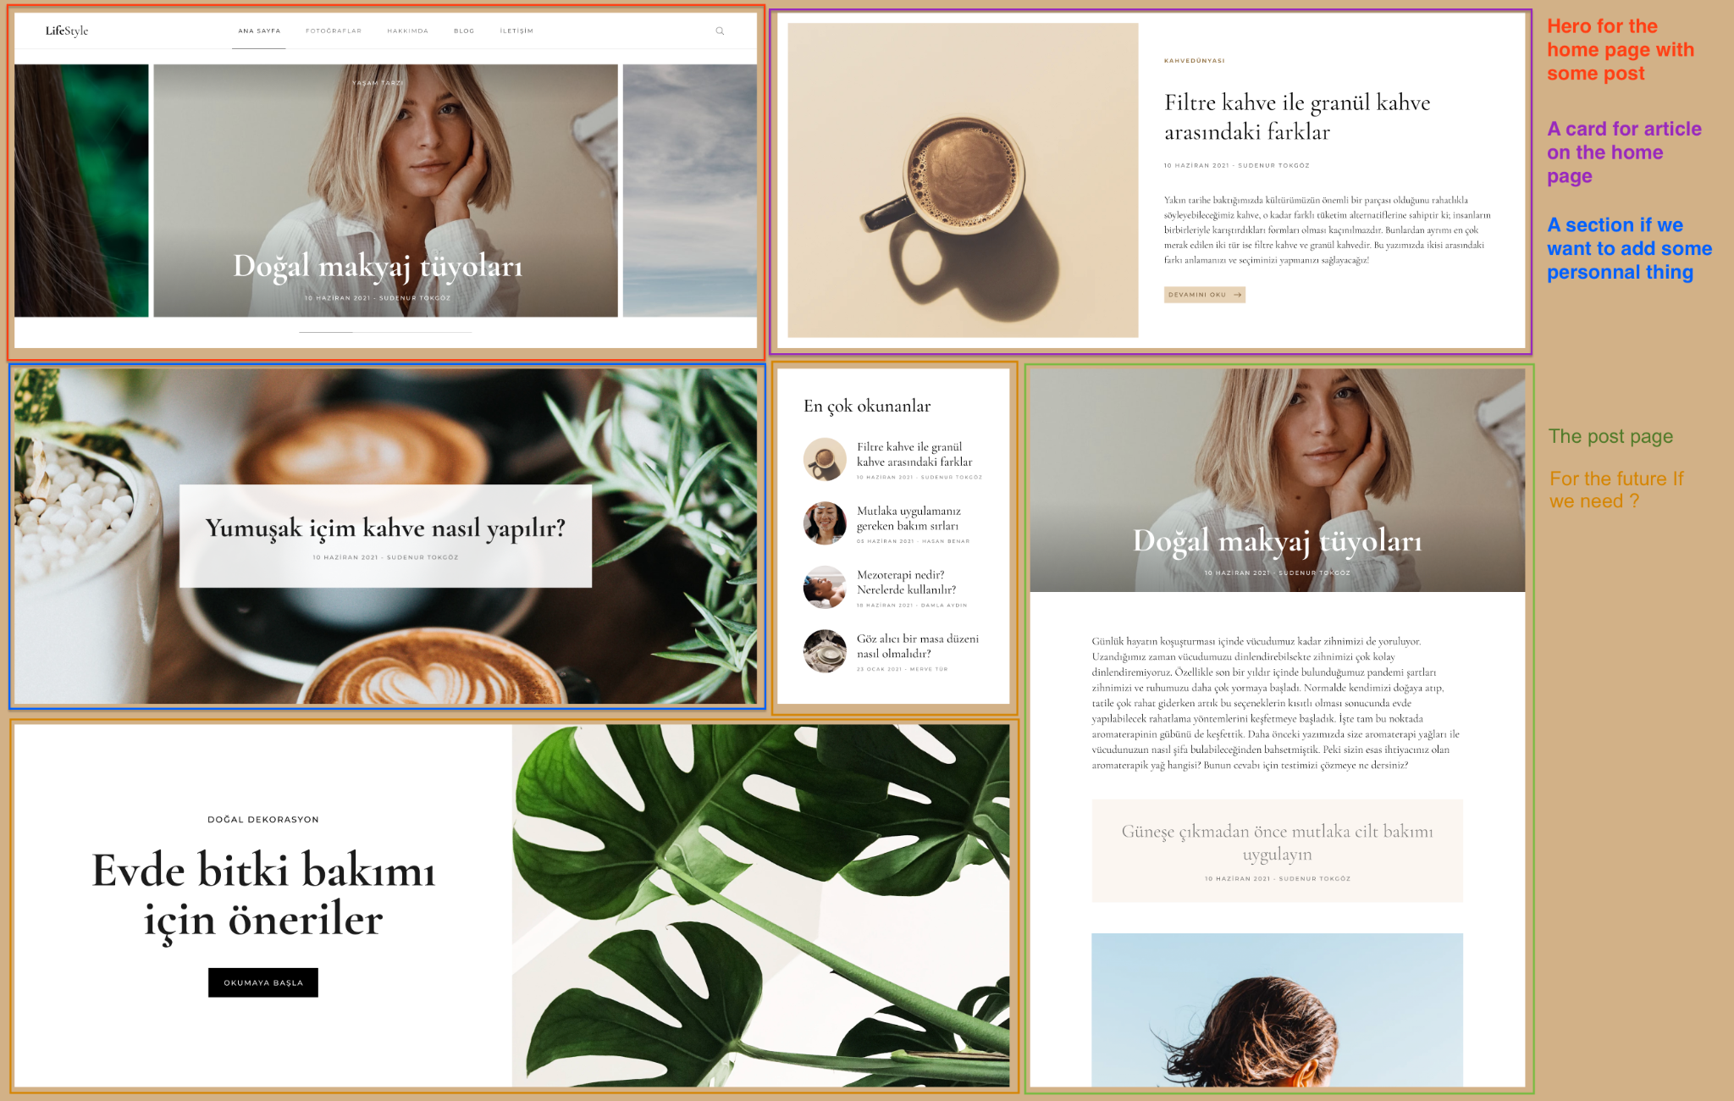

## Database

### ER diagram

## 

### Database schema

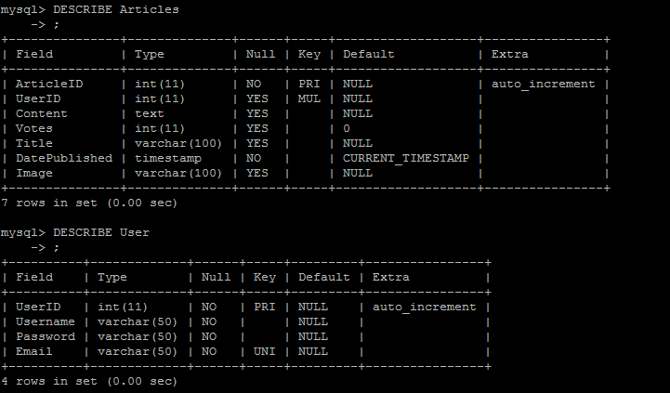

### Queries

#### CREATE:

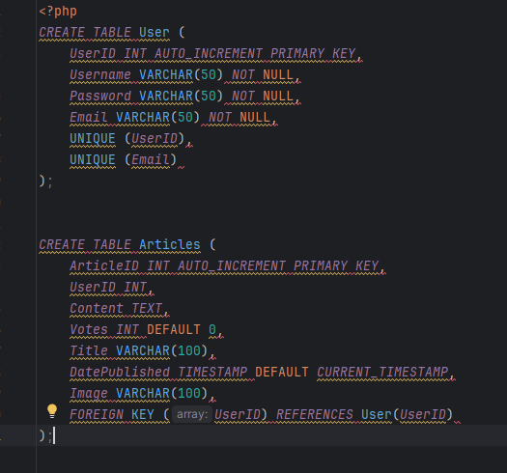

#### INSERT:

#### SELECT:

#### UPDATE:

#### DELETE:

#### 

### Database Interaction

#### Home Page:

Database Interaction:

* Query to retrieve the most recent articles to display on the home page

Display of Results:

* The retrieved articles are displayed as a list with their titles, authors, and publication dates.

#### Article Page:

Database Interaction:

* Query to retrieve details of the selected article (title, content, author, publication date).
* Query to retrieve comments associated with the article.
* Query to retrieve upvotes/downvotes for the article.

Display of Results:

* The article content, comments, and upvotes/downvotes are displayed on the page.

#### Category Page:

Database Interaction:

* Query to retrieve the list of available categories.
* Query to retrieve articles associated with the selected category.

Display of Results:

* Categories are displayed as a list.
* Articles associated with the selected category are displayed with their titles, authors, and publication dates.

#### Login Page:

Database Interaction:

* Verification of user credentials entered by the user.

Display of Results:

* Authorization of access to the user's session if the credentials are valid.

#### Registration Page:

Database Interaction:

* Insertion of new user information into the database.

Display of Results:

* Confirmation of successful registration.

#### New Article Page:

Database Interaction:

* Insertion of the new article into the database with its title, content, category, and other relevant information.

Display of Results:

* Confirmation of successful article creation.

#### Profile Page:

Database Interaction:

* Query to retrieve the list of articles created by the logged-in user.

Display of Results:

* The articles created by the user are displayed as a list.

#### Edit Profile Page:

Database Interaction:

* Update of the user's profile information in the database with the new input data.

Display of Results:

* Confirmation of successful update of the user's profile information.

### Content of the tables

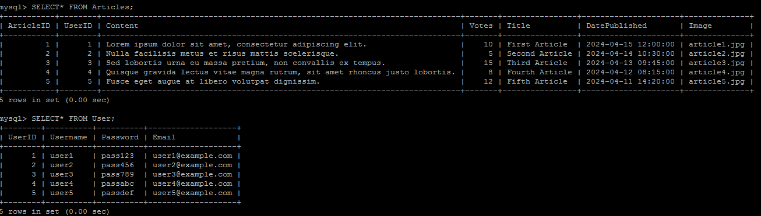

## Team Meeting Minutes

### Mar 4, 2024

Attendees: Kyle, Bryce, Romanie

Notes

* Reflection on the overall idea of the project
* Definition of its different parts
* Selection of roles for each member:
* Romanie: Front-end and Back-end
* Kyle: Front-end and database
* Bryce: Front-end
* Noah: Back-end / database
* Plan to have a meeting each week on Wednesday at 6pm

Action items

* ~~Make the project proposed plan~~
* Create the repository -> Romanie

### Mar 13, 2024

Attendees: Kyle, Bryce, Romanie

Notes

* Plan how we want to connect the web pages
* Come up with CSS for whole site
* This week we will focus on the HTML for each web page

Action items

* ~~Make the project proposed plan~~
* ~~Create the repository -> Romanie~~
* Home page (Title, description) - 2 article sections -> Bryce
* New article page (Title, picture, description, category) -> Romanie
* Make the architecture of the project -> Romanie
* Category Page (Buttons and description for categories) -> Kyle

### Mar 20, 2024

Attendees: Kyle, Bryce, Romanie, Noah

Notes

* Merge all pages
* Review web pages

Action items

* ~~Make the project proposed plan~~
* ~~Create the repository -> Romanie~~
* ~~Home page (Title, description) - 2 article sections -> Bryce~~
* ~~New article page (Title, picture, description, category) -> Romanie~~
* ~~Make the architecture of the project -> Romanie~~
* ~~Category Page (Buttons and description for categories) -> Kyle~~
* Create the result page after clicking on a category -> Noah

### Mar 27, 2024

Attendees: Kyle, Bryce, Noah

Notes

* Merge all pages

Action items

* ~~Make the project proposed plan~~
* ~~Create the repository -> Romanie~~
* ~~Home page (Title, description) - 2 article sections -> Bryce~~
* ~~New article page (Title, picture, description, category) -> Romanie~~
* ~~Make the architecture of the project -> Romanie~~
* ~~Category Page (Buttons and description for categories) -> Kyle~~
* Create the result page after clicking on a category -> Noah

### Apr 3, 2024

Attendees: N/A

Notes

* No meeting, just discord discussion

Action items

* ~~Make the project proposed plan~~
* ~~Create the repository -> Romanie~~
* ~~Home page (Title, description) - 2 article sections -> Bryce~~
* ~~New article page (Title, picture, description, category) -> Romanie~~
* ~~Make the architecture of the project -> Romanie~~
* ~~Category Page (Buttons and description for categories) -> Kyle~~
* Create the result page after clicking on a category -> Noah
* Improve the Plan -> Romanie
* Make the user interaction -> Romanie
* Fix the design for all the pages -> Romanie
* Fix merge on github
* Add the differents script for the Article Page and the New Article Page

### Apr 10, 2024

Attendees: Kyle, Noah, Romanie, Bryce

Notes

* Log In Required
* Delete article option
* Update Article

Action items

* ~~Make the project proposed plan~~
* ~~Create the repository -> Romanie~~
* ~~Home page (Title, description) - 2 article sections -> Bryce~~
* ~~New article page (Title, picture, description, category) -> Romanie~~
* ~~Make the architecture of the project -> Romanie~~
* ~~Category Page (Buttons and description for categories) -> Kyle~~
* Create the result page after clicking on a category -> Noah
* ~~Improve the Plan -> Romanie~~
* ~~Make the user interaction -> Romanie~~
* Fix the design for all the pages -> Romanie
* Fix merge on github
* ~~Add the differents script for the Article Page and the New Article Page~~
* Categories page and ERDs -> Kyle
* Registration page/ log in -> Bryce

### Apr 15, 2024

Attendees: Kyle, Noah, Romanie, Bryce

Notes

* Working on database submission.

Action items

* ~~Make the project proposed plan~~
* ~~Create the repository -> Romanie~~
* ~~Home page (Title, description) - 2 article sections -> Bryce~~
* ~~New article page (Title, picture, description, category) -> Romanie~~
* ~~Make the architecture of the project -> Romanie~~
* ~~Category Page (Buttons and description for categories) -> Kyle~~
* ~~Create the result page after clicking on a category -> Noah~~
* ~~Improve the Plan -> Romanie~~
* ~~Make the user interaction -> Romanie~~
* Fix the design for all the pages -> Romanie
* ~~Fix merge on github~~
* ~~Add the differents script for the Article Page and the New Article Page~~
* ~~Categories page and ERDs -> Kyle~~
* ~~Registration page/ log in -> Bryce~~