Weibo
One of the sources we need to scrap was the Weibo website. We retrieve the publications and the comments about Airlines companies and fly experience. In this report, we’re going to explain in a first time which data we scrap and the format of these data. In a second time, we’re going to develop our scraping method and how we automate the code with a robot and we’re going to finish with some statistics.
I Format of scraped data :
The table below summary all data we scraped and give their type and a description of what is the column.
Variable name | Type | Description
Data_Source | string | Source
Date_publication | date | Date of publication
Description | string | Description of publication
Nb_sharing | int | Number of sharing
Likes | int | Number of likes
Nb_comments | int | Number of comments

Scrapping steps :

- Creation of search equations
- for each equation we get the source code of the page.
- For each publication of each page, we will retrieve and save the different variables in a dictionary if the publication is recent. Then we translate the publication the english
- The dictionnary values feed the json file.

To load website and get the data we use the packages requests and BeautifulSoup. For the translation we use TextBlob, it’s a package using the google translate API.

Some stats:

To get the search equations we use 3 lists: One contain the air companies names, another the list of Boeing models and the last one contain the list of Airbus models.
We combine the Aircompanies list with the models lists. Then we combine the final list with the root of the website. We finally have 3431 url.

We got no null value on the variables that we get with the scraping

len_publication refers to the length of the publication’s description
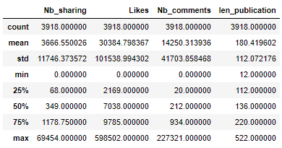

Histogram for each numeric column (length of text publication included):
