Weibo

Scrapping information about Airlines companies

variable
Nom variable | Type | Description
Data_Source | string | Source
Date_publication | date | Date of publication
Description | string | Description of publication
Date_publication | date | Date of publication
Nb_sharing | int | Number of sharing
Likes | int | Number of likes
Nb_comments | int | Number of comments

Scrapping steps :

- Création of search equations
- for each equation we get the source code of the page.
- For each publication of each page, we will retrieve and save the different variables in a dictionary if the publication is recent. Then we translate the publication the english
- The dictionnary values feed the json file.

To load website and get the data we use the packages requests and BeautifulSoup. For the translation we use TextBlob, it’s a package using the google translate API.

Some stats:

To get the search equations we use 3 lists: One contain the air companies names, another the list of Boeing models and the last one contain the list of Airbus models.
We combine the Aircompanies list with the models lists. Then we combine the final list with the root of the website. We finally have 3431 url.

We made some stats on a sample of 30 publications without filtering the publication’s date.

We got no null value on the variables that we get with the scraping

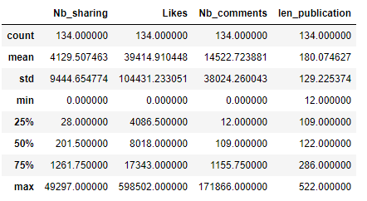
len_publication refers to the length of the publication’s description

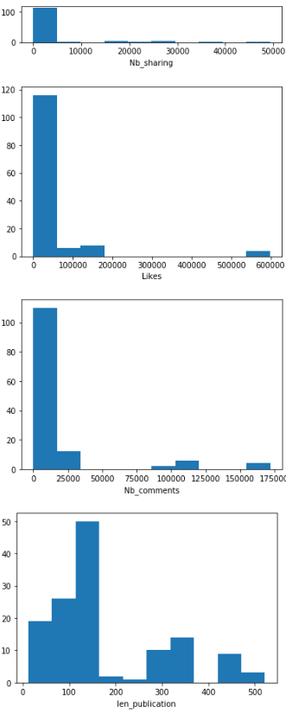
Histogram for each numeric column (length of text publication included):

