Project
Plan
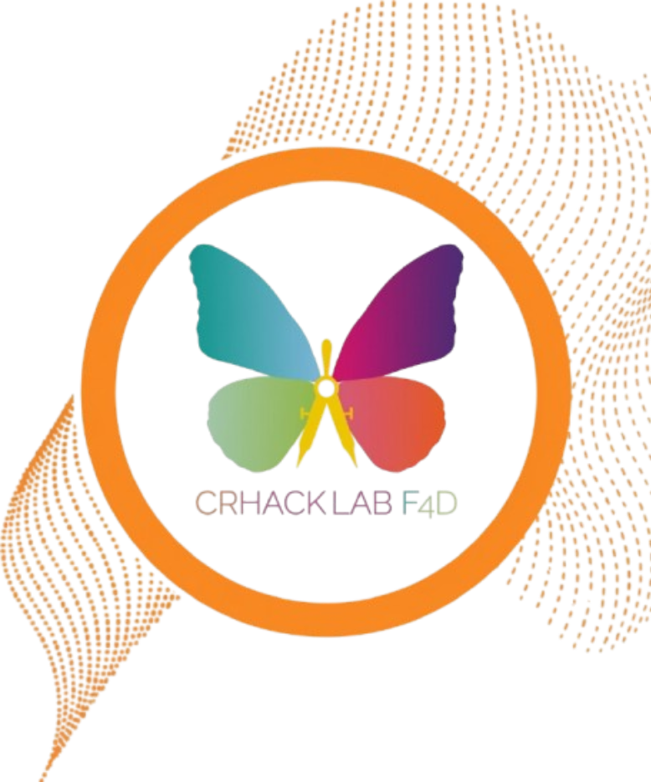
Thomas More
2025-2026

Roman Janssens

Table of contents
1. Company & Background 3
1.1. Internship Organization 3
1.2. Context of the Internship Assignment 3
2. Objectives 4
2.1. Objectives 4
3. Business Case 4
4. Project planning 5
5. Progress Reporting 5
6. Team & Responsibilities 6

Company & Background

Internship Organization
The internship takes place at EGINA, European Grants International Academy and CRHackLab Foligno 4D, two closely connected organizations based in Foligno, Italy. EGINA is a non-profit organization that focuses on education, social innovation, and digital transformation. It manages local, national, and European projects and works with experts in education, culture, and technology to design and implement initiatives that promote digital skills and innovation.

CRHackLab is a volunteer-driven innovation lab that operates within the same building as EGINA. Its mission is to give young people, especially those from disadvantaged backgrounds, the opportunity to develop digital and technological skills. The lab also organizes cultural and technological events, including the C.R.E.A. Cultura Festival, which relies on IT systems being ready in advance.

The team consists of approximately 30 people, including 9 interns. While most of the organization works together on different projects, the IT tasks related to this internship are mostly done independently. I work closely with my mentor, Paolo, who assigns tasks, provides guidance, and gives feedback. When he is unavailable, I can ask Gabriele, another IT colleague, for support.

Context of the Internship Assignment
My internship takes place within the IT section of CRHackLab / EGINA, where I focus on system management, application deployment, and documentation. The work is mostly independent, but I receive daily guidance from my mentor, Paolo, and occasional support from colleague Gabriele when needed.

The main goal of my internship is to deploy and maintain key systems on the organization’s NAS using Docker, especially Federated Wiki and a media library (Piwigo). These two systems are a priority because they need to be operational before the C.R.E.A. Cultura Festival, which is one of the organization’s major events.

In addition to deploying these systems, I am responsible for documenting all workflows, configurations, and deployment steps. This documentation ensures that future interns or team members can understand and maintain the systems easily.

All progress, daily activities, and reports are managed through a Trello board, where I update my daily reports and weekly reports. These reports describe the work I performed, any problems I encountered, and the solutions I applied. My mentor and my coach review these reports to monitor progress and provide feedback.

Communication with the team and across projects happens mainly through Telegram, with specific channels for different sections. This allows me to stay informed and ask questions when necessary while working independently on IT assignments.

Objectives

Objectives
The main objective of my internship is to support and improve the IT infrastructure of CRHackLab / EGINA while developing my own practical skills in system administration, application deployment, and project documentation.

In the first weeks, my focus is on deploying Federated Wiki and Piwigo on the NAS using Docker, ensuring these systems are fully operational before the C.R.E.A. Cultura Festival. This includes configuring the applications, managing dependencies, and verifying system stability.

Another key objective is to document all workflows and system configurations, creating clear instructions that can be used by future interns or team members. This documentation includes deployment steps, configuration details, and troubleshooting procedures.

Beyond the priority systems, the internship also aims to:
- Explore and test additional IT tools, such as private cloud solutions, password management systems, and local AI environments.
- Improve the efficiency, security, and maintainability of the organization’s IT systems.
- Develop and maintain daily and weekly reports on Trello, providing an overview of completed tasks, encountered problems, and solutions applied.

Finally, the internship has a personal development objective, allowing me to gain experience in working independently on real IT projects, managing priorities, and collaborating with a mentor and small team while learning to adapt to challenges in a professional environment.

Business Case
The internship project provides significant value to CRHackLab and EGINA by ensuring that critical IT systems are properly deployed, functional, and documented. By setting up Federated Wiki and Piwigo on the NAS, the organization will have reliable tools for knowledge management, media storage, and collaboration, which are essential for both internal projects and public events such as the C.R.E.A. Cultura Festival.

Documenting workflows and system configurations creates a structured knowledge base that can be used by future interns and team members. This reduces the time needed to learn and manage IT systems, minimizes errors, and ensures continuity even if staff members are unavailable.

The project also contributes to innovation and experimentation. By exploring additional IT tools such as private cloud systems, password management solutions, local AI environments, and Docker deployment strategies, the organization can improve efficiency, maintain security, and discover new ways to support projects and events.

Overall, the internship aligns with the goals of CRHackLab and EGINA by combining practical IT support with knowledge sharing and technological innovation. It ensures that essential infrastructure is reliable while providing the team with opportunities to test new solutions in a controlled environment.

Project planning
Phase | Timeline | Main Tasks | Deliverables / Milestones | Meetings / Feedback
Preparation | Before internship | Discuss objectives with coach, set expectations, access tools | Foundation established, tools ready | /
Initiation | Weeks  1-3 | Create and refine project plan. Start daily and weekly reporting on Trello. familiarize with NAS, Docker, and key applications. Deploy priority projects (Federated Wiki and Piwigo). | Project plan finalized, first reports on Trello | Kick-off meeting at end of week 2 with mentor and coach
Realization | Weeks  4-12 | Execute remaining internship assignments, including private cloud setup, password management migration, local AI experiments, Paper Playground tests, Tailscale setup, VoIP system exploration, Zorin OS experiments, and other IT improvements. Continue documentation and reporting. | Systems deployed and documented, realization thesis, reflections, portfolio updated | Two evaluation meetings with mentor and coach

Progress Reporting
Progress during the internship is tracked using a combination of daily updates, weekly reports, and project documentation. Daily work is summarized in the daily report document, where I record the tasks I completed, problems encountered, and solutions applied. These reports are uploaded to the Trello board, which serves as the central platform for tracking all internship activities, documents, and project plans.

Weekly summaries are also maintained on Trello, providing a broader overview of progress, milestones achieved, and any challenges or adjustments required. These reports are reviewed by my mentor, Paolo, and by my Thomas More internship coach, ensuring that both organizational and academic requirements are met.

In addition to written reporting, progress is monitored through daily in-person check-ins with Paolo. These meetings allow for immediate feedback, discussion of priorities, and guidance on any technical or organizational issues. When Paolo is unavailable, I can consult with Gabriele, who provides support and advice on IT-related tasks.

All communication with the wider team happens primarily through Telegram, which allows for real-time updates, coordination, and collaboration on shared tasks. This structured combination of written reports, daily meetings, and team messaging ensures that my work is transparent, progress is continuously monitored, and any issues are addressed promptly.

Team & Responsibilities
During my internship, I work primarily independently on IT tasks, including deploying applications, managing the NAS, and documenting workflows. Despite working alone for most assignments, I am closely supported by my mentor, Paolo, who assigns tasks, provides guidance, and gives feedback on progress. I meet with him daily to discuss completed work, plan next steps, and address any challenges.

In cases where Paolo is unavailable, I can also seek assistance from Gabriele, a colleague in the IT section who is familiar with the systems and can provide technical advice.

The broader CRHackLab / EGINA team collaborates on other projects, but IT tasks related to my internship are mostly independent. Team communication happens through Telegram, which allows for quick updates, questions, and coordination with other sections if needed.

My Thomas More internship coach monitors my overall progress, reviews my daily and weekly reports, and provides guidance on academic requirements and professional development. This ensures that my work aligns both with organizational goals and the expectations of the internship program.

In summary, the team structure combines independent work with accessible mentorship, ensuring I can complete tasks effectively while receiving support and feedback when needed.

