

**DATA VISUALIZATION FINAL PROJECT**

**Decoding Happiness: Uncovering Challenges and Proposing Solutions in Lebanon**

**Suliman S. Olayan School of Business - AUB**

**Fall Term 2023/2024**

**MSBA 325**

**Supervised by:**

Dr. FOUAD ZABLITH

**Prepared by:**

Hassan Dbouk

Karl Lameh

Yara Nassar

Sasha Nasser

Romanos Rizk

Rita Salloum

**Abstract**

This comprehensive report delves into Lebanon's declining happiness index, attributing it primarily to the economic crisis since 2019. The study identifies GDP as a pivotal factor influencing happiness and explores its components, revealing a significant decline, especially in government spending and investments. The analysis further uncovers positive trends in net exports, indicating potential for improvement. To address these challenges, the report proposes targeted reforms, including measures to attract foreign direct investment, enhance transparency in public projects, and prioritize key sectors like health, education, and infrastructure. The strategic focus on GDP not only addresses economic issues but also positively impacts other happiness index components, such as life expectancy and government trust. The situation in Singapore was also highlighted to show the positive impact of fiscal reforms on the economy and comparisons with the situation in Lebanon were drawn. The report concludes by emphasizing the necessity of specific reforms to reverse the economic downturn and elevate happiness levels in Lebanon. Overall, this study provides a detailed examination of Lebanon's economic and happiness landscape, offering concrete solutions for policymakers to consider.

Table of Contents

1.1 - Introduction to Happiness: 5

1.2 - Introduction to Happiness Index: 5

1.3 - The Components of the Happiness Index: 5

II - Problem Evidence & Background Information: 6

III - Objective of the Study 7

IV - Methodology: 7

V - Factors Affecting Happiness in Lebanon: 8

5.1 - GDP as a Main Factor: 8

5.2 - Lebanon’s GDP Over the Years: 8

5.3 - The GDP Formula: 9

5.4 - Consumption: 9

5.5 - Net Exports: 10

5.6 - Private Investment: 10

5.7 - Government Spending: 10

VI - Findings: 11

VII - Solutions and Recommendations 11

7.1 - Improving Private Investment: 11

7.2 - Increasing and Regulating Government Spending: 12

A. Health Sector: 12

B. Education Sector: 13

C. Infrastructure: 13

7.3 - Improving Net Exports: 14

7.4 - Enhancing Transparency and Accountability: 14

7.5 - Situation in Singapore: 15

Conclusion: 15

Appendix: 17

References: 26

Datasets: 26

Table of Figures

Figure 1 Lebanon's Happiness Ranking in the MENA Region 16

Figure 2 Bottom 10 Ranking Countries for Happiness 16

Figure 3 Lebanese Happiness Score over the years 17

Figure 4 Lebanese Happiness Score Explained by 18

Figure 5 Variation of GDP in Lebanon 19

Figure 6 Consumption 20

Figure 7 Net Exports 21

Figure 8 Investments 22

Figure 9 Government Expenditure 23

Figure 10 GDP in Singapore 24

I - Introduction

## **1.1 - Introduction to Happiness:**

Being in a state of happiness is a complicated and diverse mental and emotional condition that involves feeling content, pleased, and fulfilled with one's life. It is a crucial part of being human and has been a topic of study in philosophy, psychology, and science for many years. The pursuit of happiness is a universal human goal that goes beyond cultural, geographic, and socioeconomic limitations.

Furthermore, happiness is a highly subjective concept. It is a deeply personal and individual experience that can vary greatly from person to person. What brings one person immense joy and fulfillment may not have the same effect on someone else. This subjective nature of happiness is influenced by a multitude of factors, including personal and environmental circumstances.

However, Quantification is a major step to understanding the happiness state across a population, uncovering problems, and proposing solutions.

With happiness being an important factor in a person’s life, is it possible to **quantify this emotion, in an attempt to create policies that would improve the overall well-being of a population?**

## **1.2 - Introduction to Happiness Index:**

Acknowledging the importance of happiness, the United Nations Sustainable Development Solutions Network introduced the World Happiness Report in 2012. This report assigns a ranking to nations according to their Happiness Index which is a measure derived from a comprehensive survey that considers various factors such as income, social support, life expectancy, freedom to make life choices, generosity, and perceptions of corruption, to measure subjective well-being.

The United Nations Sustainable Development Solutions Network, through the World Happiness Report, aims to offer insights into the factors that influence a country’s overall happiness and encourage policymakers to prioritize well-being in their decision-making.

## **1.3 - The Components of the Happiness Index:**

Income:

* This criterion evaluates the average earnings of individuals in a specific country. Although money alone cannot ensure happiness, it is still considered a crucial factor. Higher income levels can provide people with increased access to resources, opportunities, and a more comfortable standard of living.

Social Support:

* Having a group of friends, family, and a social network that can offer aid and emotional support is what social support refers to. Having strong social connections is often associated with happiness and plays a role in creating a sense of belonging, security, and resilience.

Life Expectancy:

* Life expectancy is the average number of years a person can expect to live. Generally, longer life expectancy indicates better healthcare, living conditions, and well-being.

Freedom to Make Life Choices:

* This measure assesses individuals' perceived ability to make choices that shape their lives. Autonomy and personal decision-making contribute to a sense of well-being and happiness.

Generosity:

* The level of generosity in a country can be determined by the frequency of charitable donations, volunteerism, and other prosocial behaviors that are exhibited by its people. Engaging in acts of kindness and generosity not only brings happiness to both the giver and receiver but also contributes to higher levels of well-being in societies that prioritize giving.

Perceptions of Corruption:

* This criterion assesses corruption levels in both the public and private sectors, highlighting the detrimental effects on trust and quality of life. Countries with lower corruption rates often have higher levels of happiness.

# II - Problem Evidence & Background Information:

**Economic Crisis in Lebanon:**

Lebanon is currently experiencing a severe economic crisis, characterized by multiple challenges. The country has one of the highest debt-to-GDP ratios globally, resulting in a risky financial situation aggravated by a shortage of foreign currency reserves.

Widespread unemployment, currency depreciation, and overall economic instability have heightened stress and anxiety among people. Furthermore, due to declining income and living standards, people have limited access to essential services, which in turn has led to a decrease in overall life satisfaction. The economic challenges have also led to social and political unrest, which has created a sense of insecurity and discontent among people.

To study the effects of the economic crisis on Lebanon, it is eye-opening to see how its ranking has changed over the years. In 2022 and 2023, Lebanon ranked last in Happiness within the MENA region with a Happiness Index of 2.392. (Figure 1)

However, the most drastic demonstration of the effect of the crisis is represented when looking at the global ranking of the country. In 2023, out of 137 countries in the World Happiness Report, Lebanon ranked 136th just above Afghanistan. As reported by CNN, average life evaluations in the country are more than 5 points lower than the ones in the 10 happiest countries on the list (on a scale from 0 to 10). (Figure 2)

The continuous economic struggles have put a strain on mental health and social cohesion, leading to a noticeable decline in Lebanon's happiness index. These factors highlight the complex relationship between financial stability and the subjective well-being of a nation. (Figure 3)

# III - Objective of the Study

This study aims to evaluate the key indicators affecting the happiness index in Lebanon and its decline throughout the years, through which a framework of policies will be designed to improve the overall happiness and well-being of the Lebanese population.

# IV - Methodology:

To begin our research, we analyzed the Happiness Score Data, a time series dataset published by the United Nations Sustainable Development Solutions Network, that was obtained from Kaggle. This dataset comprises happiness scores for all countries worldwide from 2015 to 2023. We performed data cleaning procedures, including standardizing field names and filtering out irrelevant data that was not pertinent to our research focus. At this stage, Microsoft Excel and Python were used as tools for data cleaning to consolidate datasets spanning multiple years into a single comprehensive data frame.

To understand the factors that influence happiness, we identified the Happiness Score as the primary measure and considered GDP, Social Support, Life Expectancy, Freedom to Make Life Choices, Generosity, and Perception of Governmental Corruption as influential pillars. We used Tableau as our analytical tool and created multiple sheets and dashboards to establish connections between happiness and each contributing factor. This approach allowed us to observe happiness trends over time, starting from a global perspective and narrowing down to the MENA region and eventually focusing on Lebanon.

As happiness was found to be closely linked to quantifiable economic metrics, we referenced the World Development Indicators (WDI) datasets, to obtain insights regarding the GDP and Net Exports. Studies and reports conducted by Statista were also used during the analysis phase, to extract data about the government expenditure and consumption in Lebanon. The data regarding the investment was calculated in Excel using the GDP formula. Tableau was again used to visualize and interpret the complex relationships between happiness and the available indicators.

The subsequent phase involved processing and organizing the findings into coherent dashboards, which were then shared on AUB's Visualization Blogpost hosted on WordPress. This platform served as a medium to disseminate our insights, make the research accessible to a wider audience, and foster transparency in our methodology and outcomes.

# V - Factors Affecting Happiness in Lebanon:

## **5.1 - GDP as a Main Factor:**

The United Nations Sustainable Development Solutions Network introduced the following factors as pillars that explain happiness: GDP, Generosity, Freedom, Social Support (Family), Life Expectancy, and Government Trust.

Studying the state of these factors is pivotal for our study, where observing which of these factors affects happiness the most can be a starting point for an in-depth understanding of the problem’s root cause, after which solutions are proposed accordingly.

For that reason, a bar chart that explains these factors over the years was developed. The figure below illustrates the weight of these factors in Lebanon’s happiness index for the year 2023. (Figure 4)

As the bar chart shows, GDP is perceived to be the main factor that would contribute to the Lebanese happiness score. This means that for the year 2023, the Lebanese population expressed that the economic situation around them is a major contributor to their happiness levels.

Since GDP is the main player contributing to the happiness level of the Lebanese population, further analysis should be conducted:

## **5.2 - Lebanon’s GDP Over the Years:**

As an initial step, the line chart shown in the figure below was developed, showing the state of Lebanese GDP over the years. It can be seen that the Lebanese GDP reached its highest point of $55 Billion in 2018 and then started decreasing. With the beginning of the economic crisis in 2019, GDP began its free fall reaching $23 Billion in 2021, meaning that Lebanon lost more than half of its GDP in 3 years. (Figure 5)

Considering such a dramatic decrease, and knowing that GDP is the main contributor to the happiness index in Lebanon, our study will now focus on understanding the Lebanese GDP, and identifying what stands behind its deteriorating state. This step is essential to determine the root cause of the low happiness score in Lebanon, and to lay out proper solutions.

## **5.3 - The GDP Formula:**

Gross Domestic Product is a measure of the monetary value of all goods and services, bought by the final user, that are produced in a country within a given period.

As a result, an expenditure approach is used to calculate a country’s GDP:

*GDP = Consumption (C) + Investment (I) + Government Spending (G) + Net Exports (NX)*

**Net Exports:** A nation’s exports minus its imports.

**Investment:** Business expenditures by businesses and home purchases by households.

**Consumption:** Private consumption expenditures by households and nonprofit organizations.

**Gov. Spending:** The expenditures spent by the government on goods and services in different sectors.

It is important to understand how these four factors vary in Lebanon and the extent of their contribution to the decrease in the GDP over the years. Understanding these elements provides clarity on what factors, if targeted properly, would create the most significant improvement in Lebanon’s GDP.

In the following section, each factor will be analyzed individually over the years to identify potential trends in their variations.

## **5.4 - Consumption:**

The line chart illustrates the changes in consumption in Lebanon over time. It is noticeable that a sharp decline in consumption occurred in 2019. This decrease is the result of the subsidization policies applied by the Lebanese Government where prices were cut due to the government paying a part of it. An example of such subsidized goods were fuel, essential foods, and electricity. As these policies were eased and prices were inflated, consumption in Lebanon increased to normal levels in 2023. (Figure 6)

Therefore, the current stability in consumption levels makes it a non-focal point for our study, as increasing GDP would mainly be through the other factors in the GDP formula.

## **5.5 - Net Exports:**

Net Exports are a major component of GDP. Thus, to analyze the decreasing trend of Lebanon’s GDP, we must understand the state of its Net Exports. For that purpose, we developed the line chart shown in the figure, to observe the Net Exports (Exports - Imports) of Lebanon over the years. (Figure 7)

The graph shows an increasing trend since 2019. This is explained by the economic crisis that took place that year, where due to the high inflation, it became much more costly for people to import products/services from foreign countries. Furthermore, the heightened inflation encouraged the Lebanese people and the government to export goods and services, for the sake of the Dollar Currency acquisition.

The increase in exports, and a decrease in imports, made Net Exports = Exports - Imports increase.

Based on our observation, we can conclude that the primary focus for improving GDP should not be on Net Exports, as they exhibit a positive trend, showing improvement over time.

## **5.6 - Private Investment:**

Investment is also one of the GDP’s pillars. To understand the variability of private investment, we developed a line chart that shows Private Investments in Lebanon over the years. (Figure 8)

The graph indicates a major decreasing trend in Private Investment since 2019. This decline is due to the economic crisis that occurred in 2019, where Banks stopped offering Loans to businesses and inventors, deterring the chances for a major investment or growth. In addition, the economic uncertainties such as currency devaluation and political instability made the investors hesitant to invest in Lebanon, as the environment was not suitable for growth. These factors combined explain why investments heavily decreased since 2019, moving from $48 Billion to $28 Billion by 2021.

This analysis shows that investment plays a major role in GDP’s decline. Therefore, a policy change that aims to increase GDP, and subsequently increase happiness must include ways to attract investments to Lebanon.

## **5.7 - Government Spending:**

Government spending is the money spent by the government on goods and services which are mainly: education, healthcare, social protection, and defense.

Due to the economic and banking crisis in 2019, the government was no longer able to acquire a budget and funds for its expenditures. Furthermore, after defaulting on the Euro Bonds, the central bank could not take new loans to fund the government’s expenditures.

This led to a sharp drop in government expenditures, going from $16 Billion in 2019 to $2 Billion in 2021. Therefore, to increase GDP, focusing on the government spending metric is essential. (Figure 9)

# VI - Findings:

1. Happiness among the Lebanese population is primarily explained by GDP.
2. Examining changes in GDP’s four pillars, showed the following:
   * Consumption has shown consistent stability over the years.
   * Net Exports have demonstrated a positive trend in recent years.
   * Government Spending and Investment, however, have significantly decreased, notably beginning with the onset of the economic crisis in 2019.
3. Government Spending and Investment are the primary factors responsible for the decline in Lebanon's GDP. Addressing these aspects is crucial to enhance the overall happiness index in the country.
4. Even though Net Exports are experiencing a positive increasing trend, the values are still negative. Introducing certain reforms can help push that value closer to zero or possibly turn the Lebanese trade deficit into a trade surplus.

To achieve the mentioned improvements, specific reforms need to be implemented. Recommendations and solutions will be discussed in detail in the **Solutions** segment.

# VII - Solutions and Recommendations

## **7.1 - Improving Private Investment:**

To attract Foreign Direct Investment (FDI) with the primary aim of fostering economic growth and increasing Gross Domestic Product (GDP), regulations should be put in place.

1. Simplify the bureaucratic process of starting a business: simplifying administrative procedures that include business registrations and licensing will enhance the ease of doing business. In addition, having responsive and trained government agents through online platforms is a must to facilitate the investor’s decision.
2. Transparent policies are available on online platforms for all investors to abide by, which will decrease the possibility of nepotism and institutional corruption.
3. Decreasing taxes on new businesses will create a competitive edge over other countries in attracting additional investors.
4. Implementing contract reinforcement through legal systems would protect the investor’s rights. Furthermore, applying anti-discrimination policies would provide equality between all investors.

## **7.2 - Increasing and Regulating Government Spending:**

Leveraging the limited funds that Lebanon has and properly utilizing them is essential in addressing key economic challenges faced by Lebanon. Important sectors that the Lebanese government can invest these funds into include but are not limited to:

### A. Health Sector:

#### Prioritizing Locally Made Generics:

Implementing policies and providing incentives to locally produce generic medications, especially for chronic diseases like diabetes, for instance, can enhance their availability for patients in need at a lower cost than imported drugs.

#### Renovating Public Hospitals and Expanding Healthcare Services:

Upgrading public hospitals enhances the quality of healthcare services and provides a more conducive environment for both patients and healthcare professionals. Simultaneously, expanding healthcare services ensures that a broader segment of the population has access to essential medical care. This can be achieved through equipment modernization, adequate staffing levels, and the availability of remote health clinics that would reach underserved communities.

#### Introducing Government-Funded Programs for Healthcare Workers:

Establishing training programs or scholarships funded by the government for healthcare workers and nurse practitioners can help improve the overall quality of health services. These ensure that workers are highly skilled and that their capabilities are in line with the latest advancements in health practices and technologies.

#### Public Awareness Campaigns:

Public awareness campaigns should be deployed through various channels to inform the population about essential public health notions such as preventive measures, the importance of seeking medical attention when needed, and healthy living practices. This can be achieved by streamlining these campaigns through schools, universities, and municipalities.

Implementing such reforms does not only serve to improve government spending and subsequently GDP, but it also helps in improving Life Expectancy, which is another factor that directly contributes to the overall Happiness Index and increases it.

### B. Education Sector:

#### Renovating Public Schools and Improving Infrastructure:

Foreign aid and government resources should be allocated to renovate and improve the infrastructure of public schools across Lebanon. This is important to ensure that schools are equipped with the proper technological tools learning resources and materials to enhance the overall learning experience.

#### Increasing Funding for the Lebanese University:

Substantial government funding should be allocated to improve the Lebanese university. This improvement can be achieved through higher professor salaries, enhanced administrative processes, and investment in infrastructure upgrades for the Lebanese University which include modernizing classrooms, laboratories, and research facilities.

#### Curriculum Review and Career Guidance:

Proper effort should be allocated by the government for the review and update of the national curriculum to ensure its relevance to current needs and global standards. The government should also implement career guidance programs in schools, providing students with information about various career paths and aligning educational offerings with job market demands.

#### Government-Funded Programs for Training Teachers:

Establishing training programs for training teachers that are funded by the government can help improve the overall education experience for both students and teachers. Training educators on the use of technology and managing the students in modern pedagogical methods can help in fostering inclusive classrooms.

### C. Infrastructure:

#### Maintenance and Rehabilitation:

Efforts should be put in prioritizing maintenance and rehabilitation of existing infrastructure as preventive maintenance is often more cost-effective than waiting for extensive damage to occur.

#### Equip Industrial Zones for Enhanced Operations:

Funds should be allocated to equip industrial zones with essential infrastructure, including water, gas, electricity, fuel utilities, and appropriate road channels to facilitate the transportation of goods and materials. Furthermore, waste management systems should be implemented to safely manage the chemical waste generated by factories. Finally, urban planners and architects should be involved in the design of industrial zones that optimize space, accessibility, and environmental sustainability.

#### Transparent Bidding Process for Public Work Projects:

Strict regulations that ensure public disclosure of bidding processes for all public work projects are essential in promoting fairness and accountability. This would ensure that public funds are properly being used for the project and not exploited for personal gain.

## **7.3 - Improving Net Exports:**

Improving Net Exports in Lebanon could be achieved through a classical protectionist trade policy. This policy aims to boost the domestic economy by increasing tariffs on imports, making imported goods more expensive and locally-produced goods more competitive which shifts consumer demand towards domestic products. As a result, Net Exports in Lebanon will increase due to fewer imports, and more competitive local products that could be exported globally.

## **7.4 - Enhancing Transparency and Accountability:**

It is crucial to guarantee the independence and effectiveness of auditing bodies like the Central Inspection. This body plays a crucial role in overseeing the Executive authority.

The Central Inspection has the power to:

· Reveal violations of applicable laws and regulations

· Provide guidance advice and recommendations to improve administrative processes

· Coordinate joint operations between public administrations

· Carry out studies and investigations assigned by authorities

Allowing the Central Inspection to operate independently and free from political interference allows it to address inefficiencies, corruption, and financial mismanagement.

It would also help to ensure that public funds that are allocated for establishing certain programs in municipalities and ministries are efficiently and effectively used to improve public services and infrastructure development in various sectors.

Alongside the Central Inspection body, a national bureau of statistics can be established for the collection and objective analysis of country-wide macro and micro-economic data that would be accessible to the public. These open data initiatives ensure transparency and empower citizens, businesses, and researchers to scrutinize government activities.

Implementing all of these government reforms does not only contribute to the increase in the GDP. They also serve to improve the trust people have in their government, which is another factor that directly contributes to the overall Happiness Index and increases it (Government Trust).

## **7.5 - Situation in Singapore:**

Singapore has maintained an approach to implementing fiscal policies ever since it gained its independence in 1965. Its policies revolved around financial management, maintaining a balanced long-term budget as well and strategically investing in different sectors.

Singapore emphasized the importance of investing in infrastructure to promote economic growth in the 90s:

* Improving transportation by expanding its Mass Rapid Transit as well as its expressways and roads.
* Developing its sea and airport facilities to support its position as a global trade and aviation hub.
* Improving its utility infrastructure by investing in reliable water supply, proper treatment, and modern power generation facilities.

The country highlighted the importance of investing in education and developing its workforce:

* Introducing reforms to the education system by enhancing the curriculum as well as new educational programs.
* Promoting skills-based training to provide its workforce with required skills and tools.
* Placing importance on higher education by expanding and upgrading universities.

Singapore has always maintained a very strong fiscal position. This allowed the country to navigate the Asian Financial Crisis in 1997 smoothly and consistently increase its GDP throughout the years. Due to the government’s approach to continuous improvement, the country was able to become one of the world’s economic hubs. Singapore is currently the happiest country in Asia and holds the 25th position globally. (Figure 10)

Relating this to the context of Lebanon, it might be possible to validate the conclusion that by implementing the suggested fiscal policies, similar to the ones implemented in Singapore, it is possible to build a strong and resilient economy. This in turn would increase other factors that promote happiness as previously mentioned, improving the overall position of Lebanon in the World Happiness Report.

# Conclusion:

In recent years, Lebanon has witnessed a significant decline in happiness, primarily attributed to the economic crisis that struck the country in 2019. A comprehensive analysis of the happiness index components revealed that GDP plays a crucial role, indicating that an improvement in GDP would positively impact the overall happiness index.

The examination of GDP trends showed a sharp decrease of over 50% from 2018 to 2021. To understand this decline, a closer look at its four main components was essential. The analysis revealed that Government Spending and Investments were the key factors contributing to the GDP downturn, while Net Exports, despite being at a deficit, exhibited an increasing trend.

To revive the GDP in Lebanon, targeted reforms are necessary. This involves boosting Foreign Direct Investments, ensuring effective allocation of funds in crucial sectors like health, education, and infrastructure, and implementing a protectionist trade policy while enhancing transparency and accountability. Furthermore, focusing on improving GDP had positive effects on other aspects of the Happiness Index. Notably, Life Expectancy and Government Trust showed improvements, resulting in an overall increase in Lebanon's Happiness Score.

Singapore’s resilient economy and overall happiness can be attributed to its strong fiscal policies and position over the years. It can be concluded that adopting the same attitude and implementing fiscal reforms in Lebanon would improve its overall economy and GDP which would subsequently contribute to an increase in the happiness index.

In conclusion, a strategic emphasis on GDP enhancement through specific reforms is pivotal for reversing the economic downturn and, consequently, elevating the happiness levels in Lebanon

# Appendix:

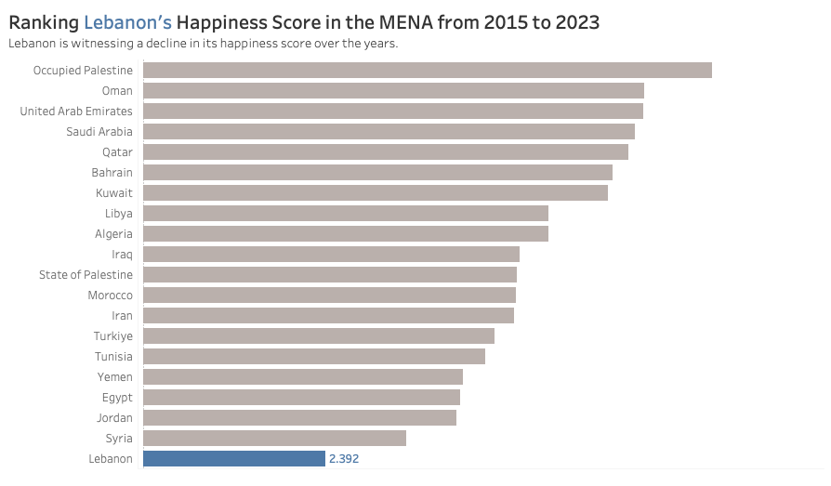

Figure 1 Lebanon's Happiness Ranking in the MENA Region

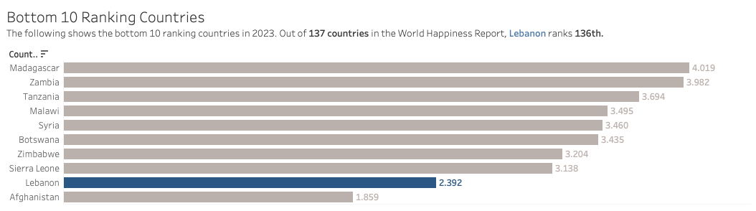

Figure 2 Bottom 10 Ranking Countries for Happiness

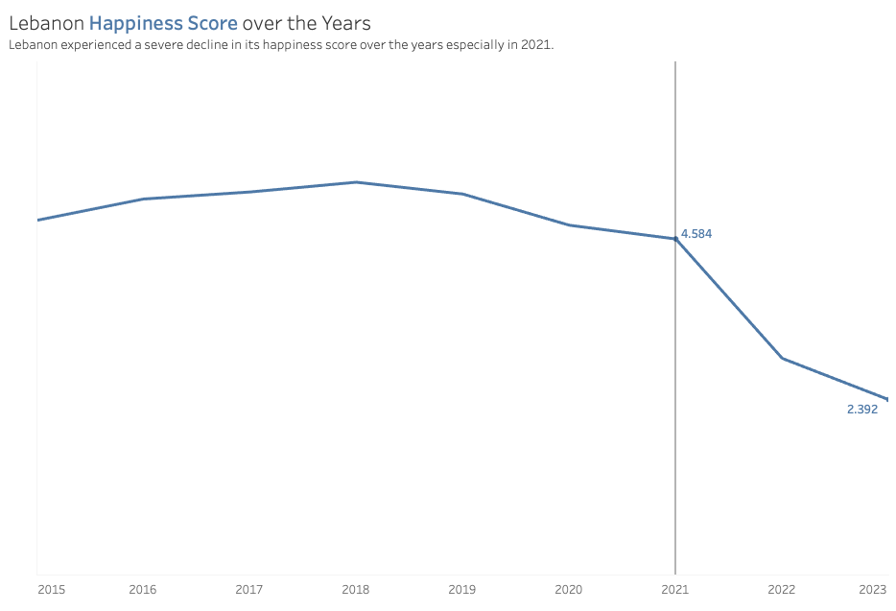

Figure 3 Lebanese Happiness Score over the years

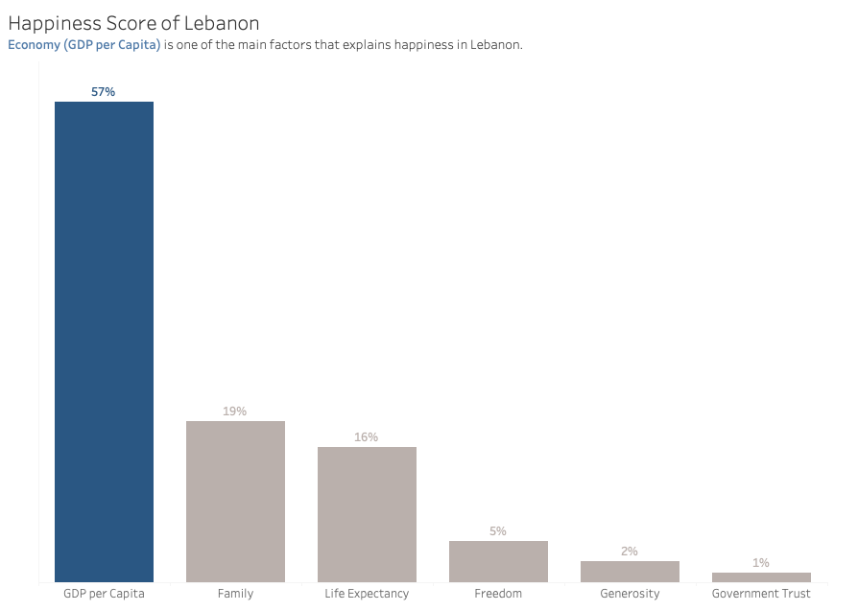

Figure 4 Lebanese Happiness Score Explained by

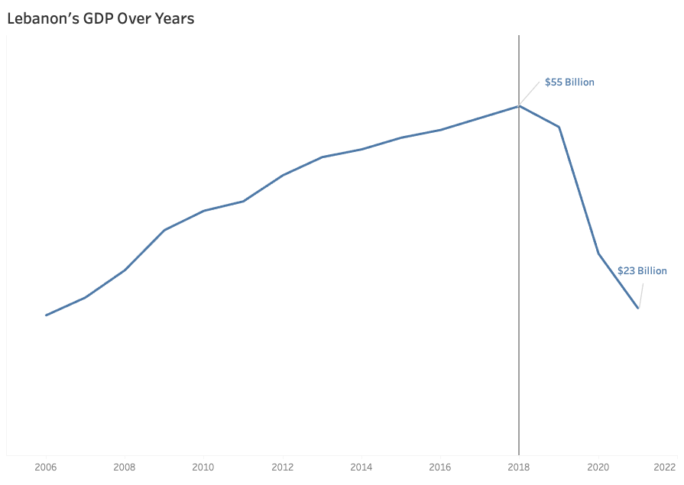

Figure 5 Variation of GDP in Lebanon

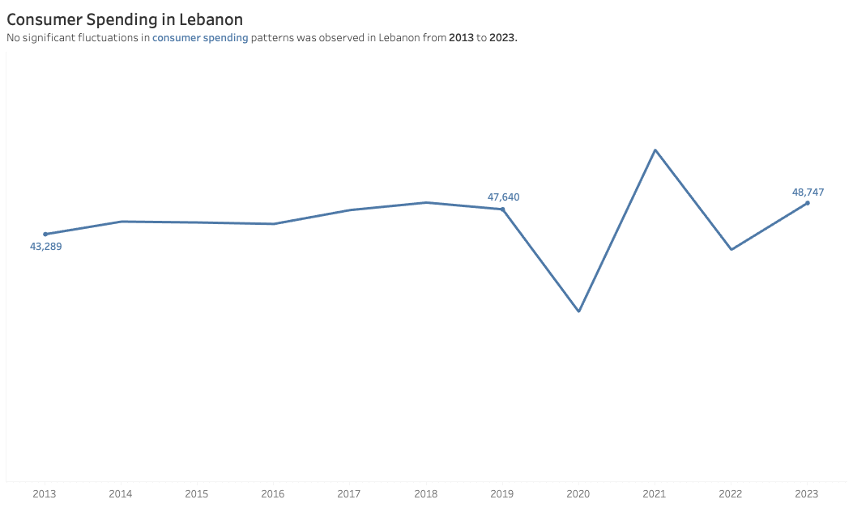

Figure Consumption

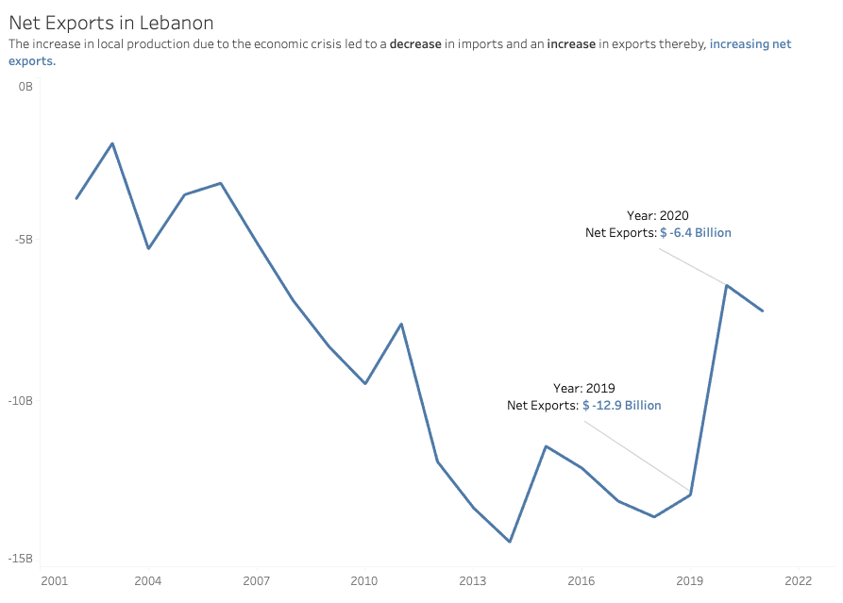

Figure Net Exports

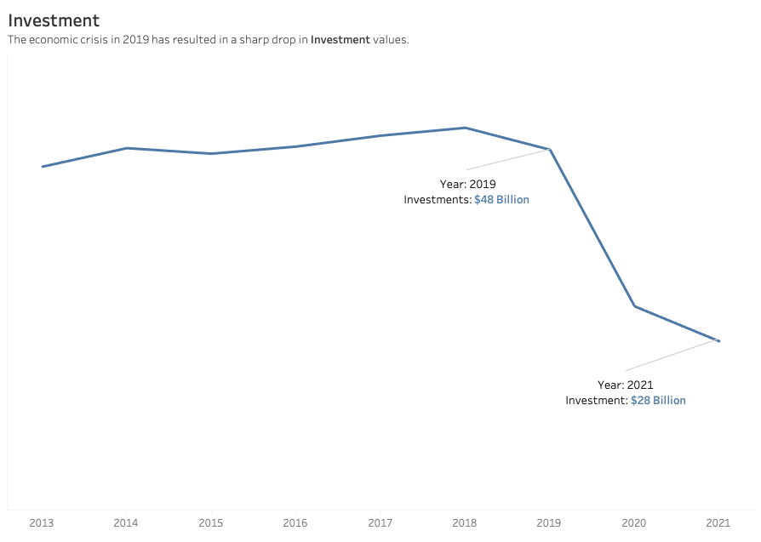

Figure Investments

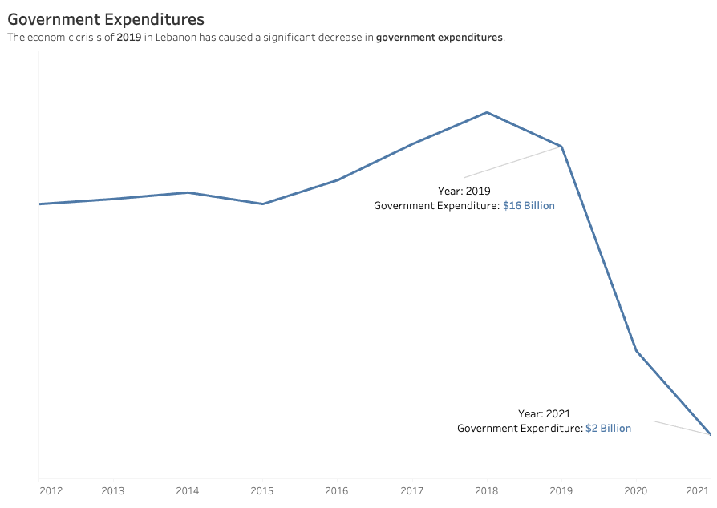

Figure Government Expenditure

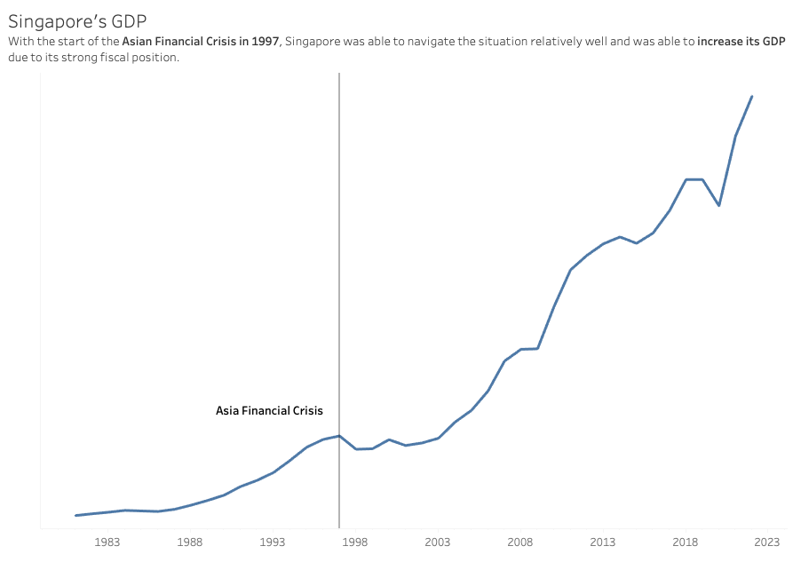

Figure GDP in Singapore

# References:

Blog Post Link: <https://sites.aub.edu.lb/datavisualization/2023/11/24/happinessinlebanon/>

Carling, R. G. (n.d.). *IV fiscal and monetary policies*. IMF eLibrary. https://www.elibrary.imf.org/display/book/9781557754639/ch004.xml

Encyclopædia Britannica, inc. (2023, November 24). *Gross domestic product*. Encyclopædia Britannica. https://www.britannica.com/money/topic/gross-domestic-product

Fiscal policy and growth: Why, what, and how? - OECD. (n.d.-a). https://www.oecd.org/g20/summits/antalya/G20-2015-Ankara-Fiscal-policy-and-long-term-growth-OECD-IMF-September.pdf

Fund, I. M. (n.d.). *Fiscal policy and growth*. IMF eLibrary. https://www.elibrary.imf.org/display/book/9781589061590/ch01lev1sec2.xml

Hunter, M. (2023, March 20). *The world’s happiest countries for 2023*. CNN. https://edition.cnn.com/travel/article/world-happiest-countries-2023-wellness/index.html

Shrestha, R. (2022, August 5). *Happiness index (HI): Definition, domains, relation between HDI and hi*. Public Health Notes. https://www.publichealthnotes.com/happiness-index/

Singapore’s economy - monetary authority of singapore. (n.d.). https://www.mas.gov.sg/bonds-and-bills/investing-in-singapore-government-securities/Singapores-Economy

*What is the happiness index? an overview of my experience*. HAPPINESS ALLIANCE. (n.d.). https://www.happycounts.org/blog/what-is-the-happiness-index

# Datasets:

WDI Dataset

<https://1drv.ms/u/s!AgzDa1pse9NTg55hTnaOj0aAGS71hA?e=ygjumV>

Happiness Index:

<https://1drv.ms/x/s!AgzDa1pse9NTg6Fbf663-OzMr8KZXg?e=p4CgjD>

<https://www.kaggle.com/datasets/joebeachcapital/world-happiness-report-2013-2023/data>

Statista:

<https://www.statista.com/statistics/455255/ratio-of-government-expenditure-to-gross-domestic-product-gdp-in-lebanon/>

<https://www.statista.com/forecasts/1160306/consumer-spending-per-capita-forecast-in-lebanon>