WeekendFly documentation

1. Definition and design.

1.1 Goals and requirements.

Purpose:
We created this application to simplify weekend trips plannig.
It is very common that, when you plan your trip for a weekend, you do not
have much time neither for planning, nor for the trip itself.
The purpose of the application is to save your time and let you enjoy the weekend at a foreign country rather then waste your time to plan it.

Audience:
People of age 18 – 45, that are busy and would rather use their smartphone then open
laptop.

Interface:
The software should be intuitive and very easy to use.
The style and font should be appeaing too the user.

Internal structure:
Database constraits are supposed to be simple, storing only user and flights information.

1.2 Design.
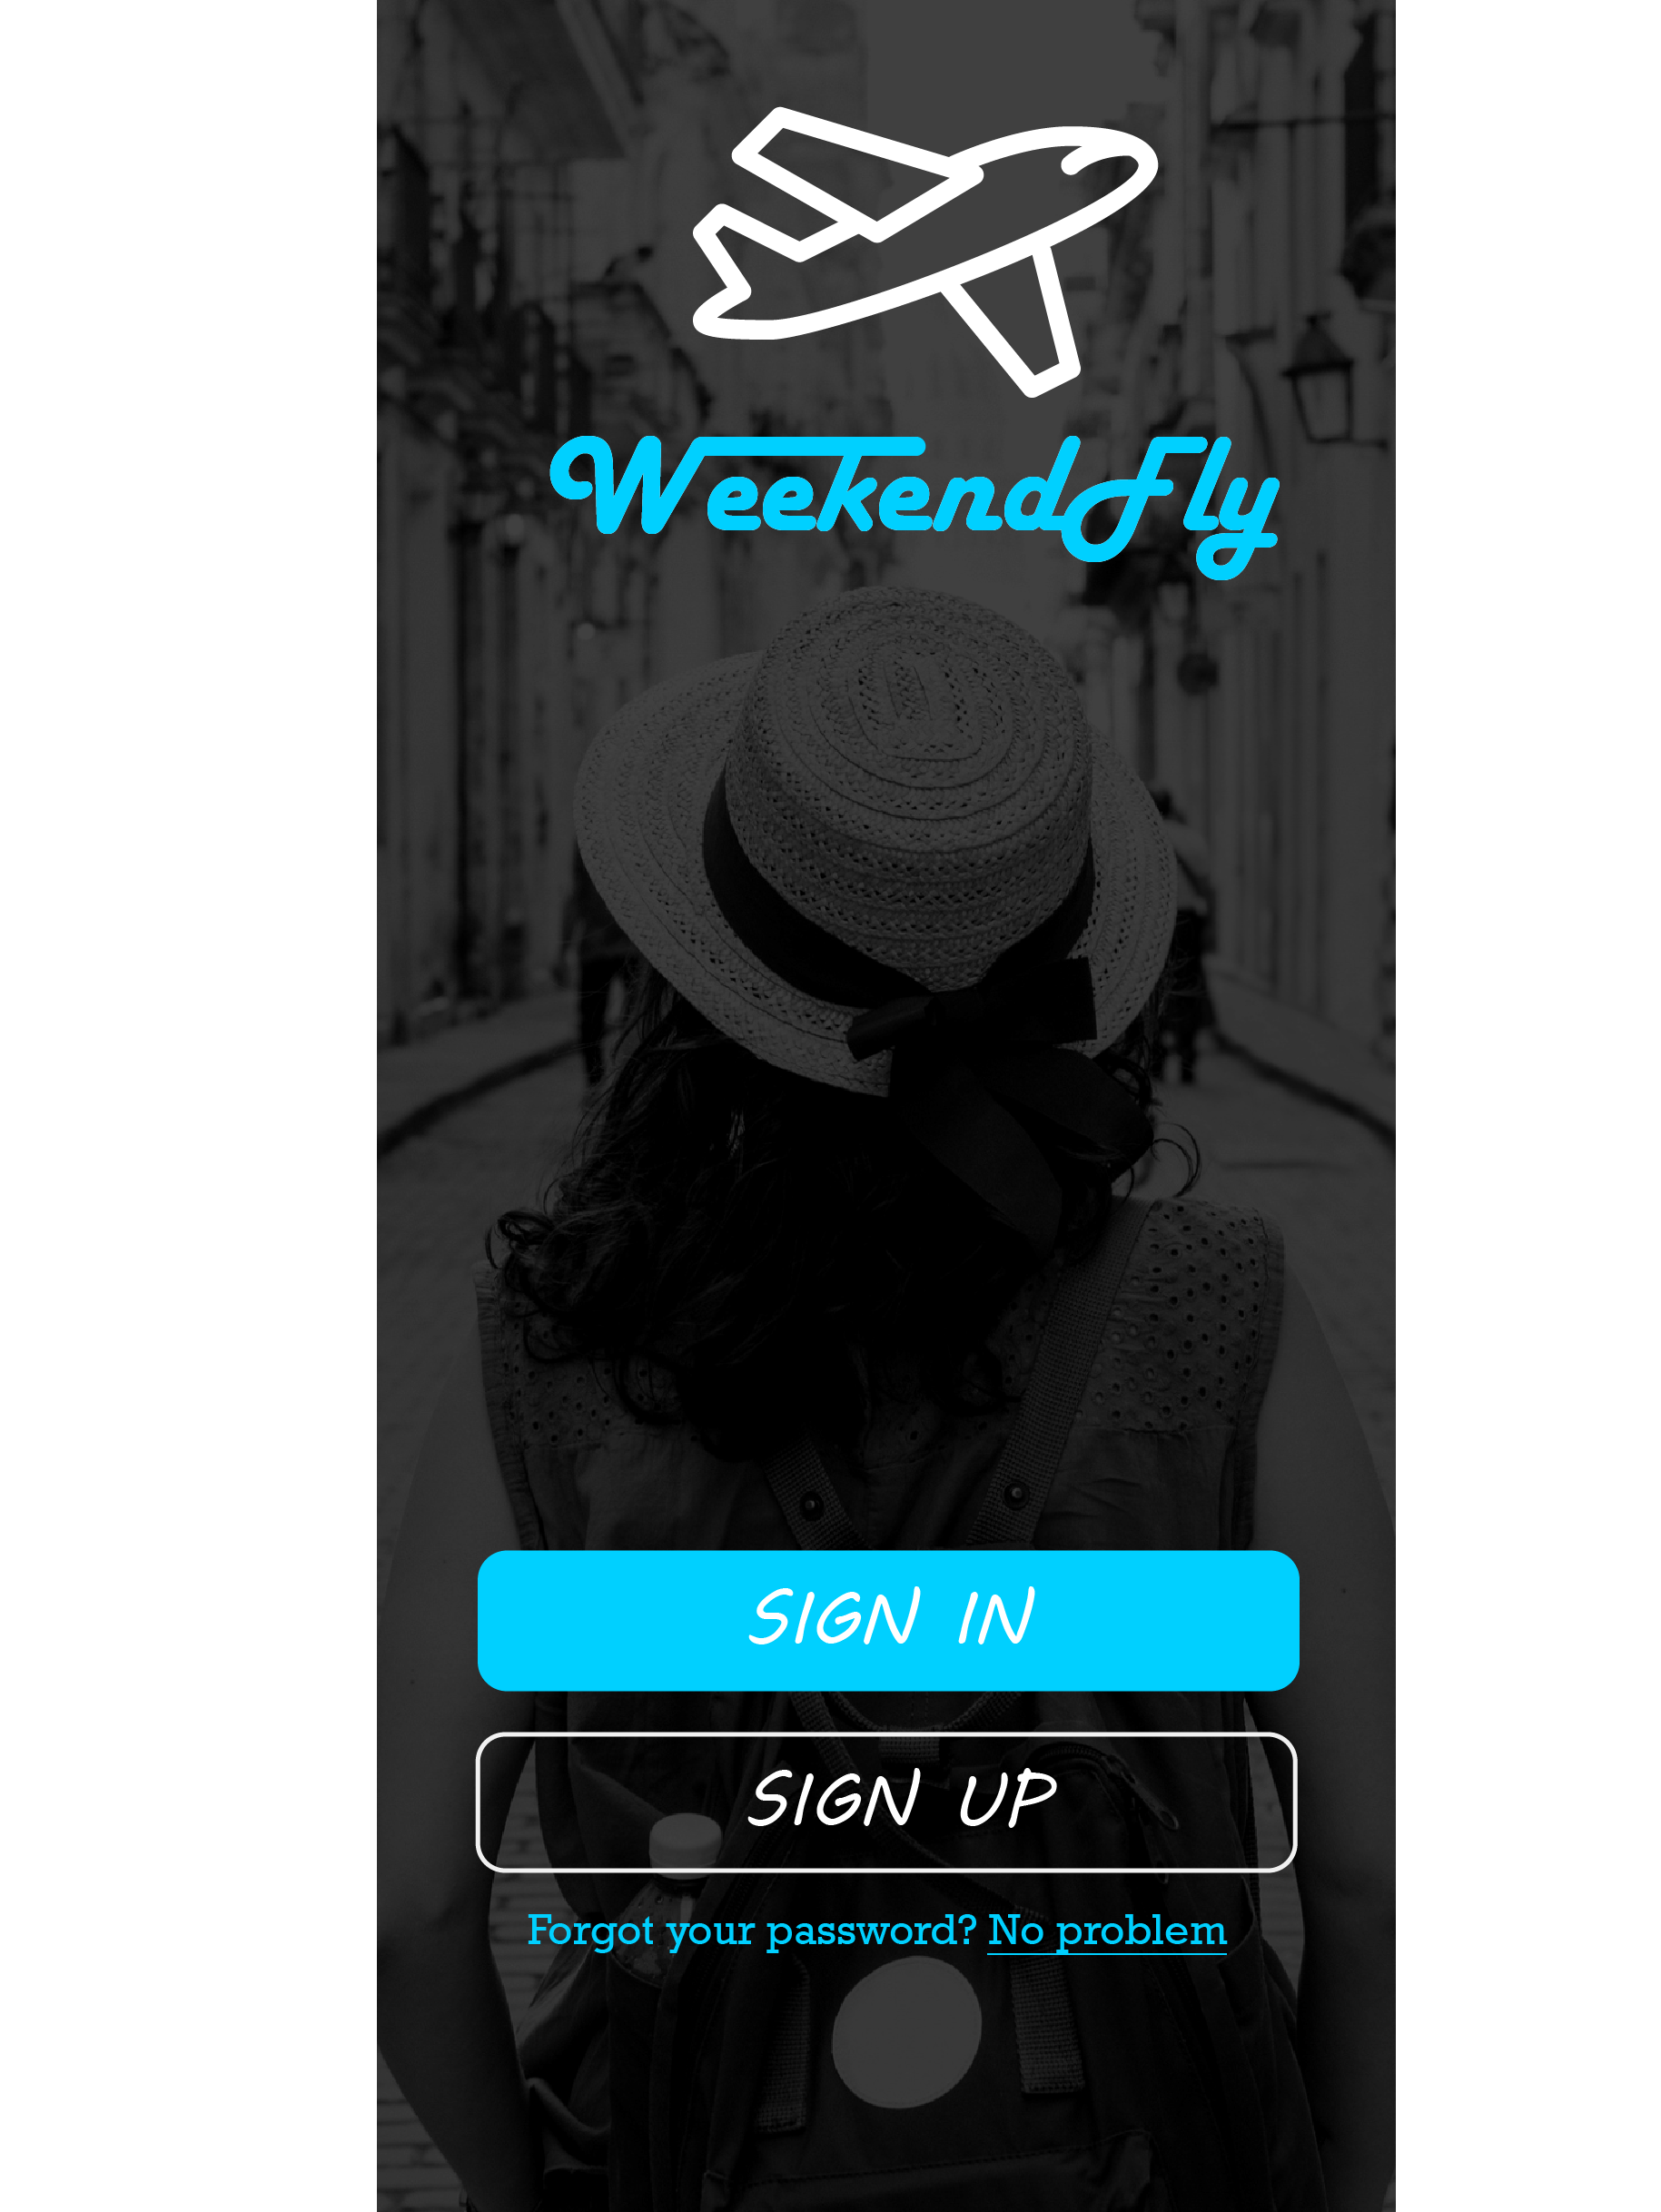
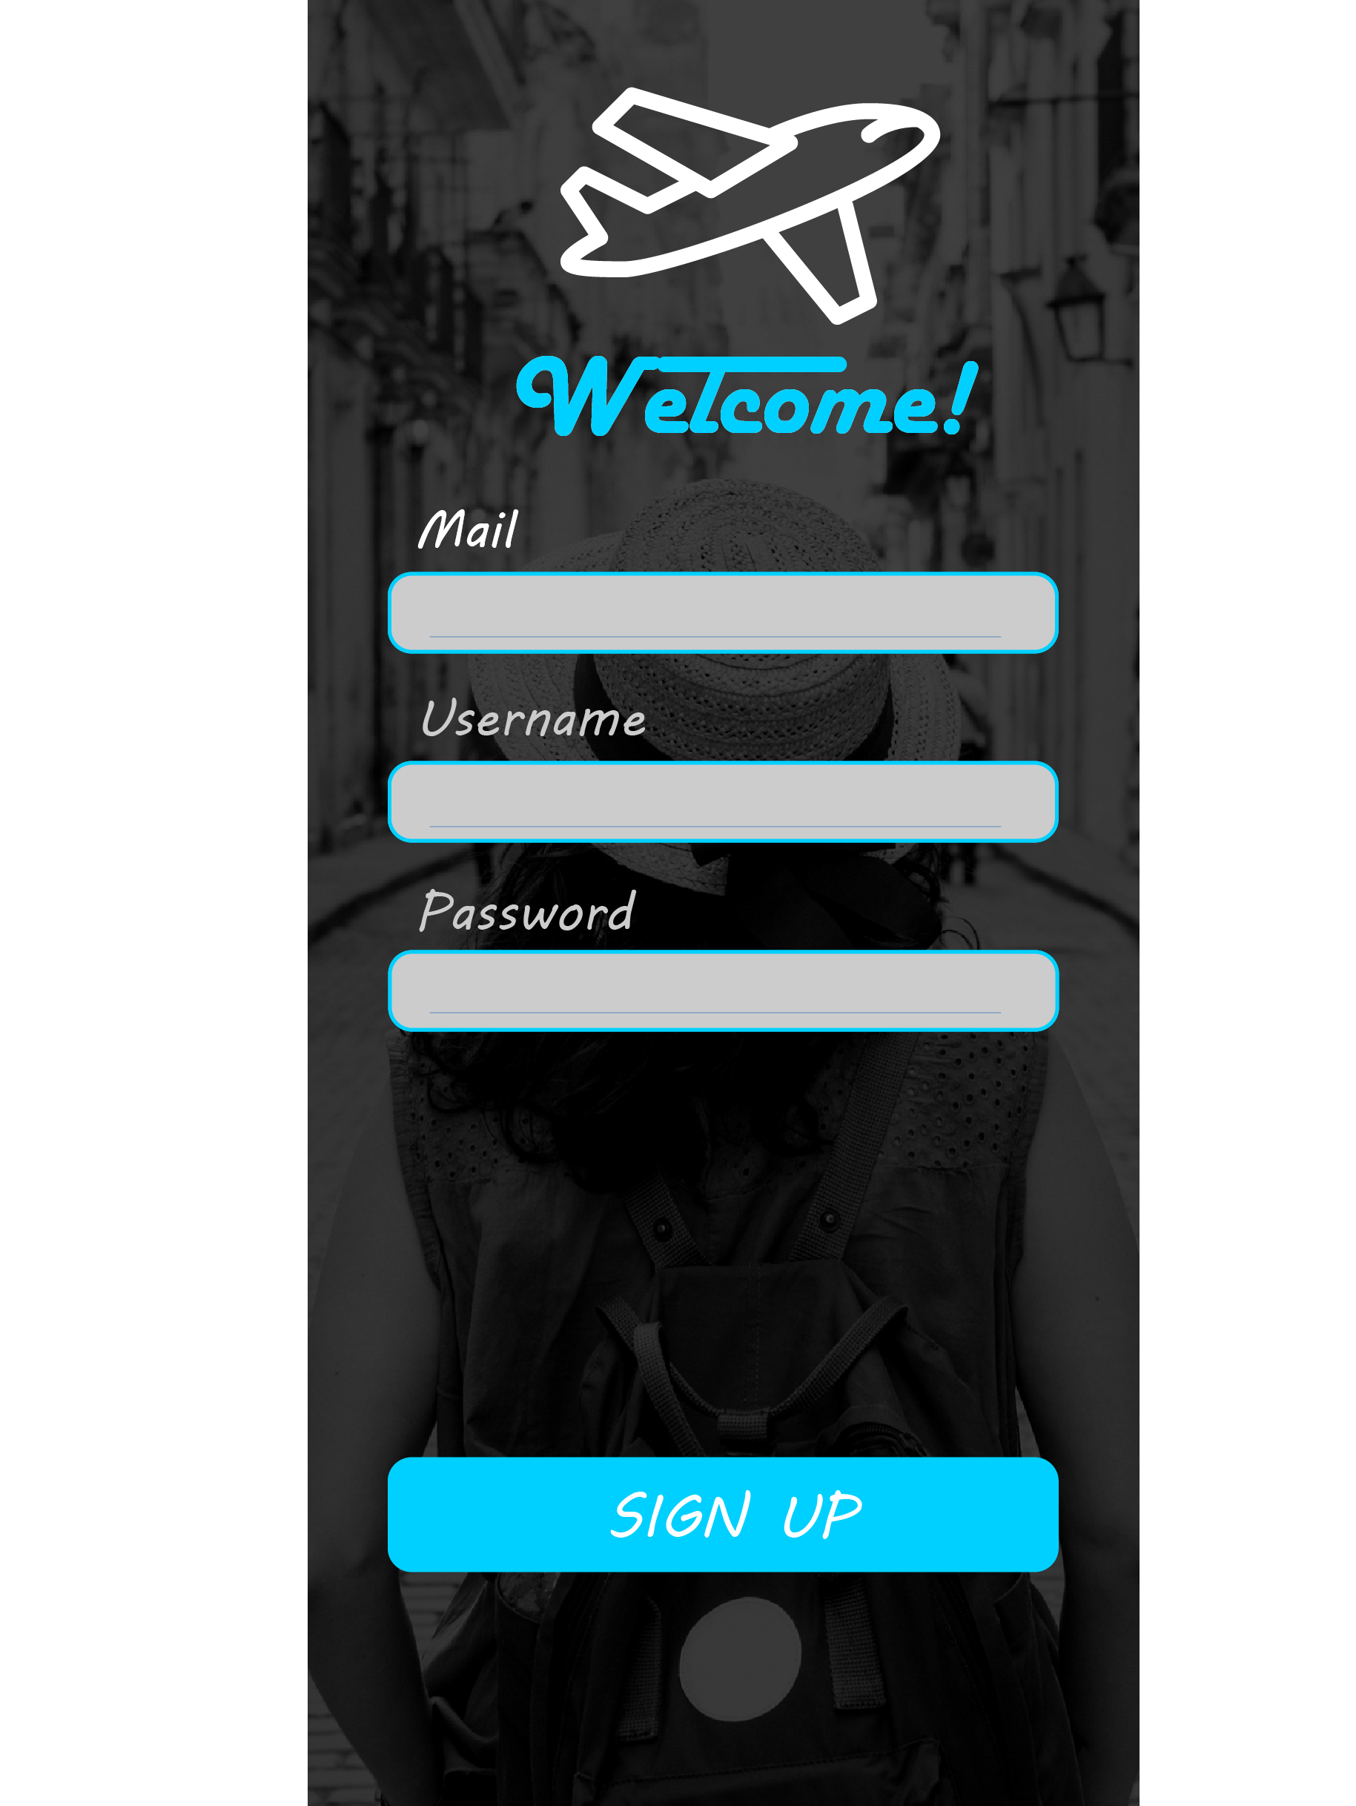
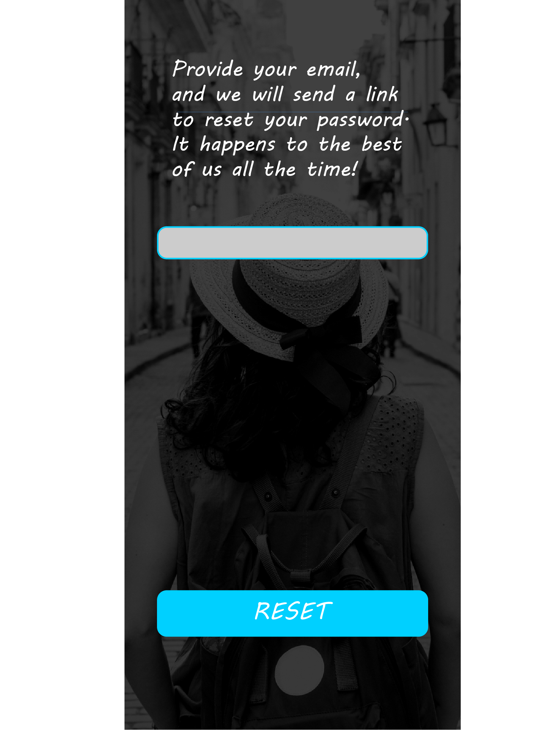

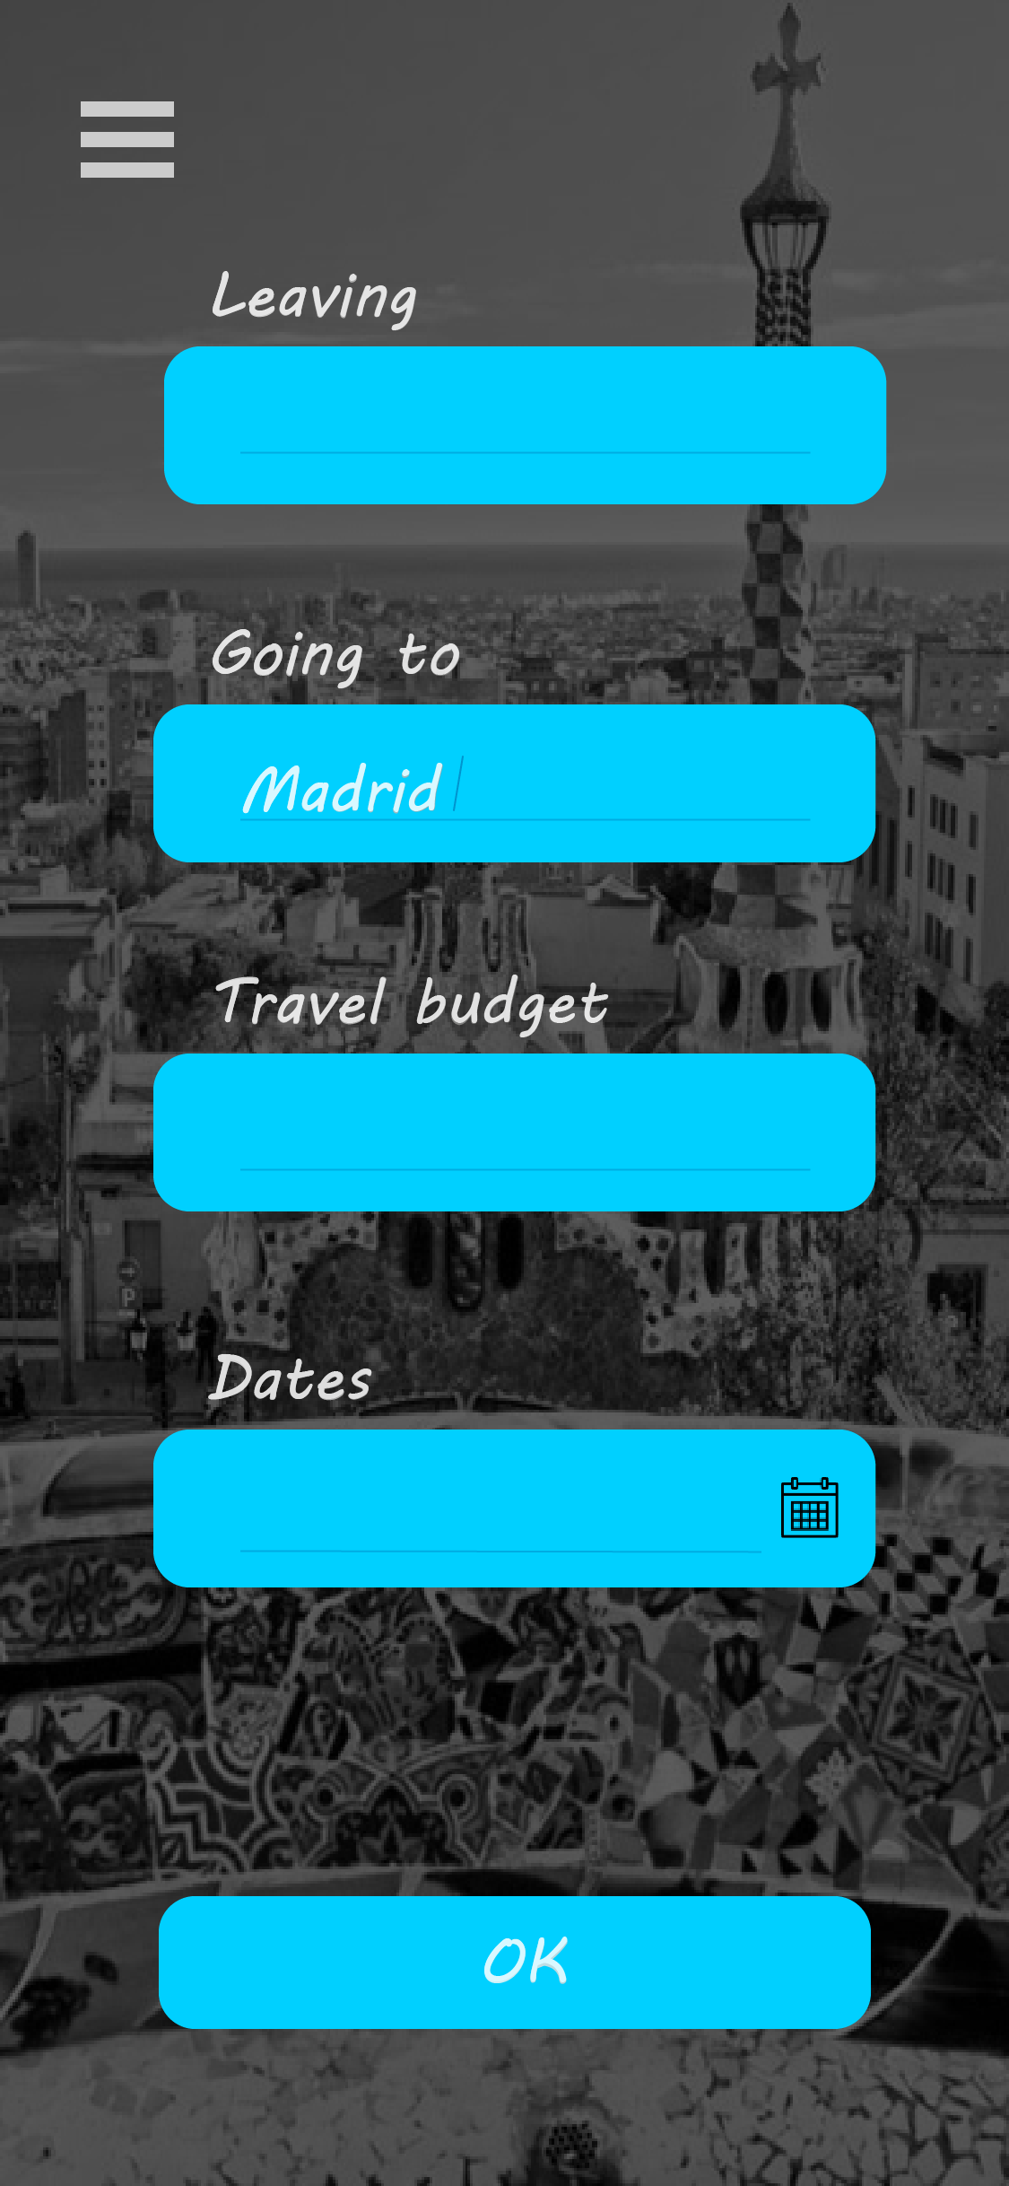
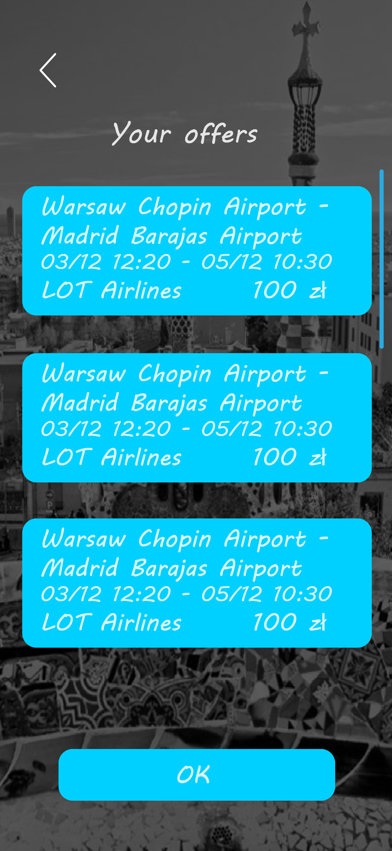
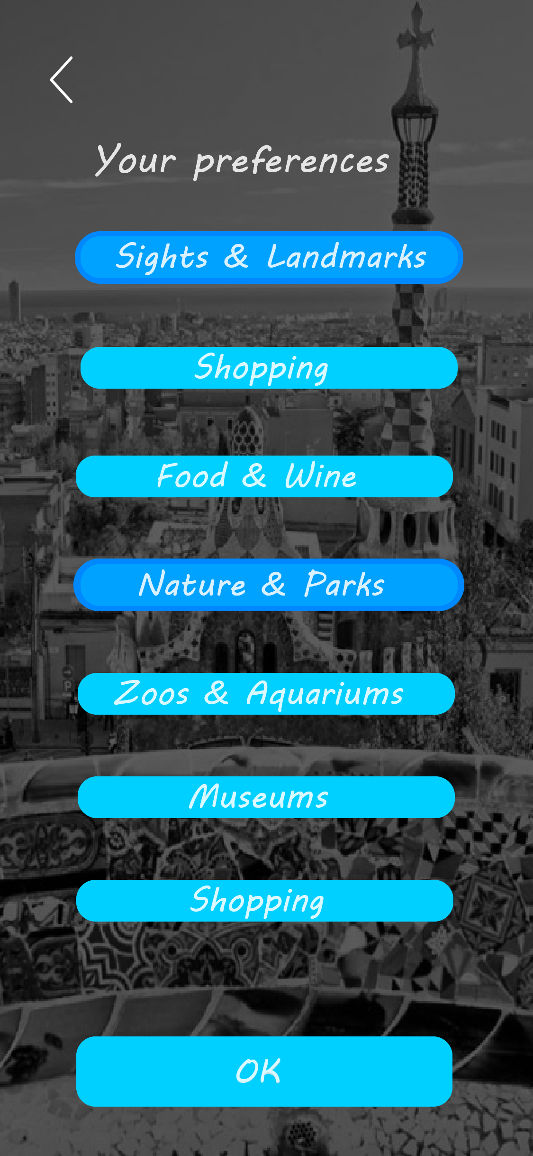
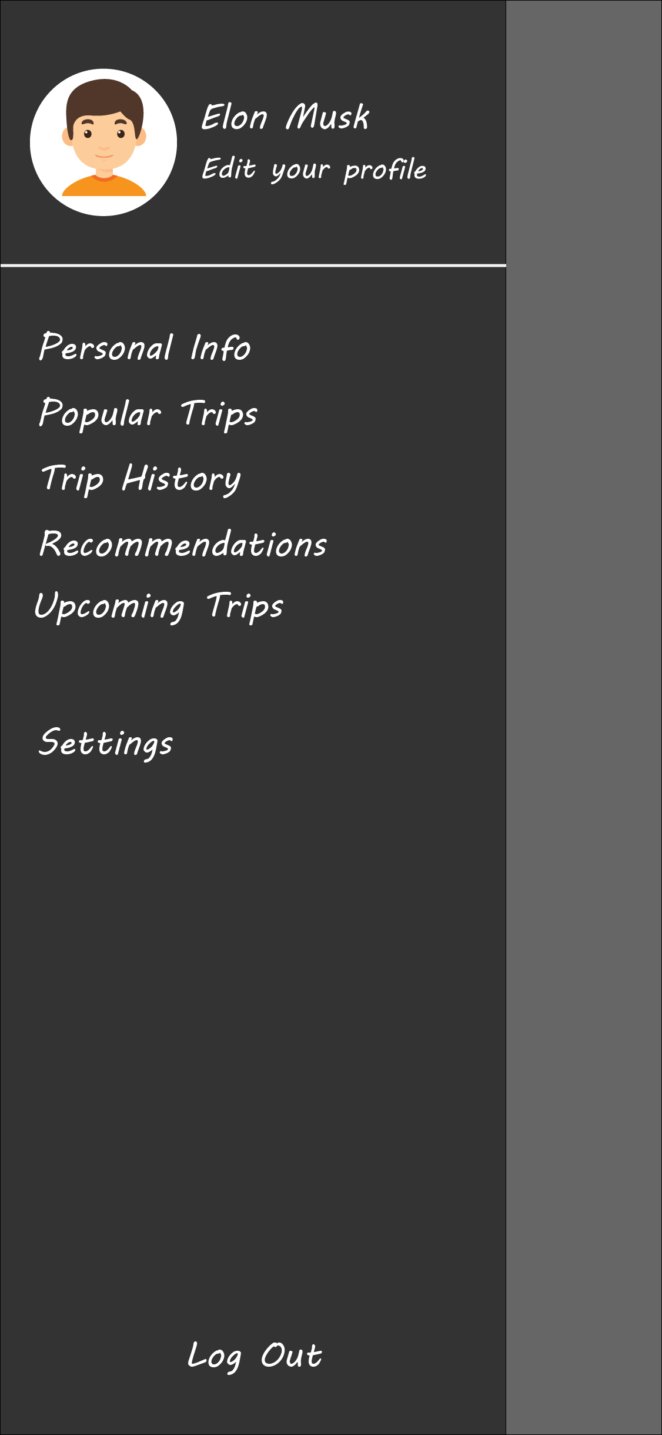
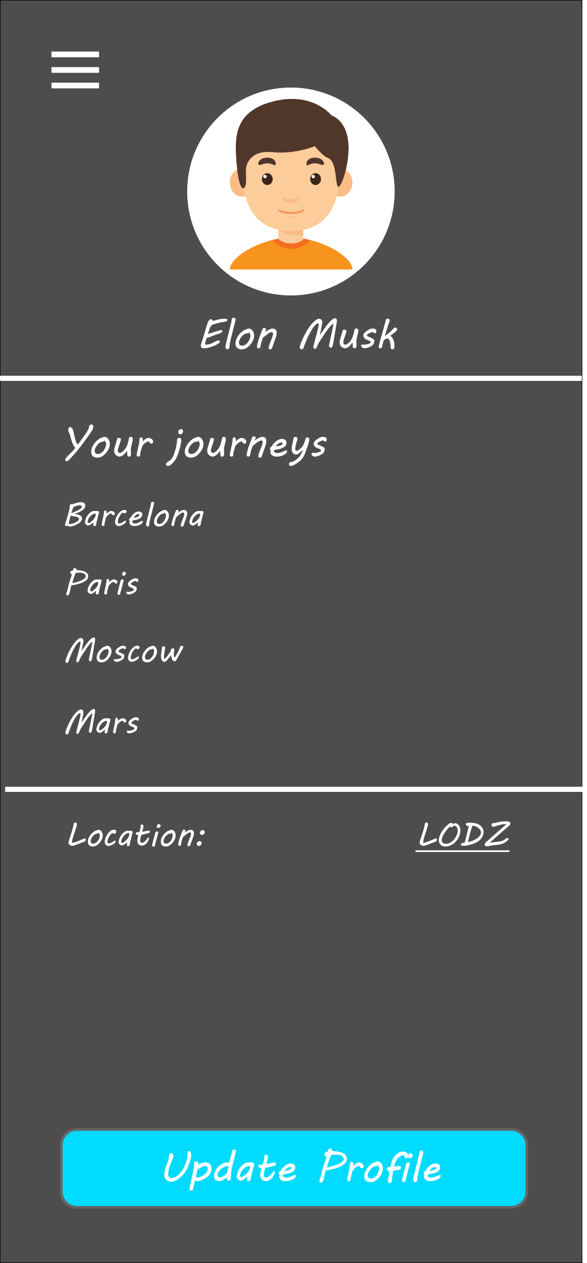
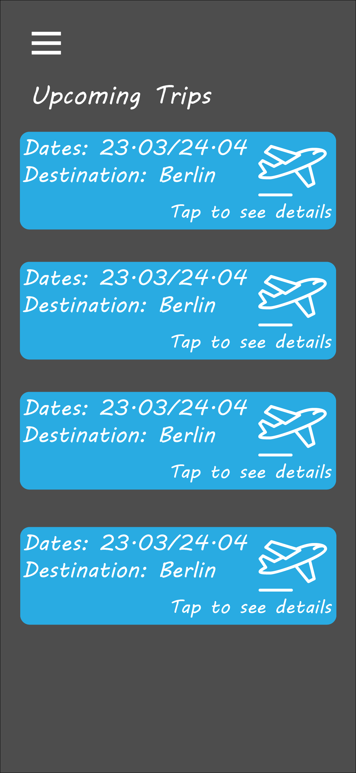

1.3 Technology stack:

JavaScript (Node, React Native, Redux, Expo), Firebase, HTML, CSS (Sass),
JSON Preventive tech: PHP, SQL

2. Tasks and testflow.

2.1 Stage 1.

Task:
Create templates and ERD.
Workflow:
Templates development, development of ERD.
Result:
Developed project structure and DB relations:
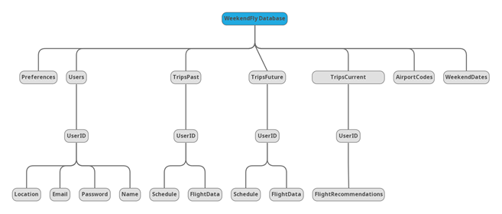
2.2 Stage 2.

Task:
Start imlementing the basic core, parsing algorythm and DB connection.
Workflow:
Implementation of basic core, beginning of development of parsing algorithm, DB connection.
Result:
Implemented Login and main menu, Rayanair parsing algorithm in progress,
connected Firebase.

2.3 Stage 3.

Task:
Implement design, test user stories, fix bugs.
Workflow:
Design implementation, testing user stories on stage, bug fixing.
Result:
Design successfully implemented, buges fixed.

2.4 Stage 4.

Task:
Fix bugs, finish implementing the core and parsing algorithms.
Workflow:
Last bug fixing, preparing for going live.
Result:
Parsing algorithm done and successfully implemented.
Presented on demo.

2.5 Stage 5.

Task:
Go live, fix bugs.
Workflow:
Finishing the project, post-production fixes.
Result:
...

3. Instructions, maintenance and use cases.

3.1 Usage instructions.

Login menu:
The user should enter email and password in specified entries in order to login.

Register menu:
The user should enter email and password in specified entries in order to register a
new account.

Trip specifications form:
The user should enter their location, destination, budget and trip date in specified
entries in order to find the flights.

Availible flights:
The user should choose their flights.

Sidebar:
The user can guide themselves through their account, manipulate default location, preferences and upcoming flights.

Preferences:
The user should choose their preferred attractions in order to create the trip plan.

Places to visit.
The user should choose the places in the city that they want to visit in order to create the
plan. The plan is restricted by time.

Confirmation screen:
The user should press OK button if they feel cute, nice and cozy.

3.2 Maintenance.
Development is in final state. No need for further changes.

3.3 Use case.

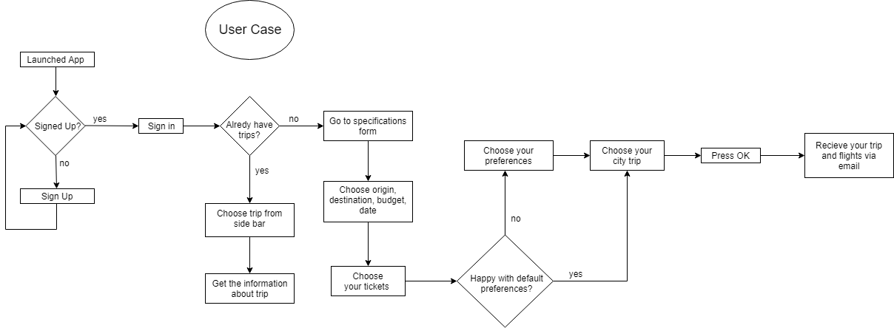

Created by:

Viktor Nikolenko, Yuri Romanov, Maskim Kuryez

