Site: <https://stackoverflow.com/questions>

**UI screenshot**

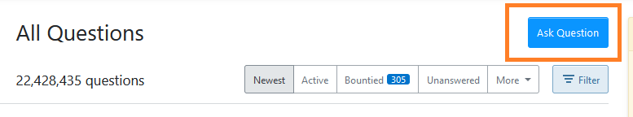

**HTML screenshot**

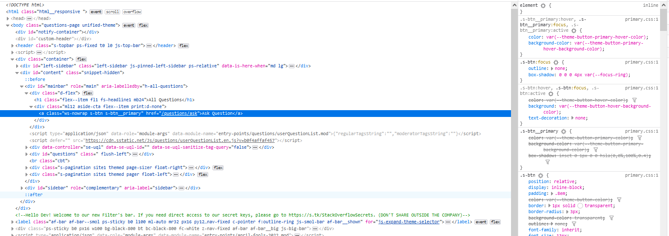

**DOM Locator**

document.getElementById("mainbar").children[0].children[1].children[0]

**CSS Locator**

#mainbar > div.d-flex > div > a

**xPath Locator**

//*[@id="mainbar"]/div[1]/div/a

**UI screenshot**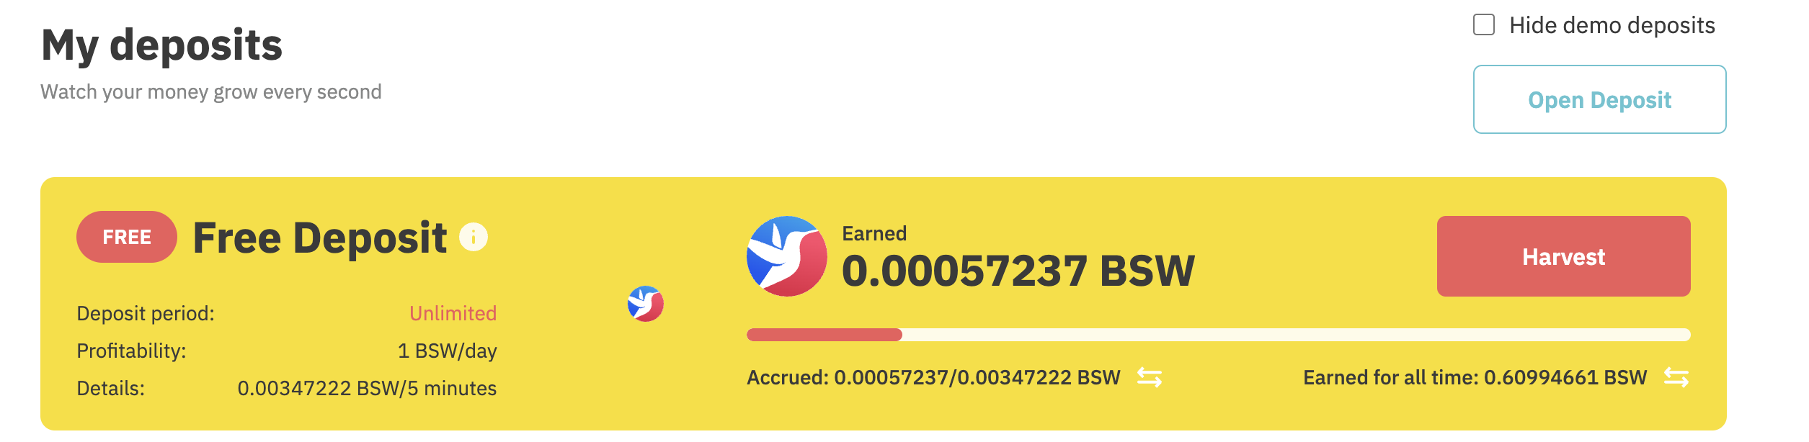

**screenshot**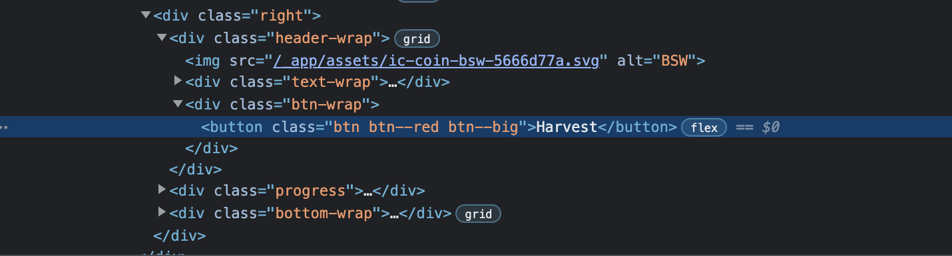

**DOM Locator**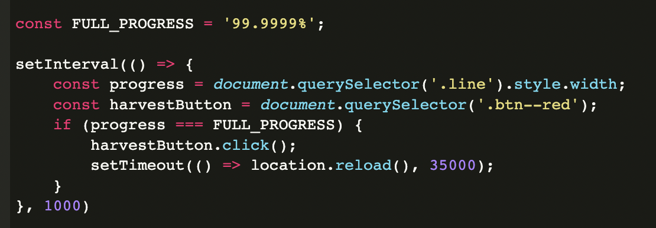

document.getElementById(«.btn—red«)

**CSS Locator**

#svelte > div > div> div > div > div button

**xPath Locator**

**//*[@id="svelte"]/div[2]/main/section[2]/div/div[2]/div[1]/div[3]/div[1]/div[2]/button**

**UI screenshot**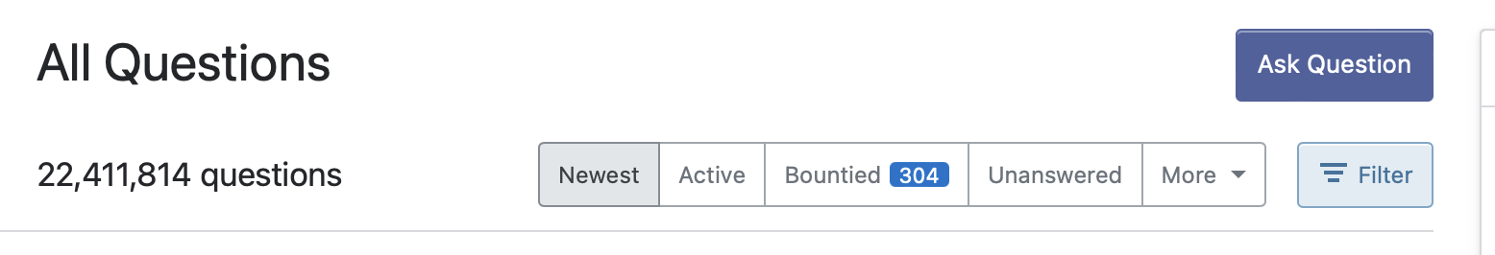

**HTML screenshot**

**DOM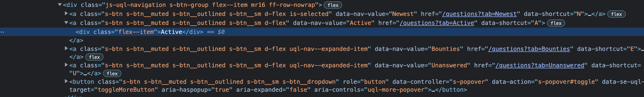 Locator**

document.getElementById("mainbar").children[3].children[0].children[1].children[0].children[0].children[1].children[0]

**CSS Locator**

#mainbar > div:nth-child(4) > div > div.uql-nav.flex--item > div > div.js-uql-navigation.s-btn-group.flex--item.mr16.ff-row-nowrap > a:nth-child(2) > div

**xPath Locator**

//*[@id="mainbar"]/div[2]/div/div[2]/div/div[1]/a[2]/div