ASSIGNMENT 1
DOCUMENTATION

ISTE 140 - Web and Mobile I
Fall 2026

Team 5

LearnWare Project

Team Information

Member | Name | ID | Contribution
1 | Ritika Lakhotia | 431006114 | Branding, Documentation & Validation
2 | Roman Martianov | 748002846 | CSS and Technical
3 | Danil Nazin | 748007523 | HTML

Team Number: 5
Tutorial Topic: Cybersecurity / Malware
Contribution statement: We confirm that the contributions listed above accurately describe each member’s work on Homework 1 and that each member can explain the submitted work.

2. Branding
Site name: LearnWare
Tagline: Think Before you click

2.1 Why we chose the site name
Our choice is "LearnWare" for its simple word association with "learn," since the website teaches individuals, and "ware," which refers to malware, the real focus of the discussion. It's also easy to pronounce, related to cyber security, and not an existing brand

2.2 Initial logo sketches

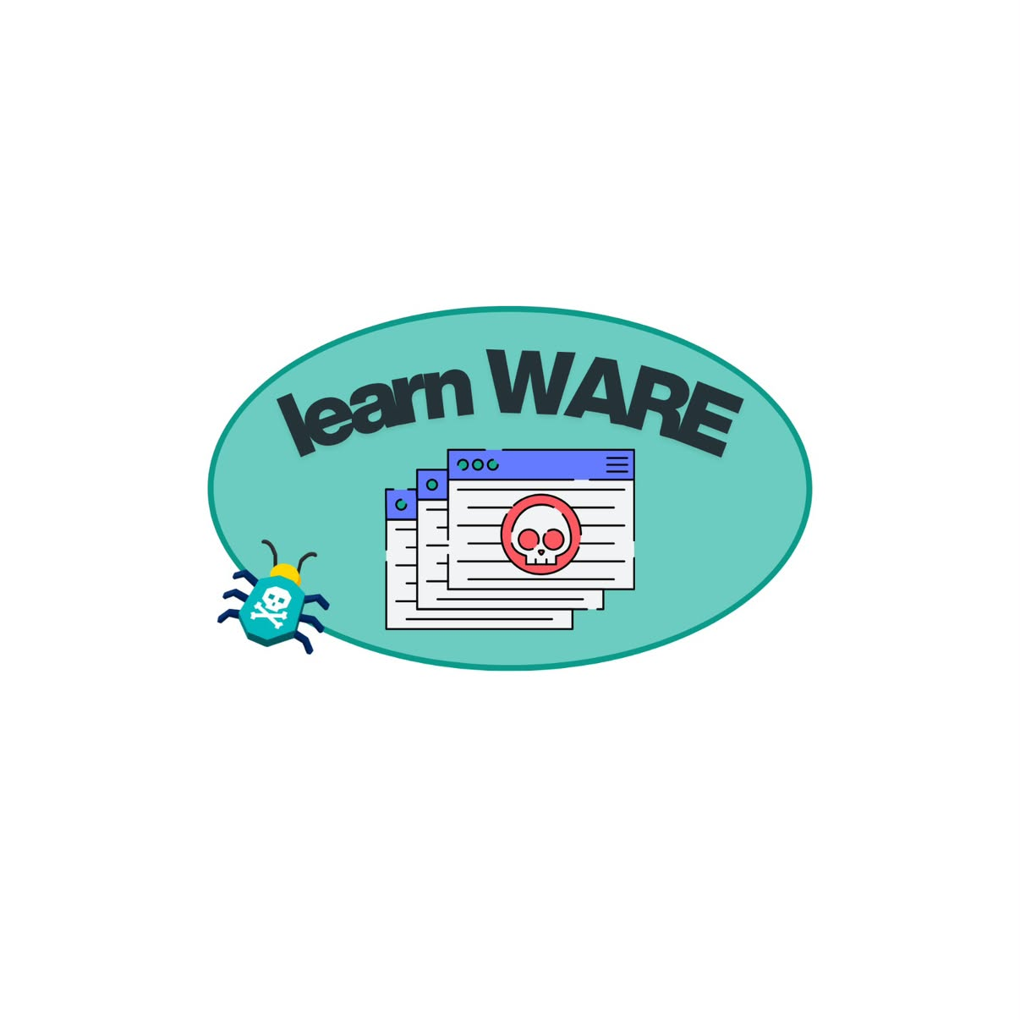

2.3 Final Logo and exlanation


The logo depicts a computer with a "CONFIDENTIAL" folder being drawn out with the help of a hook. The hook is a representation of phishing, the bug is a representation of malware, and the folder is a representation of confidential information that attackers wish to steal.

3. Q1 - UNIX and Terminal (Individual)

3.1 Ritika Lakhotia
Student ID: 431006114

    - Project folder tree

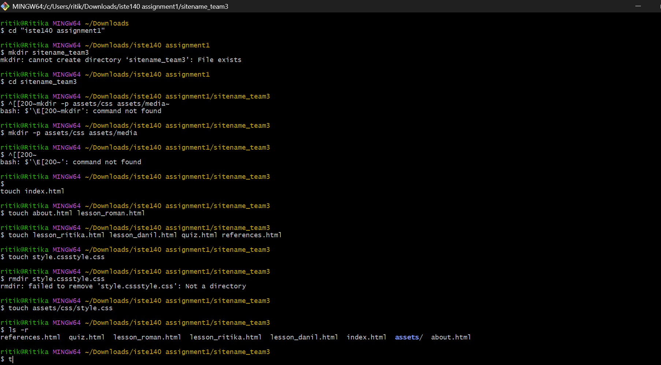

    - Mv/ rm / cp operations

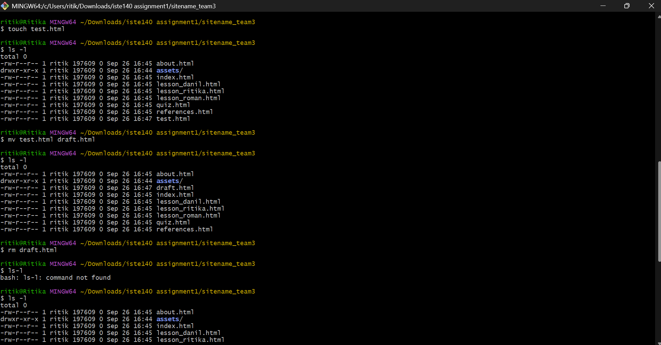
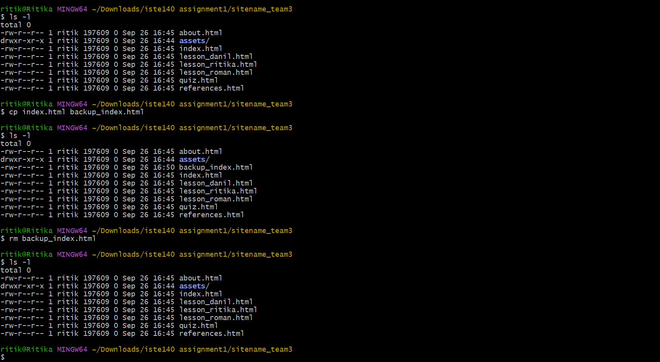
    - Permissions

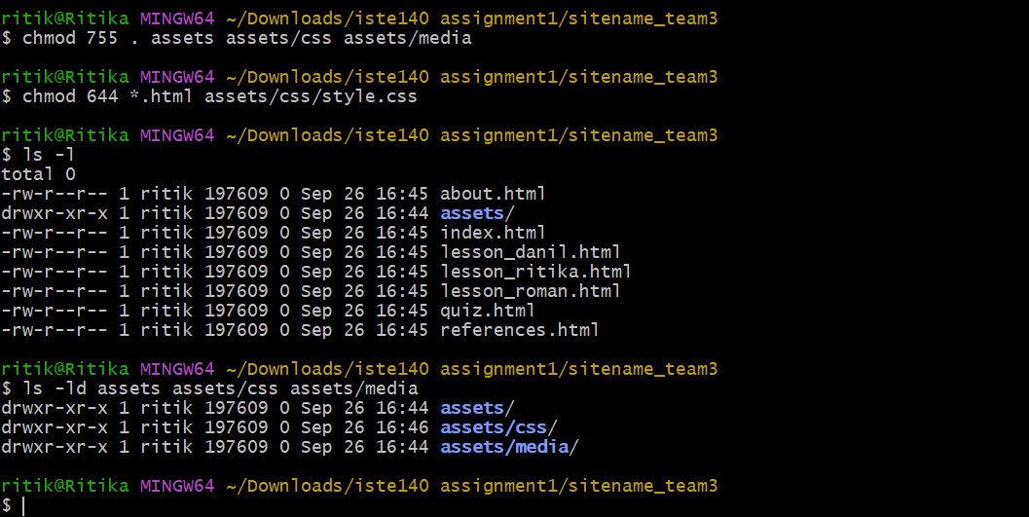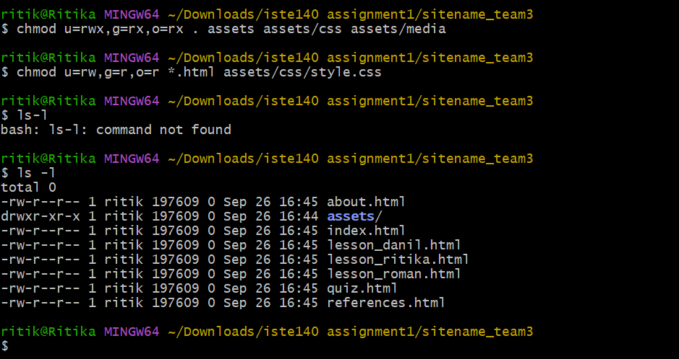

    - Answers

For assets/media/logo.png from assets/css/style.css, the relative path would be ../media/logo.png (as it has to go back one directory out of css/, then media/). For style.css from index.html, the relative path would be assets/css/style.css.
The absolute path of style.css, assuming that it is on RIT server and the project is located at /home/username/public_html/, would be /home/username/public_html/sitename_team#/assets/css/style.css.
The permission code 755 means rwxr-xr-x and means owner has rwx rights, group/others have rx rights. The permission code 644 means rw-r--r-- which means that the owner has rw rights, group/others have only r rights.
HTML files should not be executable because they are plain text files which are read by browser and presented to user. Making HTML files executable does not serve any purpose and poses unnecessary security risks.
To give rw-r----- permissions to quiz.html file, the command would be chmod 640 quiz.html. It means that owner will have rw, group will have only r, others will not have any permissions. As the web server generally has "others" permissions for accessing files, it will not be able to access quiz.html file.

3.2 Roman Martianov
Student ID: 748002846

    - Project folder tree

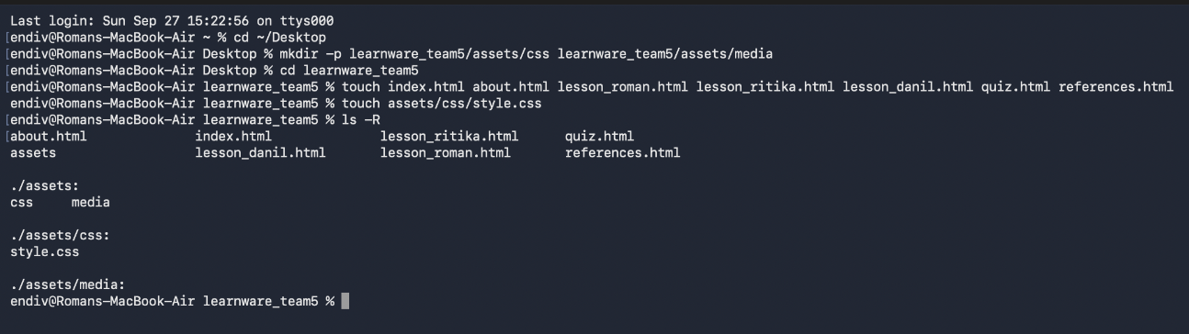

    - Mv/ rm / cp operations

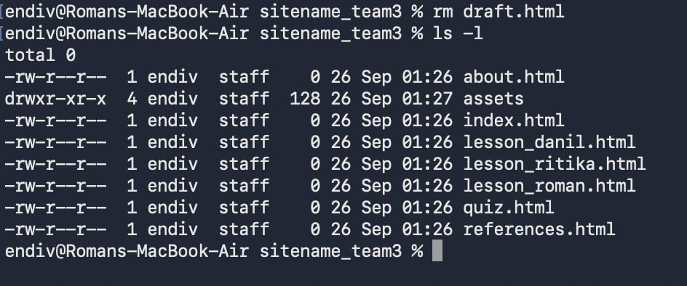
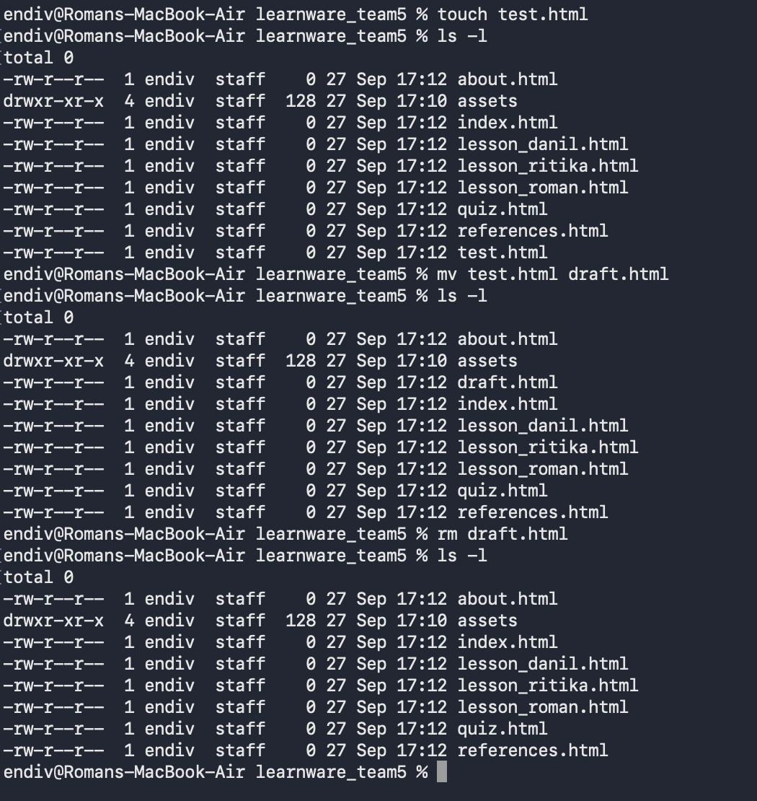

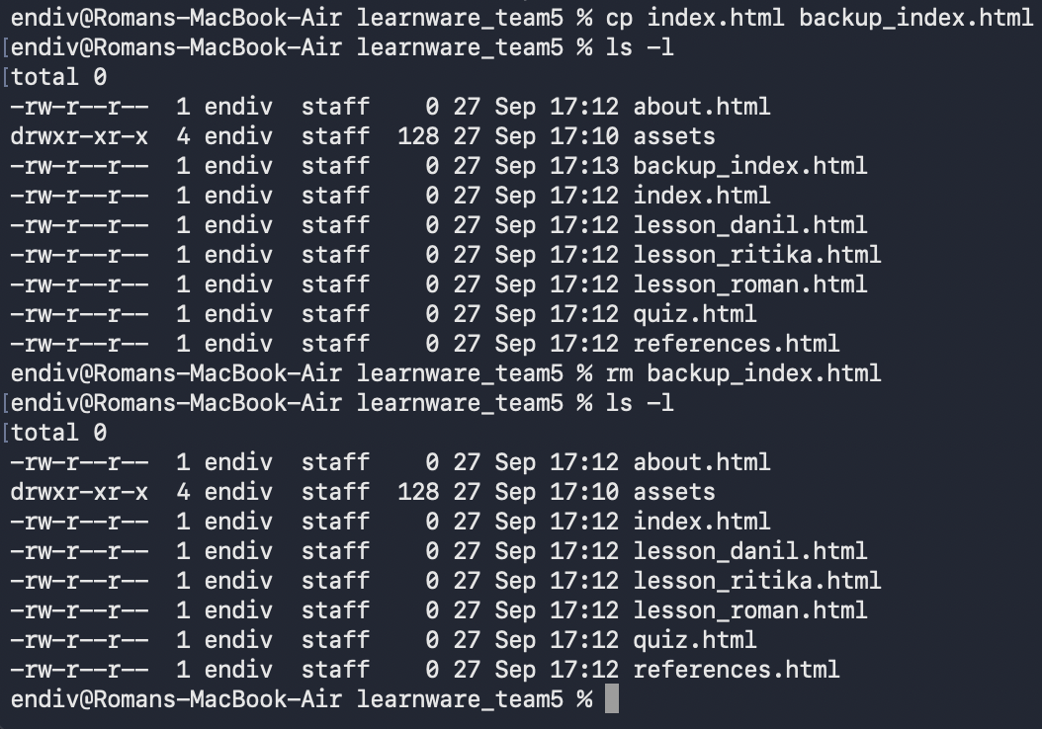

    - Permissions

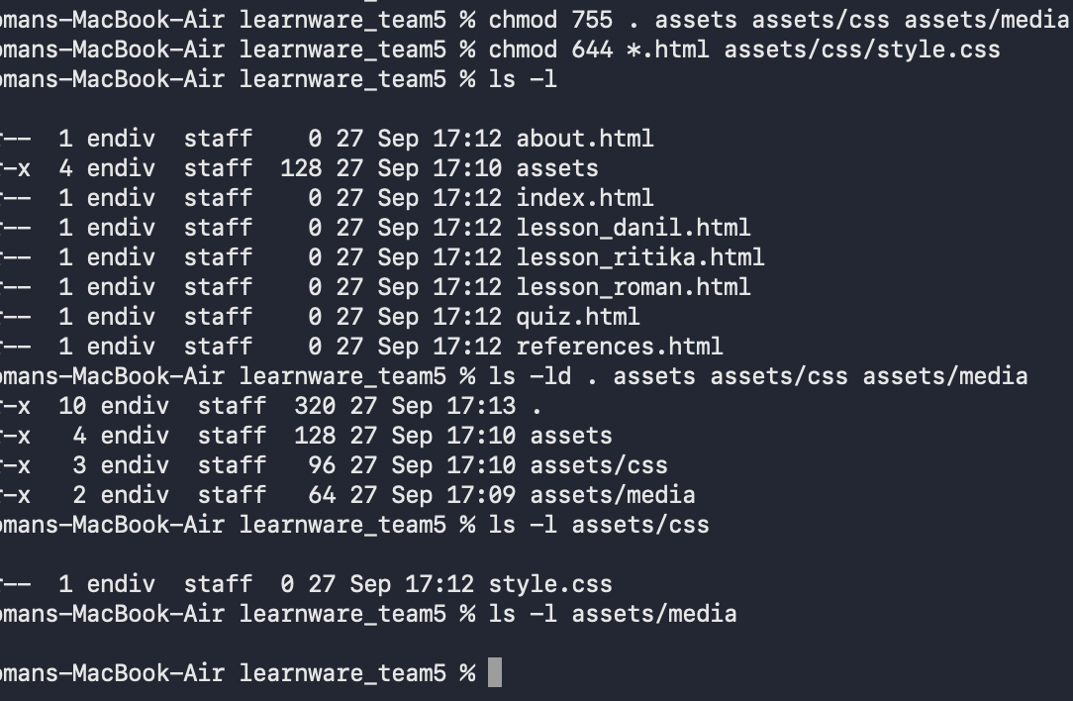
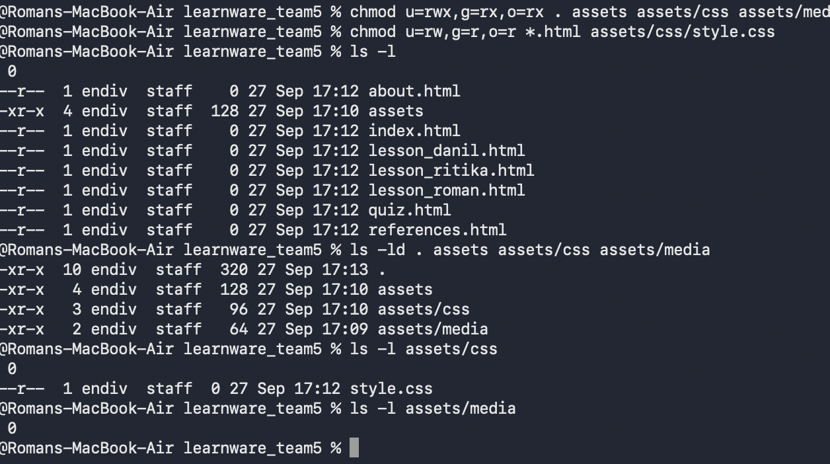

    - Answers

1. The relative paths would be `../media/logo.png` and `assets/css/style.css`. The absolute path would be `/home/username/public_html/LearnWare_team5/assets/css/style.css`.
2. `755` permits the owner full read/write/execute privileges and group/others read and execute privileges. `644` permits the owner full read and write privileges and everyone else read only. HTML files should not have the execute permission set since the browser just needs to read the file.
3. The command is `chmod 640 quiz.html`. Given these permission settings, the page will not be readable by typical website visitors, so read permission must be set.

3.3 Danil Nazin
Student ID: 748007523

    - Project folder tree

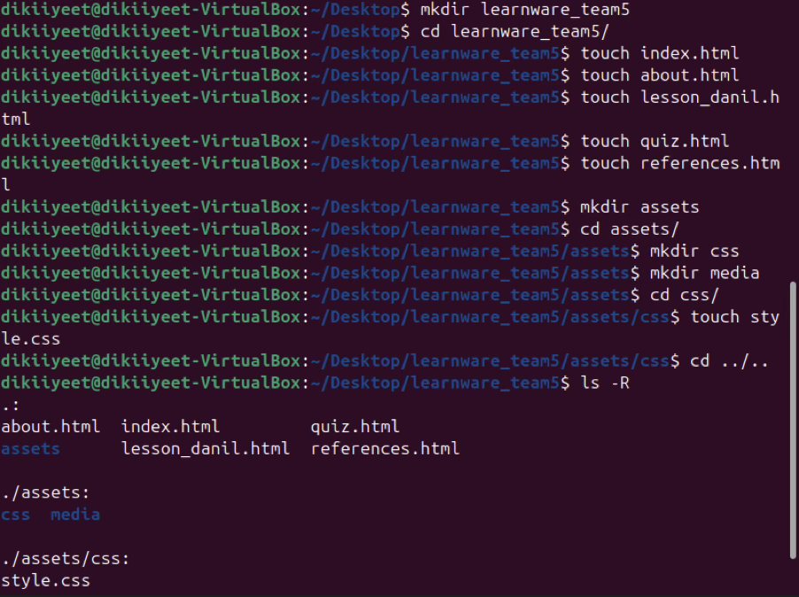

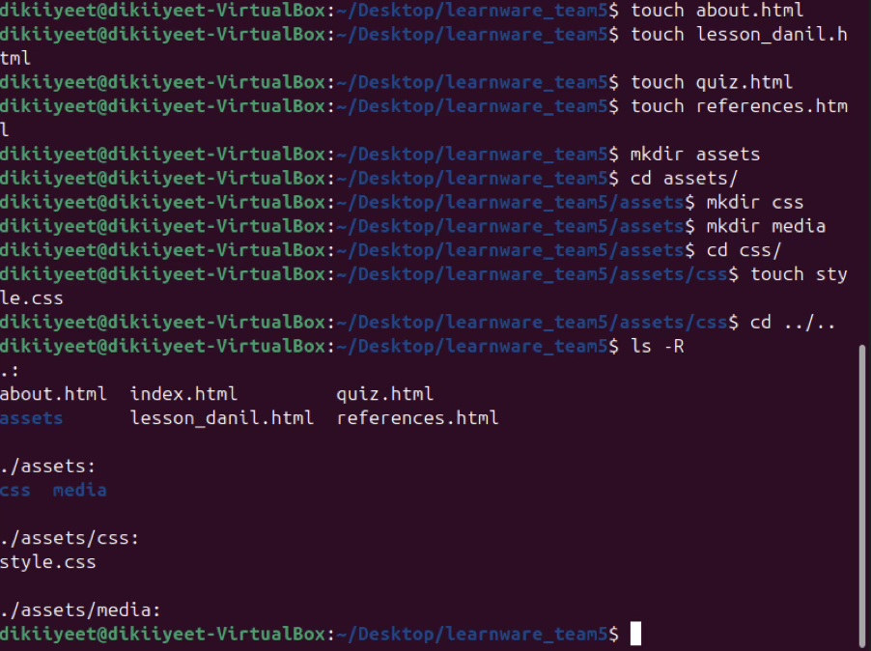
    - Mv/ rm / cp operations

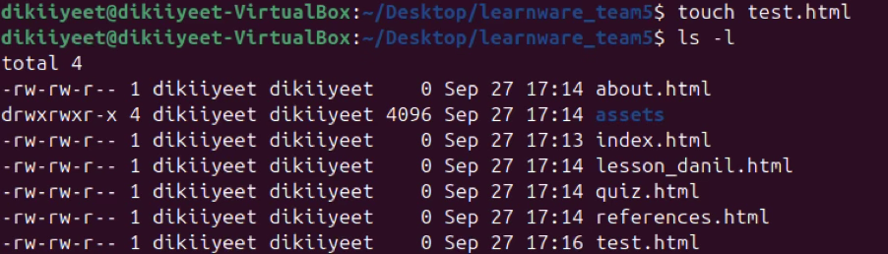

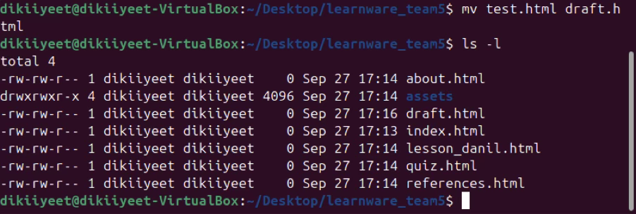
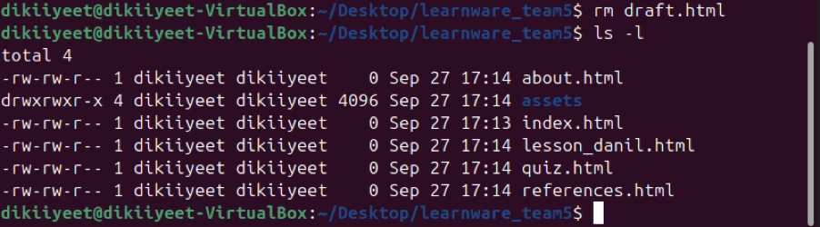
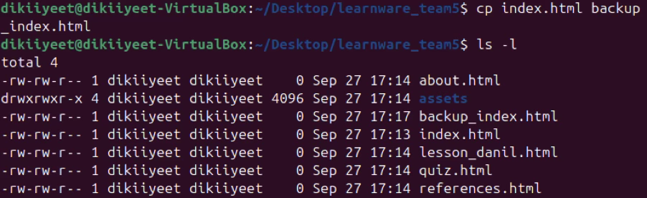
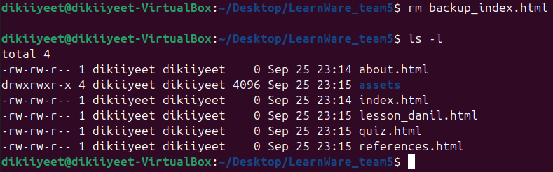
    - Permissions

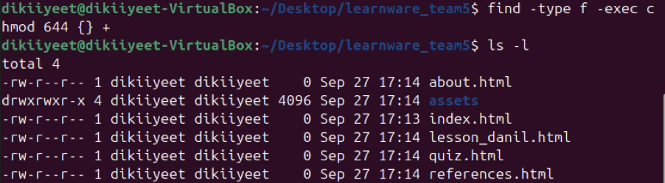
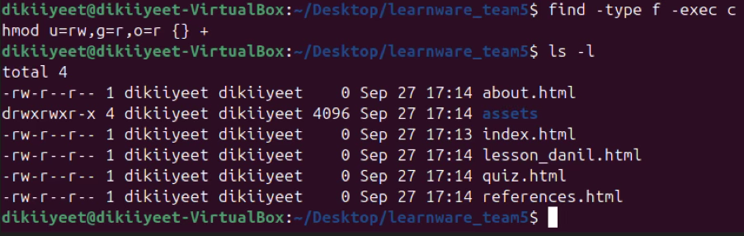
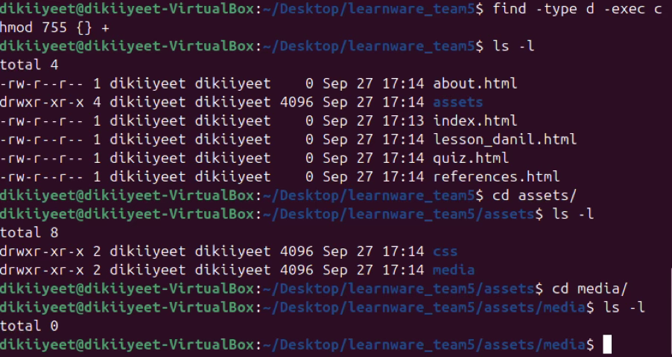

    - Answers

1. Relative path is ../media/logo.png. Second relative path is assets/css/style.css. Absolute path is /home/username/public_html/LearnWare_team5/assets/css/style.css
2. 755 for chmod means that for directories, user has permission to read, write and execute, and group and world can only read and execute. 644 for chmod means that for files, user had permission to read and write, and group and world can only read. HTML files should not be executable because they could contain malware that is bypassing through browser. As HTML is not considered a programming language, they can carry obfuscated malware which is easy to create and hard to spot.
3. Chmod 640 quiz.html is the command. If I would do that, visitor of my website will not be able to see the page, because the permission to see that page is denied, that is why "Read" permission should always be open.

4. Mac Workflow

4.1 Ritika
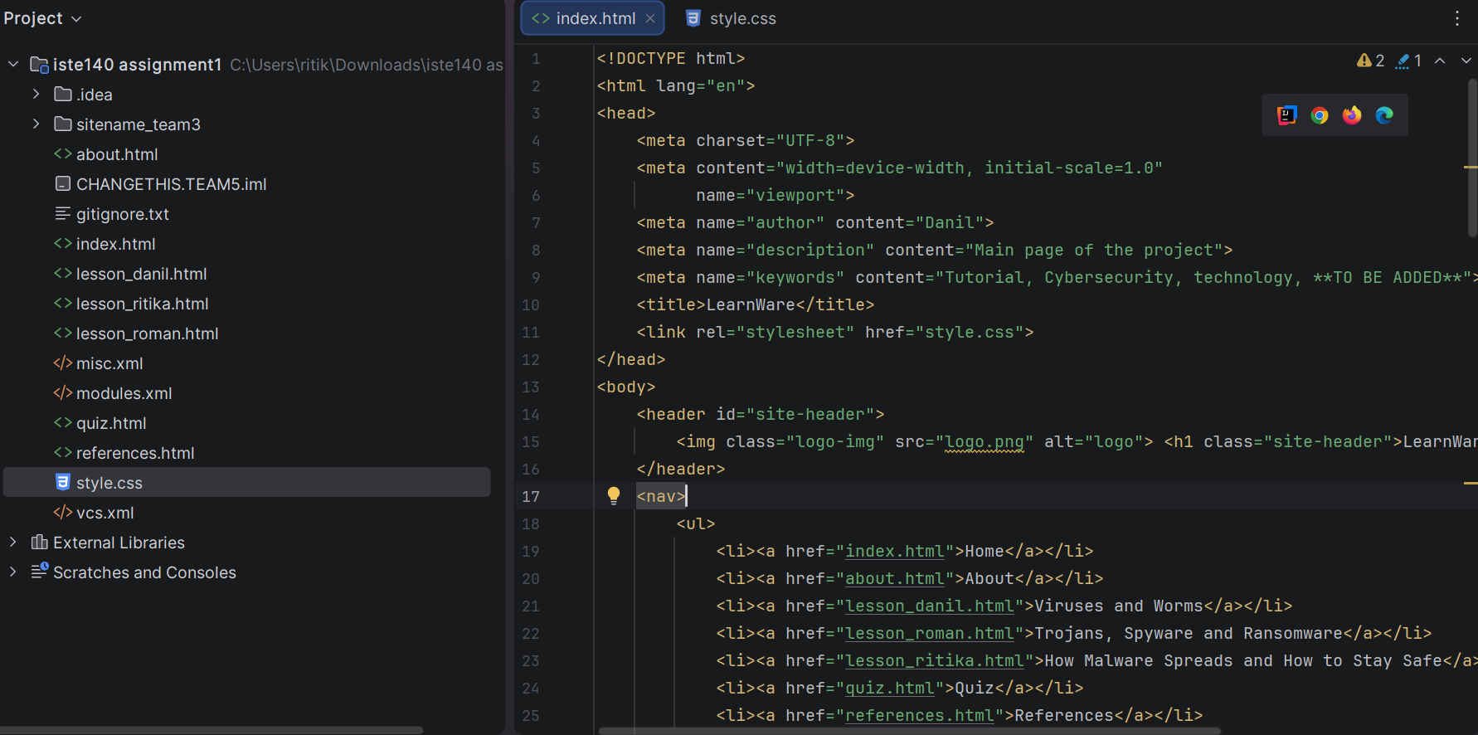

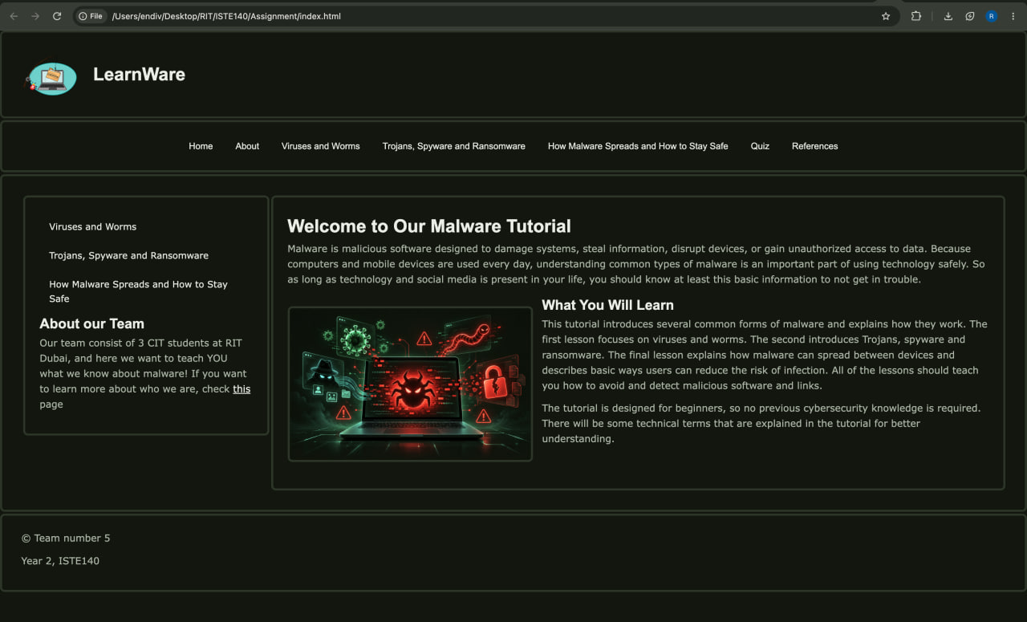

4.2 Roman

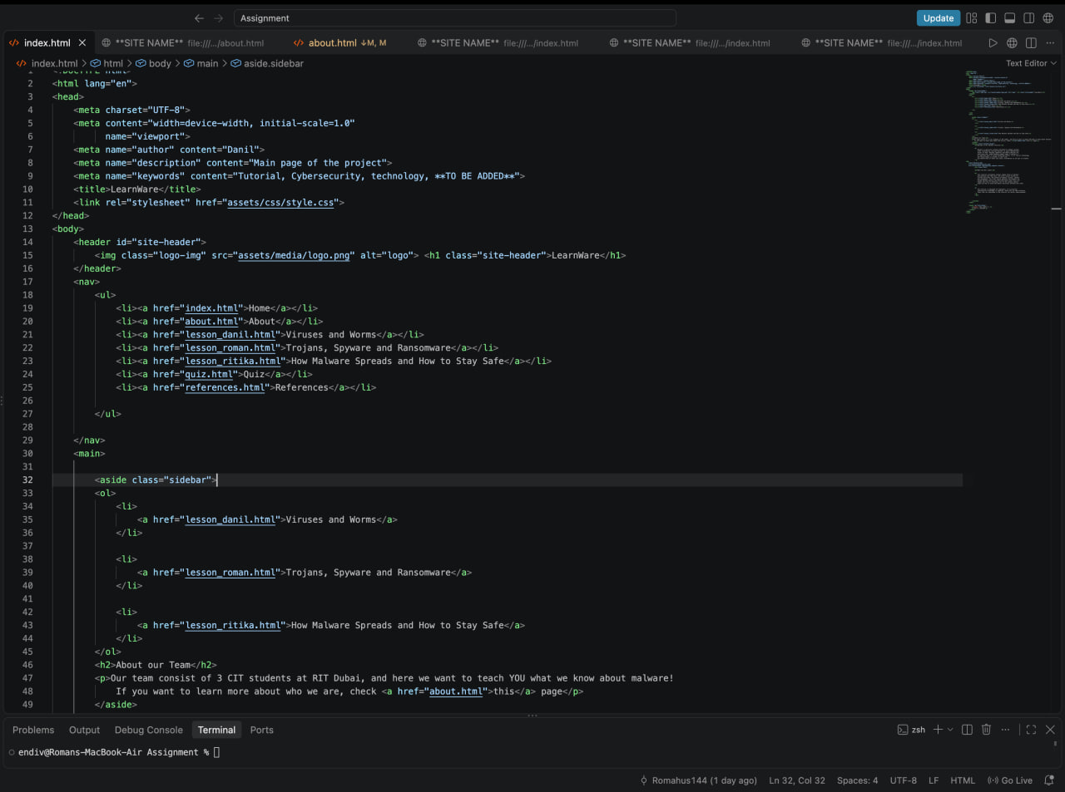

4.3 Danil
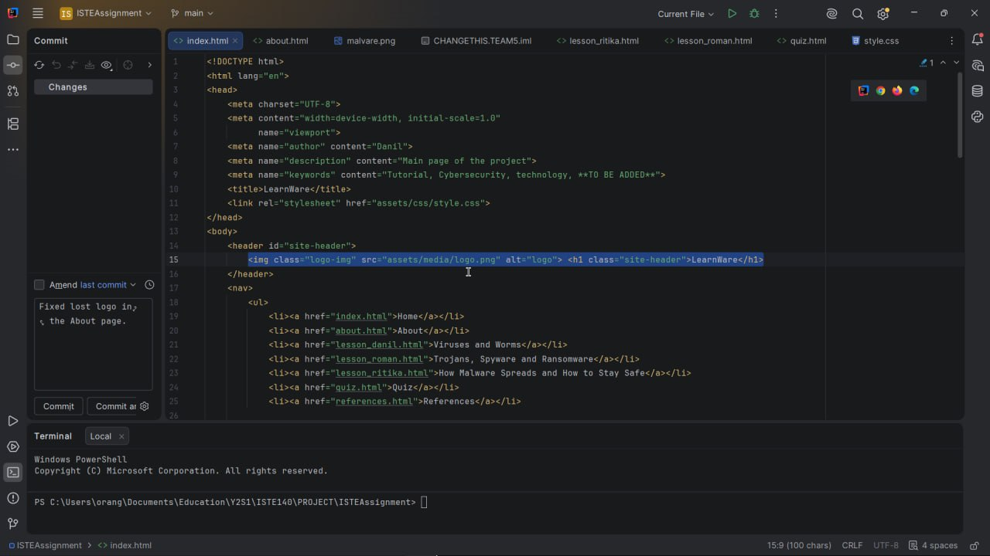
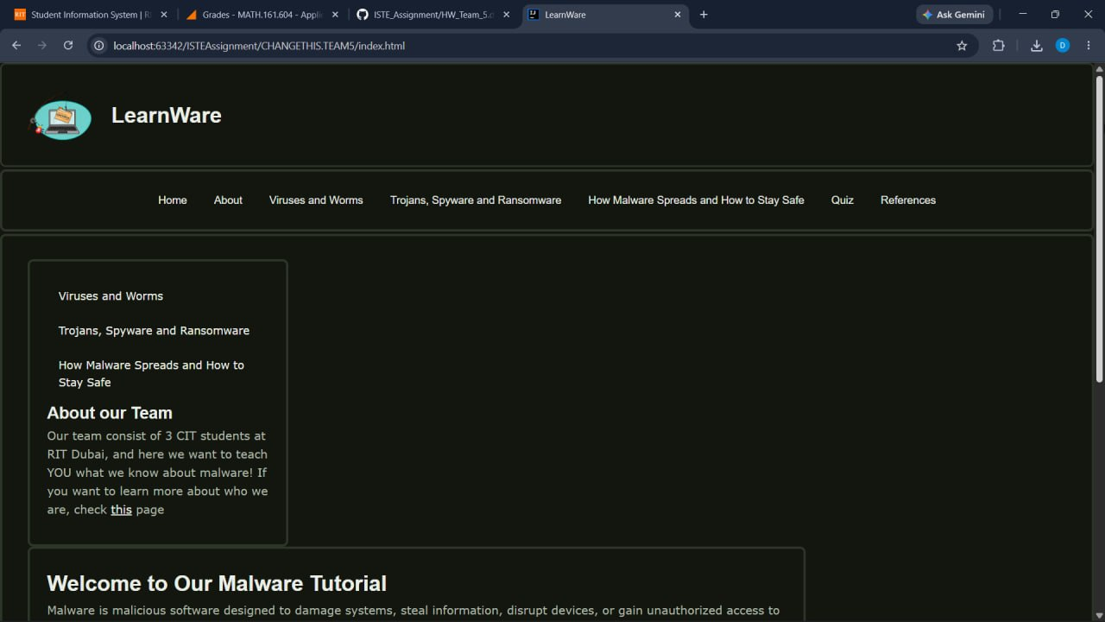

5. FileZilla Deployment

5.1 Connection Settings

Host: banjo.rit.edu
Port: 22
Username: rm6697

5.2 Remote folder tree

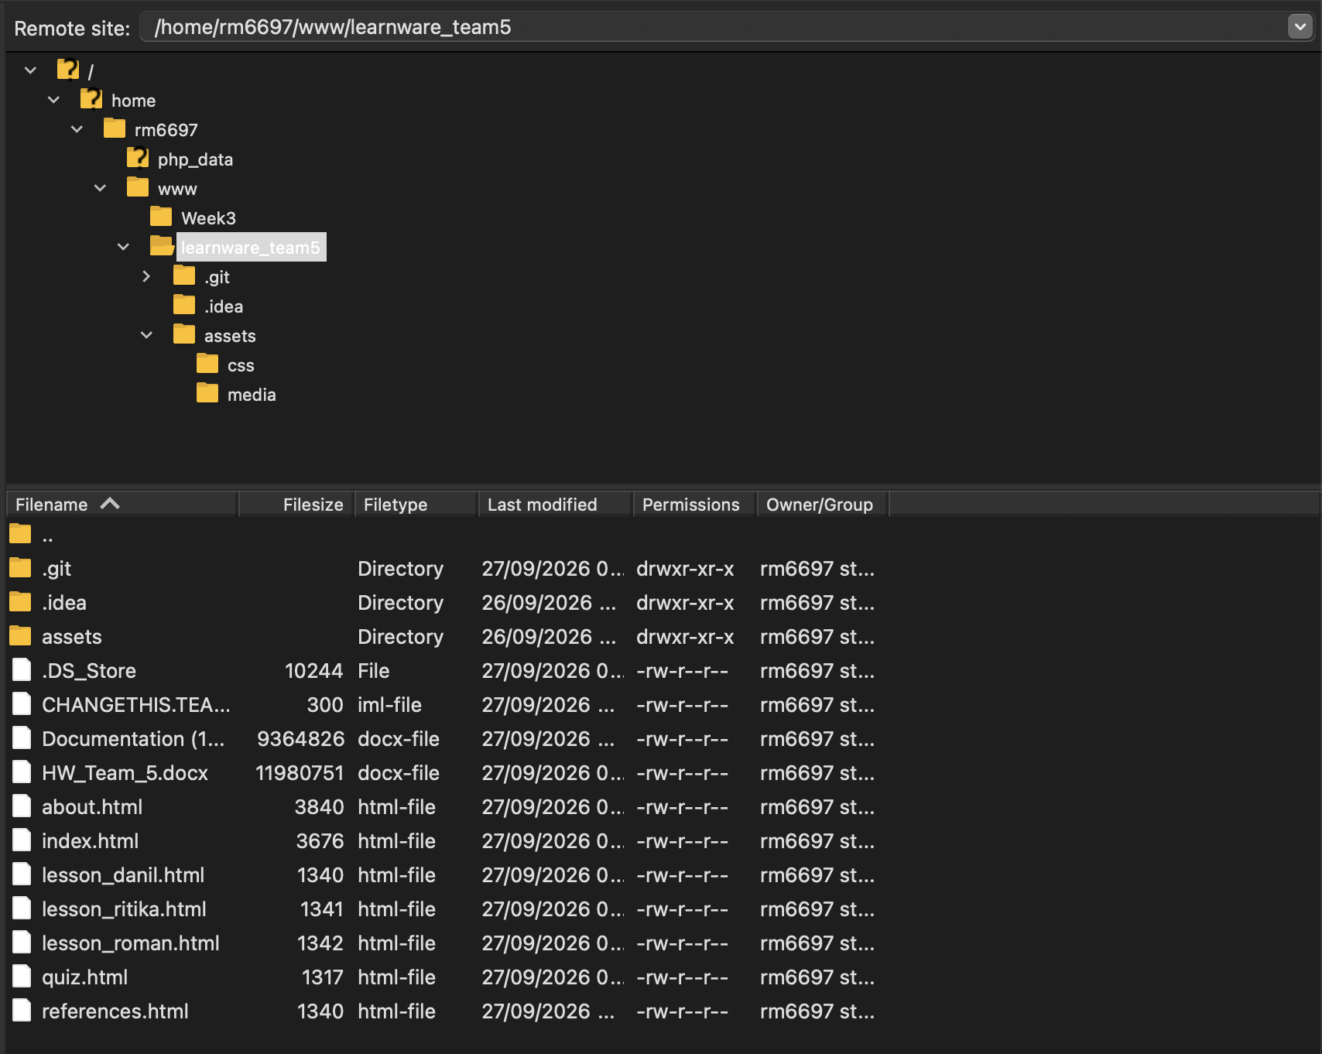

5.3 assets/media permissions

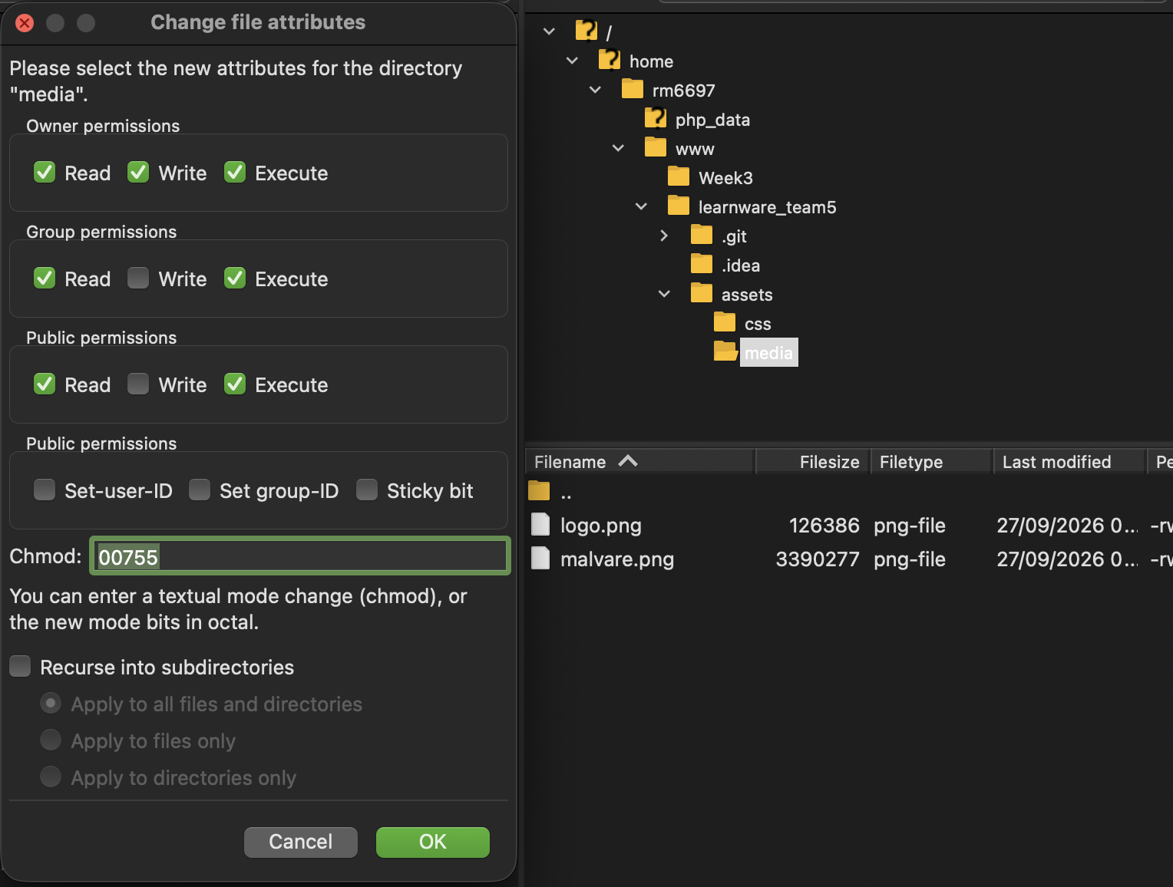

6. Live URLPublished Site

6.1 Live URLs
Roman:
https://people.rit.edu/rm6697/learnware_team5/index.html
Danil:
https://people.rit.edu/dn8157/learnware_team5/index.html

Ritika:
https://people.rit.edu/rl9910/sitename_team5/

6.2 Published-site screenshot

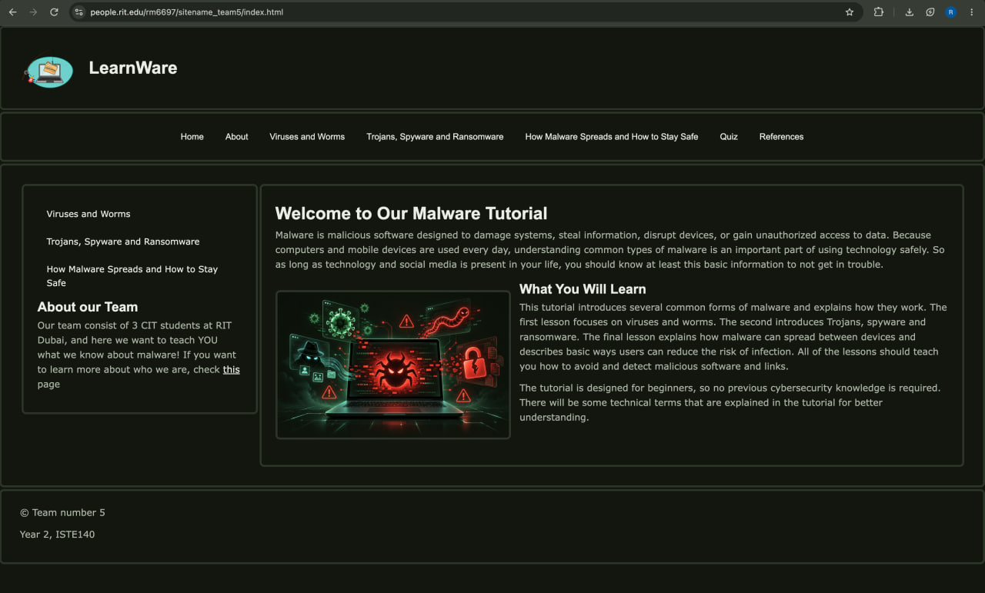

6.3 banjp.rit.edu vs people.rit.edu

banjo.rit.edu is the host we connect to using SFTP in FileZilla to manage our website files. We place the project in our RIT public web directory
people.rit.edu provides the public web address that visitors open in a browser using HTTP or HTTPS. We upload through banjo.rit.edu to manage the files, then browse through people.rit.edu to view the published website.

7. Validation

7.1 index.html - W3C HTML Validator

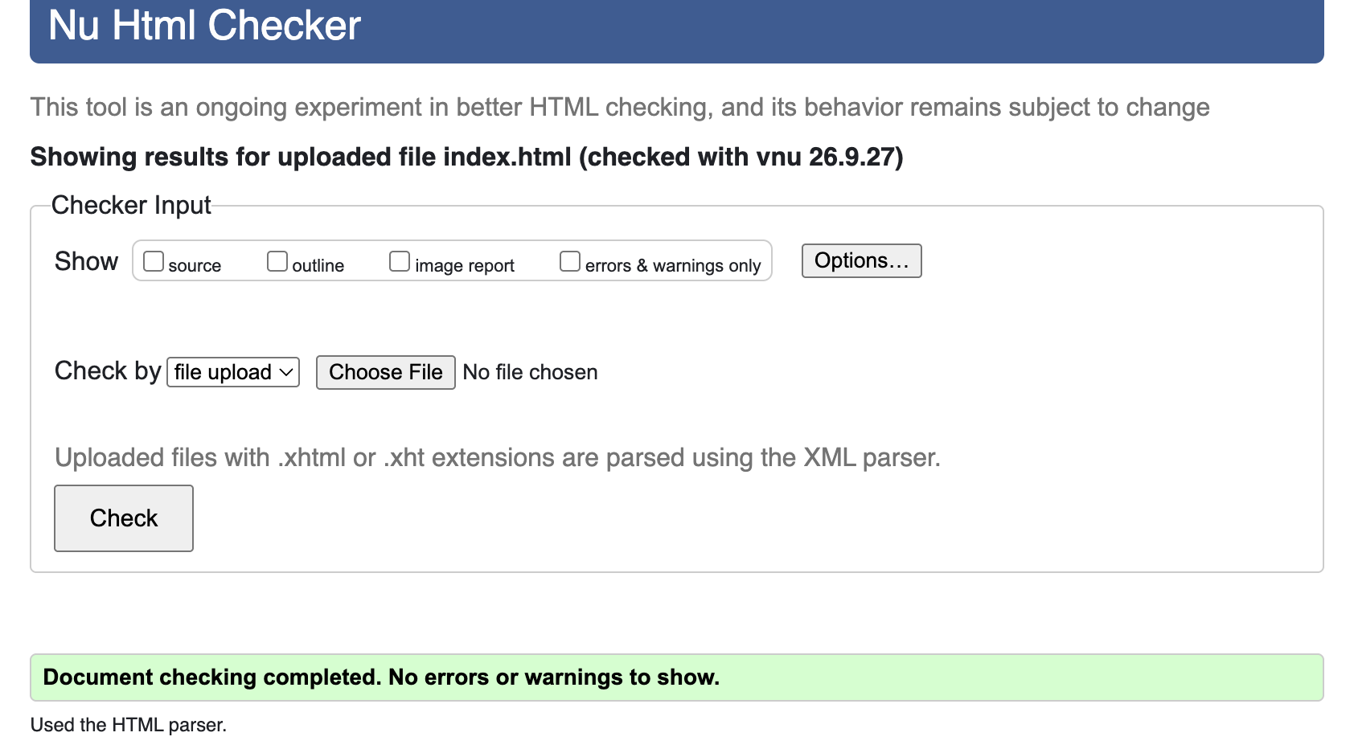
7.2 about.html - W3C HTML Validator

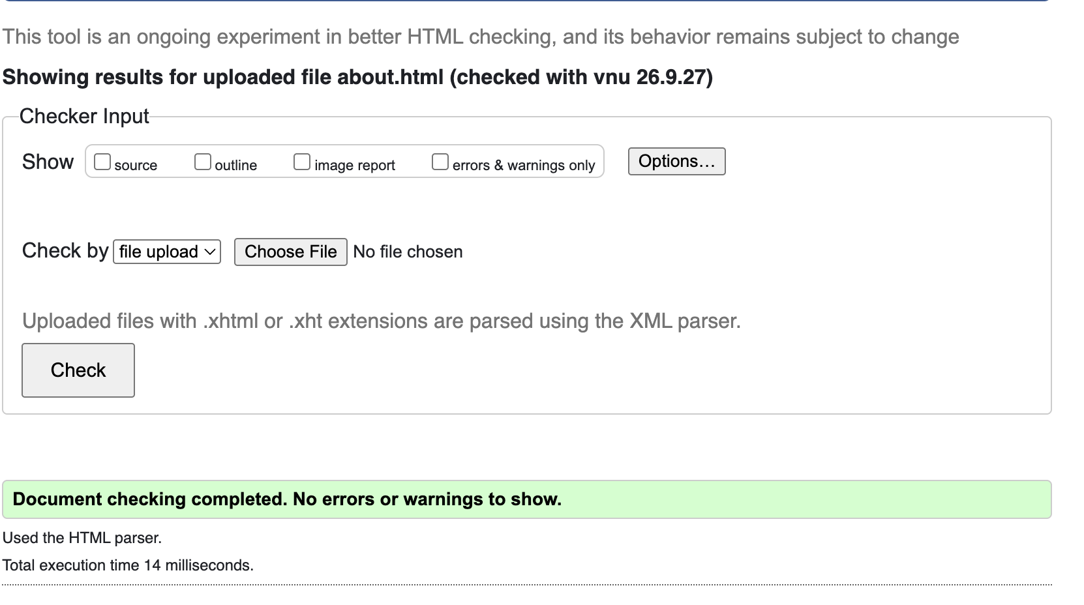

7.3 style.css - W3C CSS Validator
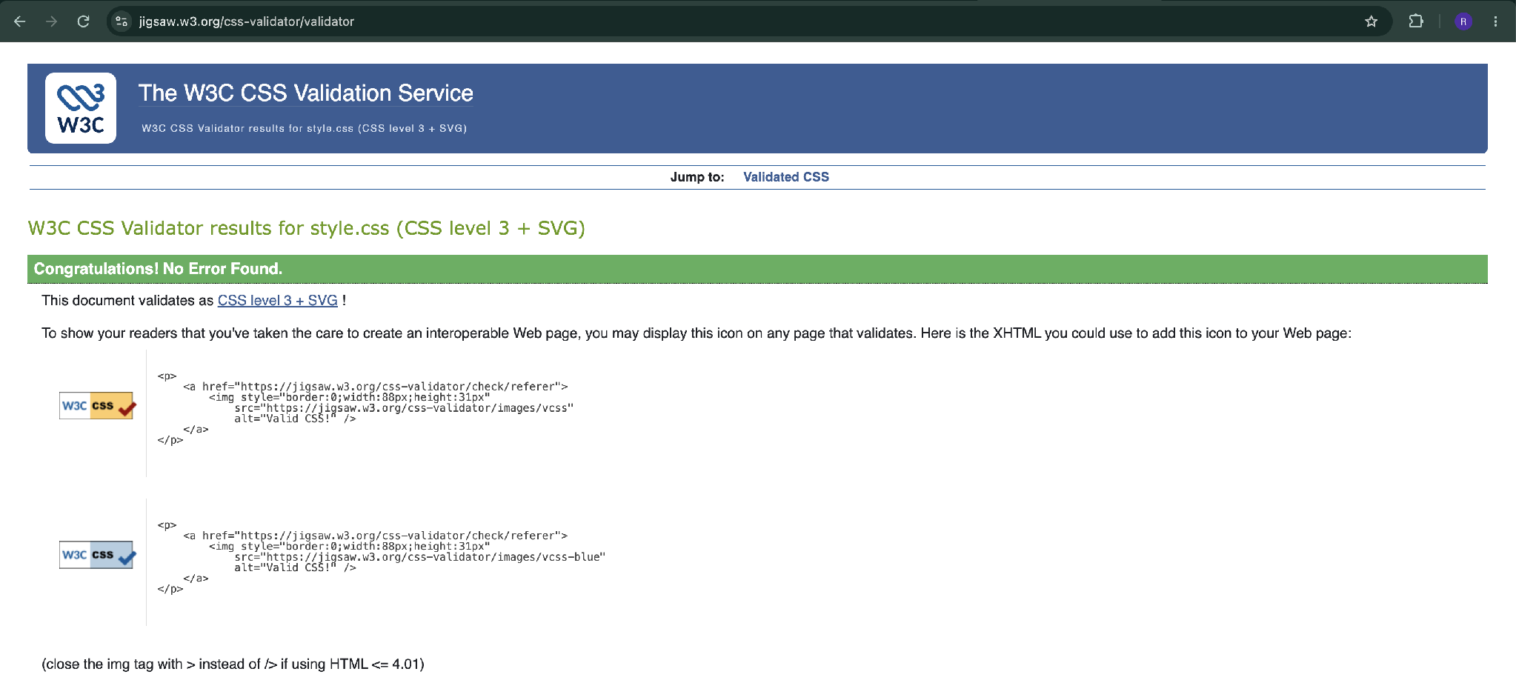

8. Validation Errors Encountered and Fixes
Two validation warnings occurred in the course of development. They have been fixed; the final HTML and CSS validation results are provided in Section 7.

Error | Fix | Why it fixed
index.html: Warning – <h1> should be used as a top-level heading only | Changed the content heading Welcome from <h1> to <h2> | The page already had a main <h1>, so the content heading should be lower-level
about.html: Warning – <h1> should be used as a top-level heading only | Changed the content heading About from <h1> to <h2>. | The page already had a main <h1>, so the content heading should be lower-level

9. Sources and asset credits

9.1 Logo
Creator: Ritika
Tool: Canva
I confirm the fact that the logo is original, not AI-generated and not a modified existing logo
9.2 Malware illustration
The malware illustration (assets/media/malware.png), “malware-img” was created by Roman and downloaded from https://ibb.co/j9hsCW0S

