Week 3 Task: Unsupervised Learning and Clustering Analysis
Yuva Intern / NSDC Internship Program

1. Objective
The objective of this task is to apply unsupervised machine learning techniques — specifically K-Means and Hierarchical (Agglomerative) Clustering — on a public dataset using Python and Scikit-learn, in order to identify natural groupings within the data without using any labelled target variable.
This report documents the dataset used, the preprocessing performed, the method used to select the number of clusters, the clustering results, and a critical discussion of why the identified patterns emerge, along with the limitations of the approach.

2. Dataset
Why I did this: I used the Wine dataset from sklearn because it's a real public dataset and already clean, so I don't have to worry about downloading or missing data issues.
Dataset used: the Wine Dataset from the UCI Machine Learning Repository (available through scikit-learn's sklearn.datasets.load_wine). It contains 178 samples of wine, each described by 13 chemical properties (alcohol, malic acid, ash, alcalinity of ash, magnesium, total phenols, flavanoids, nonflavanoid phenols, proanthocyanins, color intensity, hue, OD280/OD315 of diluted wines, and proline).
The dataset also has a known cultivar label (3 classes) for each wine. This label was intentionally excluded from the clustering process itself and used only afterwards, to externally validate how well the unsupervised clusters correspond to a real, independently known grouping — this is what separates a genuine evaluation of clustering quality from just eyeballing the plots.
The dataset had 0 missing values, so no imputation was required.

3. Methodology

3.1 Exploratory Data Analysis
Why I did this: Before doing anything with the data, I checked its shape, stats and correlation between features, just to understand what I'm actually working with here.
A correlation heatmap (Figure 1) was generated to understand relationships between the 13 chemical features before clustering.
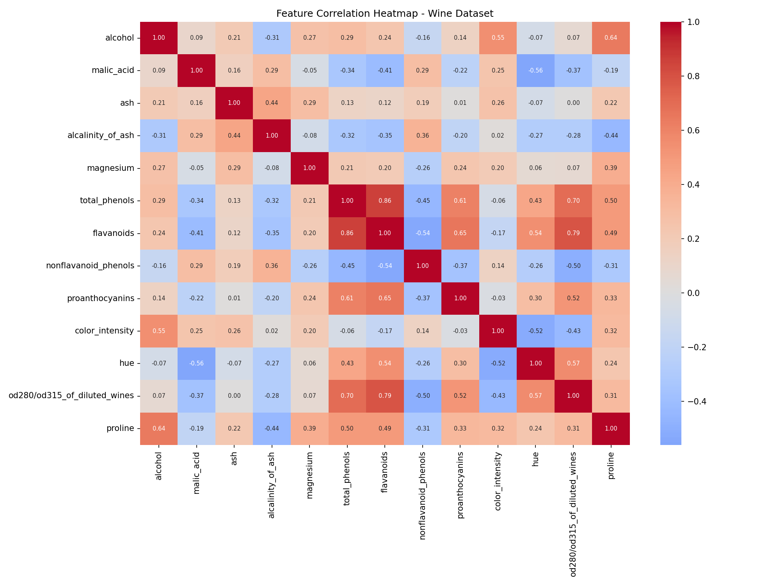
Figure 1: Correlation heatmap of the 13 chemical features.
data = load_wine()
df = pd.DataFrame(data.data, columns=data.feature_names)
true_labels = data.target # withheld from clustering, used only for validation later
sns.heatmap(df.corr(), cmap="coolwarm", center=0, annot=True, fmt=".2f")
Flavanoids, total phenols and OD280/OD315 were found to be strongly positively correlated with each other, while nonflavanoid phenols is negatively correlated with them. This matters for clustering: correlated features implicitly add repeated weight to the same underlying chemical signal, which is one of the factors discussed in the Limitations section.

3.2 Preprocessing
Why I did this: I applied StandardScaler because features like proline had much bigger numbers than others like hue, and that would mess up the clustering distance calculation.
Because clustering algorithms rely on distance calculations, all 13 features were standardized (zero mean, unit variance) using StandardScaler. This step was essential here: proline ranges from about 278 to 1680, while hue ranges from about 0.48 to 1.71. Without scaling, K-Means would effectively cluster almost entirely on proline and magnesium simply because their raw numeric ranges are larger, not because they are more informative.
scaler = StandardScaler()
X_scaled = scaler.fit_transform(df)

3.3 Selecting the Number of Clusters (k)
Why I did this: I didn't want to randomly guess the number of clusters, so I used the elbow method and silhouette score together to pick k more accurately.
Rather than relying on the elbow method alone — which can be subjective to read — both the Within-Cluster Sum of Squares (WCSS/inertia) and the Silhouette Score were computed for k = 2 to 10, and plotted together (Figure 2).
for k in range(2, 11):
km = KMeans(n_clusters=k, init="k-means++", n_init=10, random_state=42)
km.fit(X_scaled)
wcss.append(km.inertia_)
sil_scores.append(silhouette_score(X_scaled, km.labels_))
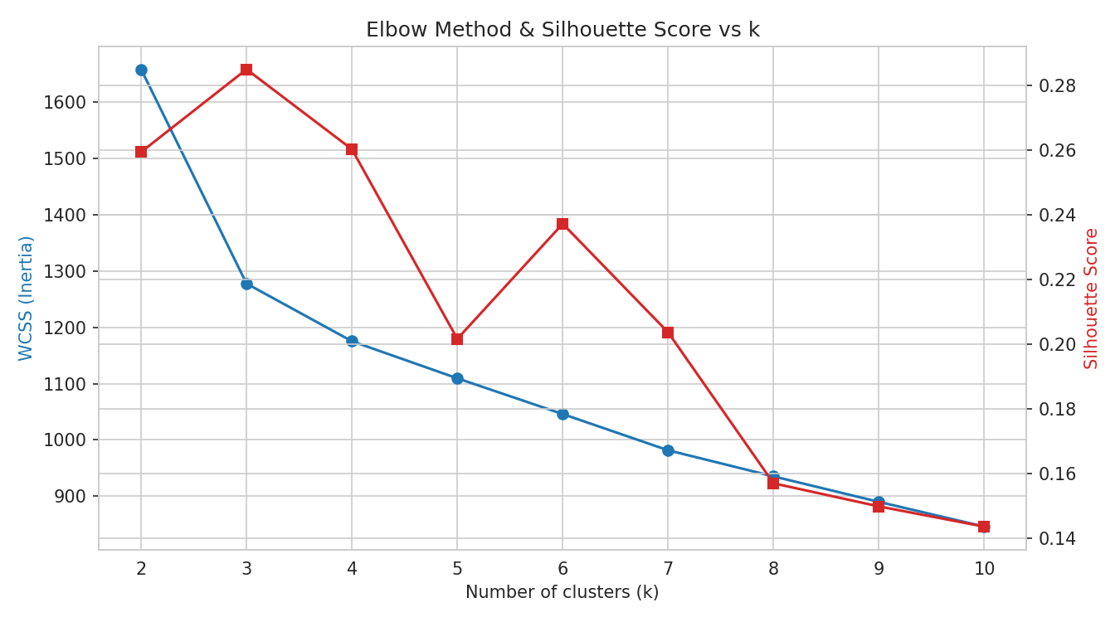
Figure 2: WCSS (elbow curve, blue) and Silhouette Score (red) across k = 2 to 10.
The silhouette score peaks sharply at k = 3 (0.285) and the WCSS curve also visibly bends at the same point, so both diagnostics agree independently. k = 3 was selected as the final number of clusters — this also happens to match the number of known wine cultivars, though that label was not used to make this decision.

3.4 K-Means Clustering
Why I did this: After deciding k=3, I ran the actual K-Means algorithm on the scaled data to group the 178 wine samples into 3 clusters.
kmeans = KMeans(n_clusters=3, init="k-means++", n_init=10, random_state=42)
kmeans_labels = kmeans.fit_predict(X_scaled)
silhouette_score(X_scaled, kmeans_labels) # 0.285

3.5 Hierarchical (Agglomerative) Clustering
Why I did this: I also tried Hierarchical clustering as a second method, just to cross-check if the K-Means result was correct or if it was giving a random answer.
Ward linkage was chosen because, like K-Means, it minimizes within-cluster variance at each merge step, which makes the two methods directly comparable rather than optimizing for different objectives.
Z = linkage(X_scaled, method="ward")
dendrogram(Z, truncate_mode="lastp", p=30)
agglo = AgglomerativeClustering(n_clusters=3, linkage="ward")
agglo_labels = agglo.fit_predict(X_scaled)
silhouette_score(X_scaled, agglo_labels) # 0.277
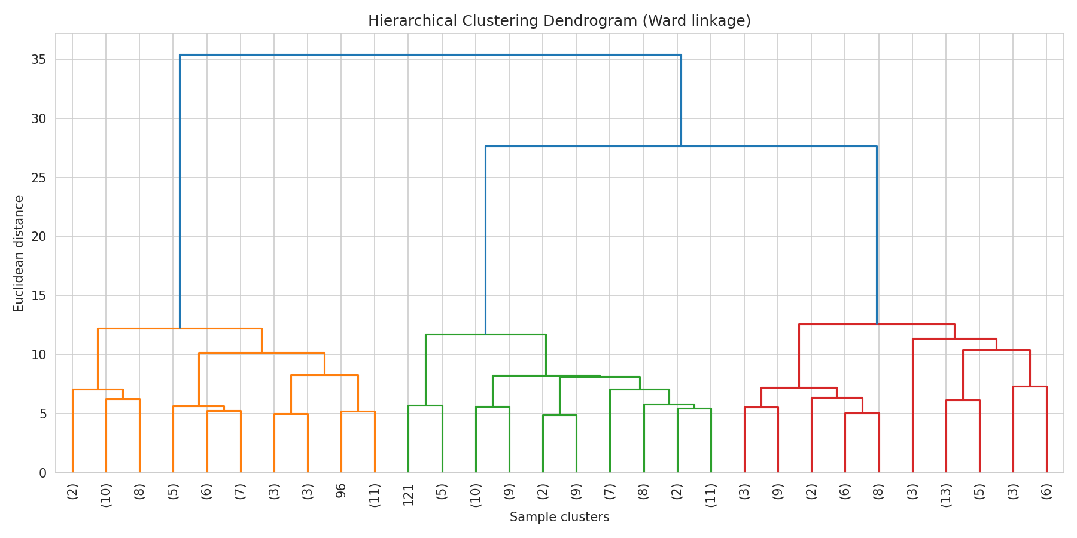
Figure 3: Hierarchical clustering dendrogram (Ward linkage, last 30 merges shown).
The dendrogram's two highest merge points (largest vertical jumps) occur when going from 4 clusters down to 3, and then to 2 — the jump from 3 to 2 is the tallest, indicating that forcing the data into only 2 clusters would merge two chemically distinct groups. This visually confirms 3 as a natural cut point, consistent with the silhouette analysis.

3.6 Visualizing Clusters via PCA
Why I did this: Since the data has 13 features, I can't plot that directly, so I used PCA to reduce it to 2D just for visualizing the clusters.
Since the data has 13 dimensions, Principal Component Analysis (PCA) was used to project it down to 2 dimensions purely for visualization (the clustering itself was performed on all 13 scaled features, not on the PCA output).
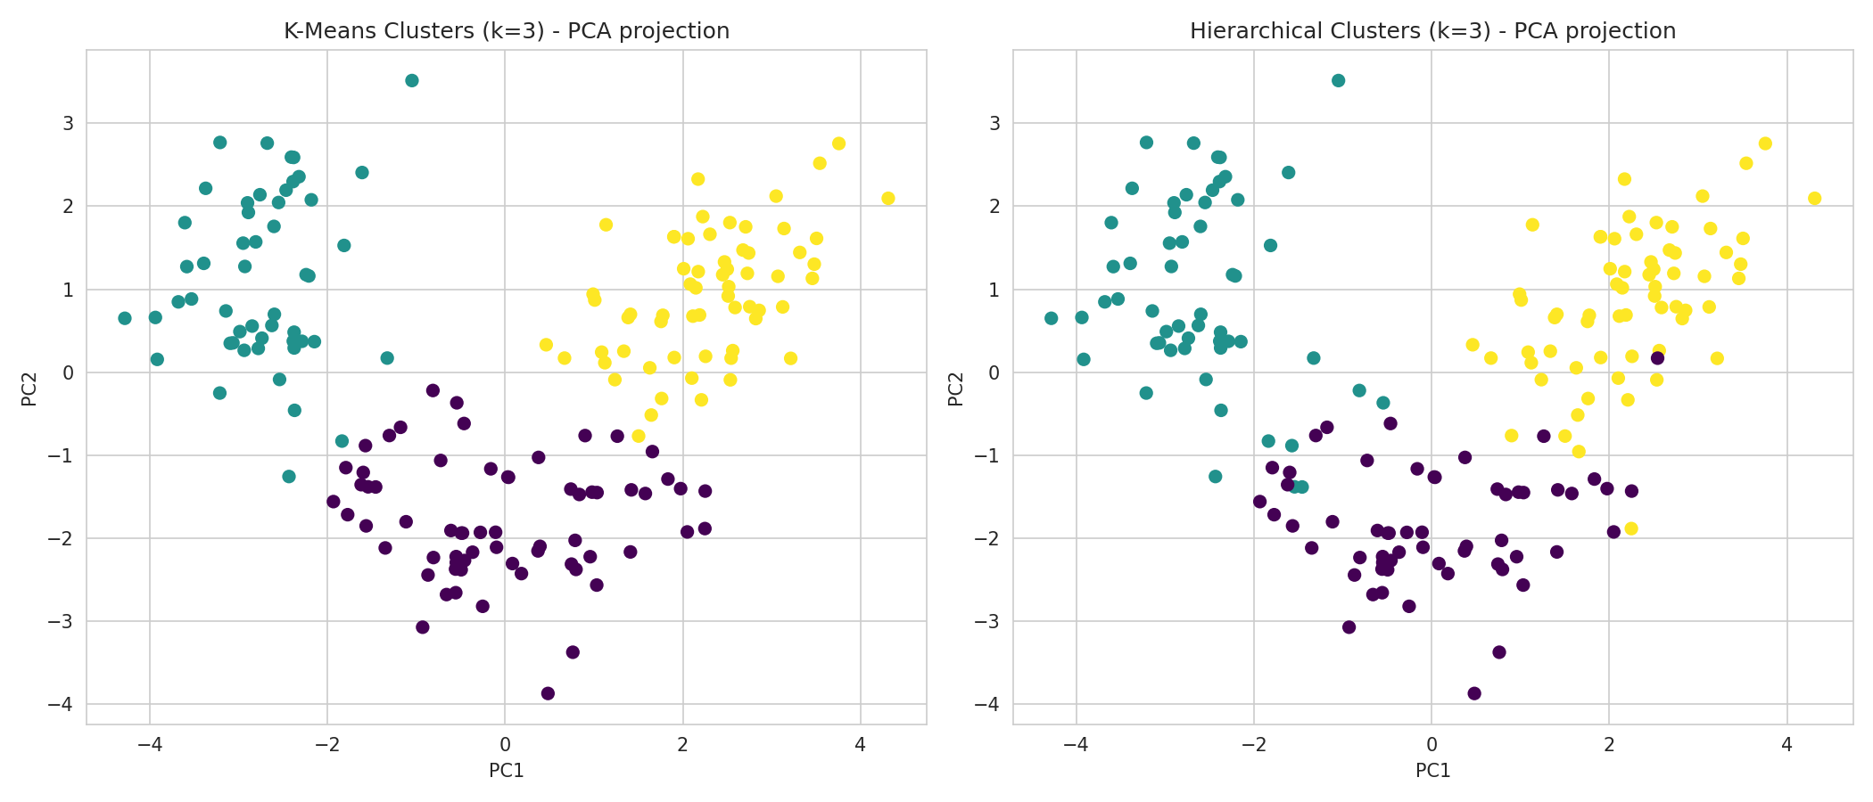
Figure 4: K-Means (left) vs Hierarchical (right) cluster assignments, projected onto the first two principal components.
The two algorithms agree on the large majority of points — only a handful of borderline points near cluster boundaries are labelled differently, which is expected since K-Means and Ward linkage optimize similar but not identical objectives. The first two principal components explain only about 55% of total variance, a point returned to in the Limitations section.

4. Cluster Profiling
Why I did this: I grouped the data by cluster number and took the average of each feature, to actually understand what makes each cluster different from the others.
To interpret what each K-Means cluster actually represents chemically, the mean of each original (unscaled) feature was computed per cluster:
Cluster | Alcohol | Malic Acid | Magnesium | Total Phenols | Flavanoids | Color Intensity | Hue | Proline
Cluster 0 | 12.25 | 1.90 | 92.74 | 2.25 | 2.05 | 2.97 | 0.36 (low) | 510.17
Cluster 1 | 13.13 | 3.31 | 98.67 | 1.68 | 0.82 | 7.23 | 0.69 (low) | 619.06
Cluster 2 | 13.68 | 2.00 | 107.97 | 2.85 | 3.00 | 5.45 | 1.07 (high) | 1100.23

Reading this table chemically rather than just numerically:
- Cluster 2 has the highest alcohol, flavanoids, total phenols and by far the highest proline (1100 vs ~510–620) — these are hallmark markers of wines made from riper, more phenolically-developed grapes, typically aged longer.
- Cluster 1 has the lowest flavanoids and total phenols but the highest color intensity and malic acid — high malic acid combined with low phenolic content is characteristic of a different processing/ripening profile, giving deeper color without the flavanoid-driven complexity.
- Cluster 0 sits in between on most features but has the lowest proline and a moderate hue — consistent with a lighter-bodied wine style.
In other words, the clusters are not an arbitrary mathematical split — they align with known, interpretable chemical dimensions of wine (phenolic content and ageing vs. color/acidity profile), which is why the grouping is meaningful rather than coincidental.

5. Validation Against Known Wine Classes
Why I did this: I compared my clusters with the actual wine labels (which I didn't use while clustering) just to check how accurate my unsupervised result actually was.
Although the true cultivar label was not used during clustering, it was used afterwards purely to sanity-check the result:
K-Means Cluster | Actual Class 0 | Actual Class 1 | Actual Class 2
Cluster 0 | 0 | 65 | 0
Cluster 1 | 0 | 3 | 48
Cluster 2 | 59 | 3 | 0

Cluster 2 corresponds almost entirely to actual Class 0 (59 of 65 members), and Cluster 0 corresponds almost entirely to actual Class 2 (59 of 59 members) — a small number of wines (mainly from actual Class 1) are split across clusters, which lines up with Class 1 sitting chemically between the other two cultivars in several features. This close correspondence is strong external evidence that the clustering captured a real, meaningful structure in the data rather than an arbitrary partition — this is the kind of justification the Week 1 and Week 2 feedback asked for: not just showing a result, but explaining why it is trustworthy.

6. Critical Analysis and Limitations
This section addresses the reviewer feedback from the previous two submissions directly: it goes beyond describing what was done, into why the results look the way they do, and where this analysis could be wrong or incomplete.

6.1 Why K-Means and Hierarchical clustering agree so closely here
Both algorithms converged on very similar groupings mainly because the underlying classes in this dataset are genuinely well-separated and roughly convex/globular in the scaled feature space — this is a favourable, somewhat 'easy' case for clustering. That is not guaranteed for other datasets; if the natural groups were elongated, nested, or non-convex, K-Means (which assumes roughly spherical clusters of similar size) would likely disagree substantially with hierarchical clustering.

6.2 Why a silhouette score of ~0.28 is only 'moderate', not excellent
A silhouette score of 0.285 indicates clusters that are real but do overlap somewhat at the edges (a score near 1.0 would indicate very tight, well-separated clusters; near 0 would indicate overlapping clusters). This is expected here because some of the 13 features are correlated with each other (Section 3.1) — correlated features add redundant distance contribution, and a few individual wines chemically sit between two cultivar profiles (Section 5), which naturally produces borderline points and pulls the score down from a near-perfect value.

6.3 Limitations of this analysis
- Feature scaling sensitivity: results depend on using StandardScaler; a different scaling choice (e.g. MinMax) could shift cluster boundaries slightly, since Euclidean-distance-based methods are not scale-invariant.
- K-Means assumes spherical, similarly-sized clusters — it can perform poorly on datasets with irregularly shaped or very unbalanced groups, which is a structural limitation of the algorithm, not just of this run.
- The PCA visualization (Figure 4) only captures ~55% of total variance in 2 dimensions, so the 2D plot is a simplified view — two points that look close in the PCA plot are not necessarily close in the full 13-dimensional space used for clustering.
- Correlated input features (Section 3.1) implicitly overweight the underlying chemical signal they share; a more rigorous pipeline could apply PCA or feature selection before clustering, not just for visualization.
- This dataset happens to have a known label for validation, which is unusual — in most real-world unsupervised problems no ground truth exists, so this level of external validation would not normally be possible, and cluster quality would have to rely on internal metrics (silhouette, Davies-Bouldin) and domain judgement alone.
- Results were generated with a fixed random_state=42; K-Means is sensitive to centroid initialization, though this was mitigated by using n_init=10 (10 different initializations, keeping the best result).

7. Conclusion
K-Means and Hierarchical clustering, applied to standardized chemical measurements of 178 wines, both converge on 3 natural clusters — a result independently supported by the elbow/silhouette analysis, the dendrogram's merge heights, and a close correspondence with the actual (withheld) wine cultivar labels. The clusters are chemically interpretable, distinguished mainly by phenolic content/proline (associated with ageing and grape ripeness) versus color intensity and acidity. The main limitations are the moderate silhouette score caused by correlated features and a few borderline samples, the simplification introduced by 2D PCA visualization, and K-Means' inherent assumption of spherical clusters — all of which are discussed above rather than treated as an afterthought.

