**Exam Management System Template**

**Login Form**

**Admin Dashboard**

* Number of teachers
* Number of students
* Number of courses
* Number of subjects

**Course Information Management**

* Course name
* Course description

**Subject Information Management**

* Subject code
* Subject name
* Subject Description

**Teacher Profile Management**

* Teacher ID Number
* First name
* Middle name
* Last name
* Course
* Email Address
* Profile Picture
* Username
* Password
* Account status

**Student Profile Management**

* Student ID Number
* First name
* Middle name
* Last name
* Course
* Email Address
* Profile Picture
* Username
* Password
* Account status

**Teacher Subject Assignment**

* Subject code
* Course
* Teacher ID Number

**Teacher Account**

**Teacher Dashboard**

* Number of subjects
* Number of students
* Number of exams

**Manage Exam Details**

* Exam Code
* Exam Name
* Instruction
* Date
* Start Time
* Start Date
* Timer in minutes

**Question Bank**

* Question ID
* Question name
* Choice 1
* Choice 2
* Choice 3
* Choice 4
* Correct Answer
* Points

**Manage Exam Questions**

* Exam Code
* Question ID

**Assign Exam to Students**

* Exam Code
* Student Name

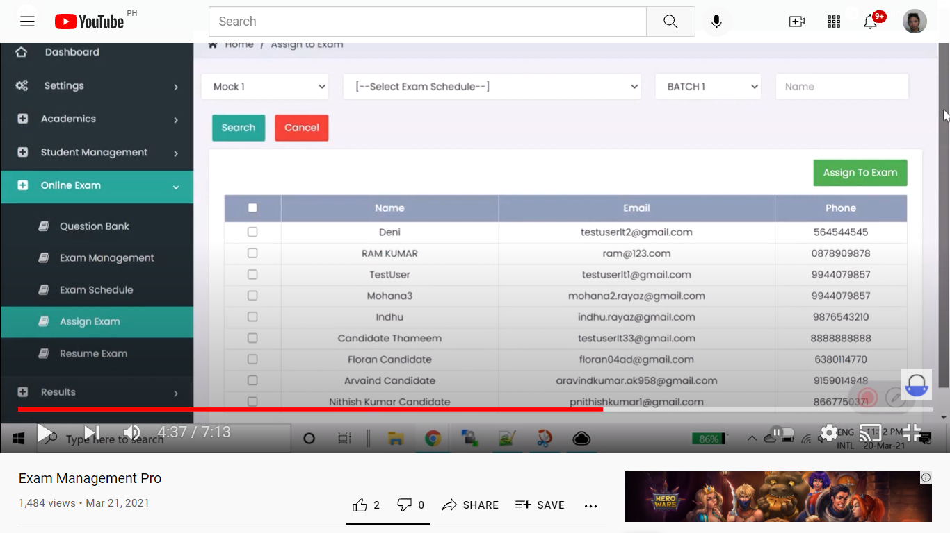

**Exam Result**

* Student name
* Exam code
* Score – 5/10
* Status – passed, failed
* View Score Card

**Score Card Details**

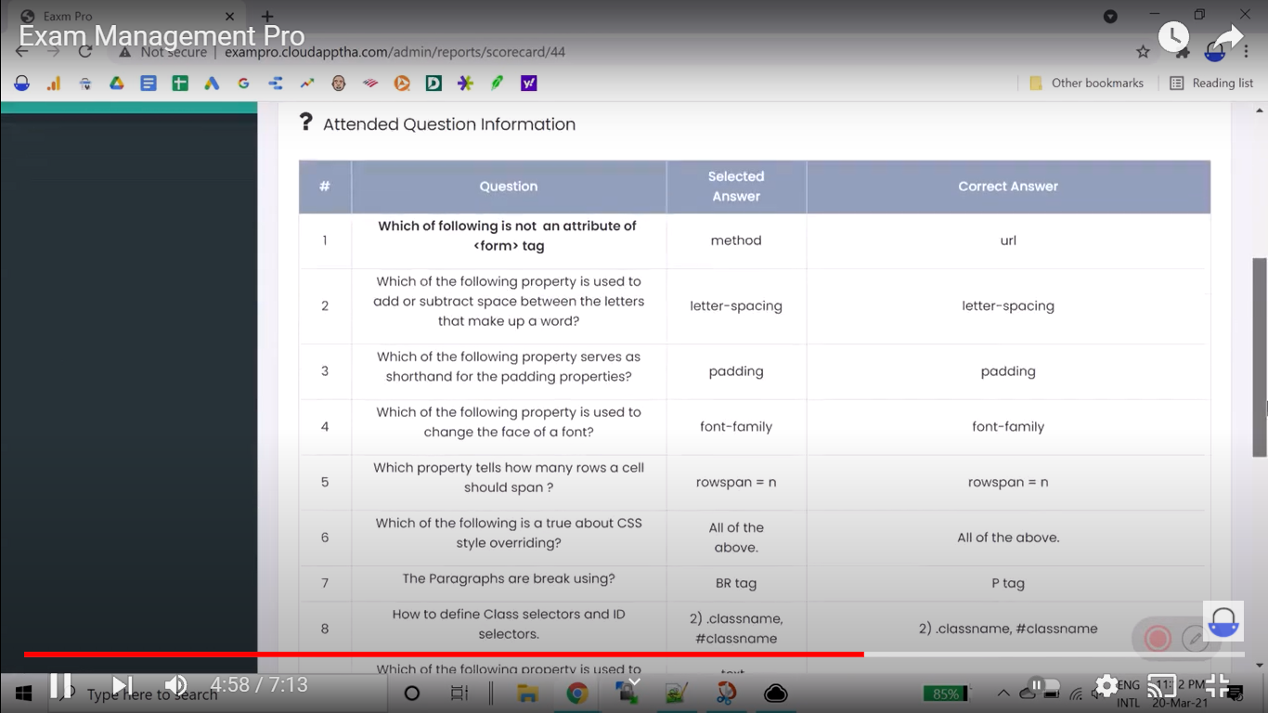

**Exam Result Summary**

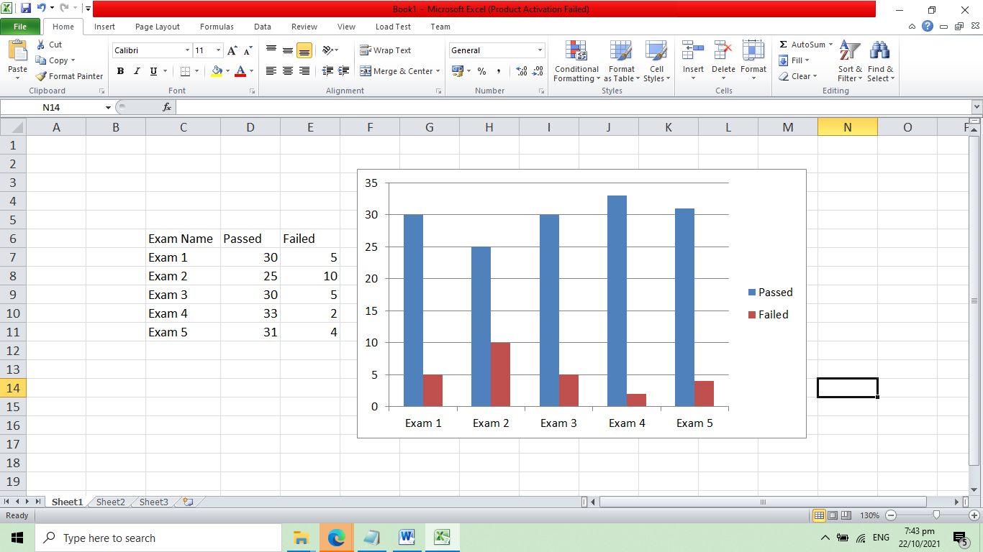

**Student Account**

**Student Dashboard**

* Number of total exam
* Number of upcoming exam

**List of Upcoming Exam**

* Exam Name
* Subject
* Duration
* Take exam button

**Exam Result**

* Exam Name
* Score
* Status – passed, failed
* View Exam Result Details – button

**Exam Result Details**

