Website Development Document
by Yikun Xian

Technology Overview
This website consists of static web pages without backend web server and database supported. Main front-end technologies are listed below.
Language: | HTML, CSS, JavaScript
UI Framework: | Bootstrap v3.3.5
MVC Framework: | AngularJS v1.4.8
Data Format: | JSON

Source code structure
├── css
├── data
│ ├── conference.json
│ ├── course.json
│ ├── event.json
│ ├── interest.json
│ ├── journal.json
│ ├── magazine.json
│ ├── member.json
│ └── project.json
├── doc
│ └── website-update-manual.doc
├── files
├── fonts
├── img
├── index.html
├── js
├── pages
│ ├── home.html
│ ├── material.html
│ ├── publication.html
│ ├── research.html
│ ├── student.html
│ └── teach.html
└── redirect.html
“css” folder contains style sheet files.
“data” folder contains data files that you will need to update.
“doc” folder contains the manual.
“files” folder contains pdf files like papers.
“fonts” folder contains font style.
“img” folder contains all website images and you shall put new images under it.
“index.html” is the website entrance file (like main function in C)
“js” folder contains Javascript that you shall not change.
“pages” folder contains web pages for each section that you will change.
“redirect.html” is the file you just leave it alone.

How to change page content
Contents on pages can be updated in two ways: either directly editing HTML file located in “pages/” directory, or modifying JSON-format file located in “data/” directory. One simple example of JSON-format file looks like following:
[
{
“key_1”: “value_1”,
“key_2”: “value_2”,
…
“key_n”: “value_n”
},
{
“key_1”: “value_1”,
“key_2”: “value_2”,
…
“key_n”: “value_n”,
},
…
{
“key_1”: “value_1”,
“key_2”: “value_2”,
…
“key_n”: “value_n”,
}
]
where square bracket “[]” defines a list, curly bracket “{}” defines key-value pairs, and double quotes “” defines a string. Notice that each item inside “[]” or “{}” must be separated by a comma “,”, except that the last item must not end with a comma “,”.

2.1 Home page
All contents on this page can be found in “pages/home.html”. Just open this file with your favorite text editor and modify the content.

2.2 Publication page
Each record of journal papers, magazine articles and conference papers are respectively stored in “data/journal.json”, “data/magzine.json” and “data/conference.json”.
To append one more record in journal list, open “data/journal.json”, go to the last line before “]”, append a comma to “}” of the last item, which should now look like “},”, and add following lines between this “},” and “]” by changing corresponding values. (DO NOT CHANGE KEYS: “author”, “title”, “link”, “source”)
{
“author”: “author names”,
“title”: “paper title”,
“link”: “PDF file name”,
“source”: “journal name”
}
Finally, place your PDF paper file under “files/” directory.
Perform the same actions to magazines and conferences to add more records.

2.3 Research page
For Sponsors/Collaborators part, edit “pages/research.html”.
For Projects part, edit “data/project.json”, where each record contains four keys:
{
“title”: “project name”,
“content”: “project description”,
“figure”: “project figure name”,
“link”: “project link (can be empty)”
}
where project figure should be placed under “img/” directory.

2.4 Teaching page
Edit “data/course.json”, where each record contains three keys:
{
“title”: “course name”,
“content”: “course description”,
“figure”: “course figure name”
}
where course figure should be placed under “img/” directory.

2.5 Students page
For Group Members part, edit “data/member.json”, where each record contains five keys:
{
“name”: “member name”,
“intro”: “member introduction”,
“avatar”: “member figure name”,
“publication”: [],
“honor”: []
}
where member avatar image should be placed under “img/” directory. Values for publication and honor are also lists. Each item in publication list is the same as the previous publication item. Each item in honor list is just a string. Both publication list and honor list can be empty.
For Event part, edit “data/event.json”, where each record contains three keys:
{
“title”: “event name”,
“content”: “event description”,
“figure:”: “event figure name”,
}
where event figure must be placed under “img/” directory if the figure name specified. The figure name can also be empty.
For Graduate Assistantship Opportunity part, please directly edit “pages/student.html”.

2.6 Useful materials page
Edit “pages/material.html”. The attachment is placed under “files/” directory.

3. How to update website on server
Since ECS server is running Unix (Solaris 5.11), it is recommended to connect to it via SSH. For Windows user, please download putty from http://www.chiark.greenend.org.uk/~sgtatham/putty/download.html.

a) Update website locally
It would be better to firstly update source codes of the website using your favorite text editor on your local computer. You can also edit directly on remote server through Vi, but it’s hard if you are not familiar with Unix.

b) Upload new source codes to server
Under Linux/Unix/OS X, the command “scp” can be used to copy files between local machine and remote server. For Windows user, putty contains a program called “pscp” which has the same function as “scp”. For example, if we want to copy file “index.html” from local to remote, the command looks like:

scp index.html xl329@coewww.rutgers.edu:/www/www8/xiangliu

where “xl329” is username for remote server, “coewww.rutgers.edu” is the domain name of remote server, “/www/www8/xiangliu” is the absolute path for destined folder on remote server. Then, the ECS system will ask for password, so just type the password (character will not show!).
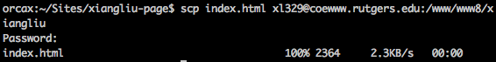
Now, the source code on remote server should be updated. Open browser and refresh home page to see changes.
(Ignore following parts if you don’t want to operate files directly on remote server.)

c) Connect via SSH:
It is more convenient to operate directly on remote server to add/delete file after you are familiar with Unix/Linux environment. We can connect to remote server via command “ssh”:
ssh xl329@coewww.rutgers.edu
You will be asked for password again. Some prompt messages will be like this after login:
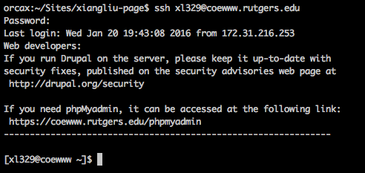

Command “ls” is to list files and folders under current directory.
Command “cd [dir_name]” is to change to different directory. (“..” means upper directory)
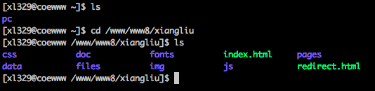
Root directory of the website on ECS server is “/www/www8/xiangliu”, so just place source codes (files and folders) under this directory. DO NOT CHANGE OTHER DIRECTORIES!

Command “mv [file_name_1] [file_name_2]” is to rename file_name_1 to file_name_2.
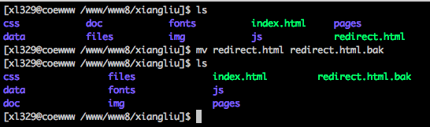

Command “rm [file_name]” is to permanently remove file, “rm –rf [folder_name]” is to permanently remove folder. Notice that removed file cannot be recovered! Be very careful to use this command!

Default text editor on Unix is Vim. It is quite hard for beginners, so I will not cover it here.

Finally, use command “exit” to log out of the server.

