На картинке есть мобильная и десктоп версии страницы логина. Задача:
1)Реализовать новую страницу как на картинке и сделать её адаптивной (clamp, @media)
2)Реализовать переход при нажатии на кнопку Логин на страницу, которую мы верстали до этого
3)Не забыть про анимацию при наведении на кнопки, поля для ввода, чекбоксы, ссылки и иконки.
В качестве ответа на дз прикреплять архив с вашим проектом в ваш личный кабинет.

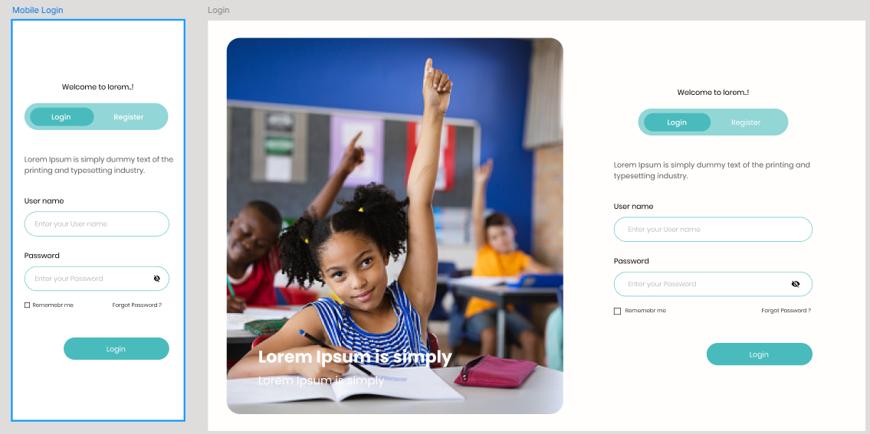

<!DOCTYPE html>
<html lang="en">

<head>
<meta charset="UTF-8">
<meta name="viewport" content="width=device-width, initial-scale=1.0">
<title>Document</title>
<link rel="stylesheet" href="styles/index.css">
</head>

<body>
<header>

<svg class="logo" width="114" height="83" viewBox="0 0 114 83" fill="none" xmlns="http://www.w3.org/2000/svg">
<path
d="M37.9648 4.9502C39.9175 2.99757 43.0825 2.99757 45.0352 4.9502L78.0498 37.9648C80.0024 39.9175 80.0024 43.0825 78.0498 45.0352L45.0352 78.0498C43.0825 80.0024 39.9175 80.0024 37.9648 78.0498L4.9502 45.0352C2.99757 43.0825 2.99757 39.9175 4.9502 37.9648L37.9648 4.9502Z"
stroke="#00FFF0" stroke-width="2" />
<path
d="M40.144 29.536V33.92H34.192V52H28.72V33.92H22.768V29.536H40.144ZM54.7943 52.224C52.6823 52.224 50.7409 51.7333 48.9703 50.752C47.2209 49.7707 45.8236 48.4053 44.7783 46.656C43.7543 44.8853 43.2423 42.9013 43.2423 40.704C43.2423 38.5067 43.7543 36.5333 44.7783 34.784C45.8236 33.0347 47.2209 31.6693 48.9703 30.688C50.7409 29.7067 52.6823 29.216 54.7943 29.216C56.9063 29.216 58.8369 29.7067 60.5863 30.688C62.3569 31.6693 63.7436 33.0347 64.7463 34.784C65.7703 36.5333 66.2823 38.5067 66.2823 40.704C66.2823 42.9013 65.7703 44.8853 64.7463 46.656C63.7223 48.4053 62.3356 49.7707 60.5863 50.752C58.8369 51.7333 56.9063 52.224 54.7943 52.224ZM54.7943 47.232C56.5863 47.232 58.0156 46.6347 59.0823 45.44C60.1703 44.2453 60.7143 42.6667 60.7143 40.704C60.7143 38.72 60.1703 37.1413 59.0823 35.968C58.0156 34.7733 56.5863 34.176 54.7943 34.176C52.9809 34.176 51.5303 34.7627 50.4423 35.936C49.3756 37.1093 48.8423 38.6987 48.8423 40.704C48.8423 42.688 49.3756 44.2773 50.4423 45.472C51.5303 46.6453 52.9809 47.232 54.7943 47.232ZM86.7665 29.536V33.92H80.8145V52H75.3425V33.92H69.3905V29.536H86.7665ZM89.8647 40.736C89.8647 38.5173 90.3447 36.544 91.3047 34.816C92.2647 33.0667 93.5981 31.712 95.3047 30.752C97.0327 29.7707 98.9847 29.28 101.161 29.28C103.827 29.28 106.11 29.984 108.009 31.392C109.907 32.8 111.177 34.72 111.817 37.152H105.801C105.353 36.2133 104.713 35.4987 103.881 35.008C103.07 34.5173 102.142 34.272 101.097 34.272C99.4114 34.272 98.0461 34.8587 97.0007 36.032C95.9554 37.2053 95.4327 38.7733 95.4327 40.736C95.4327 42.6987 95.9554 44.2667 97.0007 45.44C98.0461 46.6133 99.4114 47.2 101.097 47.2C102.142 47.2 103.07 46.9547 103.881 46.464C104.713 45.9733 105.353 45.2587 105.801 44.32H111.817C111.177 46.752 109.907 48.672 108.009 50.08C106.11 51.4667 103.827 52.16 101.161 52.16C98.9847 52.16 97.0327 51.68 95.3047 50.72C93.5981 49.7387 92.2647 48.384 91.3047 46.656C90.3447 44.928 89.8647 42.9547 89.8647 40.736Z"
fill="#5B5B5B" />
</svg>
<div class="wrapper-menu">
<ul class="menu">
<li>
<a class="item-menu" href="">Главная</a>
</li>
<li>
<a class="item-menu" href="">Курсы</a>
</li>
<li>
<a class="item-menu" href="">Карьера</a>
</li>
<li>
<a class="item-menu" href="">Блог</a>
</li>
<li>
<a class="item-menu" href="">О нас</a>
</li>
</ul>
<div class="account">
<img class="avatar" src="img/avatar.png" alt="Аватар">
<p class="login">Lina</p>
<svg class="menu-icon" xmlns="http://www.w3.org/2000/svg" height="24px" viewBox="0 -960 960 960" width="24px"
fill="#e3e3e3">
<path d="M480-344 240-584l56-56 184 184 184-184 56 56-240 240Z" />
</svg>
</div>
</div>
</header>
<main>
<a href="index.html">click</a>
<section class="section--blue">
<div class="section--blue__wrapper-title">
<p class="section--blue__title">Добро пожаловать! Вы готовы к следующему уроку?</p>
<p class="section--blue__link-history">История</p>
</div>
<div class="section--blue__cards">
<div class="section--blue__card">
<!-- Картинка карточки-->
<img class="section--blue__card-img" src="img/lessons/1.png" alt="Урок">
<!-- Название карточки -->
<p class="section--blue__card-name">Сертифицированный разработчик решений AWS</p>
<!-- Аватарка и логин-->
<div class="section--blue__card__account">
<img class="section--blue__card__avatar" src="img/avatar.png" alt="Аватар">
<p class="section--blue__card__login">Lina</p>
</div>
<!-- Прогрес -->
<div class="section--blue__wrapper-progress">
<div class="section--blue__progress section--blue__progress--completed"></div>
<div class="section--blue__progress section--blue__progress--not-completed"></div>
</div>
<!-- Метка прогреса -->
<p class="section--blue__card__progress-label">Урок 5 из 7</p>
</div>
<div class="section--blue__card">
<!-- Картинка карточки-->
<img class="section--blue__card-img" src="img/lessons/1.png" alt="Урок">
<!-- Название карточки -->
<p class="section--blue__card-name">Сертифицированный разработчик решений AWS</p>
<!-- Аватарка и логин-->
<div class="section--blue__card__account">
<img class="section--blue__card__avatar" src="img/avatar.png" alt="Аватар">
<p class="section--blue__card__login">Lina</p>
</div>
<!-- Прогрес -->
<div class="section--blue__wrapper-progress">
<div class="section--blue__progress section--blue__progress--completed"></div>
<div class="section--blue__progress section--blue__progress--not-completed"></div>
</div>
<!-- Метка прогреса -->
<p class="section--blue__card__progress-label">Урок 5 из 7</p>
</div>
<div class="section--blue__card">
<!-- Картинка карточки-->
<img class="section--blue__card-img" src="img/lessons/1.png" alt="Урок">
<!-- Название карточки -->
<p class="section--blue__card-name">Сертифицированный разработчик решений AWS</p>
<!-- Аватарка и логин-->
<div class="section--blue__card__account">
<img class="section--blue__card__avatar" src="img/avatar.png" alt="Аватар">
<p class="section--blue__card__login">Lina</p>
</div>
<!-- Прогрес -->
<div class="section--blue__wrapper-progress">
<div class="section--blue__progress section--blue__progress--completed"></div>
<div class="section--blue__progress section--blue__progress--not-completed"></div>
</div>
<!-- Метка прогреса -->
<p class="section--blue__card__progress-label">Урок 5 из 7</p>
</div>
<div class="section--blue__card">
<!-- Картинка карточки-->
<img class="section--blue__card-img" src="img/lessons/1.png" alt="Урок">
<!-- Название карточки -->
<p class="section--blue__card-name">Сертифицированный разработчик решений AWS</p>
<!-- Аватарка и логин-->
<div class="section--blue__card__account">
<img class="section--blue__card__avatar" src="img/avatar.png" alt="Аватар">
<p class="section--blue__card__login">Lina</p>
</div>
<!-- Прогрес -->
<div class="section--blue__wrapper-progress">
<div class="section--blue__progress section--blue__progress--completed"></div>
<div class="section--blue__progress section--blue__progress--not-completed"></div>
</div>
<!-- Метка прогреса -->
<p class="section--blue__card__progress-label">Урок 5 из 7</p>
</div>
</div>
<div></div>
</section>
</main>
<footer></footer>
</body>

</html>

* {
margin: 0;
padding: 0;
}

html {
font-size: 16px;
}

button {
border: none;
}

header {
display: flex;
align-items: center;
justify-content: space-between;
gap: clamp(1rem, 0.5146rem + 2.0712vw, 3rem);
padding: clamp(0.5rem, 0.1663rem + 1.4239vw, 1.875rem) clamp(1.875rem, 0.5097rem + 5.8252vw, 7.5rem);
background-color: white;
}

.logo {
width: clamp(3rem, 1.9988rem + 4.2718vw, 7.125rem);
min-width: 3rem;
flex-shrink: 0;
}

.wrapper-menu {
display: flex;
align-items: center;
gap: clamp(2.5rem, 1.8932rem + 2.5890vw, 5rem);
}

.menu {
display: flex;
gap: clamp(1.875rem, 1.1165rem + 3.2362vw, 5rem);
list-style-type: none;
}

.item-menu {
text-decoration: none;
font-size: clamp(1.125rem, 1.0643rem + 0.2589vw, 1.375rem);
color: #5B5B5B;
cursor: pointer;
transition: all 300ms ease-out;
white-space: nowrap;
}

.item-menu:hover {
filter: brightness(0.3);
}

.account {
display: flex;
align-items: center;
gap: 15px;
}

.avatar {
background-color: #D9D9D9;
border-radius: 100%;
width: clamp(2.5rem, 2.1510rem + 1.4892vw, 3.938rem);
height: clamp(2.5rem, 2.1510rem + 1.4892vw, 3.938rem);
}

.login {
font-size: clamp(1rem, 0.9697rem + 0.1294vw, 1.125rem);
}

.menu-icon {
fill: black;
background-color: #cfe7ff00;
border-radius: 100%;
cursor: pointer;
transition: background-color 300ms ease-out;
}

.menu-icon:hover {
background-color: #CFE7FF;
}

.section--blue {
display: flex;
flex-direction: column;
gap: clamp(1.25rem, 0.7949rem + 1.9417vw, 3.125rem);
padding: clamp(0.5rem, 0.1663rem + 1.4239vw, 1.875rem) clamp(1.875rem, 0.5097rem + 5.8252vw, 7.5rem);
background-color: #d8ebff;
}

.section--blue__wrapper-title {
display: flex;
gap: 10px;
align-items: center;
justify-content: space-between;
}

.section--blue__title {
font-size: clamp(1.125rem, 0.8519rem + 1.1650vw, 2.25rem);
font-weight: 600;
color: #252641;
}

.section--blue__link-history {
font-size: clamp(1rem, 0.9393rem + 0.2589vw, 1.25rem);
color: #49BBBD;
font-weight: 600;
cursor: pointer;
transition: all 300ms ease-out;
}

.section--blue__link-history:hover {
filter: brightness(0.7);
}

.section--blue__cards {
display: grid;
grid-template-columns: repeat(auto-fit, minmax(300px, 1fr));
gap: clamp(1.25rem, 0.7949rem + 1.9417vw, 3.125rem);
}

.section--blue__card {
background-color: white;
padding: 20px;
display: flex;
flex-direction: column;
gap: 20px;
border-radius: 20px;
box-shadow: 12px 12px 20px rgba(47, 50, 125, 0.2);
transition: all 300ms ease-out;
cursor: pointer;
}

.section--blue__card:hover {
filter: brightness(0.9);
transform: translateY(-2px)
}

.section--blue__card-img {
border-radius: 20px;
}

.section--blue__card-name {
color: #252641;
font-weight: 600;
font-size: clamp(1.125rem, 1.0340rem + 0.3883vw, 1.5rem);
}

.section--blue__card__progress-label {
color: #00000080;
font-size: 14px;
font-weight: 600;
text-align: right;
}

.section--blue__wrapper-progress {
width: 100%;
display: flex;
}

.section--blue__progress {
height: 8px;
border-radius: 2px;
}

.section--blue__progress--completed {
background-color: #49BBBD;
width: 70%;
}

.section--blue__progress--not-completed {
background-color: #D9D9D9;
width: 30%;
}

.section--blue__card__account {
display: flex;
align-items: center;
gap: 15px;
}

.section--blue__card__avatar {
background-color: #D9D9D9;
border-radius: 100%;
width: 42px;
}

.section--blue__card__account {
font-size: 30px;
}

.section--blue__card__login {
font-size: clamp(1rem, 0.9697rem + 0.1294vw, 1.125rem);
}

@media (max-width: 800px) {
header,
.wrapper-menu,
.menu {
flex-direction: column;
}

.section--blue__wrapper-title{
flex-direction: column;
align-items: flex-start;
}

}

/* .grid-test{
display: grid;
grid-template-columns: repeat(auto-fit, minmax(200px, 1fr));
/* grid-template-rows: 1fr 1fr; */
/* grid-template-rows:; */

/*

@media (max-width: 1000px){
.test-block{
font-size: 1rem;
}
}

@media (min-width: 480px) and (max-width: 1024px){

}

@media (orientation: landscape){
.test-block{

}
}

@media (orientation: portrait){
.test-block{

}
} */

