Literature - time resolved XPS high throughput analyses

# Iterative peak-fitting of frequency-domain data via deep convolution neural networks

Park, S. H., Park, H., Lee, H., & Kim, H. S. (2021). Iterative peak-fitting of frequency-domain data via deep convolution neural networks. Journal of the Korean Physical Society, 79(12), 1199–1208. <https://doi.org/10.1007/s40042-021-00346-1>

**Introduction:**

Computational materials database from DFT: materials project, open quantum materials database (OQMD), novel materials discovery (NOMAD)

Useful to establish statistical models.

Difficulties when analyzing experimental spectroscopic data:

1. Non uniqueness of decomposition in components, that are not orthogonal. For instance non uniqueness of the decomposition of a XPS peak.
2. Small databases of experimental results, not enough to train deep neural networks
3. Superiority of human recognition with physical intuitions

Here:

* combination of deep convolution neural networks (CNN) and conventional basin-hopping optimization
* objective: decompose a spectrum F(w) into multiple peak functions fi(w), with minimal error between F(w) and the sum of fi(w)
* 6 CNN architectures have been considered: 5 already existing and one new

The trained CNN models iteratively finds the peak with largest area, and subtracts to the total.

Used pseudo-Voigt function to avoid to use experimental database

Errors in regression process are corrected with conventional global optimizations to “fine tune the peak parameters”

**Methods:**

**Description of neural network architectures:**

Objective of the CNN: find the peak with the largest underlying area

* LeNET: first proposed CNN, composed of alternating convolution and sub-sampling layers
* Alex-ZFNet: improvement by adding maxpooling, dropout and rectified linear unit activation function
* VGGNet: uniform etwork structure and increased number of convolution filters
* ResNet: implements “skip connection” that enhance back propagation of the loss function
* SENet: “squeeze and excitation block” allows performance increase

m-SENet: model developed here: modification of SENet:

SE blocks from SENet (squeeze and excitation block) are implemented into “sparse dense block”.

A “sparse dense block”: two triplets in series: two convolution layers and a SE block in series

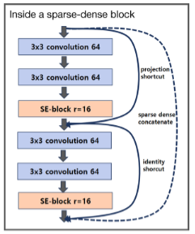

Between two sparse – dense blocks: a batch normalization and SE layer:

At the end: a regression layer and global average pooling

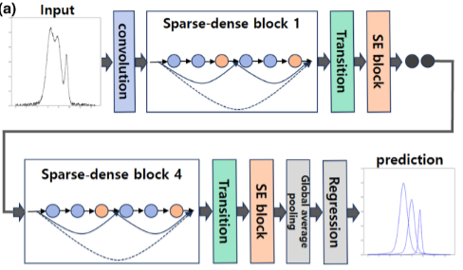

Four sparse dense blocks are employed

Total number of parameters to train: 4 183 830

**Generation of training, validation and test datasets:**

A synthetic dataset is generated with pseudo-Voigt functions.

Parameters of the function, values are randomly generated:

* $ω_{0}$: position of the peak
* $I_{0}$: maximum height
* $δ$: width of the peak

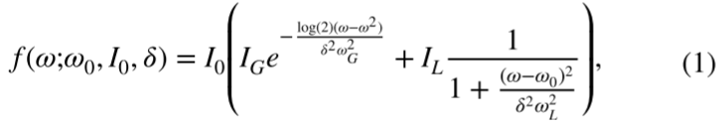

Parameters set to fixed value: $ω_{G}=0.510$, $ω_{L}=0.441$, $I_{G}=0.7$ and $I_{L}=0.3$. Values chosen according to previous study.

Up to five peaks are combined for each entry of the database. Gaussian noise is added, with std of 2% of $I_{0}$

Neighboring peaks cannot be closer than 20% of the greatest $δ$

1.5e6 spectra generated, from which:

* 1.2e6 for training
* 1.5e5 for validating
* 1.5e5 for testing

**Implementation, train and validation of neural networks:**

Framework: Keras

Backend: Tensorflow

Training was done on a GPU: Nvidia RTX 2080Ti

Adam optimizer was employed, LeakyReLU activation function, 50 epochs with 512 batch size

Total loss function: sum of loss functions for center, width, amplitude and peak number. Weights to balance between the functions:

* $ω_{0}$: 1
* $I_{0}$: 20
* $δ$: 10
* Peak number: 2

Loss function

* MSE (mean squared error): can overestimate the effect of few outliers
* MAE (mean absolute error): less impacted by outliers

**Results:**

**CNN training and validation:**

Better results with MAE: did the training and validation with both functions, and applied both models to test dataset with MAE

After comparing models, training is done over 10e6 database.

m-SENet performs best

CNN is trained to fit the peak with largest area

**Iterative peak subtraction via trained CNN and basin-hopping optimization**

CNN trained above is employed sequentially to find and subtract the peak with largest area.

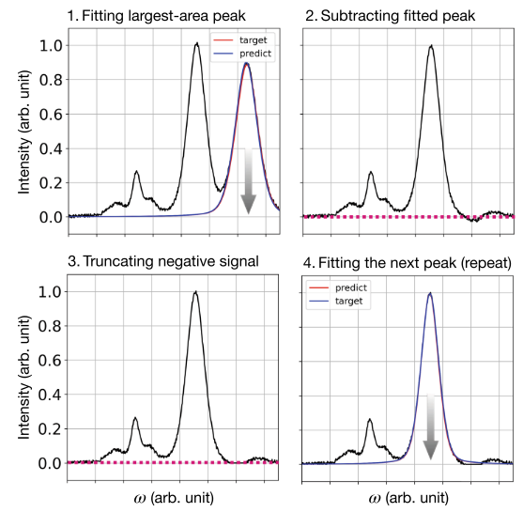

In order to avoid negative values when subtracting fitted peak: remaining spectrum truncated to 0.

It is necessary to accurately determine the number of total peaks from the beginning.

After employing the method to sequentially extract all peaks, conventional global optimization is employed. Here basin-hoping algorithm is employed

Function employed: scipy.optimize.basinhopping

The supplementary step minimizes the error, and can even strongly correct cases where the iterative CNN procedure gives poor results.

Experimental XPS spectra are pretreated to remove background: IGORPRO package

**Discussion and conclusion**

Most of experimental XPS peaks in a given energy width usually show similar width: this was not included in the model, and values for peak width are explored as a uniform random parameter.

Pseudo Voigt function was employed, with fixed internal (ratios) parameters. Using a true Voigt function could enhance performances.

# Shirley background

Python library with function to calculate Shirley background: <https://arpes.readthedocs.io/en/latest/generated/arpes.analysis.shirley.calculate_shirley_background.html>

Végh, J. (2004). The Shirley-equivalent electron inelastic scattering cross-section function. Surface Science, 563(1–3), 183–190. <https://doi.org/10.1016/j.susc.2004.06.154>

Vegh, J. (1988). The analytical form of the Shirley-type background. Journal of Electron Spectroscopy and Related Phenomena, 46(2), 411–417. <https://doi.org/10.1016/0368-2048(88)85038-2>

In XPS, the background is due to inelastic scattering of electrons when escaping the solid.

Shirley background: empirical method introduced by Shirley in 1972, no physical interpretation.

Tougaard background: introduced in 1986, calculation method based on a cross section for inelastic energy loss.

Shirley remains widely used for its simplicity.

**Procedure:**

Photo-peak intensity: $P(E)$

Associated background intensity: $S_{S}(E)$

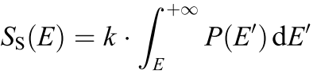

k is an arbitrary constant.

In practice, the photo-peak intensity is not available, only the measured spectrum:

$$j\left(E\right)=P\left(E\right)+S_{S}(E)$$

This expression is employed to approximate $P\left(E\right)$ with an approximation of the background.

The obtained background is re-employed to refine iteratively is value:

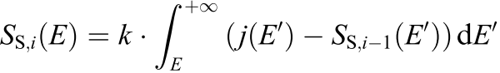

As initial approximation, a constant background is considered.

Iterations are repeated until convergence.

Example of Shirley (red dotted) and linear (black plain) backgrounds:

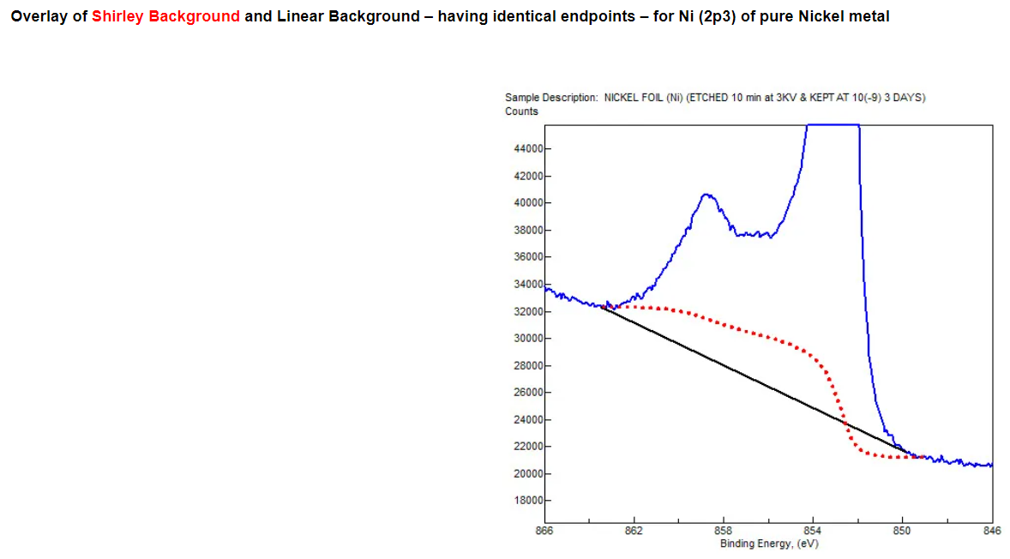

# Principles of XPS

Stevie, F. A., & Donley, C. L. (2020). Introduction to x-ray photoelectron spectroscopy. Journal of Vacuum Science & Technology A: Vacuum, Surfaces, and Films, 38(6), 063204. <https://doi.org/10.1116/6.0000412>

Béchu, S., Ralaiarisoa, M., Etcheberry, A., & Schulz, P. (2020). Photoemission spectroscopy characterization of halide perovskites. Advanced Energy Materials, 10(26), 1904007. <https://doi.org/10.1002/aenm.201904007>

**XPS: X-rays photo-electron spectroscopy**

Excitation: high energy photons (X-rays)

Measurement: spectrum of emitted electrons. Kinetic energy of the electron is measured.

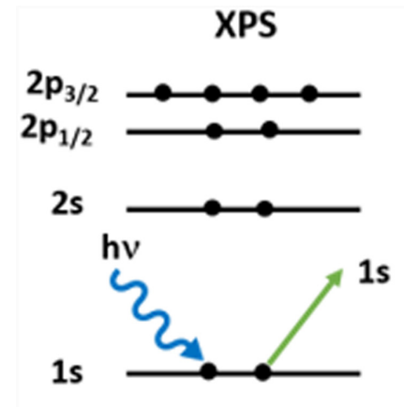

The emitted electrons come from core levels.

**Relationship between measured kinetic energy of electrons and sample core levels:**

The energy of the x-rays is passed to the system as follows:



BE is the binding energy, KE is the kinetic energy, associated to the speed at which it is emitted, and $Φ_{spec}$ is the work function of the spectrometer.

Therefore, the binding energy is quantified as:



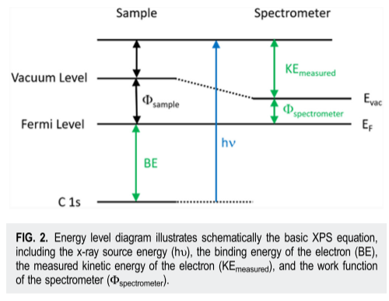

The binding energy is the difference of energy between core level and fermi level. It is an intrinsic characteristics of the chemical environment of the electron.

**Binding energies that can be probed:**

The position of the peaks is defined in the first place by the associated core level.

It is then shifted by the chemical environment of the atom (covalent bindings for instance).

Electronic configuration of Iodine: Electronic configuration of Lead:

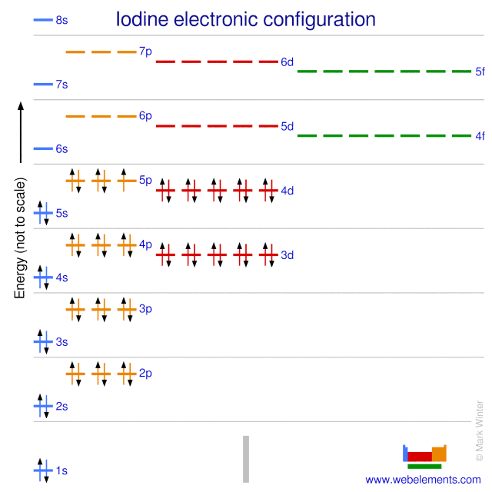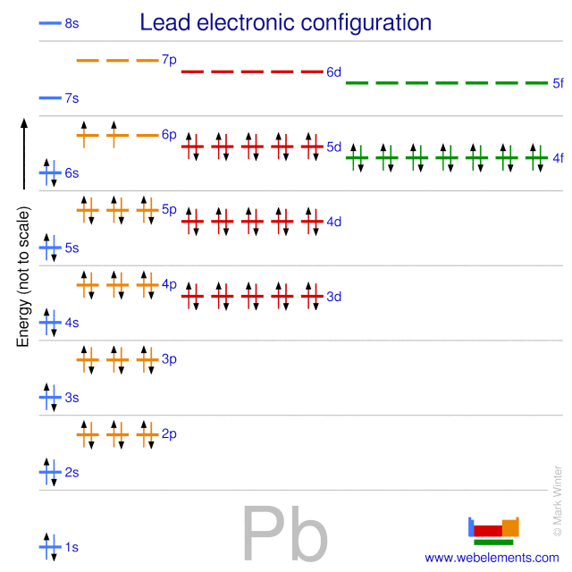

<https://winter.group.shef.ac.uk/webelements/iodine/atoms.html>

<https://winter.group.shef.ac.uk/webelements/lead/atoms.html>

Core levels probed in IPVF experiments: **I3d** and **Pb4f**.

The availability of electron energy levels is defined by the rules for the filling of atomic orbitals:

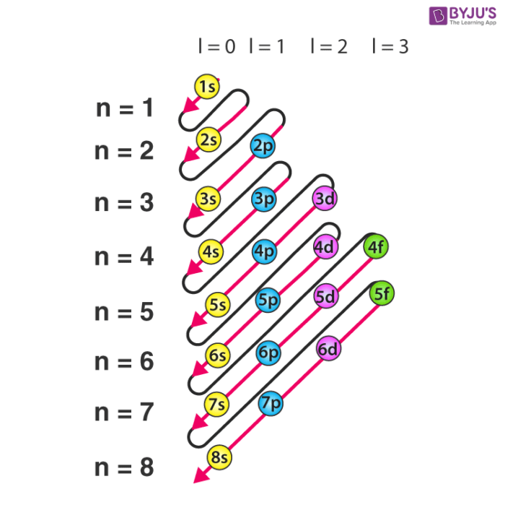

**Spin – orbit coupling:**

<https://www.harwellxps.guru/knowledgebase/spin-orbit-splitting/>

Energy levels associated to orbitals p, d and f are in fact split, due to the two possible values of total angular momentum.

The total angular momentum for an electron is the sum of the orbital momentum and the electron spin (either + 1/2 or -1/2).

|  |  |  |  |
| --- | --- | --- | --- |
| Orbital | Orbital momentum | Total angular momentum | Degeneration ratio |
| s | 0 | 1/2 | None |
| p | 1 | 1/2 ; 3/2 | 1 : 2 |
| d | 2 | 3/2 ; 5/2 | 2 : 3 |
| f | 3 | 5/2 ; 7/2 | 3 : 4 |

The -1/2 orientation of an electron is more “stable” and associated to a larger binding energy. It corresponds to p 1/2, d 3/2 and f 5/2.

For each orbital, both sub energy levels are differently degenerated, due to the number of different spin combinations that can give rise to same total angular momentum.

The ratio of degeneration of the states is directly proportional to the ratios of areas of associated peaks.

Core levels investigated in IPVF experiments:

|  |  |
| --- | --- |
| Core level | Reference binding energy (not in perovskite material) |
| I 3d 3/2 | 630.8 eV |
| I 3d 5/2 | 619.3 eV |
| Pb 4f 5/2 | 141.7 eV |
| Pb 4f 7/2 | 136.9 eV |