**ДНІПРОВСЬКИЙ НАЦІОНАЛЬНИЙ УНІВЕРСИТЕТ ІМЕНІ ОЛЕСЯ ГОНЧАРА**

Факультет прикладної математики

Кафедра обчислювальної математики та математичної кібернетики

ЗВІТ

про виконання лабораторної роботи №2

з дисципліни «Системи і методи прийняття рішень»

Виконав:

студент групи ПА-18-1

Щербак Роман

Викладач:

канд. фіз.-мат. наук, доцент

Н. Л. Козакова

Дніпро

2022

1. **Постановка задачі**
2. Опрацювати необхідний теоретичний матеріал.
3. Побудувати множини Баєса геометричним методом та методом контрольної точки для варіанту індивідуального завдання.
4. Провести аналіз якості рішення в даній інформаційній ситуації.
5. Оформити звіт про використання роботи, який повинен містити такі елементи:
   * постановку індивідуального завдання;
   * отримані множини рішень за критерієм Баєса;
   * аналіз результатів.
6. **Опис розв’язку**

Перевірку роботи програми здійснено для таких вхідних даних:

|  |  |  |  |  |
| --- | --- | --- | --- | --- |
| p |  |  |  |  |
| 0.3 |  | 1 | 3 | 1 |
| 0.2 |  | 2 | 1 | 3 |
| 0.5 |  | 3 | 1 | 2 |

1. **Код програми мовою Python**

* Модуль main.py

import sympy as sp

import get_data as gd

import bayes_values as bv

import geometric as g

import variational as v

print()

p_1, p_2 = sp.symbols("p_1, p_2")

# file_name = "example.txt"

file_name = "variant.txt"

p_var, eff = gd.get_data_from_file(file_name)

p_geom = [p_1, p_2, 1-p_1-p_2]

print("Геометричний метод: ")

print()

Bayes_values_geom = bv.get_bayes_values(p_geom, eff)

g.geom_method(Bayes_values_geom, p_1, p_2, file_name)

print()

print("Метод варіації контрольної точки:")

print()

Bayes_values_var = bv.get_bayes_values(p_var, eff)

v.variational_method(Bayes_values_var, p_var, eff)

* Модуль geometric.py

import re as re

import matplotlib.pyplot as plt

import prettytable as pt

def geom_method(Bayes_val, p_1, p_2, data_file):

coefficients = get_coefs(Bayes_val, p_1, p_2)

equations = get_equations(coefficients)

fig, ax = plt.subplots()

ax.set_xlim(0, 1)

ax.set_ylim(0, 1)

for e in equations:

print(e)

print()

points = get_points(equations)

line_arr = plotting_lines(points, ax, equations)

first_legend = ax.legend(handles=line_arr, loc='upper right')

ax.add_artist(first_legend)

Bayes_values_table = pt.PrettyTable()

Bayes_values_table.field_names = ["Координати", "B+(p, φ_1)", "B+(p, φ_2)", "B+(p, φ_3)", "Максимальне значення", "Баєсова множина"]

if data_file == "example.txt":

x = [0, 0, 0, 0.45, 0.65, 0.9]

y = [0, 0.6, 0.9, 0, 0, 0]

elif data_file == "variant.txt":

x = [0, 0, 0, 0.2, 0.4, 0.8, 0.6, 0.2, 0.2, 0.6, 0.4, 0.5, 0, 0]

y = [0, 0.6, 0.9, 0, 0, 0.6, 0.4, 0.6, 0.2, 0.1, 0.6, 0.8, 0.2, 0.4]

scatter_arr = [0, 0, 0]

i = 0

while i < len(x):

row = create_new_row(x[i], y[i], Bayes_val, p_1, p_2, points, ax, scatter_arr)

Bayes_values_table.add_row(row)

i += 1

ax.legend(handles=scatter_arr, loc='lower right')

print(Bayes_values_table)

plt.title("Геометричний метод")

plt.show()

def get_coefs(Bayes_val, p_1, p_2):

coefs = []

i = 0

while i < len(Bayes_val):

j = i+1

while j < len(Bayes_val):

difference = Bayes_val[i]-Bayes_val[j]

difference = str(difference)

split_string = re.split(r"[*]?p_\d", difference)

k = 0

while k < len(split_string):

if re.search(r"\D$", split_string[k]):

split_string[k] += '1'

else:

temp_string = re.split(r"\s", split_string[k])

t = 0

while t < len(temp_string):

if re.search(r"\D$", temp_string[t]):

temp_string[t] += temp_string[t+1]

temp_string.remove(temp_string[t+1])

t += 1

if re.search(r"\D?\d", temp_string[0]) and len(temp_string) > 1:

split_string[k] = temp_string[0]

split_string[k+1] = temp_string[1]

k += 1

if len(split_string) < 3:

if "p_1" not in str(difference):

split_string.insert(0, '0')

if "p_2" not in str(difference):

split_string.insert(1, '0')

if len(split_string) < 3:

split_string.insert(2, '0')

if '' in split_string:

ind = split_string.index('')

split_string[ind] = '0'

coefs.append(split_string)

j += 1

i += 1

return coefs

def get_equations(coefs):

equations = []

i = 0

while i < len(coefs):

change_coefs(coefs[i])

equations.append(build_equations(coefs[i]))

i += 1

return equations

def change_coefs(coefs):

j = 0

while j < len(coefs):

coefs[j] = coefs[j].replace(" ", "").replace("+", "")

if j == 0 or j == 2:

if re.match("\d", coefs[j]):

coefs[j] = "-" + coefs[j]

elif re.match("-\d", coefs[j]):

coefs[j] = coefs[j].replace("-", "")

if len(coefs[j]) == 0:

coefs[j] = "1"

j += 1

def build_equations(coefs):

k = 0

while k < len(coefs):

coefs[k] = int(coefs[k])

k += 1

if coefs[1] != "1":

k = 0

coef_p_2 = int(coefs[1])

while k < len(coefs):

coefs[k] = round(int(coefs[k]) / coef_p_2, 2)

k += 1

if coefs[2] > 0:

return f"p_2 = {coefs[0]}*p_1 + {coefs[2]}"

elif coefs[2] < 0:

return f"p_2 = {coefs[0]}*p_1 - {abs(coefs[2])}"

else:

return f"p_2 = {coefs[0]}*p_1"

def get_points(equs):

points = []

i = 0

while i < len(equs):

point_i = []

j = 0

try:

for_point_calc = equs[i].replace(r"p_2 = ", r"").split(r"*p_1 ")

while j < len(for_point_calc):

for_point_calc[j] = float(for_point_calc[j].replace(" ", ""))

j += 1

except ValueError:

for_point_calc = equs[i].replace(r"p_2 = ", r"").split(r"*p_1")

print(for_point_calc)

while j < len(for_point_calc):

if for_point_calc[j] != "":

for_point_calc[j] = float(for_point_calc[j])

j += 1

k = 0

while k < 2:

if for_point_calc[0] == "":

point_i.append((k, round(for_point_calc[1],2)))

elif for_point_calc[1] == "":

point_i.append((k, round(for_point_calc[0]*k,2)))

else:

point_i.append((k, round(for_point_calc[0]*k+for_point_calc[1],2)))

k += 1

points.append(point_i)

i += 1

return points

def plotting_lines(points, ax, equs):

line_arr = []

i = 0

while i < len(points):

x_values = [points[i][0][0], points[i][1][0]]

y_values = [points[i][0][1], points[i][1][1]]

ax.fill_between([0,1], y_values, alpha=0.4)

line = ax.plot(x_values, y_values, label=equs[i])[0]

line_arr.append(line)

i += 1

return line_arr

def get_bayes_val_for_point(x, y, Bayes_val, p_1, p_2):

point_Bayes_val = []

for i in Bayes_val:

i = i.replace(p_1, x).replace(p_2, y)

point_Bayes_val.append(i)

max_value = max(point_Bayes_val)

max_ind = point_Bayes_val.index(max_value)

return point_Bayes_val, max_value, max_ind+1

def create_new_row(x, y, Bayes_val, p_1, p_2, points, ax, scatter_arr):

row = []

row.append((x, y))

point_Bayes_val, index, max_index = get_bayes_val_for_point(x, y, Bayes_val, p_1, p_2)

Bayes_set = f"φ_{max_index}"

if max_index == 1:

if scatter_arr[0] == 0:

scatter_arr[0] = ax.scatter(x, y, c = "red", label = Bayes_set, marker='o')

else:

ax.scatter(x, y, c = "red")

elif max_index == 2:

if scatter_arr[1] == 0:

scatter_arr[1] = ax.scatter(x, y, c = "blue", label = Bayes_set, marker='o')

else:

ax.scatter(x, y, c = "blue")

elif max_index == 3:

if scatter_arr[2] == 0:

scatter_arr[2] = ax.scatter(x, y, c = "green", label = Bayes_set, marker='o')

else:

ax.scatter(x, y, c = "green")

for i in point_Bayes_val:

row.append(i)

row.append(index)

row.append(Bayes_set)

return row

* Модуль variational.py

import sympy as sp

import numpy as np

import re as re

def variational_method(Bayes_val, p_arr, eff_arr):

diff = []

i = 0

while i < len(Bayes_val):

j = i+1

while j < len(Bayes_val):

if Bayes_val[i] > Bayes_val[j]:

diff.append(Bayes_val[i]-Bayes_val[j])

else:

diff.append(Bayes_val[j]-Bayes_val[i])

j += 1

i += 1

q_1, q_2, q_3 = sp.symbols("q_1, q_2, q_3")

variations_arr = [q_1, q_2, q_3]

build_border_between_sets(0, 1, eff_arr, p_arr, diff[0], variations_arr)

print()

build_border_between_sets(0, 2, eff_arr, p_arr, diff[1], variations_arr)

print()

build_border_between_sets(1, 2, eff_arr, p_arr, diff[2], variations_arr)

def build_border_between_sets(set_1, set_2, eff_arr, p_arr, delta, var_arr):

d = []

i = 0

while i < len(eff_arr):

d.append(eff_arr[i][set_1] - eff_arr[i][set_2])

i += 1

dot_prod = (np.dot(d, var_arr))

points = get_points(dot_prod, delta, var_arr, p_arr)

get_border_equation(points)

def get_points(dot, delta, var_arr, p_arr):

points = []

i = 0

while i < 2:

res = sp.solve([sp.Eq(dot, delta), sp.Eq(var_arr[i], 0), sp.Eq(sum(var_arr), 0)])

res_vals = list(res.values())

j = 0

point = []

while j < len(p_arr):

point.append(p_arr[j]+res_vals[j])

j += 1

points.append(point)

i += 1

return points

def get_border_equation(points):

p_1, p_2 = sp.symbols("p_1, p_2")

border_equation = [(points[1][1]-points[0][1])*(p_1-points[0][0]), ((p_2-points[0][1])*(points[1][0]-points[0][0]))]

i = 0

while i < len(border_equation):

border_equation[i] = str(border_equation[i])

if type(re.search(r"\Ap_\d", border_equation[i])) != None:

border_equation[i] = re.sub(r"\Ap_", "1*p_", border_equation[i])

border_equation[i] = re.sub(r"p_\d", r"", border_equation[i])

border_equation[i] = re.split(r" ", border_equation[i])

j = 0

while j < len(border_equation[i]):

if border_equation[i][j] == "+" or border_equation[i][j] == "-":

border_equation[i][j] += border_equation[i][j+1]

border_equation[i].remove(border_equation[i][j+1])

break

j += 1

k = 0

while k < len(border_equation[i]):

if type(re.search(r"\*", border_equation[i][k])) == re.Match:

border_equation[i].insert(0, re.sub(r"\*", "", border_equation[i][k]))

border_equation[i][k+1] = ""

border_equation[i].remove(border_equation[i][k+1])

break

k += 1

i += 1

i = 0

while i < len(border_equation):

j = 0

while j < len(border_equation[i]):

border_equation[i][j] = float(border_equation[i][j])

j += 1

i += 1

b = round((-border_equation[1][1] + border_equation[0][1]) / (border_equation[1][0]), 2)

k = round((border_equation[0][0])/(border_equation[1][0]),2)

if b > 0:

print(f"p_2 = {k}*p_1 + {b}")

elif b == 0:

print(f"p_2 = {k}*p_1 + {b}")

else:

print(f"p_2 = {k}*p_1{b}")

* Модуль bayes_values.py

def get_bayes_values(p_arr, eff_arr):

Bayes_val = []

i = 0

while i < len(eff_arr[0]):

res = 0

j = 0

while j < len(eff_arr):

res += eff_arr[j][i] * p_arr[j]

if type(res) == float:

res = round(res, 2)

j += 1

Bayes_val.append(res)

i += 1

return Bayes_val

* Модуль get_data.py

def get_data_from_file(file_name):

p = []

eff = []

f = open(str(file_name))

for s in f:

s = s.strip().split(" ")

arr = []

i = 0

while i < len(s):

if i == 0:

p.append(float(s[i]))

else:

arr.append(int(s[i]))

i += 1

eff.append(arr)

return p, eff

1. **Скриншоти роботи програми**

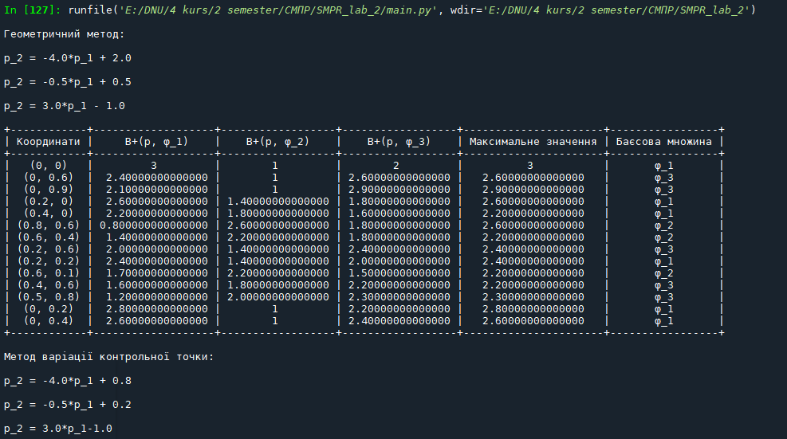

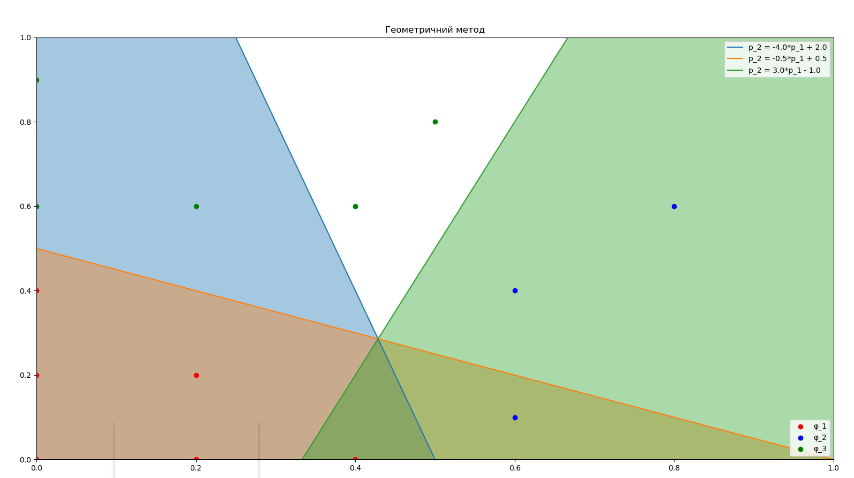

1. **Висновок**

Внаслідок роботи геометричного методу отримано три множини Баєса:

Внаслідок роботи методу варіації точки отримано три множини Баєса:

Помітно, що всі множини попарно подібні одна до одної, незалежно від методу.