Q1. Consider the traffic deadlock shown in the Figure below. Give simple rule to avoid the deadlock in this system.
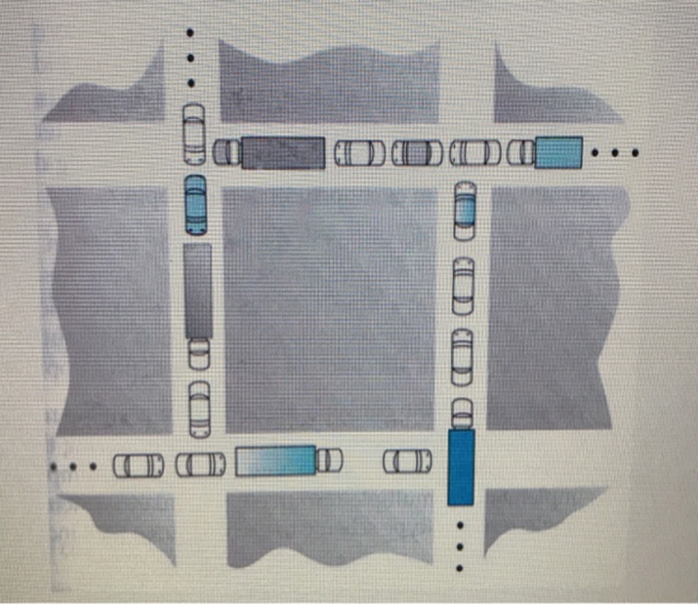
A1.
If we assume reach road is one way, we can apply the following rule to avoid the deadlock: As each car approaches its first intersection, stop and check their left. If there was a car before they got there, they must wait before moving. If there was not a car before they got there, then they may move forward. As they approach the second intersection, stop and check their right. If there was a car before they got there, they must wait before moving. If there was not a car before they got there, then they may move forward. Resolve any ties to the left, so that cars already into the block will get out as fast as possible. I THINK that would work.

Q2. What is meant by a dual core tightly coupled multiprocessor system ? Will there be shared memory in this case?
A2. A dual core multiprocessor system is a system that has multiple CPUs, and each CPU has two cores. Multiprocessors doesn’t always mean “multiple CPUs”, but in this context it is used to describe a system with multiple CPUs, like a server. Dual core explicitly states that every CPU has two processing cores, meaning each CPU can run two processes at the same time. Tightly coupled indicates that there is shared memory between the CPUs and CPU cores. There will be shared memory in this case!

