Q1. Please discuss all types of hypervisors with example.
A1.
There are 3 levels of hypervisors, Type 0, Type 1, and Type 2 hypervisors. These all support virtualized hardware in different ways, and with less hardware interaction as the type number increases. Type 0 hypervisors directly manage virtualization of machines using dedicated hardware and firmware, such as IBM LPARS, or logical partitions, which can virtualize a machine while sharing physical hardware access. Type 1 hypervisors utilized software designed to interact with the physical hardware similar to an entire operating system, however this software sits above an already active operating system and is used to run virtualized environments with (limited) hardware access. Some examples of type 1 hypervisor are VMWare ESX and Citrix XenServer, as well as Hyper-V, a common Windows VMM. Finally, Type 2 hypervisors are essentially applications that run similar to that of a game and simulate another operating system. Since these are programs, theirs is typically an interactive VMM and ability to modify guest OS settings and resource utilization. Some examples of type 2 hypervisors are VMWare Workstation, Oracle VirtualBox VM.

Q2. Create a VM Ubuntu 22.04 using Virtual Box
A2.
See below:
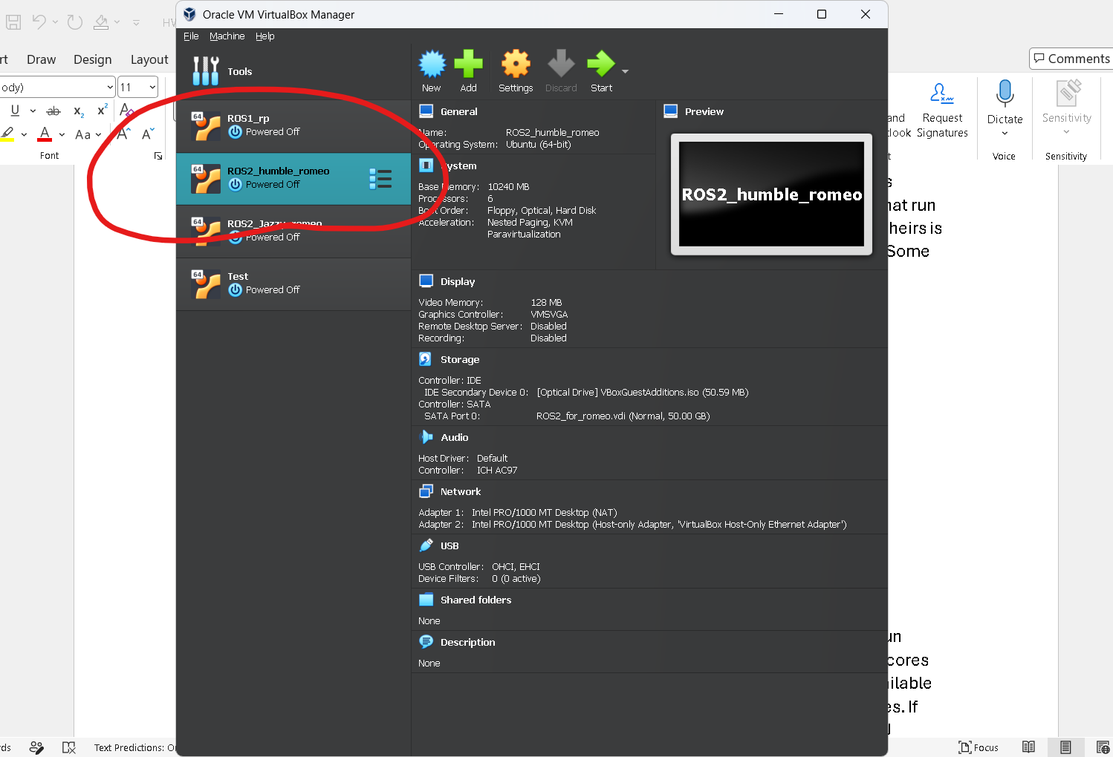
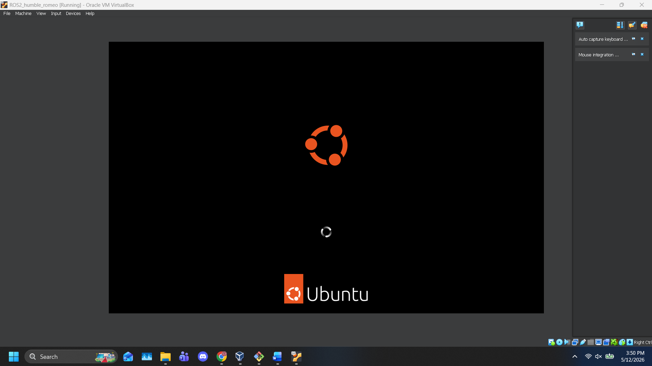
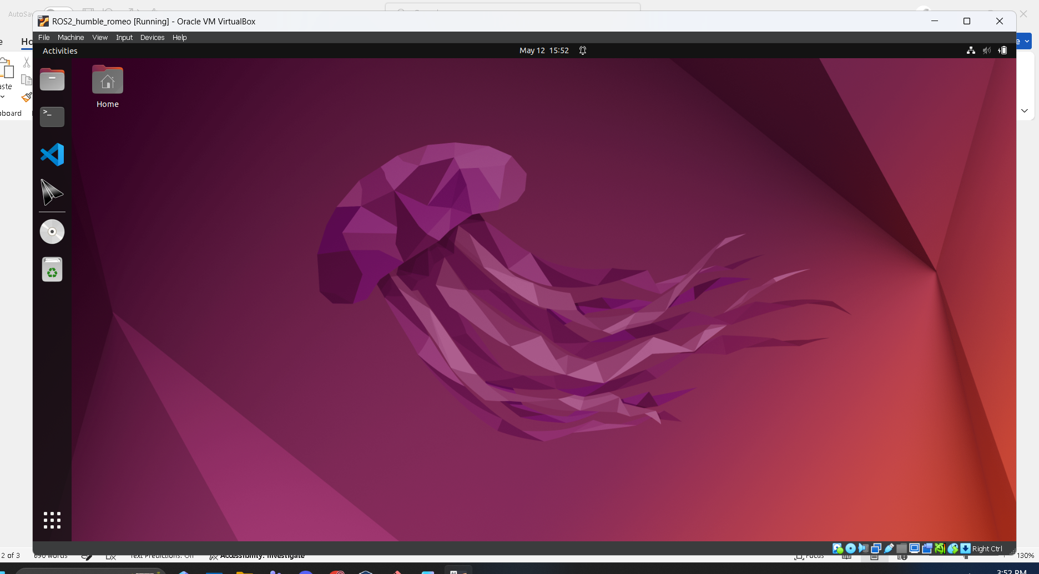
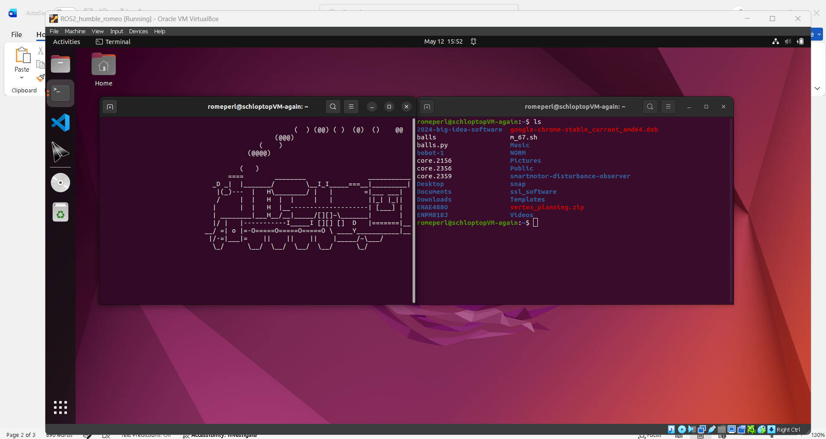

Q3. Create a copy of VM in Q2. and run copy
A3.
See below:
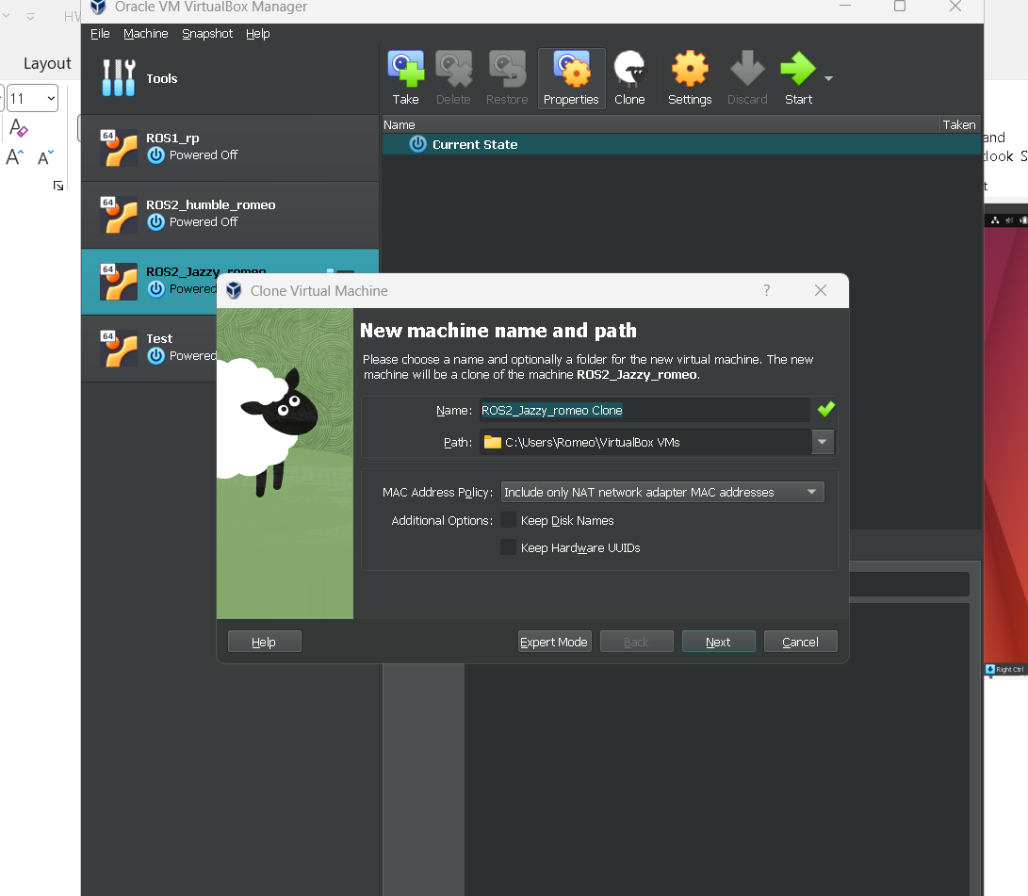

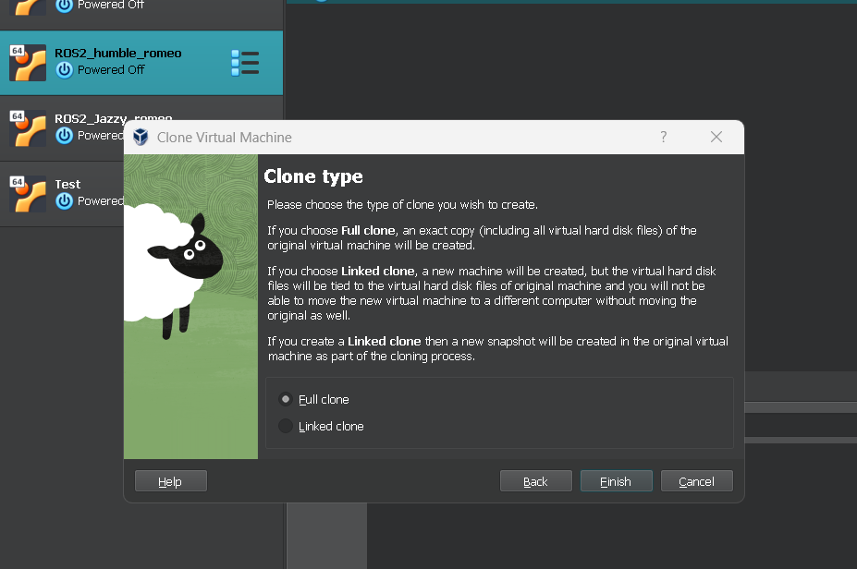
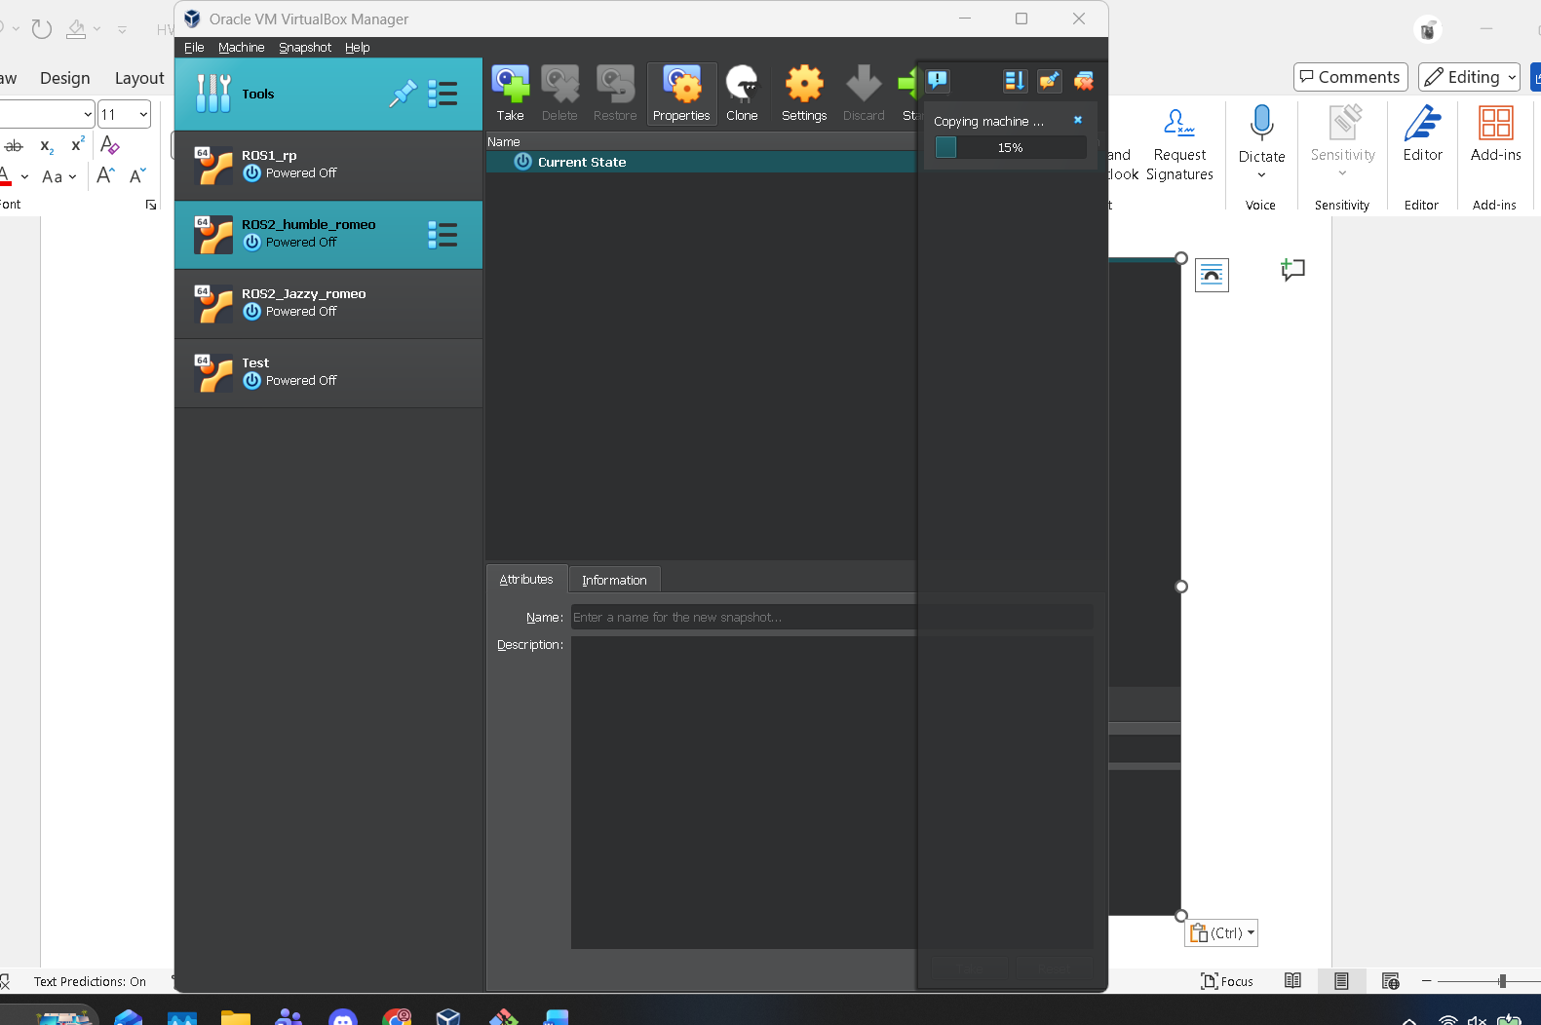
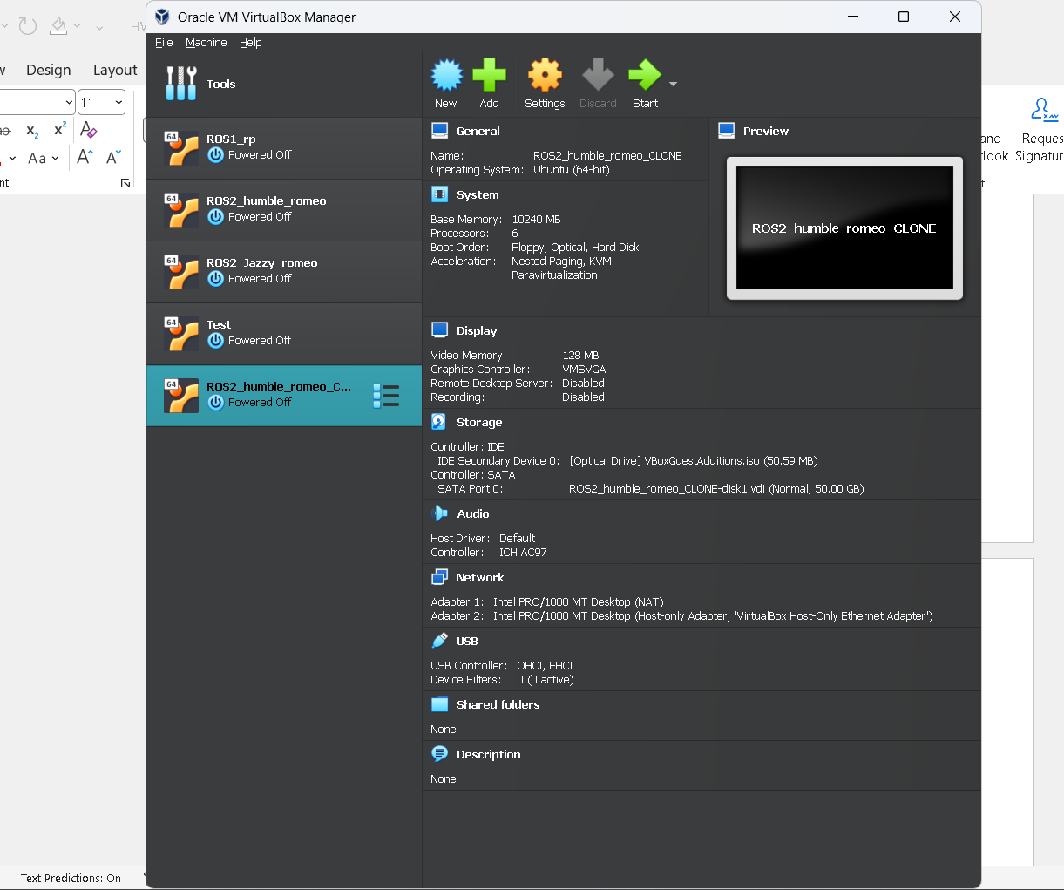
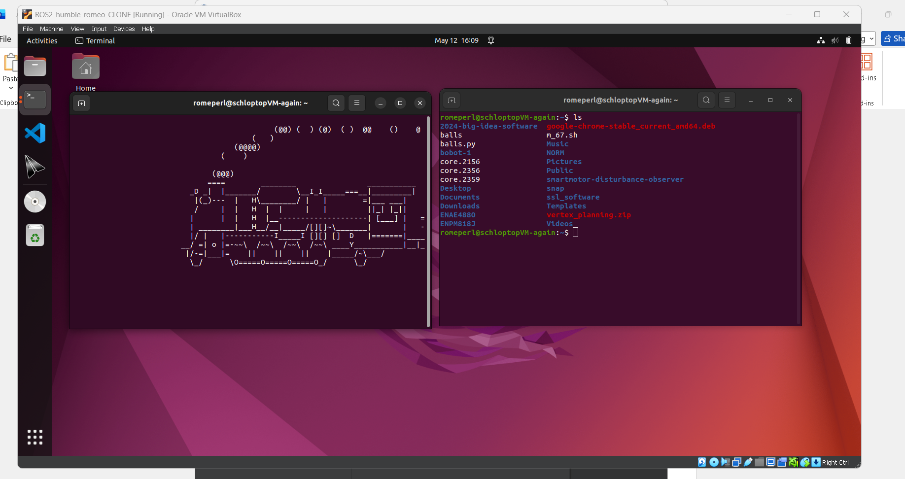

Q4. Discuss VM OS components.
A4.
VM’s have access, either directly or indirectly, to physical hardware components to run processes, utilize memory, and render graphics. VMs are allocated a certain amount of CPU cores from the host machine that it can run its own processes on. If there are not enough cores available in the system, then the VMM will attempt to schedule the VM processes on the available cores. If there are enough cores for each VM active, then each VM will stick to using it’s allocated CPU resources during its lifetime. VMs are also allocated a certain amount of memory with which they can operate . This works in a similar way to video games or intensive applications, where the memory is allocated to them during runtime and can’t be used by other systems (generally). This can be tricky if the host system does not have ample memory, as the VM and host could request more memory than required. For I/O, the VM can directly access peripherals and claim them during runtime, as well as generate new I/O interfaces for the host to interact with. Similarly, networking can be bridged between the host and the VM using network address translation or even network bridging. Each VM also has a storage system, and depending on the hypervisor may set it up in in different ways. A type 1 hypervisor will create a root file system and a disk image, whereas a type 3 hypervisor will create a shared folder in the host machine’s file system. All VMs will start off with a virtual partition of a set size provided by the user (as it’s borrowing data from the host), however some allow for dynamic storage sizing, either to not allocate all of the storage immediately, or to allow for storage expansion later on.

Q5. Discuss two VM examples with architecture.
A5.
The VM I am most familiar with is VirtualBox VM by Oracle. It is a Type 2 hypervisor that virtualizes operating systems. The file system is a shared file system that is hosted on the “host” OS and can be directly interacted with from the host if desired. Since it is a Type 2 hypervisor, it does not directly interact with physical hardware on the host but uses a VMM to manage hardware calls and resource acquisition. It is able to fully virtualize a Linux machine, including the GUI, hardware drivers and environment, though typically slower than the host machine.
Another VM I am not familiar with but would like to be is Windows Subsystem for Linux 2 (WSL 2), unlike WSL 1, WSL 2 is an actual Type 1 hypervisor that can directly interact with the host hardware. Because it is a Type 1 hypervisor, the file system is store in a virtual hard disk file, rather than directly creating a file tree in the host’s file system.

