

Republic of the Philippines
BOHOL ISLAND STATE UNIVERSITY
Balilihan Campus
Magsija, Balilihan, Bohol
Tel. no. (038)416-0797, e-mail: e-mail:bisu_balilihan@yahoo.com

VISION: A premier S& T University for the formation of a world-class and virtue-laden human resource for sustainable development in Bohol and the Country.
MISSION: BISU is committed to provide quality higher education in the arts and sciences, as well as in the professional and technological fields; undertake research and development, and extension services for the sustainable development of Bohol and the country.

ACCOMPLISHMENT REPORT
Period Covered: September 2025 - April 2026
AREA | Programs/ Activities/ Projects | Photo Documentation | Unit/ Personnel/ Student Involved | Date and Place | Remarks
 | Campus Virtual Tour Technical Support | 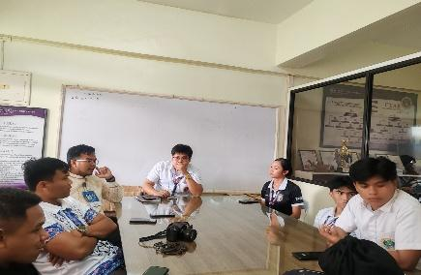  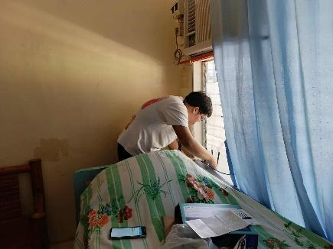 | The Legion President,  and Legion Members | September 5, 2025  at Bisu Balilihan Campus
 | Himamat Codm Tournament |  | The Legion President, Vice President  and Legion Members | September 8, 2025,  at Room 206
 | Himamat  Mr and Ms Fresh Fusion Tabulation | 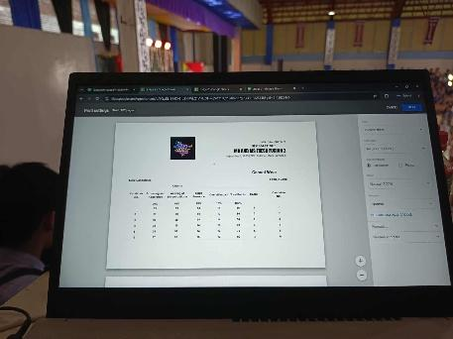 | The Legion President,  and Legion Members | September 8, 2025,  at Bisu Balilihan Gymnasium
 | Paugnat ug Pasundayag 2025  Tabulation | 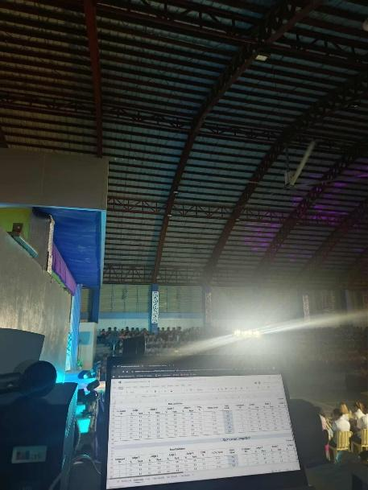 | The Legion President,  and Legion Members | September 10, 2025,  at Bisu Balilihan Gymnasium
 | Paugnat ug Pasundayag 2025  Movie Booth  Day 1 | 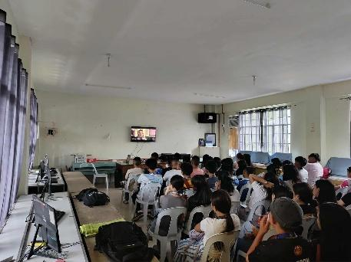 | The Legion President,  and Legion Members | September 11, 2025,  at Room 205

 | Paugnat ug Pasundayag 2025  Movie Booth  Day 2 | 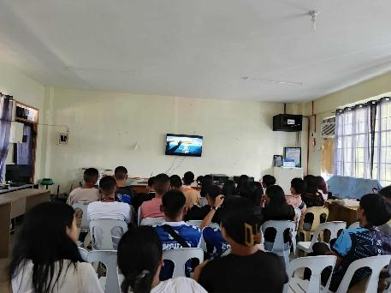 | The Legion President,  and Legion Members | September 12, 2025,  at Room 205
 | Hiv and Early Pregnancy  Projector Set-up | 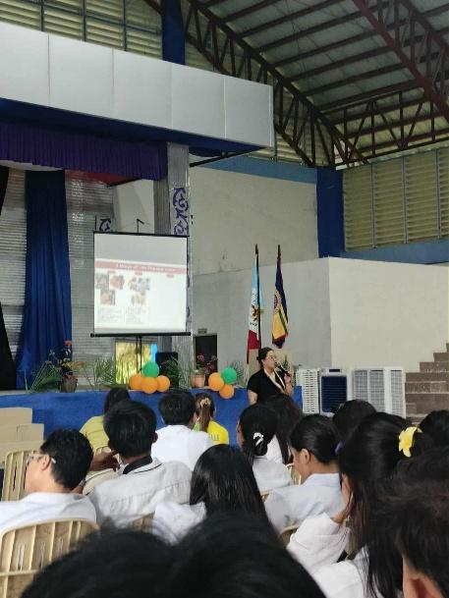 | The Legion President,  and Legion Members | October 16, 2025,  at Bisu Balilihan Gymnasium

 | SCUAA 2025  Internet Set-up | 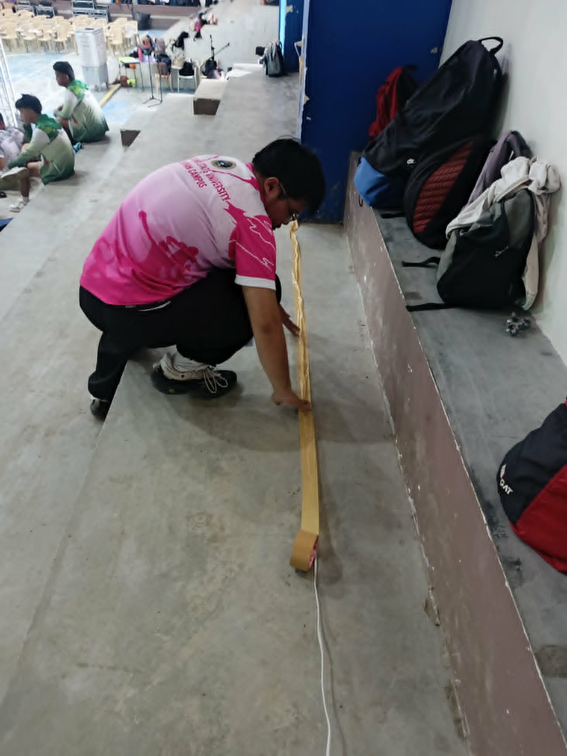 | The Legion President,  and Legion Members | November 14, 2025,  at Bisu Balilihan Gymnasium
 | Leadership Training Team Building  Activity 2026 | 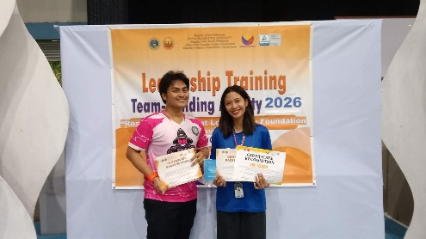 | The Legion Vice President,  and Legion Members | March 7, 2026 at Bisu Balilihan Gymnasium
 | Echoes of Hope , One Heart, One Community a Tzu Chi Foundation | 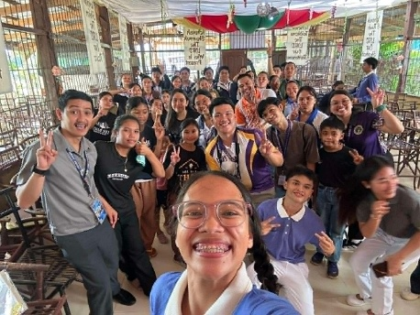 | The Legion Vice President | March 26, 2026 at Catigbian, Bohol
 | Mr and Ms Avant- GardeTabulation | 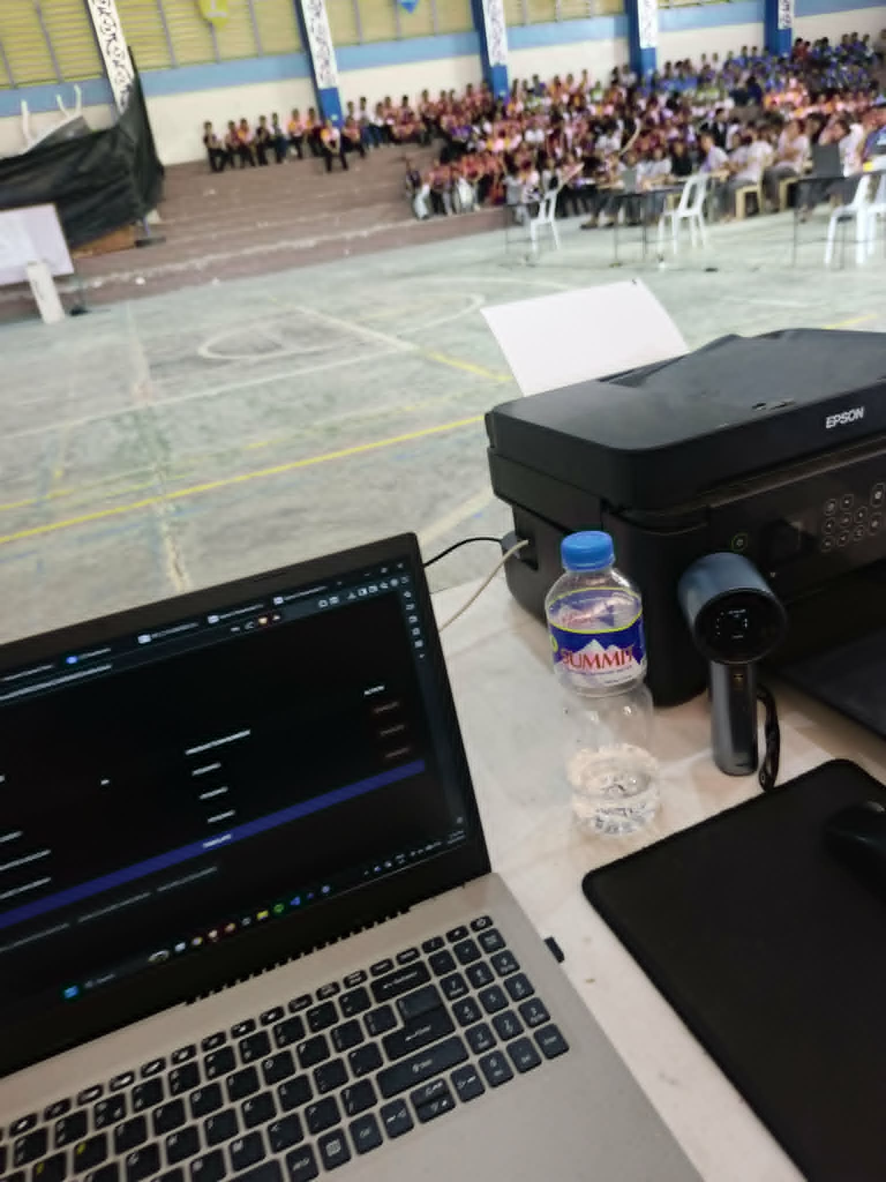 | The Legion President,  and Legion Members | April 28, 2026  at Bisu Balilihan Gymnasium

 | CCIS Days  HOK Tournament | 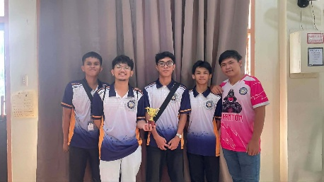 | The Legion President,  and Legion Members | April 29, 2026  at Room 206
 | PINILIAY 2026  Election Results  Committee | 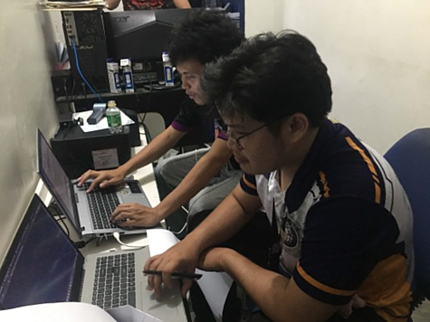 | The Legion President | April 29, 2026  at EDP Office

Prepared by:

MARC JAY V. MAGAN
President

Approved by:

EDUARDO B. CARPIO JR., MSM Adviser

