**Name: John Romel D. Lucot Date: 10/01/2025**

**Course, Year & Section: BSIT - 4C**

**Activity No. 4**

**“Letters Across Time – Rizal’s Voice, My Voice”**

**Objective:**

To help students internalize Rizal’s motivations, struggles, and ideals by crafting reflective letters that blend historical understanding with personal insight.

**Instructions:**

1. **Part 1: Write as Rizal**
   * You will write a **fictional letter from Rizal’s perspective** during one of the following moments:
     + Upon arriving in Calamba in 1887
     + In Hongkong and Macao
     + Romantic Interlude in Japan
   * The letter should express:
     + His thoughts on the state of the Philippines
     + His hopes for reform and unity
     + His emotional response to being misunderstood
     + His happiest sojourn in Japan
2. **Part 2: Write as Yourself**
   * You will then write a **response letter from their own perspective**, addressed to Rizal.
   * They should reflect on:
     + What they admire or question about Rizal’s choices
     + How his actions relate to their own values or civic responsibilities
     + What they would say to encourage or challenge him
3. **Part 3: Artistic Integration**
   * You may decorate your letters with symbolic illustrations (e.g., a lantern for enlightenment, a broken chain for freedom, etc).
   * Picture your artistic integration, and;
   * Turn it in on our google classroom

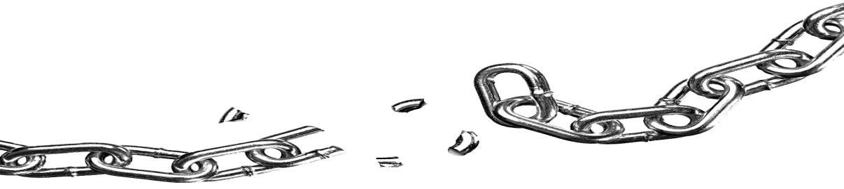

**Tokyo, Japan**

**March 1888**

**My dear friend,**

**Here in Japan, honestly, I feel a peace that I almost forgot could exist. The land is full of beauty, the flowers, the mountains, and the streams make my heart calm. The people are polite, clean, and hardworking, plus their honesty really amazes me. In fact, you hardly see beggars in the streets and even in hotels people can leave money on the table without worry. Truth is, this country shows me how discipline and respect can lift a nation, and it became one of the happiest times of my life.**

**While I enjoy this stay, my mind still goes back to our homeland. I can’t help but to compare, and I think our people should try to imitate the good values I see here like politeness, cleanliness, and honesty of Japanese people. If they can live this way, then why not us too? Basically, I believe these traits can also help us become a nation that is respected by others.**

**But even in the middle of this joy, I don’t forget the struggles of the Philippines. Seeing Japan strong makes me hope that one day our country can also rise in freedom and dignity. Even though many misunderstand my writings and think wrongly of me, I keep believing this path will help our people. My happiness here is real but it also gives me strength to keep dreaming for our people. I share this experiences of mine with you my friend, because I believe Filipinos like you will carry this dream and make it possible.**

**Your friend,**

**Dr. Jose Rizal**

**Dear Dr. Jose Rizal,**

**I really appreciate the way you told me about your time in Japan, to be honest it makes me imagine being there too. Honestly, it makes me admire how peaceful that country is. The discipline of the people is something that really caught my attention. I also dream of experiencing those things someday. The politeness, the honesty, and the beauty you said about Japan all sound so amazing to me. Truth is, I can feel your happiness in your words. It also inspires me that even when you are far away, you never forget our homeland. Someday, I also wish to see what have you seen in there.**

**But right now, I can’t help but feel worried about your safety. My suggestion for now is that you should not come back to the Philippines, because your enemies are waiting to harm you. Actually, it would be better for you to continue your writings in another country where you are safer. Your words are already opening the eyes of our people, and you can do more good if you are alive and free.**

**Sincerely,**

**John Romel D. Lucot**