**BISU BALILIHAN BUDGET MONITORING SYSTEM**

**FOR ADMINISTRATIVE PERSONNEL**

______________

A Thesis Presented to

The Faculty of the College of Computing and Information Sciences

**BOHOL ISLAND STATE UNIVERSITY**

Balilihan Campus

Magsija, Balilihan, Bohol

______________

In Partial Fulfillment

of the Requirements for the Degree in

**Bachelor of Science in Information Technology**

John Romel D. Lucot

Ray H. Apura

Vanessa l B. Docena

Jessarell L M. Gingo

**September 2025**

**Chapter 1**

**THE PROBLEM AND ITS SCOPE**

**INTRODUCTION**

**Rationale**

In many educational institutions, proper financial management is essential to ensure that resources are used efficiently and effectively. Schools and universities rely heavily on accurate budget tracking to plan programs, manage operations, and support both staff and students. Traditionally, budget management has been handled manually using paper records or simple digital tools like spreadsheets. According to the Commission on Audit (2016), using computerized budget tracking tools helps reduce human error and improves transparency. These digital systems are designed to reduce human error, improve transparency, and streamline the budgeting process. By automating data entry and calculations, they minimize the risk of manual mistakes and provide real-time insights into financial allocations and expenditures.

The Bohol Island State University–Balilihan Campus is currently facing challenges in managing and tracking its budget effectively. Most of the budgeting tasks are still done manually, using paper documents, Excel spreadsheets, or basic files. Many schools, offices, and government agencies today are starting to use digital systems to handle budgets faster and more accurately. Using computerized budget tracking tools helps reduce human error and improves transparency.

Therefore, the creation of the BISU-Balilihan Budget Monitoring System will

be developed to assist administrative personnel in efficiently monitoring the budget at BISU-Balilihan Campus. It includes features such as real-time budget tracking, secure access, reports, error reduction, and data storage and backup. Users can monitor fund allocation and expenses, ensuring that only authorized users can log in and make transactions. It will continue to play a critical role in ensuring that the campus can provide the best possible services and resources to students, faculty, and staff while maintaining financial stability.

**Literature Background**

The concept of budget monitoring systems has been widely discussed in academic literature, particularly in relation to improving financial management in public institutions, including educational sectors. Effective budgeting is critical for ensuring that financial resources are allocated efficiently and transparently, which is essential for maintaining institutional stability and promoting long-term growth.

The Unified Theory of Acceptance and Use of Technology: A New Approach In Technology by Marikyan (2020) examines the acceptance of technology, determined by the effects of performance, effort expectancy, social influence and facilitating conditions. In the case of the BISU-Balilihan Budget Monitoring System

For Administrative Personnel, this theory can help understand how and why authorized users will accept the new system. By applying the UTAUT model, the implementation of the proposed system can be better designed to meet the needs of its users, ensuring smoother adoption and successful integration into the organization.

A Review of Theory, Theoretical and Conceptual Frameworks in Education

**Unified Theory of Acceptance Use of Technology by Marikyan.** These theories examine the acceptance of technology, determined by the effects of performance expectancy, effort expectancy, social influence and facilitating conditions. (Marikyan, 2020)

**A Review of Theory, Theoretical and Conceptual Frameworks in Education Technology by Schad.**

Explains frameworks facilitate the process of generating knowledge in the evolving field of educational technology. (Schad, et al 2020)

**Section 10 of Article XIV of the Philippine Constitution. Science and Technology** are essential for national development and progress. (Bernas, 1987)

**Section 12 of Article XIV of the Philippine Constitution**. The State shall regulate the transfer and promote the adaption of technology from all sources for the national benefit (Bernas, 1987).

-------

**BISU Balilihan Budget Monitoring System for Administrative Personnel**

System Characteristics and Features:

* Develop the core system functionalities, such as budget tracking, real-time data updates, and expenditure reports
* Keeps record data
* Data and information are managed systematically
* Friendly user interface
* Accurate

**Proposed Implementation Plan**

**Figure 1.0: Theoretical and Conceptual Framework**

Technology by Schad et. al (2021) explains frameworks facilitate the process of generating knowledge in the evolving field of educational technology. For the BISU-Balilihan Budget Monitoring System for Administrative Personnel this theory helps the researchers understand how and why the system will be adopted by its users. The adoption process will depend on factors like the perceived benefits of the system and how easily users can integrate it into their daily tasks. Early adopters, who are more open to new technologies, will likely be the first to use the system, followed by the majority as they see the benefits in improving budget monitoring and transparency.

This study is also related to WebPy-BudgetAnalytics: Budget Monitoring and Analytic Support Tool for Universities and Colleges by Rodriguez and Dela Fuente (2024). This study aims to develop a web-based budget monitoring system with an analytic support tool using a multiple linear regression model to enhance the financial management system of state universities and colleges (SUCs). The existence of these study served as the basis of the researchers in developing the system that can be implemented in the campus.

The Preliminary Study for Budget Monitoring System in Government Agencies by Nayu Humairoh (2024) a study explores the critical role of budget monitoring systems in enhancing financial management and accountability within government agencies. The study identifies a pressing need for automated systems that provide real-time data and better integration with existing financial tools. The study highlights the inefficiencies of traditional budget monitoring methods, which rely on outdated software and manual processes, leading to errors and delays. Similarly, the BISU-Balilihan Budget Monitoring System for Administrative Personnelaims to modernize budget tracking, ensuring real-time data access and seamless integration with financial tool.

The study entitled, The Analysis of the Impact of Financial Structure Optimization on Budget Performance Management in Universities Based on the Perspective of Internal Control and Final Accounts – Using ABC Model as a Framework by Wang (2025) focuses on how universities can improve the way they manage money to make their budgeting work better. It talks about how rules and final reports at the end of the year help schools use money the right way. The study uses the ABC model, which is a method to track how money is spent on different tasks or activities. This is helpful for universities like BISU-Balilihan, especially for those in charge of managing the budget. By understanding this study, the university can build a better budget system. It will help them see where the money is going, avoid wasting it, and make smarter decisions when planning future expenses.

Another study entitled, Fiscal Management Practices and Program Performance of State Universities and Colleges in the Philippines by Ramos et al. (2023), the purpose of this study was to find out how fiscal management practices like planning, budgeting, and involving stakeholders affect the program performance of state universities and colleges in Region XII, Philippines. This connects to the BISU-Balilihan Budget Monitoring System because it also aims to improve how the budget is managed. By using this system, administrative staff can track spending better, make smarter decisions, and support the goals of the school. The study supports the idea that proper budgeting tools and practices lead to better results in universities.

The study entitled Fiscal Management Practices Framework of State Universities and Colleges in Region XII byMamburao et al. (2023) sought to understand how financial literacy, decision-making, and internal control systems affect how schools manage their budgets. It focused on the people responsible for handling school funds and looked at whether they have enough knowledge and skills to make smart financial decisions. This study is closely related to our project on the BISU-Balilihan Budget Monitoring System for administrative personnel because it highlights the importance of financial knowledge, good decision-making, and strong control systems in managing school funds. Just like in Region XII, BISU-Balilihan can benefit from having a clear and effective system that helps staff monitor and manage the budget properly.

Moreover, Article XIV, Section 10 of the 1987 Philippine Constitutions states that:

Science and Technology are essentials for national development and progress. The state shall give priority to research and development, invention, innovation and their utilization, and to science and technology education, training and services. It shall support indigenous, appropriate, and self-reliant scientific and technological capabilities and their application to the country’s productive systems and national life (Bernas, S. J., 2009).

The Article states that, the state shall give priority to its people who research, develop and create new systems that can help in the progress of our country. This law encouraged people with innovative ideas to foster country. It is essential for students to be equipped with a strong foundation of technology so that our country will be a technologically oriented nation.

Furthermore, in Article XIV, Section 12 of the Philippine Constitution states that:

The states shall regulate the transfer and promote adoption of technology from all sources for the national benefit. It shall encourage the widest participation of the private groups, local government and community based organizations in the generation and utilization of Science and Technology (Bernas, S. J., 2009).

To attain the goals and success in accomplishing the assigned task, it is important that the state shall support in the development and promotions new inventions because the adoption of new technologies can transform better technological advances for the country. This Republic Act encourages people to be productive by means of sharing innovative ideas in order to fasten the country’s growth and development. As the society faces a fast-changing development processes, it will contribute efficiently to the citizens involved.

**THE PROBLEM**

**Statement of the Problem**

This study aims to develop the **BISU Balilihan Budget Monitoring System for Administrative Personnel** to improve the efficiency, accuracy and transparency of the budgeting process.

Specifically, this study sought to answer the following questions:

1. How is the current budget monitoring process being conducted by the Administrative Personnel of BISU Balilihan Campus?
2. What are the challenges and constraints encountered under the existing manual system of budget monitoring?
3. What key system features should the proposed BISU Balilihan Budget Monitoring System include in terms of:
4. Budget Allocation and Tracking;
5. Expenditure Monitoring and Verification;
6. Report Generation and Analytics; and
7. User Access and Security.
8. What is the proposed implementation program of BISU Balilihan Budget Monitoring System?

**Significance of the Study**

The **BISU Balilihan Budget Monitoring System for Administrative Personnel** aims to improve the efficiency, accuracy and transparency of the campus budgeting process. The study is beneficial to the following:

**Administrative Officer.** To provide a more organized and efficient way of monitoring and managing the campus budget. The system will help in tracking fund allocations, approvals, and expenditures in real time, reducing manual work and minimizing errors. This will allow better financial decision-making and ensure proper budget utilization.

**Major Final Output 1 (MFO1), Major Final Output 2 (MFO2), Major Final Output 3 (MFO3), and Major Final Output 4 (MFO4)**. To streamline the process of requesting, approving and tracking funds for their respective departments or units. This system will allow them to submit budget requests more conveniently and monitor the status of their allocated funds in real time. By ensuring that financial transactions are well-documented, this system can help prevent overspending and ensure proper resource allocation.

**For Future Researchers.** To serve as a useful reference for future studies related to budget monitoring and financial management systems providing insights for further improvements.

**RESEARCH METHODOLOGY**

**Research Design**

This study uses a developmental research design to monitor the budgeting processes of BISU Balilihan. The design focuses on analyzing the existing budgeting process, identifying its limitations, and developing a system that aims to enhance efficiency, accuracy, and transparency. The system will be designed, built, and tested based on gathered data to ensure it meets the needs of the Administrative Personnel.

**Research Environment and Participants**

The study will be conducted at Bohol Island State University - Balilihan Campus located in Magsija, Balilihan, Bohol. BISU Balilihan is chosen as the environment because it currently uses manual processes in budget monitoring, making it ideal for implementing and testing the proposed system. The participants involved are the Administrative Officer, **Major Final Output (MFO) Heads.** These participants were selected as they are directly responsible for managing and monitoring the campus’s budget. Their practical experience and familiarity with current budgeting processes make them ideal respondents for providing relevant insights and feedback for the development of the proposed system.

**Research Instruments**

The data is gathered through personal interviews and observations of the respondents. These instruments were selected because they were considered effective in collecting firsthand information about the current budgeting process and identifying areas that need improvement. Through these methods, the researchers aim to find out whether developing a digital system would result in a more convenient, accurate, and efficient budgeting process for the Administrative Personnel.

As part of the process, the researchers interview the Administrative Officer to know about the challenges faced in monitoring the budget. The respondent discussed the current budgeting process including fund allocation, approval procedures and reporting. The Administrative Officer also shared expectations for an improved system. This helped identify key features needed for the Budget Monitoring System.

Moreover, the researchers observed how the budgeting process was carried out in real-time. They noted inefficiencies, delays and manual tasks that could be improved. Documents related to budget requests, approvals and reports were reviewed to understand the workflow. This ensured that the system aligned with actual practices and requirements.

**Research Procedure**

This study will follow a step-by-step process to develop the BISU Balilihan Budget Monitoring System. Each phase will ensure that the system met the needs of the Administrative Personnel.

**Phase 1. Planning.** The researchers identified the problem and set the study’s objectives. The timeline, resources and methods for data collection were also prepared to ensure an organized and systematic approach to the study.

**Phase 2. Requirement Analysis.** The researchers conducted personal interviews and observations with Administrative Personnel to collect necessary information for the system. Data about the current process was gathered and analyzed to determine the requirements for the new system.

**Phase 3. Design.** This phase comprised the design and selection of the system architecture based on the gathered requirements. It will include designing input, process and output control, security measures and database management to ensure accurate budget monitoring. The selection of the appropriate programming language and framework was also considered.

**Phase 4. Development.** The researchers will develop the system based on the design specifications. Features were programmed, the database was set up and all necessary functions were integrated. The system was built with a focus on user-friendliness and efficiency. Regular evaluations were conducted to check progress and address any issues during development.

**Phase 5: Testing.** After the system is develop, it will be tested to check its accuracy, reliability and overall performance. The researchers will conduct different types of testing such as functionality testing to verify each feature and user acceptance testing to ensure the system met user expectations. Administrative Personnel interacted with the system to identify any issues or areas for improvement. Based on their feedback, necessary adjustments will be made to enhance usability and efficiency before the system’s final deployment.

**Phase 6. Implementation and Maintenance**. This phase will involve deploying the final system for actual use. Administrative Personnel will be given access and training how to use it. Feedback will be collected to identify any issues or areas for improvement. Regular maintenance and updates will be performed to enhance system performance security and reliability. Pulihan ug final documentation

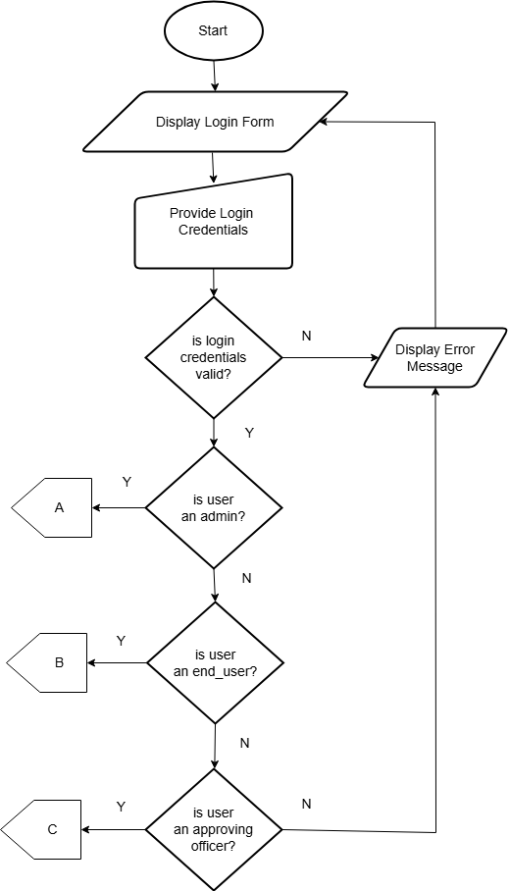

**Figure 2.0: Flowchart Login**

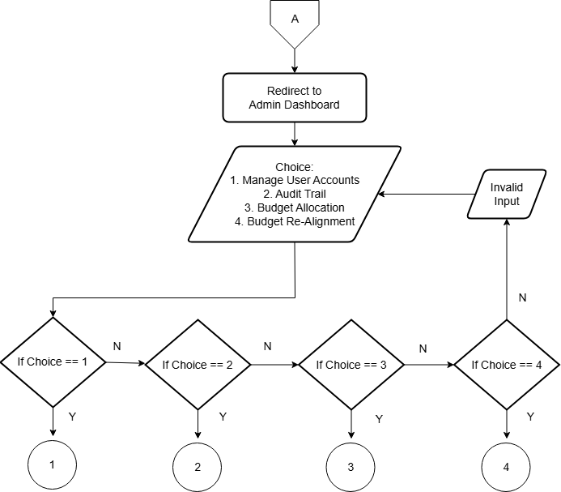

**Figure 2.1: Flowchart Admin Menu**

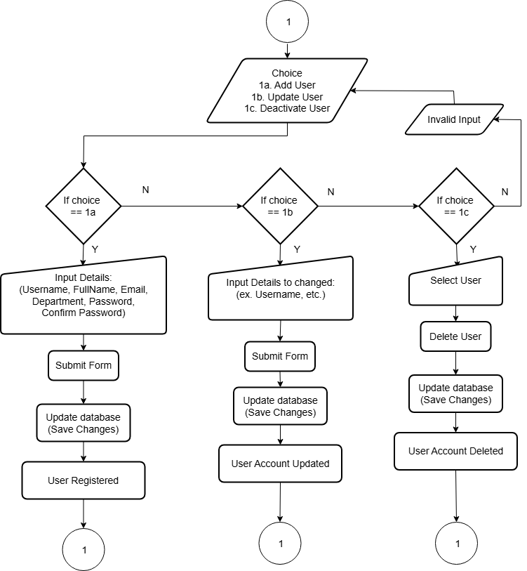

**Figure 2.2: Flowchart Admin Manage Users**

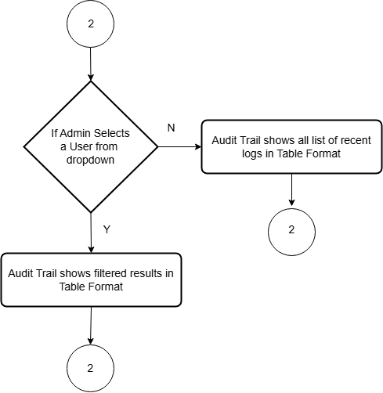

**Figure 2.3: Flowchart Admin Audit Trail**

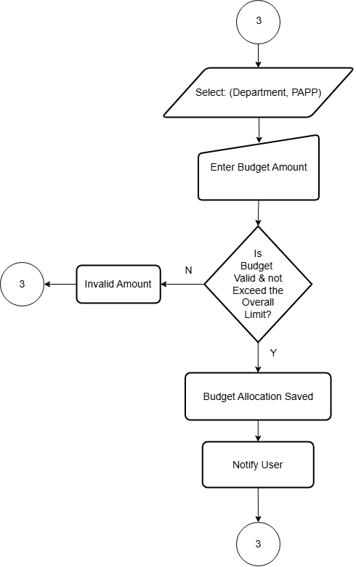

**Figure 2.4: Flowchart Admin Budget Allocation**

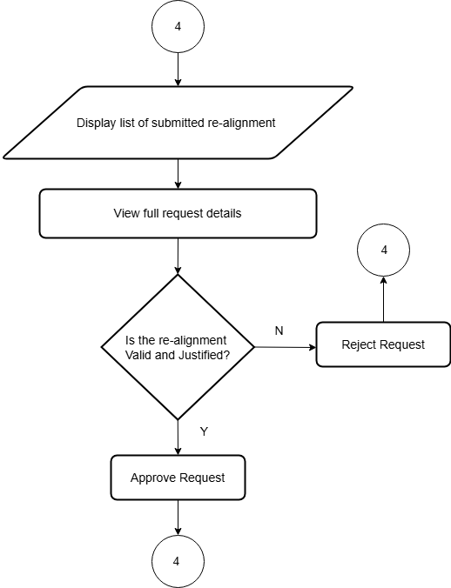

**Figure 2.5: Flowchart Admin Budget Re-alignment**

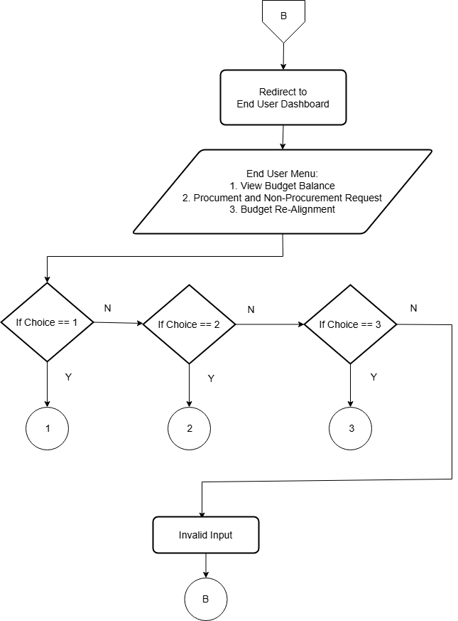

**Figure 2.6: Flowchart End User Dashboard**

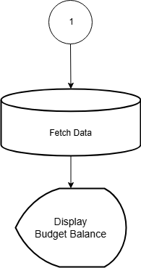

**Figure 2.7: Flowchart End User View Balance**

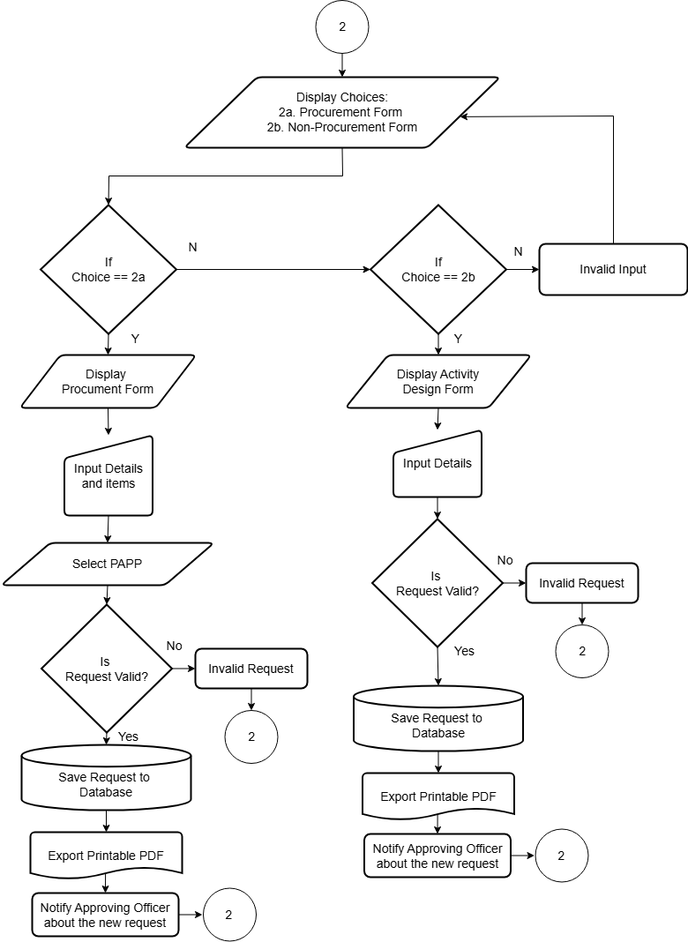

**Figure 2.8: Flowchart End User Procurement and Non-procurement**

**Request**

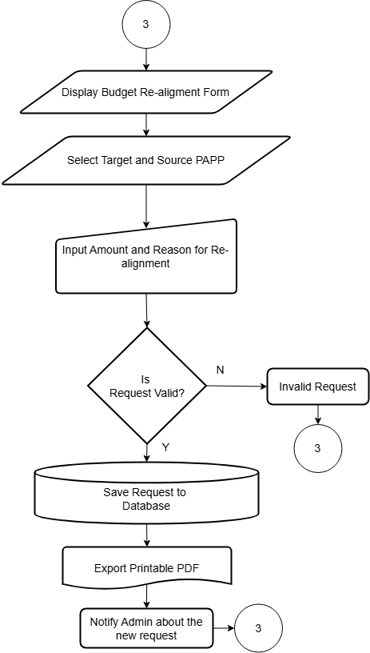

**Figure 2.9: Flowchart End User Budget Re-alignment**

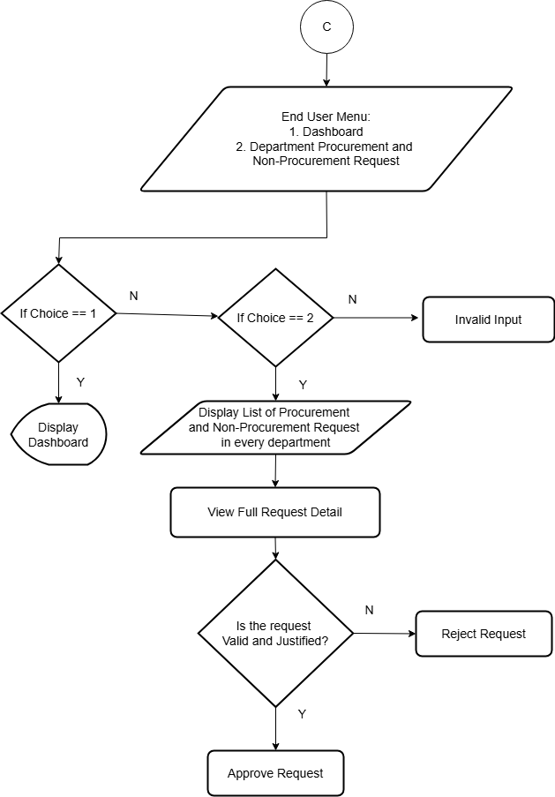

**Figure 2.10: Flowchart Approving Officer Dashboard**



**Figure 3.0: Gantt Chart**

**DEFINITION OF TERMS**

The following terms are operationally defined:

**Administrative Personnel** – Refers to the individuals responsible for managing and overseeing the budget of BISU Balilihan Campus. This includes the **Administrative Officer, Department Heads, and Non-Academic Unit Heads** who ensure that financial resources are properly allocated, monitored and utilized.

**Major Final Output (MFO)** –

**Dashboard** – A centralized interface in the BISU Balilihan Budget Monitoring System that provides an overview of budgets, balances, and purchase request statuses. Administrators use the dashboard to manage system functions, while end-users utilize it to monitor their financial data.

**REFERENCES**

Bernas, S. J. (1987). The 1987 Constitution of the Republic of the Philippines

<https://www.officialgazette.gov.ph/constitutions/the-1987-constitution-of-the-republic-of-the-philippines/the-1987-constitution-of-the-republic-of-the-philippines-article-xiv/>

Commission on Audit. (2016) COA Quality Management System Manual

<https://www.coa.gov.ph/wpcontent/uploads/transparency/COA_QMS_Man> ual.pdf

Humairoh, N. (2024), The Preliminary Study for Budget Monitoring System in

Government Agencies

<https://journal.lenterailmu.com/index.php/jafotik/article/download/41/44>

Mamburao, R, Manubag, E., (2023), Fiscal Management Practices Framework of

State Universities and Colleges in Region XII

https://www.researchgate.net/publication/374836984_Fiscal_Management_Practices_Framework_of_State_Universities_and_Colleges_in_Region_XII

Marikyan, The Unified Theory of Acceptance and Use of Technology: A New

Approach in Technology.

https://open.ncl.ac.uk/theories/2/unified-theory-of-acceptance-and-use-of-technology/

Ramos, R., Lumapenet, H. (2023), Fiscal Management Practices and Program

Performance of State Universities and Colleges in the Philippines

[https://www.researchgate.net/publication/375993423_Fiscal_Management_Practices_and_Program_Performance_of_State_Universities_and_Colleges_in_the_Philippines?](https://www.researchgate.net/publication/375993423_Fiscal_Management_Practices_and_Program_Performance_of_State_Universities_and_Colleges_in_the_Philippines?utm_source=chatgpt.com)

Rodriguez, A. A., & Dela Fuente, M. B. (2024), WebPy-BudgetAnalytics: Budget

Monitoring and Analytic Support Tool for Universities and Colleges

<https://www.researchgate.net/publication/389277855_WebPy-BudgetAnalytics_Budget_Monitoring_and_Analytic_Support_Tool_for_State_Universities_and_Colleges>

Schad et. al, A Review of Theory, Theoretical and Conceptual Frameworks in

Educational Technology (2021)

<https://eric.ed.gov/?id=EJ1290710>

Wang, X. (2025), The Analysis of the Impact of Financial Structure Optimization

on Budget Performance Management in Universities Based on the Perspective of Internal Control and Final Accounts - Using ABC Model as a Framework

<https://sciendo.com/article/10.2478/amns-2024-3620>

**Chapter 2**

**PRESENTATION OF THE PRESENT SYSTEM AND PROPOSED SYSTEM**

1. **PRESENT SYSTEM**

**System Narrative**

The current budget monitoring system of BISU Balilihan Campus is entirely manual. The Administrative Personnel records and monitors the budget using paper and spreadsheets. The records include the allocated budget, expenses and remaining balance. Each entry is manually written or encoded and updates depend on the officer’s recording.

The Department Heads do not have direct access to monitor their budget unless they record it on their own. They take down the approved budget, track any requests for expenditures and deduct the amounts accordingly. However, this manual system has significant drawbacks. If someone forgets to record a transaction or makes a mistake in calculation, the budget information may become unreliable. Additionally, if there are discrepancies or missing data on their record, the staff must approach the Administrative Officer to clarify and confirm the details.

For the Campus Director, who approves or rejects purchase requests, all requests are submitted manually by the Administrative Officer. The request is forwarded for approval or rejection without any automated process. Since everything is handled in paper form, there is also the possibility that the Purchase Request may be misplaced or lost before it reaches the Campus Director.

In the current setup, there is no centralized database or automated system to ensure that budget records are updated in real-time. Each department handles its monitoring independently, and there is no standard way to manage or share the financial data. This lack of coordination makes it difficult to retrieve accurate and up-to-date information. Overall, the manual system is time-consuming, prone to errors, and lacks efficiency.

**Findings/Constraints**

The study revealed the following constraints:

1. The system is fully manual, making budget tracking slow and difficult.
2. Errors in recording or calculations can lead to wrong budget information.
3. There is no central system, so each department manages its budget separately.
4. Checking and verifying records takes time and causes delays.
5. Departments cannot access real-time budget updates, leading to outdated information.

In general, the computerization of the system will provide faster, more accurate, and well-organized budget tracking. It will reduce errors, allow real-time updates, and improve coordination between departments, making financial management more efficient.

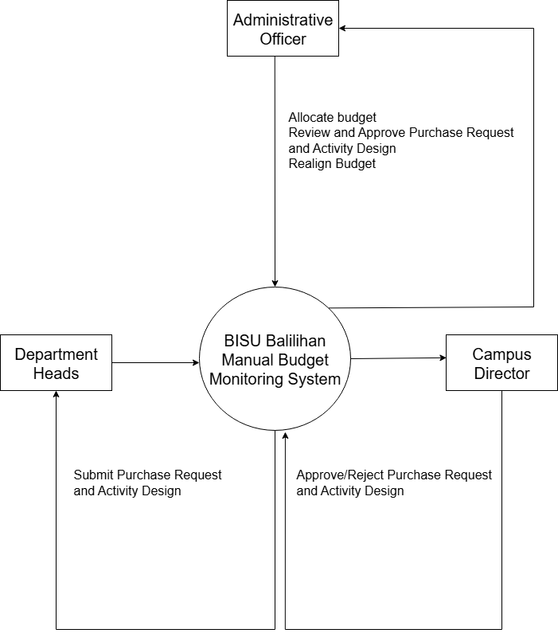

**Figure 1: Context Diagram of the Present System**

**Event List**

1. **Budget Allocation**
2. **Process Purchase Request**
3. **Approval of Purchase Request**

**Event List Diagram**

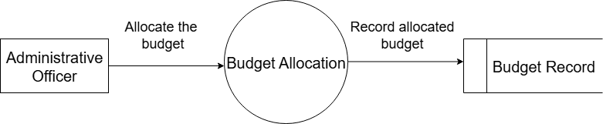

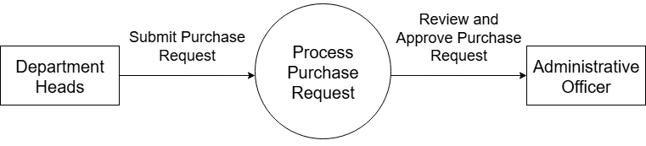**Figure 2: Event 1. Process Budget Allocation**

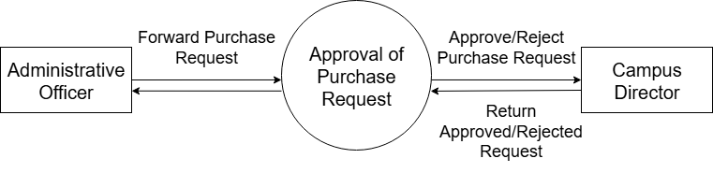**Figure 3: Event 2. Process Purchase Request**

**Figure 4: Event 3. Process Purchase Request**

1. **PROPOSED SYSTEM**

**System Rules**

The proposed system, titled **BISU Balilihan Budget Monitoring System for Administrative Officer**, aims to streamline the process of managing and monitoring the budget of BISU Balilihan Campus. This system will ensure accurate tracking of financial allocations, expenditures, and balances, while providing real-time updates to authorized personnel. The system is designed to be user-friendly and efficient, catering to the specific needs of budget officers, administrators, and department heads.

The system will follow a well-defined process flow. First, users will log into the system using their assigned credentials. Upon login, authorized personnel will have access to a dashboard displaying an overview of the current budget status, including allocated funds, utilized amounts, and remaining balances. The dashboard will also highlight notifications for pending approvals or discrepancies in budget utilization.

Budget allocation will be initiated by the administrator or budget officer. Departments will submit their budget requests through the system, specifying their needs and justifications. The system will then allow administrators to review, approve, or reject these requests. Approved allocations will be recorded in the system, automatically updating the overall budget.Expenditure tracking is a core feature of the system. Departments will log their expenses by uploading receipts and specifying the purpose of each transaction.

Expenditure tracking is a core feature of the system. Departments will log their expenses by uploading receipts and specifying the purpose of each transaction. The system will verify if the expenditure aligns with the approved budget. Once verified, the system will deduct the expense from the allocated budget and update the remaining balance in real-time. Any discrepancies or overspending will trigger an alert for immediate action.

Reports and analytics are another essential component. The system will generate detailed financial reports, showing monthly and annual summaries of income, expenses, and balances. These reports will help administrators identify trends, forecast future budget needs, and ensure transparency in financial management.

To maintain data security and integrity, the system will implement role-based access. Only authorized users will have access to specific features, ensuring that sensitive financial information is protected. The system will also feature an audit trail to track all activities, such as budget approvals, expense entries, and system modifications.

In summary, the BISU Balilihan Budget Monitoring System will provide a reliable, transparent, and efficient solution for managing the campus budget. By automating key processes, the system will minimize errors, improve decision-making, and enhance the overall financial management of BISU Balilihan Campus.

**Context Diagram**

- Submit PRE / PR / AD

- Monitor Budget

- Request Realignment

End User

- Manage Budgets

- Allocate Budgets

- Manage Requests

- Manage Accounts

View Audit Trail

BISU Balilihan Budget Monitoring System

Admin