**Name: John Romel Lucot Date:02/14/2025**

**Course & Section: BSIT - 3C**

**Simple E-Commerce Hosting Link: *https://romelodev.github.io/Simple-E-commerce-Site/***

**Homepage:**

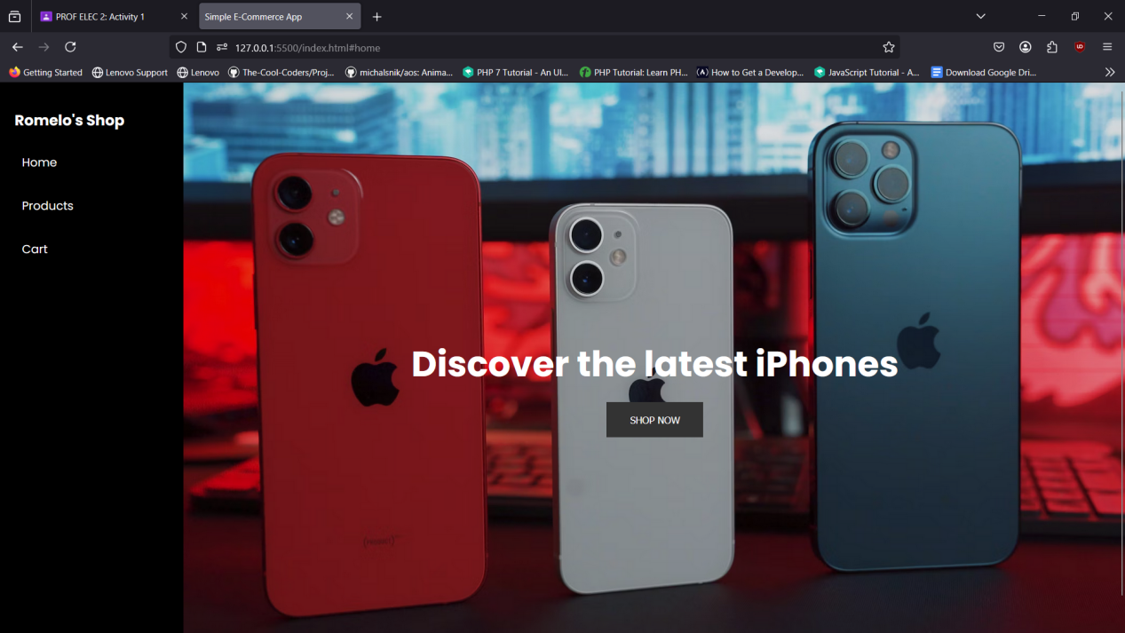

This is the homepage of my Simple E-Commerce Website, its just a simple homepage that have a background image, text, and a “SHOP NOW” button that redirects to products section.

**Products Section:**

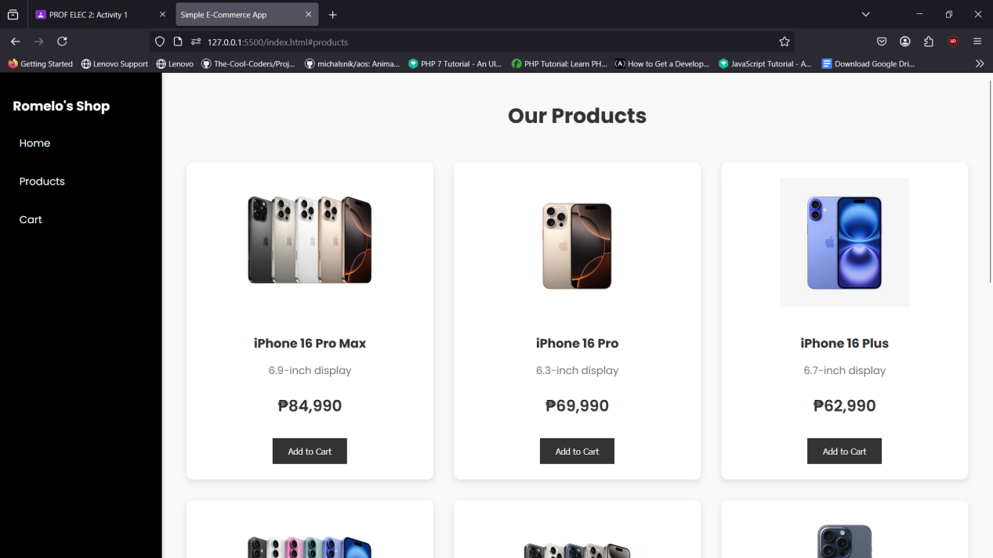

In this Products Section of my simple e-commerce website, users can browse available items displayed in a grid layout with product images, names, and prices. Each product card includes an "Add to Cart" button, allowing users to add items to their shopping cart for purchase.

**Cart Section:**

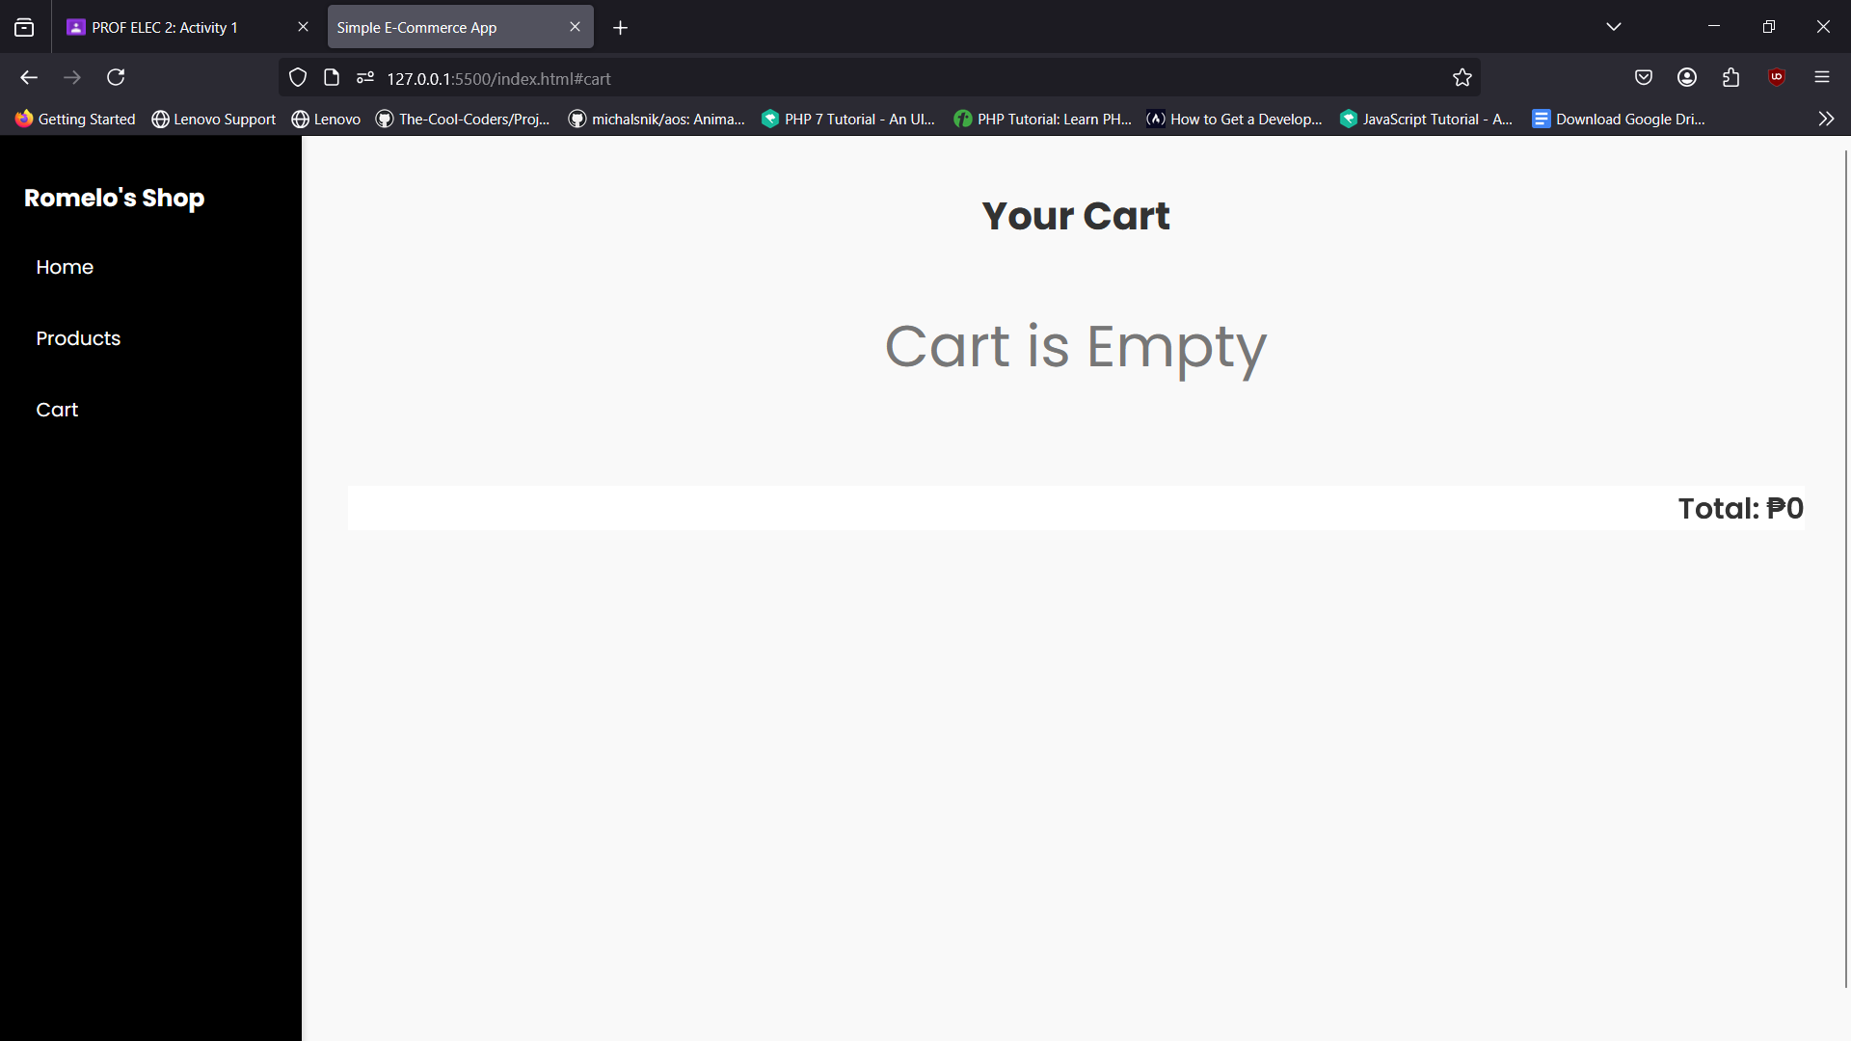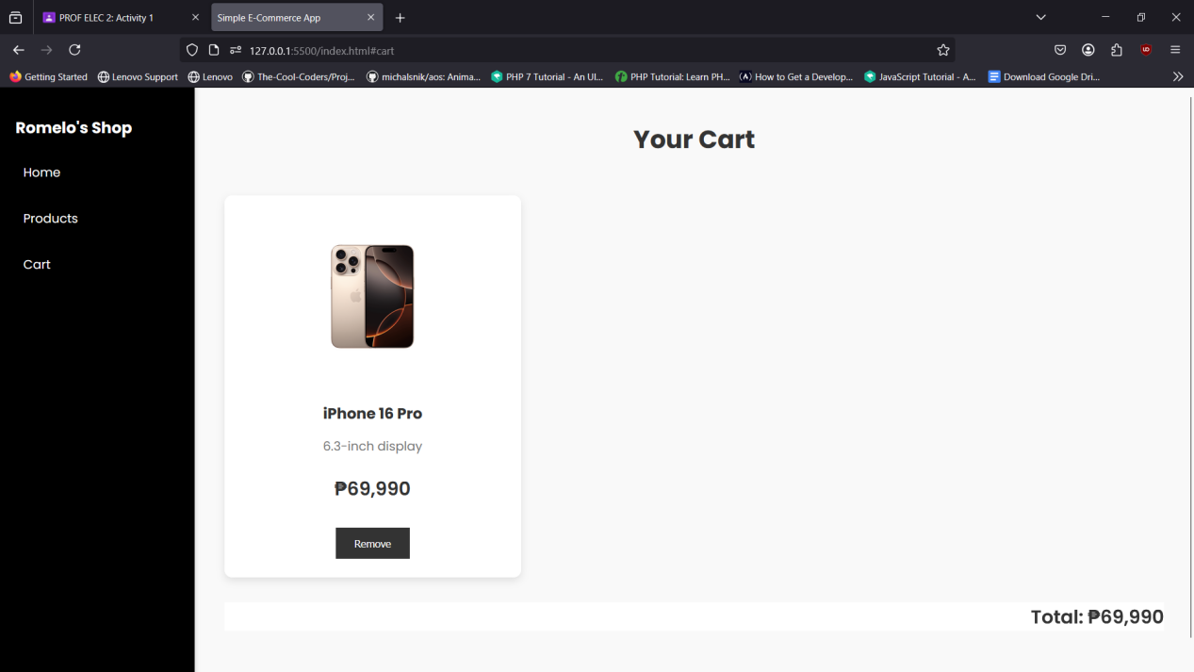

In this Cart Section of my simple e-commerce website, users can view the products they have added to their cart, along with their details, including name, and price, if the cart is empty there is a text display that the cart is empty. A "Remove" button is provided for each item, allowing users to manage their selections before proceeding to checkout. The total price is displayed at the bottom, ensuring transparency and ease of purchase.