**COSC 436: Object-Oriented Design and Programming**

**In-class Exercise: Class Diagram**

Classify the following into (5 pts)

generalization (G), association(A), aggregation (AG), or composition (C):

a) A building has a lab room C

b) A dining philosopher uses a fork A

c) A file is an ordinary file or a directory file G

d) library contains books AG

e) A person uses a computer language on a project A

Use the following class diagram to answer the questions that following it. If there isn't enough information in the diagram to answer the question, state as much. (2 pts)



1. Can you have a company without any employees?

No, the diagram suggests that a company must have at least one employee since the multiplicity on the employee side is 1..* (meaning one or more employees).

2. Can a person be unemployed?

Yes, according to the diagram, a person may not be employed as the employer multiplicity is *.

Use the following figure to answer the questions that follow. (4 pts)

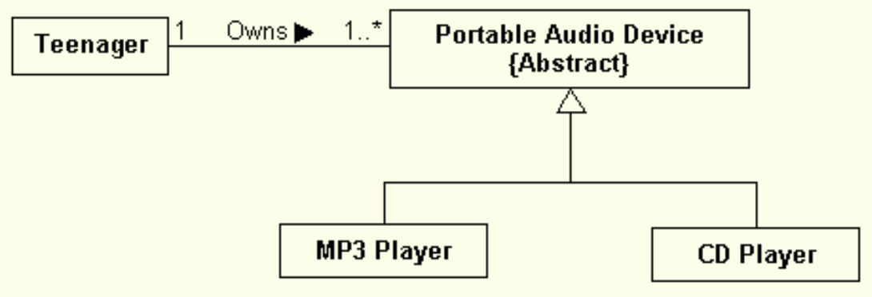s

a. How many portable audio devices does each teenager own? 1 or more

b. Can there be a portable audio device not owned by any teenager? No

c. Can there be an MP3 player not owned by any teenager? No

d. Can there be an MP3 player owned by many teenagers? No

Draw a class diagram representing a book defined by the following statement: “A book is composed of a number of parts, which in turn are composed of a number of chapters. Chapters are composed of sections.” Focus only on classes and relationships. (3 pts)

Draw a class diagram representing the relationship between parents and children. Take into account that a person can have both a parent and a child. Annotate associations with roles and multiplicities (3 pts).

A company consists of departments. Departments are located in one or more offices. One office act as a headquarter. Each department has a manager who is recruited from the set of employees. Your task is to model the system for the company. (3 pts)