Romerico David

09/12/2025

Assignment #1

1. lsA screenshot of a computer

   Description automatically generated

Prints out all the directories inside the current directory that I am in

1. pwd

Prints the path of the current working directory

1. cd Downloads

Switches current working directory to the Downloads subdirectory (and generally helps you switches between directories)

1. top

Displays all currently running processes along with detailed system and resource usage information

1. grep “test” test.txt

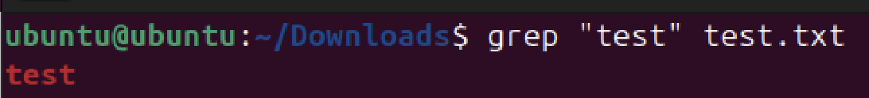

Searches/Greps a file e.g. test.txt for some matching word e.g. 'test' (or regex) and print the matching line(s)