Administrator Guide

To start application:

Run the provided JAR file

Open in your web browser>
http://localhost:8080/admin?authkey=1234 ( where ?authkey=**** is the authentication key)

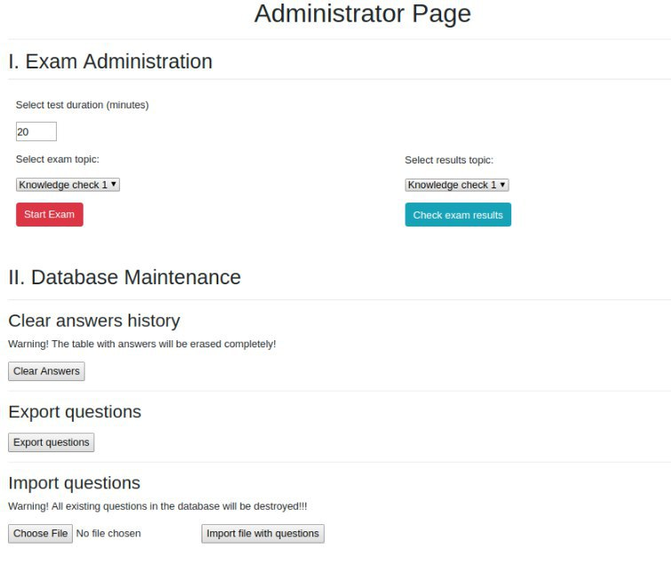

1.Exam Administration

This section is used to control the exam.

first you have to select the exam topic from the drop down list.

In order to start the exam you click on “Start Exam” Button
after which you are redirected to the following page:

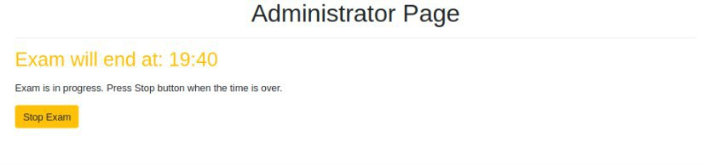

after 20 minutes the exam will close automatically.
(if need be administrator can close test manually by pressing “Stop Exam”)

in order to view the results of the test we can “select results topic”
and click “check exam results” button

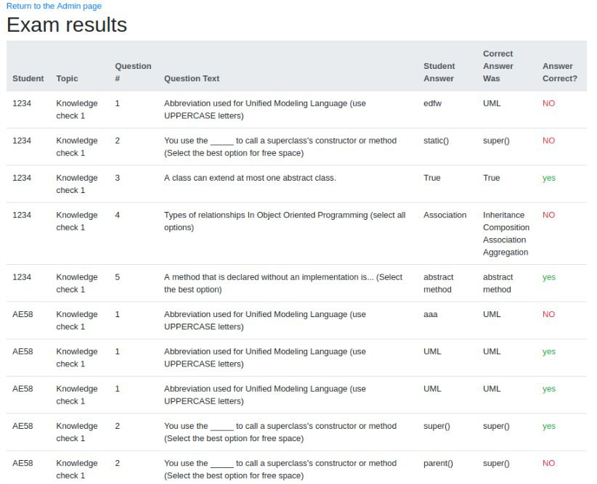
After Clicking Check Exam Results you will be redirected to the following page where you can view the results:

2.Database Maintenance

this section used to control the database

in order to import questions into the data base you need to click choose file , and choose the .txt file you want to import in the following structure(example file provided in the root directory):
WARNING: all existing questions will be over written
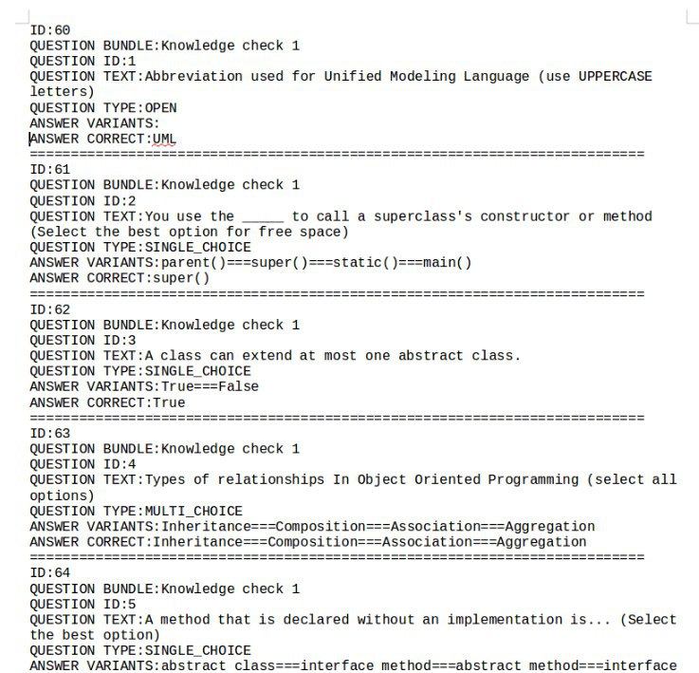

in order to export questions in a .txt format you click on the export questions button. And you will be provided with a download of the file.

In order to clear all answers table you can push
the button “clear answers”.
WARNING: all existing questions will be over written

