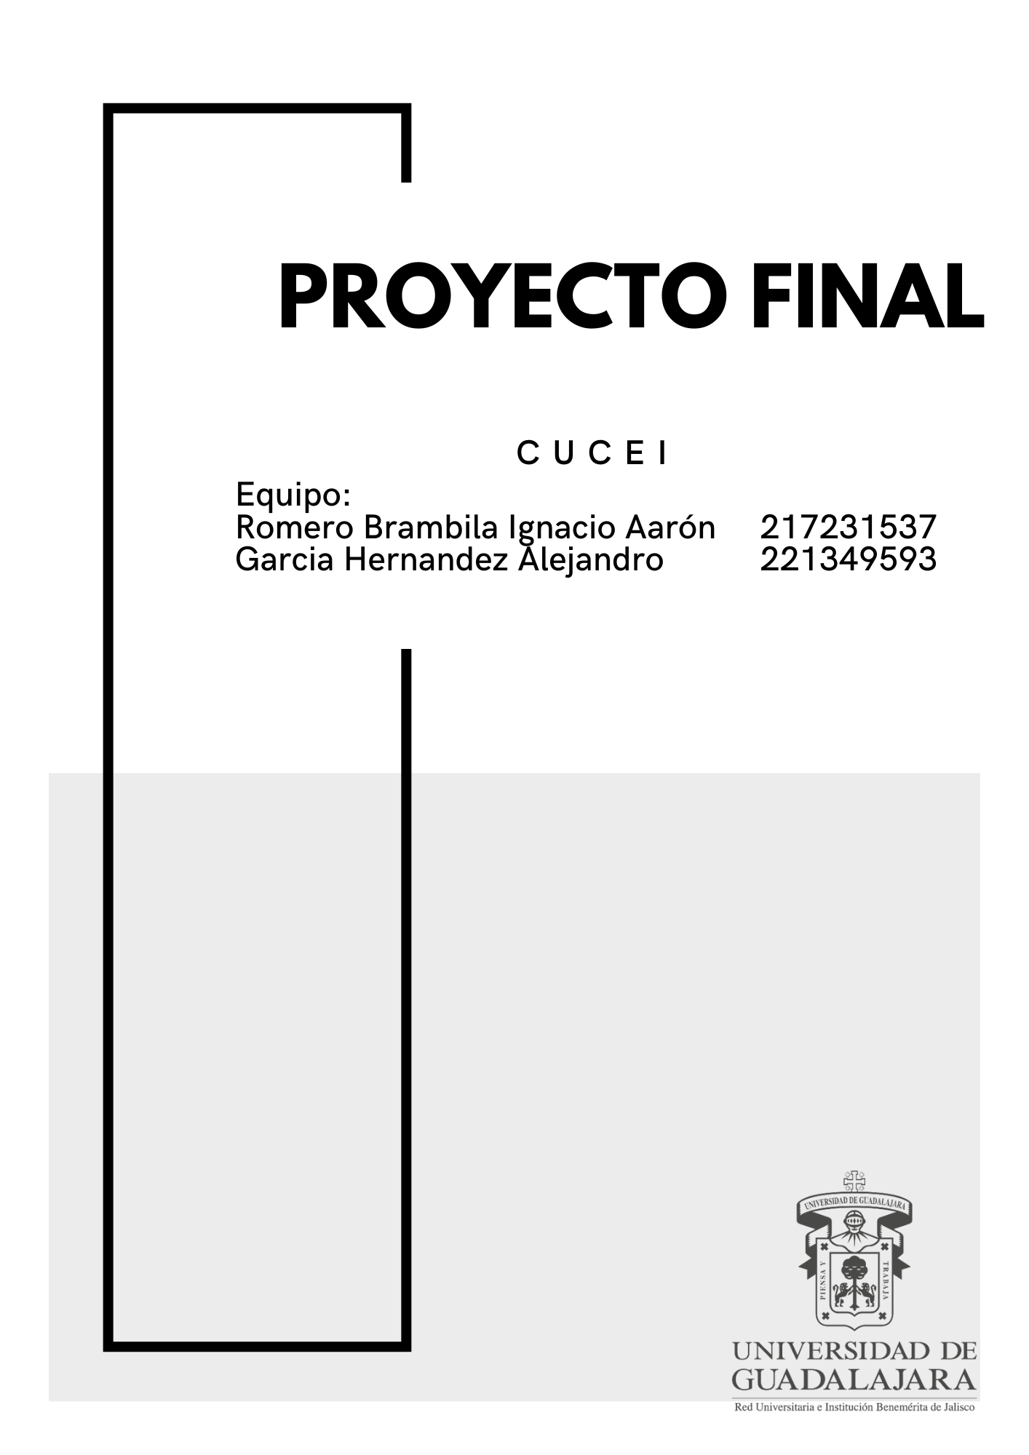

**Cotización**

Proyecto de redes

|  |  |  |  |
| --- | --- | --- | --- |
| **Tipo de producto** | **Precio Unitario** | **Cantidad** | **Precio Total** |
| Computadora Dell OptiPlex 7010 | $8,619.00 | 42 | $361,998.00 |
| Telefonos IP | 499,00 | 20 | $9.980.00 |
| Host | $200.00 / mes | 12 | $800.00 |
| Intel xeon | 1.890,00 | 3 | $5.670.00 |
| AP- WAP121 | $1.160,00 | 4 | $4.640.00 |
| Router Cisco 2900 | $4,200 | 36 | $151,200.00 |
| Switch catalyst | $989,00 | 70 | $69,230.00 |
| Internet | $2,289 / mes | 12 meses | $27.468.00 |
| Rack 18U | $ 6,747.71 | 1 | $6,748.00 |
| Rack 40U | $ 5,219.99 | 2 | $ 10,438.00 |
| Bobina Enson 6A | $3,259.00 | 21 | $68,439.00 |
| **Total** |  |  | $716,611.00 |
|  |  |  |  |
| **Mano de obra** |  |  |  |
| **Trabajadores** | **Costo mensual** | **Meses de trabajo** | **Total** |
| 5 | 14.000,00 | 4 meses | $280.000,00 |
|  |  |  |  |
| **Costo Total** |  |  | $996,611.00 |

**Visualización de la topología**

