**Assignment 20: Smart Contracts**

Make sure, there are 4 accounts – 1 for HR and 3 for employees to transfer the funds. The 4 accounts can be used from Ganache.

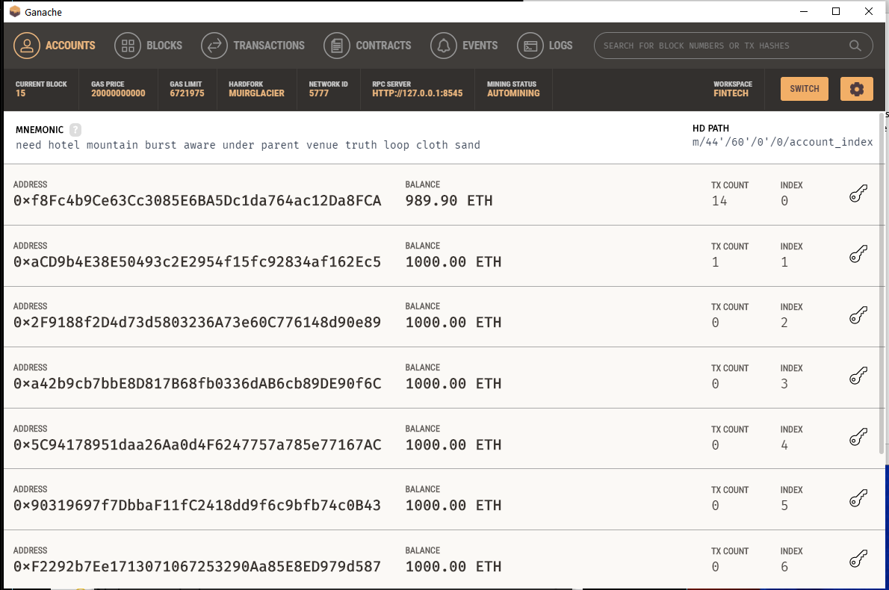

Assume the first account for HR.

HR Account:

**0xf8Fc4b9Ce63Cc3085E6BA5Dc1da764ac12Da8FCA**

The next 3 are for employees

Employee 1 account:

**0xaCD9b4E38E50493c2E2954f15fc92834af162Ec5**

Employee 2 account:

**0x2F9188f2D4d73d5803236A73e60C776148d90e89**

Employee 3 account:

**0xa42b9cb7bbE8D817B68fb0336dAB6cb89DE90f6C**

Use the below set up to deploy the contract:

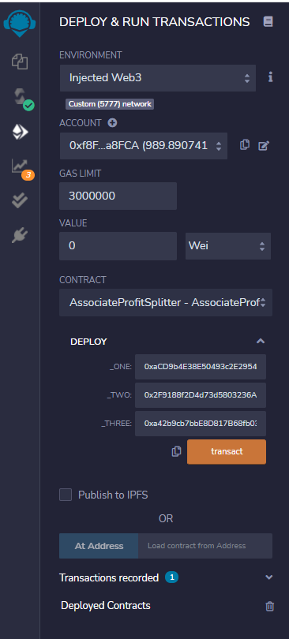

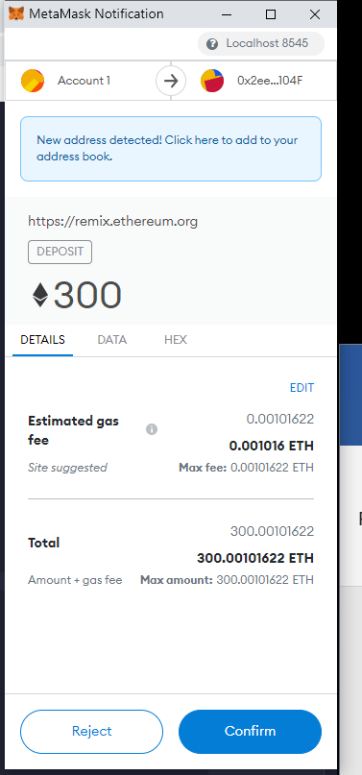

Funds transferred confirmation

