HarmonySync: A Causally-Aware, Confidence-Weighted Architecture for Cross-Device Music Preference Synchronization in Connected Vehicles
Romila Mukul
School of Computer Science and Engineering, Vellore Institute of Technology, Chennai, India
romila.mukul2024@vitstudent.ac.in
Abstract—Connected-vehicle audio personalization today depends almost entirely on Bluetooth pairing or FM broadcast, both of which require a companion phone to be physically present and paired to the vehicle. This dependency breaks down in common real-world scenarios: rental vehicles, shared household cars of different makes, or a driver’s own vehicle when their phone is elsewhere. Existing manufacturer-led connected-car systems relay cloud-hosted account settings to the vehicle over a cellular or Wi-Fi link, but they largely assume a single, authoritative source of preference data and resolve conflicting updates from multiple client devices using naive last-write-wins semantics, which silently discards higher-quality signal whenever a lower-confidence device happens to synchronize last. This paper proposes HarmonySync, an architecture that synchronizes a user’s music preferences to a vehicle head unit without Bluetooth or FM, built around a causally-aware, confidence-weighted conflict resolution engine. Every client update carries a vector clock, which distinguishes causally ordered updates from genuinely concurrent ones; true conflicts are resolved through a device-confidence-weighted merge rather than a timestamp-based one. A working prototype was implemented using an MQTT publish/subscribe transport, a PostgreSQL-backed versioned profile store, and an SQLite offline-first vehicle cache, and validated against a twenty-two-case automated test suite covering causal-dominance detection, weighted numeric and categorical merging, end-to-end MQTT/PostgreSQL round-trips, offline vehicle playback, and privacy-preserving edge pre-aggregation. Results show the proposed resolver produces materially different, and more representative, outcomes than last-write-wins under concurrent multi-device updates, while preserving a fully auditable trail of every resolution decision.
Keywords—Connected vehicles, IoT, vector clocks, conflict-free replication, MQTT, distributed systems, preference synchronization, edge computing.
Code: [GitHub repository link to be added]

I. Introduction
The proliferation of Internet-connected devices in the automotive domain has enabled a wide range of in-vehicle personalization features, of which audio and media preference continuity is among the most frequently used. At present, this continuity is achieved almost exclusively through two short-range mechanisms: Bluetooth pairing, which streams audio from a nearby paired smartphone to the vehicle head unit, and FM transmission, which broadcasts audio over a locally tuned radio frequency. Both mechanisms are inherently session-based and device-proximate: they require a specific companion device to be physically present and actively paired for the duration of use.
This dependency introduces friction in several increasingly common usage patterns: a driver using a rental or a family member’s vehicle of a different make, a household with multiple vehicles and a single shared streaming account, or simply a driver whose phone is not immediately at hand. Recent connected-vehicle platforms address a narrower version of this problem by giving the vehicle its own persistent network connection (embedded cellular modem or home Wi-Fi) and synchronizing account-level settings from a manufacturer cloud, removing the requirement for a paired phone. However, these systems typically assume preference data flows from a single canonical source to the vehicle, and where multiple client devices (phone, vehicle, secondary devices) can independently modify preference state, conflict resolution defaults to a timestamp-based last-write-wins (LWW) policy.
Last-write-wins is a well-documented failure mode in distributed data systems: because it orders updates purely by wall-clock arrival time, it is vulnerable to clock skew and network jitter between devices, and, more importantly for this domain, it treats every update source as equally trustworthy regardless of context. A driver’s deliberate skip on the vehicle’s own dashboard carries materially more intent than a background application passively logging a play event on a laptop, yet LWW has no mechanism to reflect that distinction; whichever update happens to arrive at the resolution point last simply overwrites the other, irrespective of its evidentiary quality.
This paper proposes HarmonySync, a distributed architecture that (i) synchronizes preference data to a vehicle head unit over a persistent cloud-mediated connection rather than a device-paired one, and (ii) introduces a conflict resolution mechanism that combines vector-clock-based causal ordering with device-confidence-weighted merging to resolve genuinely concurrent updates. Section II reviews related work. Section III presents the system architecture. Section IV details the conflict resolution algorithm. Section V describes the implementation, Section VI presents results from the prototype’s automated test suite and comparison scenarios, and Section VII concludes with future work.

II. Literature Survey
Prior work on connected and smart-vehicle IoT systems has largely focused on cloud-mediated connectivity between a vehicle and manufacturer infrastructure for telematics, diagnostics, and account-level personalization, giving the vehicle its own persistent network identity independent of any paired companion device. This establishes the feasibility of phone-independent vehicle connectivity but does not, in general, address how the cloud-side profile should be constructed when multiple independent client devices contribute conflicting updates.
Reconciling divergent state across independently updating, intermittently connected replicas has been studied extensively in distributed systems. Lamport’s work on logical clocks showed that, without a shared global clock, the causal order of events can be recovered from counters exchanged between processes, forming the basis for the vector clocks used here to detect causal dominance [1]. DeCandia et al.’s Dynamo applied vector clocks to reconcile concurrent writes in a highly available, eventually consistent store, favoring availability over strict consistency and delegating unresolved conflicts to application-level merge logic, a philosophy this paper adopts and extends with a device-confidence weighting scheme specific to multi-device preference synchronization [2]. Shapiro et al. formalized Conflict-free Replicated Data Types (CRDTs), whose merge operations converge without coordination, providing the grounding for treating numeric preference fields as mergeable rather than requiring a single arbitrarily chosen winner [3]. The MQTT specification defines the lightweight publish/subscribe model adopted as the transport layer, chosen for its suitability to many independently and intermittently connected clients [4].
In the IoT and smart-infrastructure literature, several studies propose sensor-network architectures in which heterogeneous edge devices report readings to a central aggregation point, typically over long-range or low-power radio links such as LoRa [5]. These systems address a different domain but share a structurally similar problem: reconciling readings from multiple asynchronously reporting sources into a single actionable state. The surveyed work, however, does not incorporate an explicit causality-aware or confidence-weighted reconciliation mechanism; aggregation is typically simple averaging, or the most recent reading is treated as authoritative.
The present work differs in combining (a) the causal-ordering guarantees of vector clocks, (b) a CRDT-inspired merge-rather-than-overwrite approach for concurrent updates, and (c) a device-role-specific confidence weighting scheme, applied to cross-device music preference synchronization for connected vehicles, a combination not reported in the reviewed literature. Table I situates HarmonySync against the nearest prior work.
TABLE I
HarmonySync vs. typical connected-vehicle cloud synchronization
Dimension | Connected-vehicle cloud sync (e.g., manufacturer platforms) | HarmonySync (this work)
Update model | Single canonical source pushed to vehicle | Multiple independent sources merged
Conflict handling | Implicit last-write-wins | Vector-clock causal dominance + weighted merge
Source trust | All sources treated equally | Device-specific confidence weighting
Auditability | Typically opaque | Immutable versioned snapshots with per-decision audit tag

III. Proposed System
The architecture is organized into four layers (Fig. 1): (A) client devices, which generate preference evidence; (B) a publish/subscribe transport layer; (C) a cloud conflict-resolution and persistence layer; and (D) an offline-first vehicle head unit. Updates flow from A through B to C, and the merged result returns through B to D; skip and like events generated on the vehicle close the loop back to C. Each layer is described below, followed by a component-level view in Fig. 2.
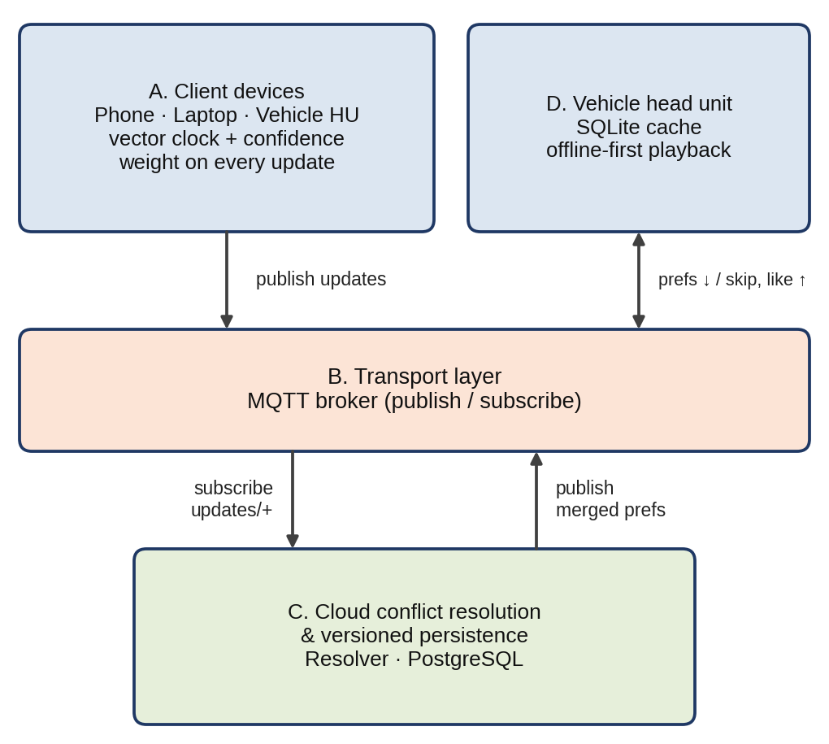
Fig. 1. Four-layer system architecture.

A. Client Devices
Three classes of client device are considered: the vehicle head unit, a companion smartphone, and a secondary device such as a laptop. Each is assigned a fixed confidence weight reflecting the reliability of the listening signal it produces (Fig. 10). The vehicle head unit is weighted highest (0.9), since in-vehicle interactions such as skips and volume adjustments represent deliberate, high-context driver intent; the smartphone is weighted 0.5, reflecting a mix of active and passive usage; and the laptop 0.4, reflecting predominantly passive background listening. Every update a device emits is tagged with a per-device vector clock, incremented on every local change and merged with the highest clock values the device has previously observed from other devices.

B. Transport Layer
Devices and the cloud resolver communicate over MQTT. Each device publishes updates to a per-device topic under its user’s namespace, users/{user_id}/updates/{device_id}; the resolver subscribes to all devices of a user through a single wildcard subscription, users/{user_id}/updates/+, and republishes the merged result to a separate topic, users/{user_id}/preferences, to which the vehicle subscribes (Fig. 3). This decouples every component from needing to know about any other, and lets the vehicle receive updates the moment they are resolved, without polling.
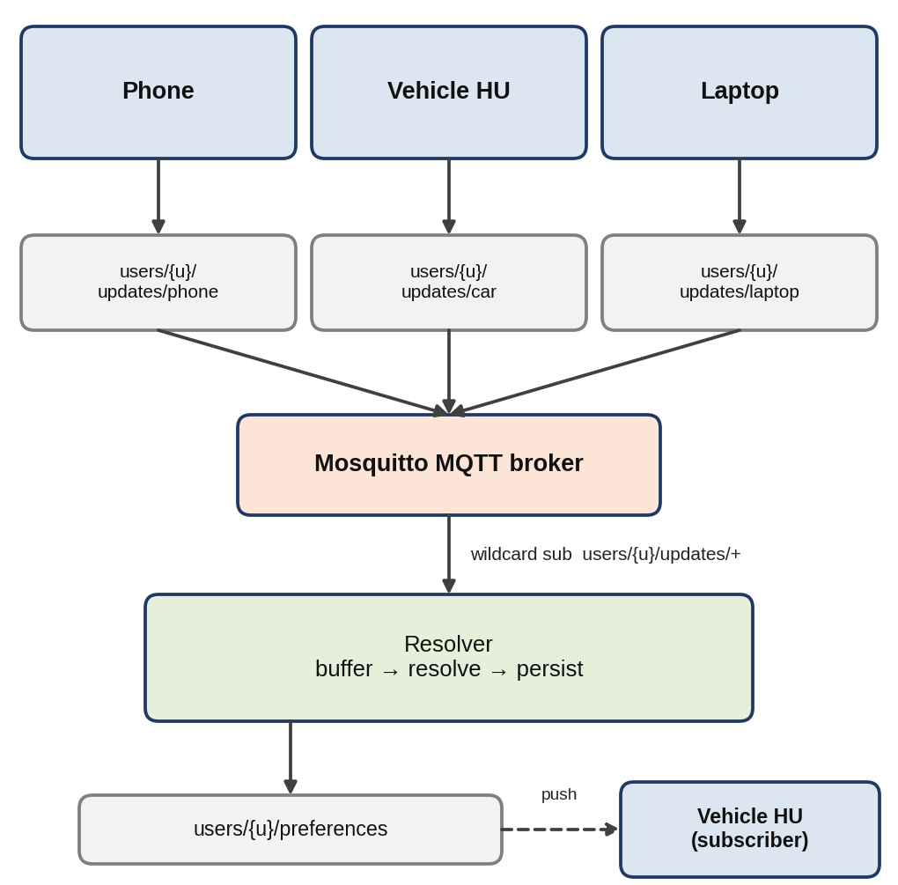
Fig. 3. MQTT topic hierarchy and publish/subscribe message flow.

C. Cloud Conflict-Resolution and Persistence Layer
The cloud layer buffers incoming updates per user within a short merge window (2 s in the prototype) before resolving them, so that near-simultaneous updates from different devices are considered together rather than one at a time. For each preference field touched within the window, the resolver first checks whether one update’s vector clock causally dominates all others touching that field; if so, the dominant update is taken directly, since it already incorporates the information the others carried. Where no single update dominates, the updates are genuinely concurrent and the resolver falls back to a confidence-weighted merge (Section IV). Every resolution, whichever path it takes, is persisted as a new, immutable, version-numbered row rather than overwriting the previous state, giving a complete and auditable history together with a machine-readable tag identifying which strategy produced it.

D. Vehicle Head Unit
The vehicle keeps a local, embedded cache of the most recently received preference snapshot together with its version number. Playback decisions are made exclusively from this cache and never block on network availability, so connectivity gaps such as tunnels, underground parking, or coverage dead zones do not interrupt playback. On reconnection, the vehicle reports its last known version to the cloud, which returns either an incremental update or, where the gap is too large to reconcile incrementally, a full snapshot. Skip and like events generated in the vehicle are themselves republished as new preference updates, closing the loop back to the resolver.
Fig. 2 consolidates layers A–D into a single component-level diagram, and Fig. 4 traces one complete update through every component, from device publish to on-vehicle playback.
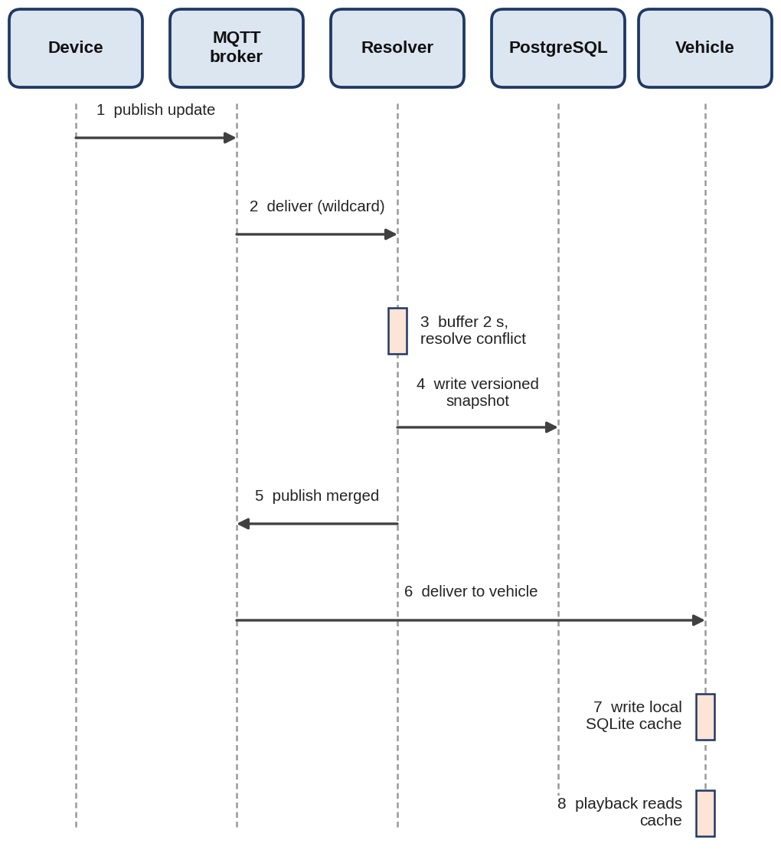
Fig. 4. End-to-end sequence of one update, from device publish to on-vehicle playback.

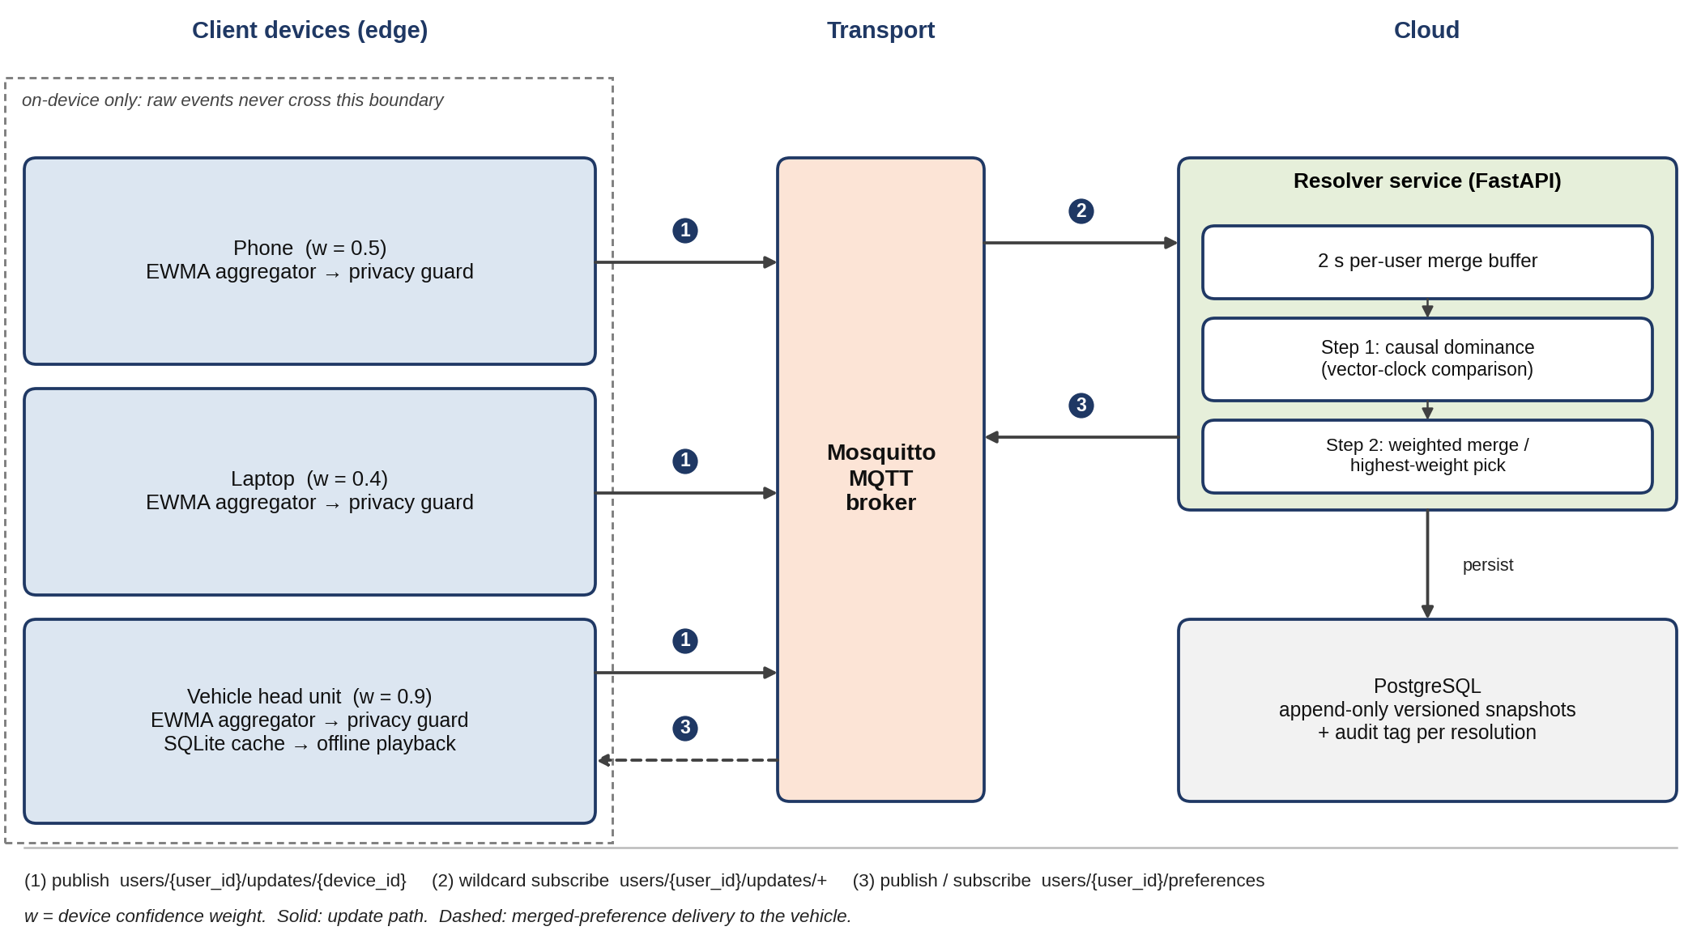
Fig. 2. Component-level architecture: client devices with on-device aggregation, MQTT transport, cloud resolver with versioned store, and the vehicle head unit.

IV. Conflict Resolution Algorithm
The core contribution of this work is the conflict resolution procedure shown in Fig. 5. Given a set of updates touching the same preference field within a merge window, the algorithm proceeds through the following decision steps.
Step 1 — Causal dominance check. For each candidate update, its vector clock is compared element-wise against every other update in the set. An update dominates when every element of its clock is greater than or equal to the corresponding element of every other update’s clock, with at least one element strictly greater. If exactly one update dominates all others, it is taken as the resolved value without further processing.
Step 2 — Concurrency detection. If no single update dominates, the updates are treated as causally concurrent: they occurred independently, with neither device aware of the other’s change.
Step 3a — Numeric fields. For concurrent updates to a continuous-valued field (e.g., volume), the resolved value is the confidence-weighted average of all contributing updates, so no source is discarded outright but higher-confidence sources contribute proportionally more.
Step 3b — Categorical fields. For concurrent updates to a discrete-valued field (e.g., genre), which cannot be meaningfully averaged, the resolved value is taken from the update with the highest confidence weight; the most recent timestamp breaks exact ties in weight only.
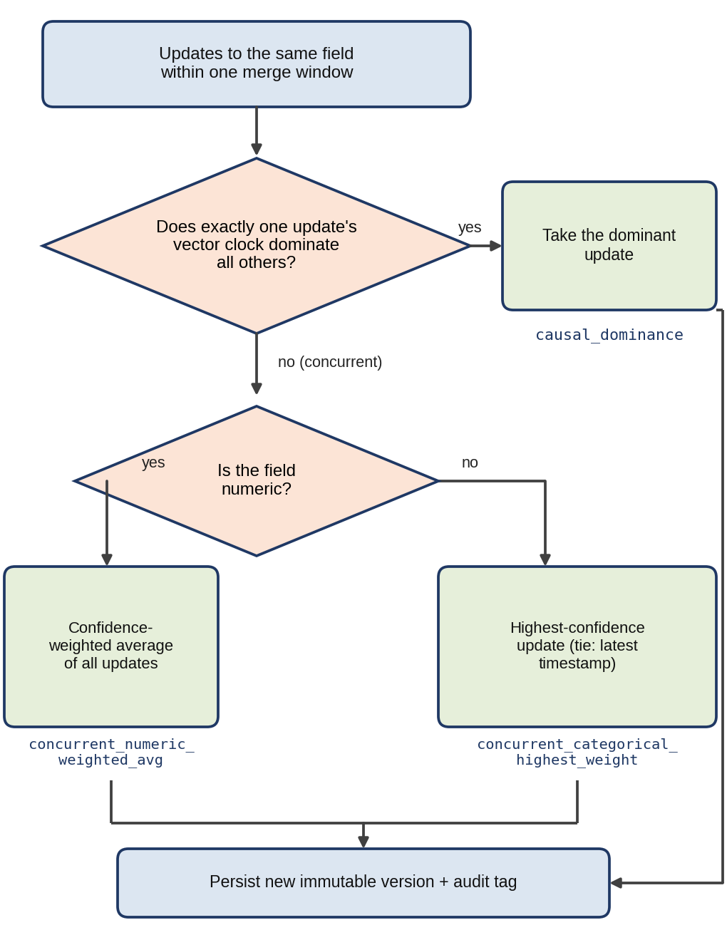
Fig. 5. Conflict resolution decision flowchart.
The procedure checks the cheap, unambiguous case (causal dominance) first and invokes the weighted-merge logic only when a genuine conflict exists. Every resolution records an audit tag, one of causal_dominance, concurrent_numeric_weighted_avg, or concurrent_categorical_highest_weight, so any resolved value can be traced to the reasoning that produced it.
Fig. 6 works through a concrete causal-dominance comparison: the element-wise reasoning the resolver applies to two competing vector clocks before concluding that one update supersedes the other and can be taken directly.
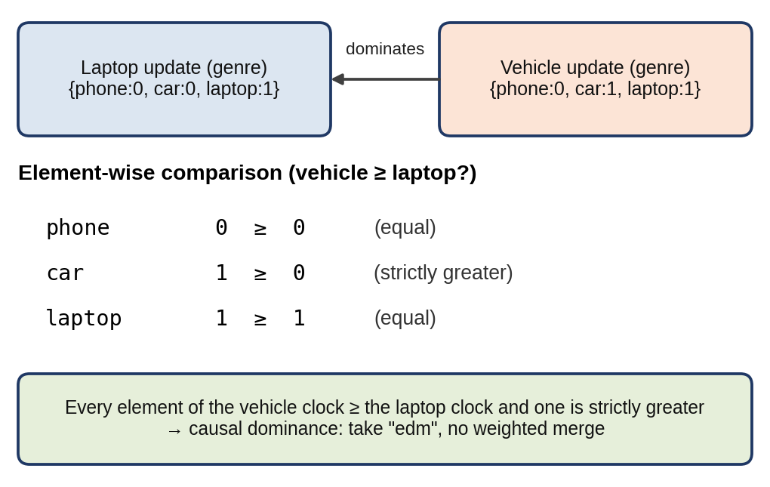
Fig. 6. Worked example of vector-clock element-wise dominance comparison.

V. Implementation Setup
A working prototype was implemented in Python 3.11. The cloud conflict-resolution service was built with FastAPI for its native asynchronous request handling, which is needed to run MQTT subscription handling, a periodic buffer-flush loop, and REST endpoints concurrently. Incoming and outgoing data were validated against strict Pydantic schemas, ensuring every update conforms to the expected vector-clock and confidence-weight structure before processing. The transport used the Eclipse Mosquitto MQTT broker, and persistence used PostgreSQL via SQLAlchemy, with a composite primary key of user identifier and version number enforcing the append-only, never-overwritten snapshot design of Section III-C. The vehicle head unit was simulated with an embedded SQLite database, reflecting the single-writer, no-server-process characteristics of an embedded automotive environment. The broker and database were containerized with Docker for a reproducible local test environment (Table II).
TABLE II
Implementation technology stack by architectural layer
Layer | Technology | Role
API / orchestration | FastAPI, Pydantic | Async request handling, schema validation
Transport | Eclipse Mosquitto, paho-mqtt | Publish/subscribe messaging
Cloud persistence | PostgreSQL, SQLAlchemy | Versioned, append-only snapshot store
Vehicle persistence | SQLite | Embedded, single-writer local cache
Infrastructure | Docker, docker-compose | Reproducible local broker + database
Testing | pytest | Unit + integration verification

A privacy-preserving extension was also implemented: each client device performs local pre-aggregation of raw interaction events, using an exponentially weighted moving average (EWMA) per preference field, before any data is transmitted. Only the resulting compact delta, never the raw event log, crosses the device boundary, and a privacy-assertion routine recursively scans every outgoing payload, including auxiliary metadata, to ensure no raw interaction data is included before publication is permitted. Fig. 7 shows this pipeline, from raw event capture to the privacy-checked delta that is published over MQTT using the same schema the core resolver consumes.
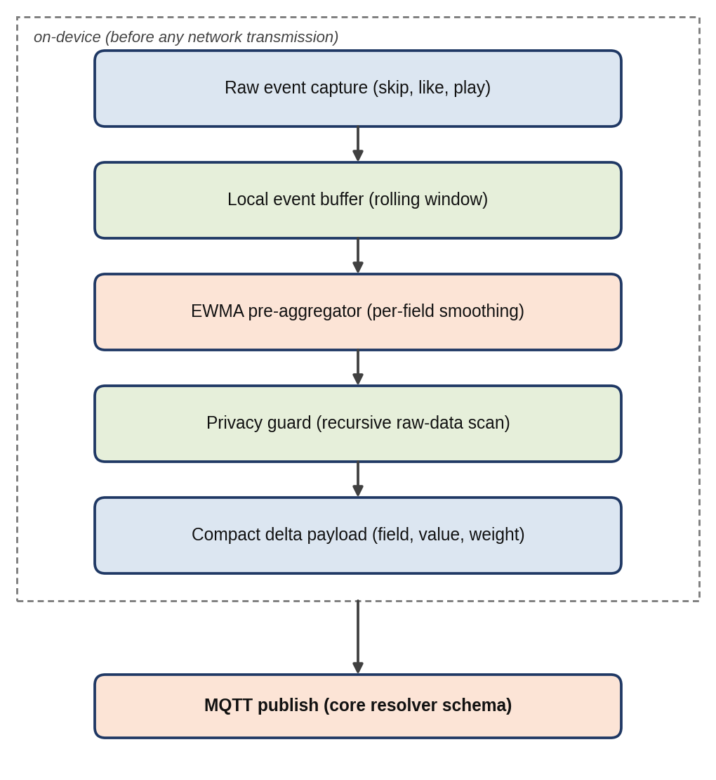
Fig. 7. Privacy-preserving local pre-aggregation pipeline (on-device, before any network transmission).

VI. Results and Analysis
The prototype was validated against an automated test suite of fourteen cases for the core resolver and eight for the pre-aggregation layer, including unit-level verification of vector-clock dominance, the weighted-merge computation for numeric and categorical fields, and integration-level verification against the live MQTT broker and PostgreSQL instance (not mocked), confirming an end-to-end update-to-persistence round trip within three seconds. All twenty-two test cases passed (Fig. 8).
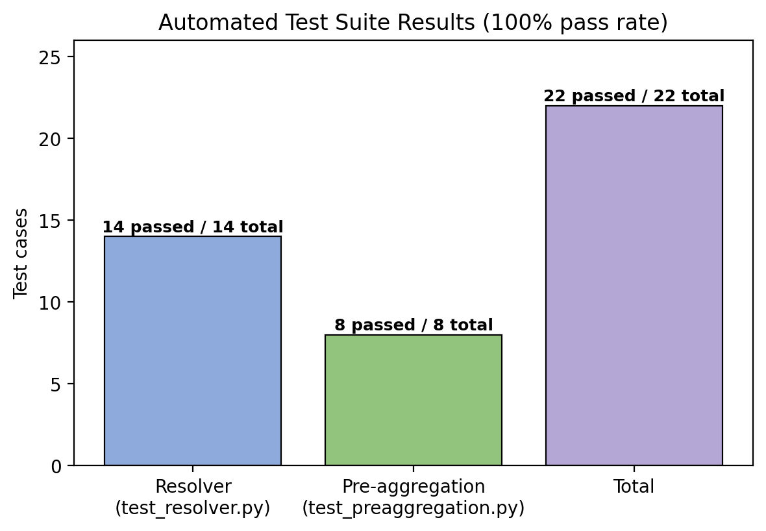
Fig. 8. Automated test suite results by suite.
To characterize the practical difference from naive LWW, two concurrent-update scenarios were compared directly (Table III). In the numeric scenario, a phone update (volume = 80, weight 0.5) and a laptop update (volume = 40, weight 0.4) arrive one second apart. LWW selects 40, discarding the higher-confidence phone signal entirely, whereas the weighted merge yields (80×0.5 + 40×0.4) / (0.5 + 0.4) = 62.22, reflecting both sources in proportion to their trustworthiness (Fig. 9).
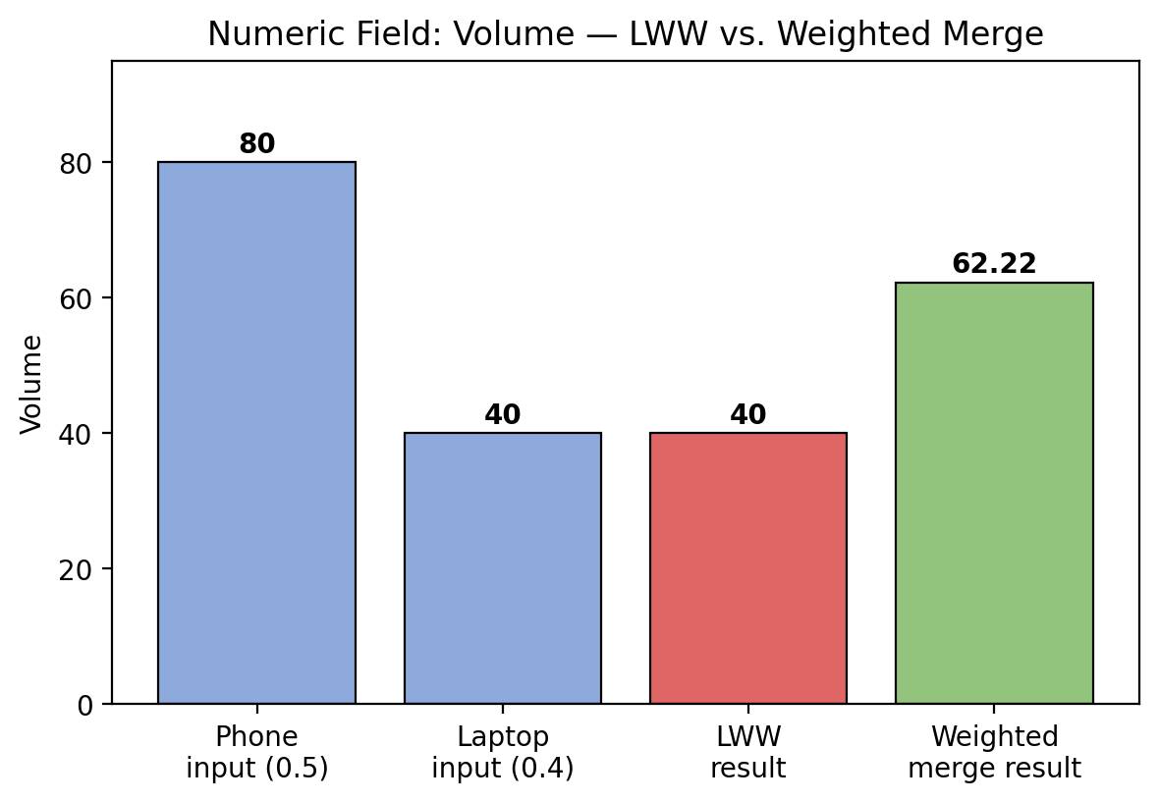
Fig. 9. Numeric-field scenario: inputs versus LWW and weighted-merge outcomes.
In the categorical scenario, a vehicle-dashboard genre selection of “jazz” (weight 0.9) is followed one second later by a background phone update of “rock” (weight 0.5). LWW selects “rock,” overwriting an explicit driver action with a low-context background update, whereas the proposed resolver preserves “jazz” on the basis of its higher device confidence (weights in Fig. 10).
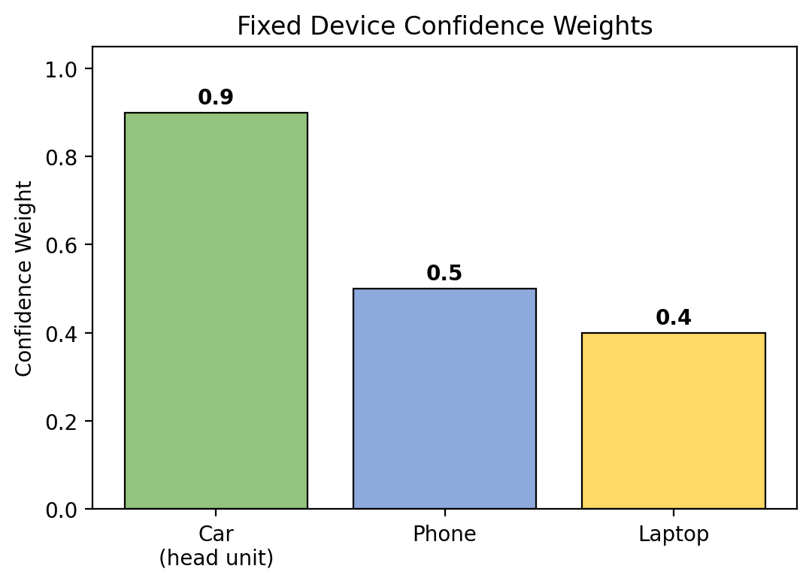
Fig. 10. Fixed confidence weight per device class, the basis for categorical-field resolution in the second scenario.
TABLE III
LWW vs. weighted merge on representative concurrent-update scenarios
Scenario | Inputs | LWW result | Weighted-merge result
Numeric (volume) | Phone: 80 (w=0.5); Laptop: 40 (w=0.4) | 40.00 | 62.22 (weighted avg)
Categorical (genre) | Car: jazz (w=0.9); Phone: rock (w=0.5) | rock | jazz (highest weight)

A third scenario verified causal-dominance detection independently of the weighted-merge path. A laptop update to genre (“acoustic”) with vector clock {phone:0, car:0, laptop:1} was followed by a vehicle update to “edm” with clock {phone:0, car:1, laptop:1}, which element-wise dominates the laptop’s, indicating the vehicle update already incorporated the laptop’s change (the comparison of Fig. 6). The resolver identified this as causal dominance rather than a concurrent conflict and selected “edm” without invoking the weighted merge, confirming that both resolution paths of Section IV are exercised correctly and are distinguishable in the audit trail.
Vehicle-side offline resilience was verified by disconnecting the simulated head unit from the broker and confirming that playback continued from the local SQLite cache, then reconnecting and confirming the vehicle requested and received only the incremental delta since its last known version rather than a full snapshot. Taken together with Figs. 8–10, these results indicate that the resolver behaves correctly across every mechanism described in Section III and produces more representative outcomes than naive LWW in both concurrent-conflict categories the system is designed to handle.

VII. Conclusion and Future Work
This paper presented HarmonySync, an architecture for synchronizing music preferences to a connected vehicle without dependence on Bluetooth pairing or FM broadcast, centered on a causally-aware, confidence-weighted conflict resolution mechanism. Unlike approaches that default to timestamp-based LWW when multiple devices update preference state independently, the proposed resolver distinguishes causally ordered updates from genuinely concurrent ones using vector clocks, and resolves true conflicts through a confidence-weighted merge that preserves proportionate signal from every contributing source. A working prototype, validated against a twenty-two-case automated test suite and demonstrated on numeric, categorical, and causal-dominance scenarios, confirms that the approach yields different and more representative outcomes than naive LWW while maintaining a fully auditable record of every resolution decision.
Future work includes adapting the confidence weights dynamically from observed device reliability rather than fixed per-device constants; evaluating behavior under a larger and more heterogeneous set of concurrently reporting devices; integrating the privacy-preserving pre-aggregation layer with a real streaming-service API to validate against genuine rather than synthetic listening data; and extending the vehicle-side prototype to a real embedded head-unit environment to characterize performance under realistic automotive network conditions.

References
[1] L. Lamport, “Time, clocks, and the ordering of events in a distributed system,” Commun. ACM, vol. 21, no. 7, pp. 558–565, 1978.
[2] G. DeCandia et al., “Dynamo: Amazon’s highly available key-value store,” in Proc. 21st ACM Symp. Operating Systems Principles (SOSP), 2007, pp. 205–220.
[3] M. Shapiro, N. Preguiça, C. Baquero, and M. Zawirski, “Conflict-free replicated data types,” in Stabilization, Safety, and Security of Distributed Systems (SSS), Lecture Notes in Computer Science, vol. 6976. Springer, 2011, pp. 386–400.
[4] A. Banks and R. Gupta, Eds., MQTT Version 3.1.1, OASIS Standard, 2014.
[5] R. Jayanthi, R. Lakshmana Kumar, K. Lavina, and S. Kadry, “A novel smart village model using long range radio (LoRa) technology,” in Proc. [conference], [year].

