4-2 Assignment: Evaluate an Object Model

Romi’on Price
Southern New Hampshire University
CS-255: System Analysis and Design
Professor Goodman
May 31, 2026

Hamp Crafts is a family-owned craft store that has been in business for decades. Its current operations are limited to its physical (brick-and-mortar) storefront. Recently, the owners have determined that one of the best ways to gain additional revenue is through online sales. You have reassured Hamp Crafts’ owners that adding in an online storefront will work with their current processes. In this assignment, you will review an object model, specifically a UML class diagram for the new online store. You will interpret the diagram and reflect on how well it meets Hamp Crafts’ needs.
- First, review Hamp Crafts’ needs for their online storefront. Then review the UML class diagram for the new online storefront. A version with alternative text is also available: Module Four Online Shopping Cart Object Diagram With Alternative Text.
Hamp Crafts would like customers to be able to create an account with their shipping, billing, and contact information. For customer orders, Hamp Crafts would like to accept credit and debit cards for transactions. Hamp Crafts plans on using an established credit card vendor service (e.g., Square, Shopify) to receive customer payments. Once a transaction is complete, the customer should receive a notification based on the information in their personal profile regarding order status and confirmation. On the administrative side of the online storefront, Hamp Crafts should receive an alert of the transaction. Customers should be able to check the status of their order any time online from their personal account profile under order history. The business owners also need an administrative back end for customer support and updates to customer information and the website.
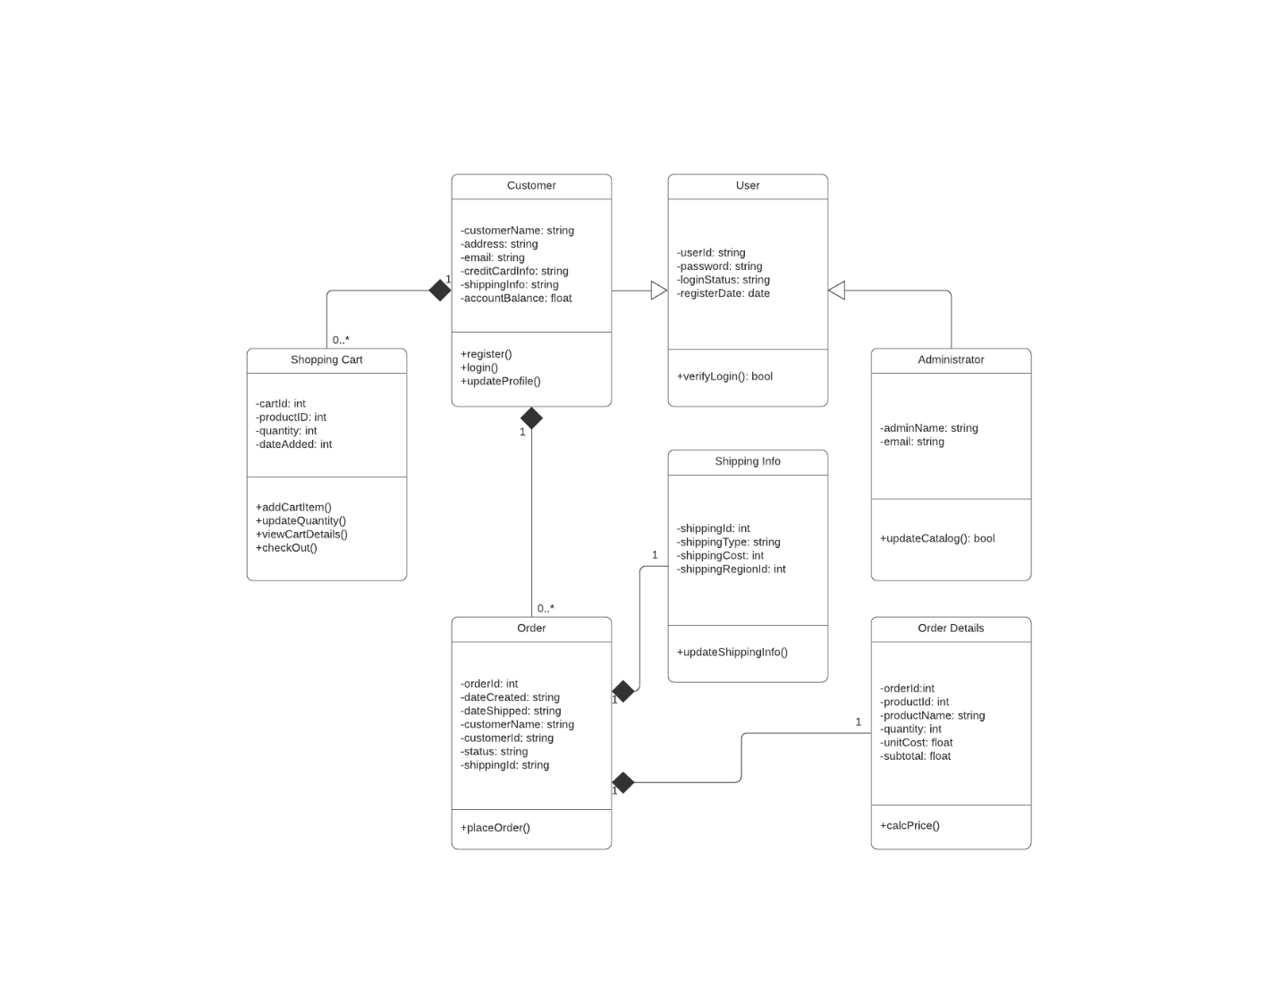
- Interpret the object model for the new online storefront by responding to the following prompts:
  - What are the different functions of the online storefront? How are they represented in this type of model?
A: There are 12 different functions in which their names are +register(), +login(), +updateProfile(), +AddCartItem(), +updateQuantity(), +viewCartDetails(), +checkOut(), +placeOrder(), +verifyLogin(): bool, +updateShippingInfo(), +updateCatalog(): bool, and +calcPrice(). The first three functions are from the Customer class, while the next four are from the Shopping Cart class. +placeOrder() is from the Order class. +verifyLogin(): bool is from the User class and is Boolean which makes it true or false. +updateShippingInfo() is from the Shipping Info class, while +updateCatalog() is from the Administrator class and is Boolean too. Lastly, +calcPrice() is from the Order Details class. Each one has a plus in front of the function names to show it’s a public function.
  - What are the different classes of “users” represented by this object model? What are the associations between these classes?
A: The different classes of “users" are Customers and Administrators. The Customer and Administrator classes are subclasses to the User super class. Those two “child” classes use Inheritance to take on the attributes of the “parent” User class, this is shown with a solid line with a closed, hollow arrow.
  - How would the objects “use” their respective variables and functions?
A: An object uses their respective variable to capture data and store it, so the functions can use that data when needed. For example, the Customer object would use the variables of the User superclass to get information like userID, password, loginStatus, and registerDate and store data into those variables. If the information entered is correct then the function verifyLogin() would be updated to true or false, this would also update the variable loginStatus if the information entered is correct or not. The registerDate would show the date the account was made on. The userID, password, customerName, address, and email variables would be used for the register function, while only userID and password would be used for the login function. The variables customerName, address, email, creditCardInfo, shippingInfo, and accountBalance would be used for the updateProfile() function to display customer information and allow them to update information. Objects of other classes would be similar but would use their own variables and functions.
  - Does this object model capture all of Hamp Crafts’ desired functionality? Why or why not?
A: Overall, it does capture most of the Hamp Crafts desired functionality. There are some functionalities missing, like the established credit card vendor service for receiving transactions. The administrative side of the online storefront is missing alerts for the transactions. It is also lacking if the administrative back end has customer support and updates to customer information and the website.
  - The above diagram uses a solid diamond shape to represent a form of aggregation. What type of aggregation does this represent? What does it imply about the relationship between the classes? Why is a solid diamond the appropriate choice here?
A: The type of aggregation this represents is composition; this implies that there is a part-of relationship between the two classes. If the parent object is deleted, the child object is destroyed as well. The solid diamond is the appropriate choice in this situation. For example, the Order Details object can’t exist without the Order object. If the order is canceled and deleted, the order details must be deleted too. Same with the shipping info if the order is wiped from the system, the tracking becomes meaningless and is deleted too.
- Finally, think through the two different models you’ve explored for Hamp Crafts’ systems: a process model and an object model. Then compare these models by responding to the following prompts:
  - How well do you think a process model describes the system? What information does it make easier to understand? What aspects of the system are more difficult to understand or are not represented?
A: A Process model is an effective way to describe the system in a simpler format. It helps visualize the steps or processes that come with the system, such as with a customer placing an order through checkout, the order being fulfilled by delivery or shipping through a specific shipper. Aspects like customer information, order details, shipping and shopping cart details are not being represented a process are made more difficult to understand or not be represented at all. A process model doesn’t represent how each aspect works together or how the system will be developed.
  - How well do you think an object model describes the system? What information does it make easier to understand? What aspects of the system are more difficult to understand or are not represented?
A: An object model describes the system well by containing more detail than a process model with more attributes. It provides a better understanding of the whole system by how each class works with each other to meet the requirements of the client. Some aspects are more difficult to understand like how attributes can be inherited from a superclass and the type of relationship between two classes.

