3-2 Assignment: Evaluate a Process Model

Romi’on Price
Southern New Hampshire University
CS-255: System Analysis and Design
May 24, 2026

Hamp Crafts is a family-owned craft store that has been in business for decades. Its current operations are limited to its physical (brick-and-mortar) storefront. Recently, the owners have determined that one of the best ways to gain additional revenue is through online sales. The online sales process is new to the owners. They need to fully understand how online ordering works, and how it can be integrated with their current in-store purchase and supply process.
You are a systems analyst working with Hamp Crafts to modernize their business. First, you will analyze their current purchase and supply process for items in their brick-and-mortar store. Then you will suggest ways to integrate new processes for an online storefront.

- Review the following data flow diagram and description of Hamp Crafts’ current purchase and supply process for their brick-and-mortar store.
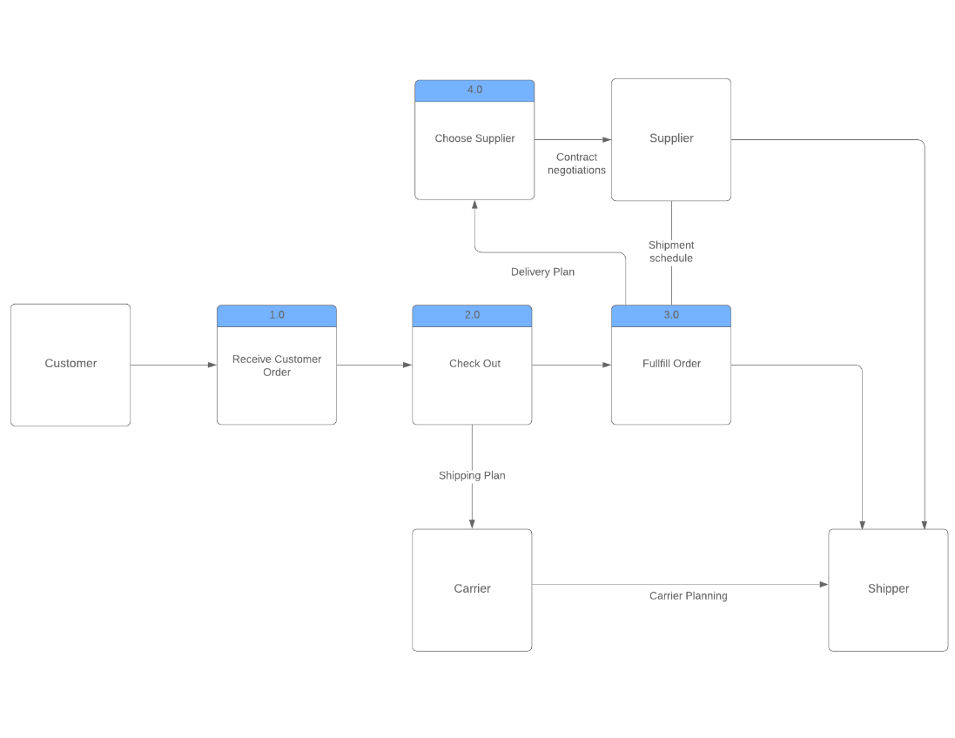

- Describe Hamp Crafts’ current purchase and supply process by responding to the
Interpret the provided data flow diagram. What does it show? What does the current purchase and supply process entail?
What are the data sources involved in the current process?
A: The Data Flow Diagram is for the company craft store called “Hamp Crafts” and it shows their current purchase and supply process for their brick-and-mortar store. It first starts with the customer and proceeds with the 1.0 process of receiving the customer order. It moves to the 2.0 process which is the checkout and gives the customer the option to have a shipping plan with a carrier, in which the carrier plans with the shipper. The next process is 3.0 of fulling the order, this allows the customer to fulfill their order with a delivery plan with a chosen supplier and shipment schedule or fulfilling the order with a shipper. If a delivery plan is chosen, a supplier is needed in process 4.0. A supplier is selected based on inventory selection from the customer. The supplier makes final shipment schedule adjustments based on input of shipping company. All options require a shipper in the end.

3. For the new online storefront, Hamp Crafts’ owners want to ensure that customers can easily view products, pay for them, and receive confirmation of their orders. The owners want to be sure that any payments will be transferred to Hamp Crafts’ business account. You have also suggested adding an administrative backend to provide customer support, update customer information, and maintain the website.
In order to add this functionality, you will need to consider Hamp Crafts’ current purchase and supply process. Then you will need to determine the additional requirements needed to support an online storefront by responding to the following prompts:
  - What additional processes are necessary to integrate an online storefront?
  - What additional data sources would the system need to access the products and inventory?
  - What additional databases, if any, are needed to support the online storefront?
A: Other processes such as home page with deals, account creation for faster checkout, inventory data access, out of stock or low stock indicators, invalid provider parameters, shipping addons, emails with receipts or tracking numbers.
Some additional data sources would be having data for inventory, order IDs, addresses, names, support tickets, suppliers, shipping company availability, shipping prices, selection data, etc.
Some additional databases needed for an online storefront would be having tables with customer information such as their name, address, new or old orders, order ID associated with them, and payment details for returning customers. Another table would contain the quantity of stocked items based on the name or SKU associated with item. Finally, the shipper and carrier tables that for shipment or delivery availability.

4. Finally, determine how to integrate the new online storefront into Hamp Crafts’ current purchase and supply process by responding to the following prompt:
  - Would you recommend creating a separate new system for the online storefront or incorporating elements of the online storefront into the current process model? Explain your reasoning.
A: I would recommend creating a new system for the online storefront but incorporating some of the existing processes from the in-store purchase and supply process. This would make for a strong foundation for adding other processes like account creation, inventory management, shipping information, supplier details, and availability of shipping or delivery.

