Objective
To apply fundamental Python control structures, such as loops (for, while) and conditional statements (if-else), to solve a variety of introductory programming problems and build foundational coding skills
Theory
User Input and Output
Programs interact with the user through input and output functions. The input() function prompts the user for keyboard entry, which is always captured as a string. To use this input for mathematical calculations, it must be converted to a number using a function like int(). Conversely, the print() function displays information to the console. Its default behavior can be modified; for instance, including the end=' ' parameter tells Python to end the output with a space instead of a new line, allowing subsequent print statements to continue on the same line.
Loops for Iteration
Loops are fundamental for repeating a block of code without rewriting it. The for loop is ideal for iterating a specific number of times over a sequence, such as a list or a series of numbers generated by the range() function. In contrast, the while loop is used when the number of iterations is unknown beforehand; it continues to execute its code block as long as a specified condition remains true, checking the condition before each repetition.
Conditional Logic
Conditional logic allows a program to make decisions and execute different blocks of code. This is achieved using an if-elif-else structure, which evaluates conditions sequentially. More complex logic can be built by combining conditions with operators like and (which is true only if all parts are true) and or (which is true if at least one part is true). A key tool for conditional checks is the modulo operator (%), which returns the remainder of a division and is essential for determining if a number is even, odd, or perfectly divisible by another.
Loop Control Statements
The standard flow of a loop can be altered with special control statements. The break statement immediately terminates the entire loop and program execution continues at the next line of code after the loop. The continue statement is less final; it skips the remainder of the current iteration and moves directly to the start of the next one, allowing the loop to proceed with its next repetition.
Data Types and Built-in Methods
Python’s built-in data types come with powerful, ready-to-use features. Strings, which are sequences of characters, can be easily manipulated. For example, string slicing (word[::-1]) offers a concise way to create a reversed copy. Strings also have helpful methods like .isalpha() and .isdigit() to check if their contents are exclusively letters or numbers. Another key data type, the list, is an ordered collection of items defined by square brackets ([]) and is highly effective for storing and accessing multiple values.
Using Modules
Python’s functionality can be extended by importing modules, which are files containing pre-written code. This is done with the import statement. The random module, for example, is essential for programs involving unpredictability. Functions like random.randint(a, b) can generate a random integer within a specific range, while random.choice(sequence) is used to select a single random element from a list or another sequence.

Q1. Write a Python program to find the sum of n natural numbers.
a = int(input("Enter a number: "))
b = 0
for c in range(1, a + 1):
b += c
print("Sum is:", b)
OUTPUT
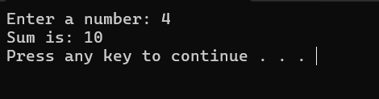
Q2. Write a program to read an integer from user. For all numbers except those divisible by 10, print them.
a = int(input("Enter a number: "))
for b in range(1, a + 1):
if b % 10!= 0:print(b)
OUTPUT
Q 3. Write a Python program that prints all the numbers from 0 to 6 except 3 and 6. Use 'continue' statement.
for a in range(7):
if a == 3 or a == 6:
continue
print(a)
OUTPUT
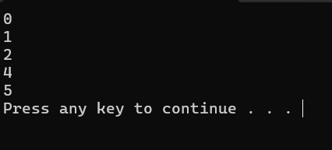
Q 4. Write a Python program to get the Fibonacci series up to a given number.
a = int(input("Enter limit: "))
b, c = 0, 1
while b <= a:
print(b, end=' ')
b, c = c, b + c
OUTPUT
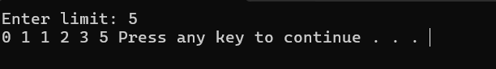
Q 5. Write a Python program to find those numbers which are divisible by 7 and multiple of 5 between 1500 and 2700 (both included).
for a in range(1500, 2701):
if a % 7 == 0& a % 5 == 0:
print(a, end=' ')
OUTPUT
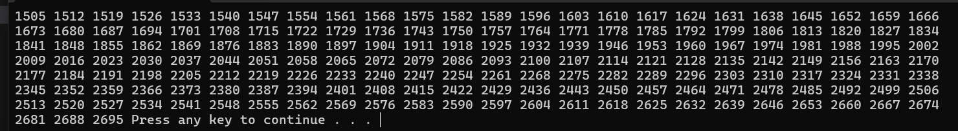
6. Write a Python program to guess a number between 1 and 9. Keep asking until the guess is correct. Use random.
import random
a = random.randint(1, 9)
while True:
b = int(input("Guess the number (1-9): "))
if b == a:
print("Well guessed!")
break
OUTPUT
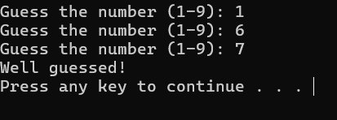
Q 7. Write a Python program to input n numbers from user, count even and odd numbers, and stop when input is 0.
n = int(input("Enter the maximum number of times you want to loop: "))
for y in range(1, n + 1):
b = int(input("Enter a number or enter 0 to stop: "))
if b == 0:
print("You entered 0 stopping the loop.")
break
if(b%2==0): print("You entered even number")
else:print("you entered odd humber")
print("Loop finished.")
Q 8. Write a Python program that accepts a string and calculates the number of letters and digits.
a = "Python 3.2"
b = c = 0
for d in a:
if d.isalpha():
b += 1
elif d.isdigit():
c += 1
print("Letters", b)
print("Digits", c)
OUTPUT
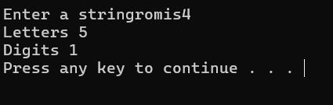
Q 9. Write a Python program to develop a rock paper scissors game using user input. Stop the game when user presses 'n'.
import random
a = ['rock', 'paper', 'scissors']
while True:
b = input("Enter rock/paper/scissors or 'n' to stop: ")
if b == 'n':
break
c = random.choice(a)
print("Computer chose:", c)
if b == c:
print("Draw!")
elif (b == 'rock' and c == 'scissors') or (b == 'scissors' and c == 'paper') or (b == 'paper' and c == 'rock'):
print("You win!")
else:
print("You lose!")
OUTPUT
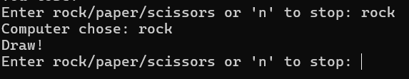
Q 10. Write a Python program to create the multiplication table (from 1 to 10) of a number.
a = int(input("Enter a number: "))
for b in range(1, 11):
print(a, "x", b, "=", a * b)
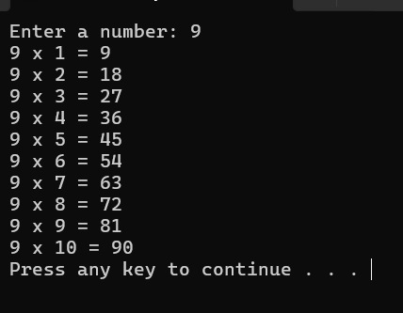
Q11.Write a Python Program to Accept Word From User and Reverse It.
word = input("Enter a word: ")
rword = word[::-1]
print("Reversed word:", rword)
OUTPUT
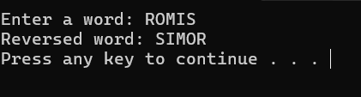
Q12. Write a Python Program to Print Pattern Using Nested for Loop
n = 5
for a in range(1, n + 1):
for b in range(a):
print("* ", end="")
print()
for a in range(n - 1, 0, -1):
for b in range(a):
print("* ", end="")
print()
OUTPUT
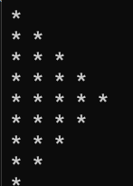
CONCLUSION
In this lab session we have learnt to apply fundamental Python control structures, such as loops (for, while) and conditional statements (if-else), to solve programming problems

