Objective
To learn how to create, access, and manipulate Python lists by performing operations such as iteration, searching, sorting, removing duplicates, summing/multiplying items, filtering elements, and applying list comprehensions, while understanding basic concepts like prime number checking, merging, and slicing.
Theory
Python lists are versatile structures that allow storing, manipulating, and processing collections of data efficiently using loops, comprehensions, and built-in methods
1. Lists in Python
A list is a mutable collection that can store multiple items of different data types. Items can be accessed using indexing and modified after creation.
2. Iterating Through a List
We can use for loops to traverse all items in a list and perform operations like printing, summing, or multiplying elements.
3. Range Function
The range() function generates sequences of numbers. It is useful for iterating through numbers or filtering even/odd numbers.
4. Checking List Properties
Lists can be checked for emptiness using conditions like if not list, and items can be removed using del, pop(), or list comprehensions.
5. Merging and Sorting Lists
Two lists can be merged using +, and sorted numerically using sort() or custom keys for nested lists.
6. Reversing and Slicing Lists
Lists can be reversed using reverse() or slicing (list[::-1]) and sliced to get sublists, like first or last elements.
7. List Comprehensions and Transformations
Comprehensions allow quick transformations, like adding a prefix to each element, finding squares, or filtering by conditions.
8. Copying and Inserting Elements
Lists can be copied using copy() to create independent duplicates, and new items can be inserted at specific positions using insert().
Q 1. Write a Python Program to print all the items in a list.
a = int(input("Enter the number of items: "))
lst = [None] * a
for b in range(a):
lst[b] = input("Enter item: ")
for b in lst:
print(b)
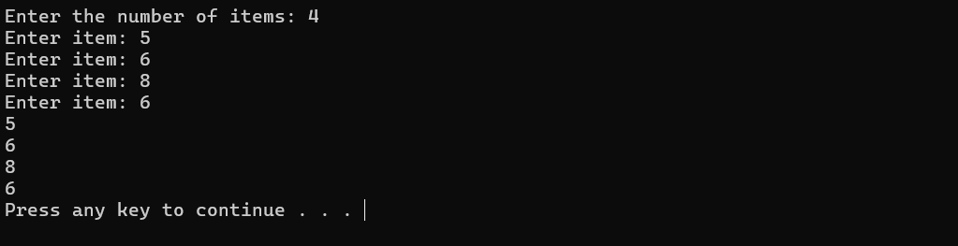
Q2. Use range function to print all the even numbers from 1 to 10.
for a in range(1, 11):
if a % 2 == 0:
print(a)
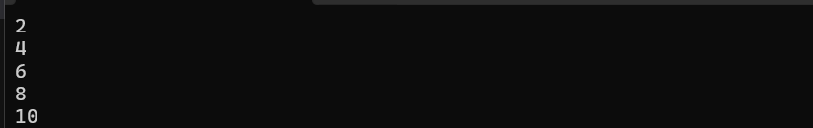
Q 3. Write a Python Program to get the largest and smallest number in a list without using built-in functions.
n = int(input("Enter the number of items: "))
a = [0] * n
for i in range(n):
a[i] = int(input("Enter number: "))
big = a[0]
small = a[0]
for b in a:
if b > big:
big = b
if b < small:
small = b
print("Largest:", big)
print("Smallest:", small)
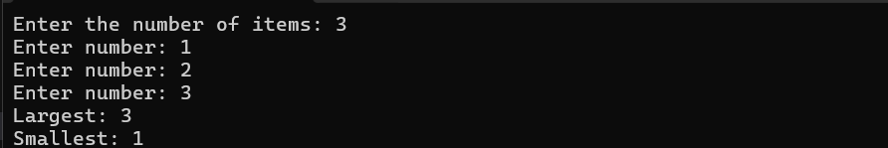
Q 4. Find the second smallest and second largest numbers in a list.
a = [4, 1, 8, 3, 9]
a.sort()
print("Second smallest:", a[1])
print("Second largest:", a[-2])
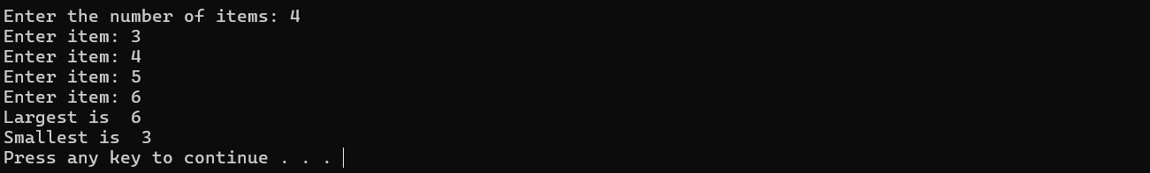
Q5. Sum all the items in a list.
a = int(input("Enter the number of items: "))
lst = [None] * a
for b in range(a):
lst[b] = input("Enter item: ")
lst.sort()
l = lst[-1]
s = lst[0]
print("Largest is ",l)
print("Smallesy is ",s)
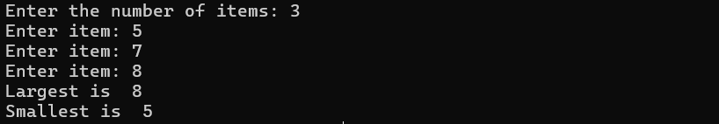
Q 6. Multiply all the items in a list.
a = [1, 2, 3, 4]
b = 1
for c in a:
b *= c
print(b)
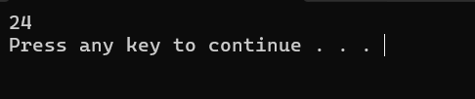
Q 7. Check if a list is empty or not.
a = []
if not a:
print("Empty")
else: print("Not empty")
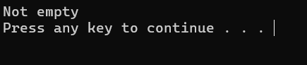

Q8. Print the numbers of a specified list after removing even numbers.
a = [1, 2, 3, 4, 5, 6]
b = [c for c in a if c % 2 != 0]
print(b)
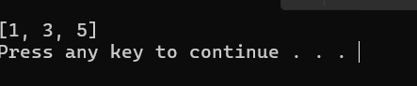
Q9. Remove 0th, 4th and 5th element from list.
a = ['Red', 'Green', 'White', 'Black', 'Pink', 'Yellow']
for i in sorted([0, 4, 5], reverse=True):
del a[i]
print(a)
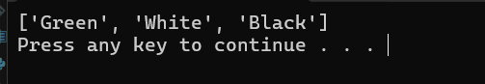
Q10. Check if each number is prime in a given list.
a = [3, 4, 5, 10, 13]
for b in a:
if b > 1:
for c in range(2, b):
if b % c == 0:
break
else:
print(b, "is prime")
else:
pass
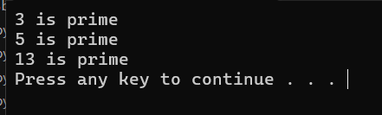
Q 11. Remove duplicates from a list.
a = [1, 2, 2, 3, 4, 4]
b = []
for c in a:
if c not in b:
b.append(c)
print(b)
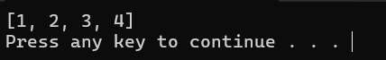
Q12. Merge two lists and remove duplicates.
a = [1, 2, 3]
b = [3, 4, 5]
c = a + b
d = []
for e in c:
if e not in d:
d.append(e)
print(d)
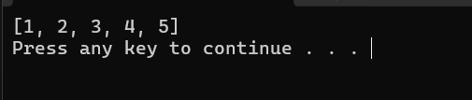
Q13. Print a list in reverse order.
a = [1, 2, 3]
a.reverse()
print(a)
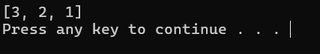
Q 14. Sort a list of strings (numbers) numerically.
a = ['4', '12', '45', '7', '0', '100', '200', '-12', '-500']
a = [int(b) for b in a]
a.sort()
print(a)
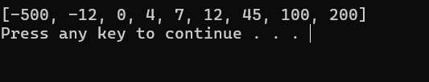
Q 15. Apply various list functions.
a = [1, 2, 3]
a.append(4)
a.remove(2)
a.pop()
a.insert(1, 5)
print(a)
print("Max:", max(a))
print("Min:", min(a))
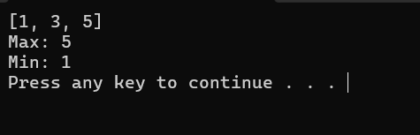
Q16. Copy content of one list to another.
a = [1, 2, 3]
b = a.copy()
print(b)
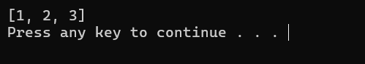
Q 17. Sort a list of lists by a given index.
a = [[1, 3], [3, 2], [2, 1]]
a.sort(key=lambda x: x[1])
print(a)
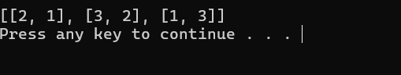
Q 18. Generate and print first and last 5 elements where values are square numbers between 1 and 15.
a = [b**2 for b in range(1, 16)]
print(a[:5] + a[-5:])
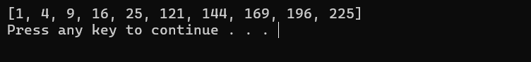
Q 19. Insert a string at the beginning of all items in a list.
a = [1, 2, 3, 4]
b = 'emp'
a = [b + str(c) for c in a]
print(a)
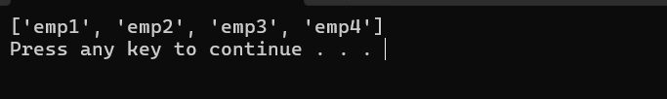
Q 20. Find values in a list greater than a specified number.
a = [1, 2, 3, 4, 5]
n = 3
b = [c for c in a if c > n]
print(b)
a = [1, 2, 3, 4, 5]
for b in a:
print(b)
print(a)
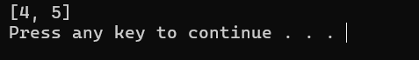
Conclusion
In this lab session, We have learnt about lists and different operation in list.

