Objective
- To practice Python tuples and sets, including accessing, modifying, sorting, finding duplicates, converting tuples to integers, and performing set operations like union, intersection, and difference.
Theory
Tuples
Tuple: A tuple is an ordered collection of items in Python that cannot be changed (immutable). It can store integers, floats, strings, or even other tuples.
Accessing and Modifying: Elements are accessed using indexing. Since tuples are immutable, to modify them, we create a new tuple with the required changes.
Finding Repeated Items: Repeated elements in a tuple can be found by counting occurrences using loops or dictionaries.
Sorting Tuples: Tuples containing numbers or strings can be sorted using the sorted() function, custom functions, or loops. Sorting can be done in ascending or descending order.
Tuple to Integer Conversion: A tuple of digits can be converted into a single integer either by joining elements as strings or using arithmetic operations.
Sets
Set: A set is an unordered collection of unique items in Python. Duplicate elements areautomatically removed. Sets are mutable, meaning elements can be added or removed.
Creating Sets: Sets are created using curly braces {} or the set() function. Elements can be integers, floats, strings, or tuples, but not lists or dictionaries.
Accessing Elements: Since sets are unordered, elements cannot be accessed by index. Membership can be checked using the in keyword.
Modifying Sets: Elements can be added with add(), multiple elements with update(), and removed with remove() or discard(). pop() removes an arbitrary element.
Set Operations: Sets support mathematical operations like union (|), intersection (&), difference (-), and symmetric difference (^).

Q1. Write a Python program to convert a tuple to a string.
a = ('p', 'y', 't', 'h', 'o', 'n')
b = ''.join(a)
print(b)
Q2. Write a Python program to get the 4th element from the last element of a tuple.
a = (1, 2, 3, 4, 5, 6, 7, 8, 9)
print(a[-4])
Q3. write a python program to find repeated item in a tuple
a = (1, 2, 3, 2, 4, 5, 2, 6)
count = {}
for x in a:
if x in count:
count[x] += 1
else:
count[x] = 1
for k in count:
if count[k] > 1:
print(k)
Q4. Program to replace the last value of tuples in a list
a = [(10, 20, 40), (40, 50, 60), (70, 80, 90)]
b = []
for x in a:
temp = list(x)
temp[-1] = 100
b.append(tuple(temp))
print(b)
Q5. Program to sort a tuple by its float element using loop.
a = [('item1', '12.20'), ('item2', '15.10'), ('item3', '24.5')]
a = list(a)
n = len(a)
for i in range(n):
for j in range(0, n-i-1):
if float(a[j][1]) < float(a[j+1][1]):
a[j], a[j+1] = a[j+1], a[j]
print(a)
Q6. Write a Python program to convert a given string list to a tuple.
a = "python 3.0"
b = tuple(a)
print(b)
Q7. Write a Python program to calculate the product of all numbers in a tuple.
a = (4, 3, 2, 2, -1, 18)
p = 1
for i in a:
p *= i
print(p)
b = (2, 4, 8, 8, 3, 2, 9)
p = 1
for i in b:
p *= i
print(p)
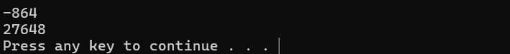
Q 8. Write a Python program to calculate the average value of numbers in a tuple of tuples.
a = ((10, 10, 10, 12), (30, 45, 56, 45), (81, 80, 39, 32), (1, 2, 3, 4))
b = [sum(x)/len(x) for x in a]
print(b)
c = ((1, 1, -5), (30, -15, 56), (81, -60, -39), (-10, 2, 3))
d = [sum(x)/len(x) for x in c]
print(d)
Q9. Program to convert a tuple of positive integers into an integer
a = (1, 2, 3)
num = ""
for x in a:
num += str(x)
b = int(num)
print(b)
Q10: Write a Python program to compute the element-wise sum of given tuples.
a = (1, 2, 3, 4)
b = (3, 5, 2, 1)
c = (2, 2, 3, 1)
res= tuple(map(sum, zip(a, b, c)))
print(res)
Q11. Compute the sum of all the elements of each tuple stored inside a list of tuples.
first
a = [(1, 2), (2, 3), (3, 4)]
b = [sum(x) for x in a]
print("First :")
print(b)
second
c = [(1, 2, 6), (2, 3, -6), (3, 4), (2, 2, 2, 2)]
d = [sum(y) for y in c]
print("Second")
print(d)
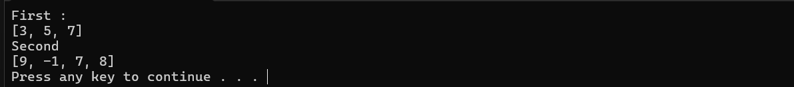
Q12: Demonstrate various set operations.
a = {1, 2, 3, 4, 5}
b = {4, 5, 6, 7, 8}
print("Set a:", a)
print("Set b:", b)
print()
Union
c = a.union(b)
print("Union of a and b:", c)
print()
Intersection
d = a.intersection(b)
print("Intersection of a and b:", d)
print()
Difference
e = a.difference(b)
print("Difference (a - b):", e)
print()
Symmetric Difference
f = a.symmetric_difference(b)
print("Symmetric Difference of a and b:", f)
print()
Length, Max, Min of a set
print("Length of set a:", len(a))
print("Maximum value in set a:", max(a))
print("Minimum value in set a:", min(a))
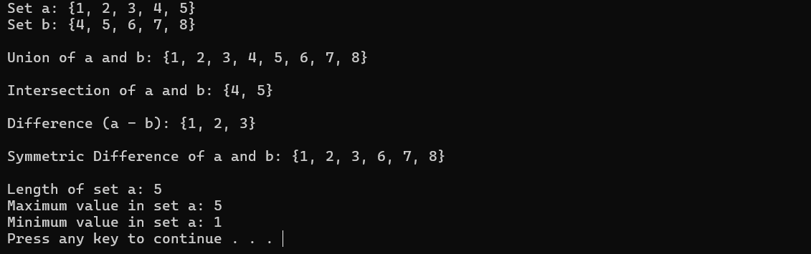
CONCLUSION
In this lab session, we have learnt about tuples and sets and different sets operation on them.

