**Q1. Write a Python program to find the sum of n natural numbers.**

a = int(input("Enter a number: "))

b = 0

for c in range(1, a + 1):

    b += c

print("Sum is:", b)

**OUTPUT**

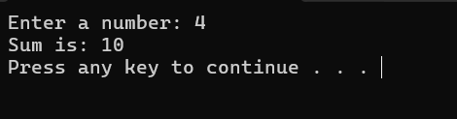

**Q2. Write a program to read an integer from user. For all numbers except those divisible by 10, print them**.

a = int(input("Enter a number: "))

for b in range(1, a + 1):

    if b % 10!= 0:print(b)

**OUTPUT**



**Q 3. Write a Python program that prints all the numbers from 0 to 6 except 3 and 6. Use 'continue' statement.**

for a in range(7):

    if a == 3 or a == 6:

        continue

    print(a)

**OUTPUT**

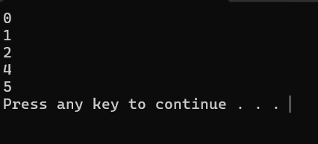

**Q 4. Write a Python program to get the Fibonacci series up to a given number.**

a = int(input("Enter limit: "))

b, c = 0, 1

while b <= a:

    print(b, end=' ')

    b, c = c, b + c

**OUTPUT**

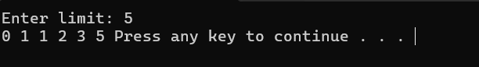

**Q 5. Write a Python program to find those numbers which are divisible by 7 and multiple of 5 between 1500 and 2700 (both included).**

for a in range(1500, 2701):

    if a % 7 == 0& a % 5 == 0:

        print(a, end=' ')

**OUTPUT**

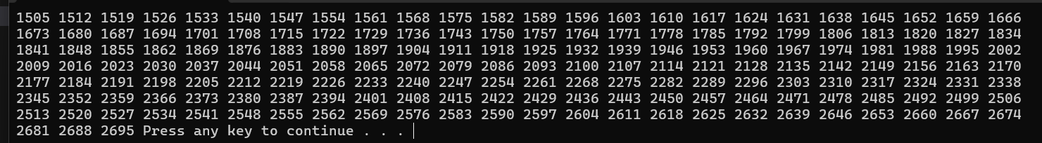

**6. Write a Python program to guess a number between 1 and 9. Keep asking until the guess is correct. Use random.**

import random

a = random.randint(1, 9)

while True:

    b = int(input("Guess the number (1-9): "))

    if b == a:

        print("Well guessed!")

        break

**OUTPUT**

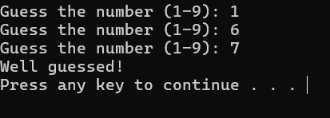

**Q 7. Write a Python program to input n numbers from user, count even and odd numbers, and stop when input is 0.**

n = int(input("Enter the maximum number of times you want to loop: "))

for y in range(1, n + 1):

    b = int(input("Enter a number or enter 0 to stop: "))

    if b == 0:

        print("You entered 0 stopping the loop.")

        break

    if(b%2==0): print("You entered even number")

    else:print("you entered odd humber")

print("Loop finished.")