**Objective**

To learn how to create, access, and manipulate Python lists by performing operations such as iteration, searching, sorting, removing duplicates, summing/multiplying items, filtering elements, and applying list comprehensions, while understanding basic concepts like prime number checking, merging, and slicing**.**

**Theory**

Python lists are versatile structures that allow storing, manipulating, and processing collections of data efficiently using loops, comprehensions, and built-in methods

**1. Lists in Python**

A list is a mutable collection that can store multiple items of different data types. Items can be accessed using indexing and modified after creation.

**2. Iterating Through a List**

We can use for loops to traverse all items in a list and perform operations like printing, summing, or multiplying elements.

**3. Range Function**

The range() function generates sequences of numbers. It is useful for iterating through numbers or filtering even/odd numbers.

**4. Checking List Properties**

Lists can be checked for emptiness using conditions like if not list, and items can be removed using del, pop(), or list comprehensions.

**5. Merging and Sorting Lists**

Two lists can be merged using +, and sorted numerically using sort() or custom keys for nested lists.

**6. Reversing and Slicing Lists**

Lists can be reversed using reverse() or slicing (list[::-1]) and sliced to get sublists, like first or last elements.

**7. List Comprehensions and Transformations**

Comprehensions allow quick transformations, like adding a prefix to each element, finding squares, or filtering by conditions.

**8. Copying and Inserting Elements**

Lists can be copied using copy() to create independent duplicates, and new items can be inserted at specific positions using insert().

.

**Q 1. Write a Python Program to print all the items in a list**.

a = int(input("Enter the number of items: "))

lst = [None] * a

for b in range(a):

    lst[b] = input("Enter item: ")

for b in lst:

    print(b)

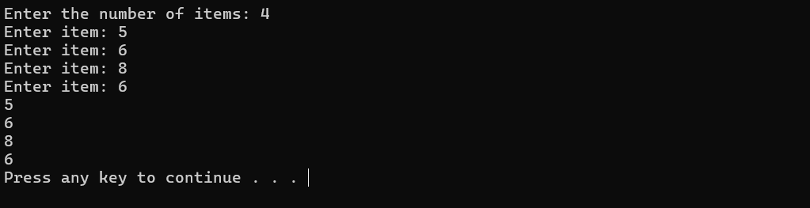

**Q2. Use range function to print all the even numbers from 1 to 10.**

for a in range(1, 11):

if a % 2 == 0:

print(a)

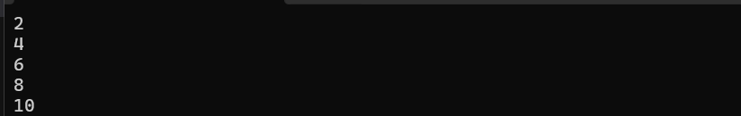

**Q 3. Write a Python Program to get the largest and smallest number in a list without using built-in functions.**

n = int(input("Enter the number of items: "))

a = [0] * n

for i in range(n):

    a[i] = int(input("Enter number: "))

big = a[0]

small = a[0]

for b in a:

    if b > big:

        big = b

    if b < small:

        small = b

print("Largest:", big)

print("Smallest:", small)

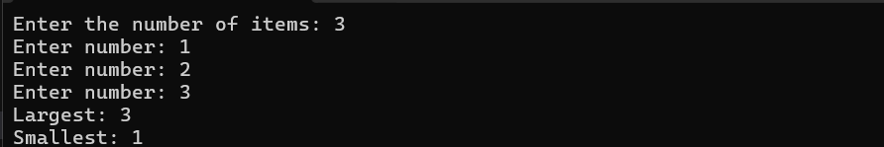

**Q 4. Find the second smallest and second largest numbers in a list.**

a = [4, 1, 8, 3, 9]

a.sort()

print("Second smallest:", a[1])

print("Second largest:", a[-2])

**Q5. Sum all the items in a list**.

a = int(input("Enter the number of items: "))

lst = [None] * a

for b in range(a):

    lst[b] = input("Enter item: ")

lst.sort()

l = lst[-1]

s = lst[0]

print("Largest is ",l)

print("Smallesy is ",s)

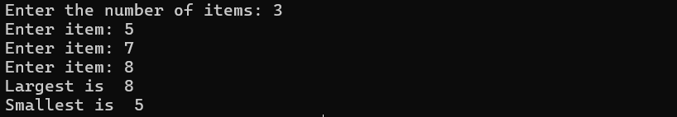

**Q 6. Multiply all the items in a list.**

a = [1, 2, 3, 4]

b = 1

for c in a:

b *= c

print(b)

**Q 7. Check if a list is empty or not.**

a = []

if not a:

print("Empty")

else:

print("Not empty")

**Q8. Print the numbers of a specified list after removing even numbers.**

a = [1, 2, 3, 4, 5, 6]

b = [c for c in a if c % 2 != 0]

print(b)

**Q9. Remove 0th, 4th and 5th element from list.**

a = ['Red', 'Green', 'White', 'Black', 'Pink', 'Yellow']

for i in sorted([0, 4, 5], reverse=True):

del a[i]

print(a)

**Q10. Check if each number is prime in a given list.**

a = [3, 4, 5, 10, 13]

for b in a:

if b > 1:

for c in range(2, b):

if b % c == 0:

break

else:

print(b, "is prime")

else:

pass

**Q 11. Remove duplicates from a list.**

a = [1, 2, 2, 3, 4, 4]

b = []

for c in a:

if c not in b:

b.append(c)

print(b)

**Q12. Merge two lists and remove duplicates.**

a = [1, 2, 3]

b = [3, 4, 5]

c = a + b

d = []

for e in c:

if e not in d:

d.append(e)

print(d)

**Q13. Print a list in reverse order.**

a = [1, 2, 3]

a.reverse()

print(a)

**Q 14. Sort a list of strings (numbers) numerically.**

a = ['4', '12', '45', '7', '0', '100', '200', '-12', '-500']

a = [int(b) for b in a]

a.sort()

print(a)

**Q 15. Apply various list functions.**

a = [1, 2, 3]

a.append(4)

a.remove(2)

a.pop()

a.insert(1, 5)

print(a)

print("Max:", max(a))

print("Min:", min(a))

**Q16. Copy content of one list to another.**

a = [1, 2, 3]

b = a.copy()

print(b)

**Q 17. Sort a list of lists by a given index.**

a = [[1, 3], [3, 2], [2, 1]]

a.sort(key=lambda x: x[1])

print(a)

**Q 18. Generate and print first and last 5 elements where values are square numbers between 1 and 15.**

a = [b**2 for b in range(1, 16)]

print(a[:5] + a[-5:])

**Q 19. Insert a string at the beginning of all items in a list.**

a = [1, 2, 3, 4]

b = 'emp'

a = [b + str(c) for c in a]

print(a)

**Q 20. Find values in a list greater than a specified number.**

a = [1, 2, 3, 4, 5]

n = 3

b = [c for c in a if c > n]

print(b)

a = [1, 2, 3, 4, 5]

for b in a:

print(b)

print(a)